Microscopy-Teil der biologischen Analytik (Achtung, nicht gesamte Prüfung, nur Microscopy-Part)
Question 1 – Single molecule microscopy
Why can you localize individual fluorescent molecules at a precision that that is higher than the classical diffraction limit (which is approx. ½ wavelength of light used in experiment)?
Question 2 – Multiple Choice
Stokes shift of a fluorescent molecule is proportional to wave-length of the exciting light (true/false) Explain why
Why do the excitation and emission spectra of fluorophores have a broad distribution?
- Because the electron does not always emit the same amount of energy when it falls back into the ground state. (True/False)
- Because the number of photons that are emitted when one electron falls back into the ground state varies between different molecules. (True/false)
- The peaks are sharper when the fluorophore is excited by a monochromatic laser compared to the excitation with a composite light source (True/False)
Question 3 - FRET
a. What does the abbreviation FRET stand for?
b. Explain the molecular principle of FRET (you can use drawings as appropriate).
c. A PhD students uses FRET to measure the interaction of a protein of interest (Pol1 with different potential interactors (Pini-3), As control, the student uses samples that contain only the donor or only the acceptor. The graphs below show the resuits for three measurements.
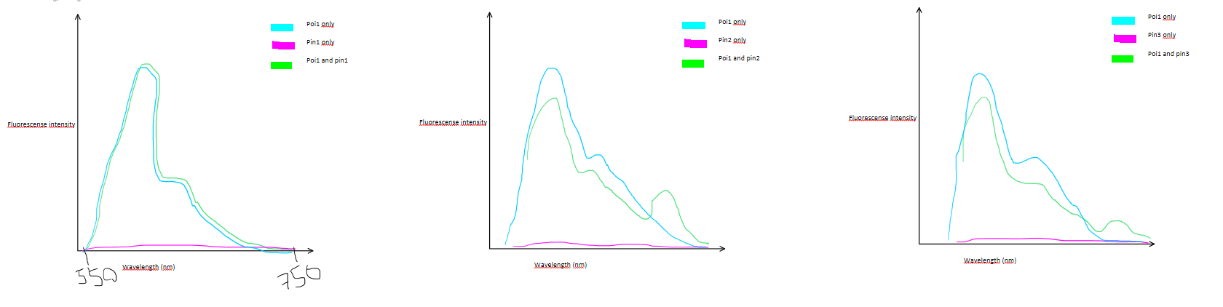
i. Is Poi1 or are Pin1-3 labelled with the donor fluorophore?
ii. Draw how approximately the emission and excitation spectra of the acceptor fluorophore might look like.
iii. What is the purpose of including donor-only control?
iv. What is the purpose of including an acceptor only control?
v. Which of the following conclusions can be drawn from the experiment (True7False)?
- The concentration of Poi1 in the samples is higher than the concentration of Pin2.
- The fluorophores on Poi1 and Pin1 are not in the correct orientation to allow for energy transfer via FRET.
- Pin3 and Pin2 exhibit FRET with Poi1, indicating close spatial proximity.

Question 4- FRAP
A researcher conducts a FRAP experiment on stress granules, cytoplasmic structures
involved in the regulation of translation and RNA decay. He has labelled either the stress
granule protein SGP1 or SGP2 with GFP and expresses each of therm in two different cell
lines.
a) Describe in a form of a bullet point list the principle steps of FRAP. Draw a graph depicting a potential experimental outcome.
b) The fluorescence intensity that he measures for SGP1 in the stress granule at the end of the experiment is 30 % of the initial value. By contrast, he observes a 100% recovery for SGP2. Provide an explanation for this experimental outcome.

