Questions for Self Study Lesson: Challenge 1 computation

Please answer the following questions and upload your answers on the course's Moodle page.

Question 1: Give an example of a biological process where a flux-balance analysis would not be appropriate (do not use the example given in the self-study material)

A process, which is not balanced. A muscle cell under respiratory stress, which accumulates lactate is consuming more sugar, than can be oxidized by oxygen.
Process, in which need of Input changes, or accumulate, so the fluxes are not balanced.

Question 2: In figure 9 of the self-study hand out, the reactions between the metabolites are represented by a single, one-headed arrow. But, in your biochemistry class you will have learned that chemical reactions are generally reversible.
- Explain under which conditions it will still make sense to represent biochemical reaction by a one-directional arrow.

If the reaction is very exergonic, so the flux backwards is very small.
or if the concentration is not balanced of educt and product, so from mass action one of the fluxes is unlikely. The Product is used by another reaction, so the Productconcentration is always very low, so then the reverse reaction is not likely to happen.

- If you are dealing with a reversible reaction. How could you represent this in the stoichiometry matrix.

With a 0 , as the forward 1, and backward -1 on the same Substrates have the effective change of 0.

Question 3: Please set up the stoichiometry matrix that describes the following set of equations.
R1
R2
R3
R4

 | R1 | R2 | R3 | R4
A | -1 | 0 | 1 | 0
B | 2 | -2 | 0 | 0
C | 0 | 2 | -2 | 0
D | 0 | 0 | 1 | -3
E | 0 | 0 | 0 | 2
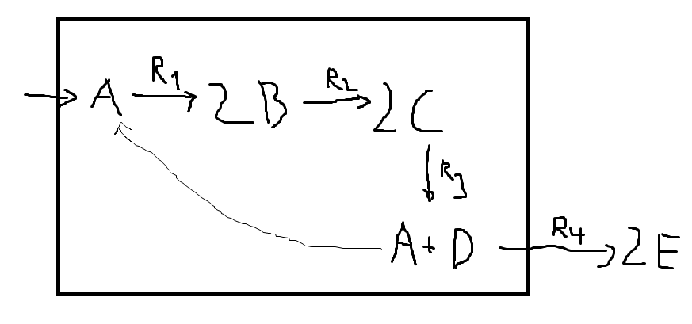

Question 4: In the hand out we discussed how stoichiometric relationships are used as constraints in Flux Balance Analysis. What other constraints could one use in addition?

Fluxes in general
Maximal or minimal influx or output of the system.
Diffusionrate. Compartimentalisation of reactions in the cell. Transport in between those.

Question 5: A question for the mathematically savvy. In the example given in figure 11 of the hand out the constraints of the linear programing problem are given in the form of the stoichiometry matrix. How could you include additional constraints in a linear programming problem?

With additional Vectors to each reaction of the matrix.

Question 6: In Flux Balance Analysis we use the objective function to select out of all possible flux vectors that flux vector which maximizes the objective function. From what you have learned about linear programming, is it possible that two or more flux vectors give the same maximal value?

Yess, but the path to the maximal value may differ.

