Molecular Disease Mechanism – Summary
Inhalt
Introduction (M.Stoffel) 6
Important terms 6
Different kind of Disease’s 6
Disease Mechanisms 7
Genes, Chromosoms - Genetics and single gene disorders (M. Stoffel) 7
Organization of the human genome 7
Methods to observe human chromosomes 7
General features of Chromosom 7
Identifying the genetic basis of disease 8
Genetic linkage 9
Polygenic, complex diseases (M.Stoffel) 9
Key concepts of complex disease 9
Multifactorial diseases 9
Models to explain multifactorial diseases 9
Different studies 9
Factors which influence success of studies 10
Mitochondrial diseases (M.Stoffel) 10
Mitochondria 10
Mitochondria in aging an cancer 10
Genetic facts 11
Identification of Mitochondrial Mutations 11
Chromosomal abnormalities (M.Stoffel) 11
Aneuploidies 11
Differen types of chromosome abnormalities 11
Gene Therapies (M.Stoffel) 12
What is the ideal outcome of gene therapy ? 12
Different types of gene therapies 12
Germline Gene therapy 12
Somatic cell Gene theraphy 12
Vectors 12
Risks associated with gene therapy 13
Advantages of gene therapy 13
Disadvantages of gene therapy 13
Biogenesis of mammalian small RNAs (C. Ciaudo) 13
RNA 13
How to regulate gene expression ? 14
Small RNAs as ubiquitous (allgegenwärtige) regulators of gene expression in mice 15
Regulation of miRNAs Biogenesis 15
PiRNAs 16
Techniques (C.Ciaudo) 16
Main characteristics of endogenous miRNAs 16
How to extract RNA ? 16
Different Techniques 16
Reverse Transcriptase PCR (RT-PCR) 16
PCR 17
Northern Blot 17
MicroRNA visualisation 18
How to find microRNA targets ? 18
Repetition (alles nochmals erklärt) (C.Ciaudo) 18
miRNA 18
Technique 19
Bioinformatic analysis after deep sequencing of small RNAs (C.Ciaudo) 19
omiRas 19
Experimental Methos in genomic analysis (C.Wolfrum) 19
Introduction 19
Sequencing 20
High-troughput Methods (HTPM) 20
HTPM : Modern DNA sequencing 21
DNA Microarrays 23
Summary Sequencing 23
Transcriptomics 23
Central dogma of molecular biology 23
The human transcriptome 24
Methods to observe the transcriptome 24
Stem cell Concept Introduction (A.Wutz) 24
Cell regeneration (cell turnover) 25
Stem cells 26
Development and tissue homeostasis from the perspective of the cell 26
Cell culture 26
Media supplementation 26
Adaption of culture substrate 27
Early Embryo Stem Cells (A.Wutz) 28
Mouse model 28
Defining properties of an embryonic stem cell 29
Differentiation of embryonic stem cells 29
Regneration in animals (A.Wutz) 29
Hydra 29
Pathways 29
Intestinal epithelium 30
Lgr5 30
Stem cell niche 30
Cells in Inestinal epithelium 30
The hematopoietic system 30
Reprogramming and plasticity (A.Wutz) 32
Cloning 32
Strategies to induce epigenetic reprogramming 33
Stemcell technology and application (A.Wutz) 33
Concept of pluripotency 33
Technological applications from stem cell research 34
Rett syndrome 35
Parkinson 35
Disease mechanisms – open questions (A.Wutz) 35
Chronic myeloid leukemia (CML) 36
Strategies for targeting tumor stem cells 36
Arise of cancer stem cells 37
Factors that contribute to tumor initiating cell phenotype 37
Metastatic disease 37
A stem cell perspective of tissue architecture (A.Wutz) 38
Delivering stem cells to the heart 39
Heart development 39
Molecular mechanisms of Cell differentiation (A.Wutz) 39
Modelorganism in ageing research (M. Ristow) 40
Some defintions 40
Mechanisms of ageing 40
Modelsystems 41
Yeast 41
C.elegans 42
Drosophila melangolaster 42
African killifish N. furzeri 42
Mouse (mus musculus) 42
Rhesis Maqaques (Macaca Mulatta) 43
Calorie restriction and ageing 43
Calorie Restriction in humans (M.Ristow) 43
The Valljo study 43
Calerie study 43
Calerie 1 43
Calerie 2 44
Calorie restriction mimetics (Nachahmung) 44
Resveratrol 44
Rapamycin 44
Metformin 44
Growth Hormone Axis and Ageing 45
Laron Syndrome 45
Insuling/IGF-1 Signaling 45
mTOR pathway 46
Protein homeostasis (Proteostasis) 46
Protosomal degradation 46
Autophagy 47
Histonemodification 47
Biological functions of protein acetylation 48
Telomeres in ageing 48
Replicative Senescene is a block to tumor formation 48
Telomeres and Ageing in mouse model 49
Telomeres and Ageing – link to mitochondrial function 49
Diseases 49
The progerias 49
Theories 49
AMP-dependent kinase 50
Energy homeostasis (M.Ristow) 50
Definitions 50
Energy sources 50
Quantifying energy Expenditure 51
Methods to quantify body componsition 51
Intake 52
Regulation of energy storage 52
Circadian control (C.Wolfrum) 52
Circadian rhythm biology 52
SCN 53
What occurs in the cell? 53
Clockgenes in human & flies 53
Genetic variation in circadian rhythm within populations 53
Mechanical injuries and therapies (M. Zenobi) 54
Arthritis 54
Oseteoarthritis 54
Cartilage 54
Cartilage structure 55
Cartilage nutrition 55
Cartilage ECM 56
Water content 56
What is good and what worse for cartilage? 56
Molecular mechanisms of injury (M.Zenobi) 56

Introduction (M.Stoffel)

Important terms
Health: physical,mental and social well-being
Disease: An abnormality in body function that threats health
Etiology: The study of factors which cause a disease
Idiopathic: Refers to a disease with an unknown cause
Signs & symptoms: The objective & subjective abnormalities associated with a disease
- Symptoms:
  - Subjective
  - observed by patient
  - can not be measured directly
  - acute
  - chronic
  - relapsing
  - asymptomatic (eg. Subclinical infection)
  - non-specific
- Signs:
  - Observed by other people
- Syndrome:
  - Association of several medical signs & symptoms
Pathogenesis: The pattern of a disease’s development (infectious, non infectious)

Different kind of Disease’s
- Infectious diseases (infektiös)
- Contagious diseases (ansteckend)
- Foodborne illness (Lebensmittelinfektion)
- Communicable disease (übertragbare)
- Non-communicable disease
- Airborne disease (Luftausbreitend)
- Lifestyle disease
- Mental disorders

Disease Mechanisms
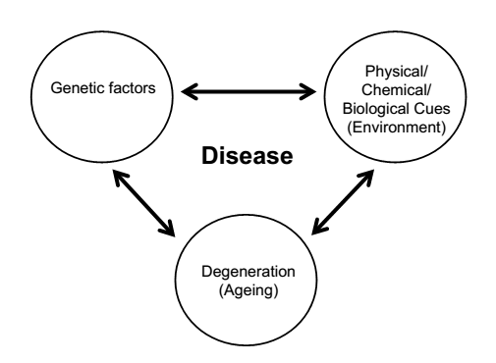

Genes, Chromosoms - Genetics and single gene disorders (M. Stoffel)

Organization of the human genome
- 3.5 x 10⁹ pairs of nucleotides in DNA
- 23 chromosoms
  - 22 Autosomses
  - X-chromosome
  - Y-Chromosome
- Karyotype: collective features of a set of chromosomes in late prophase or metaphase stages of mitosis

Methods to observe human chromosomes
- Fluorescent in situ hybridization (FISH) specific labeling trough molecular probes
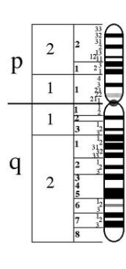
- Under microscope (white blood cell)

General features of Chromosom

P: indicates short arm
Q: long arm
End of chromosoms: telomers
Dark bands: A-T rich
Light band: G-C rich

Mammals have accumulated repetitive elements and noncoding regions majority of DNA sequences (in human 52% non coding and 44% repetitive sequences only 1.2% of the mammalian genome encodes for protein function

- Telomeres:
  - Hexametric element (TTAGGG)
  - Tandem arrays up to 5‘000-10000
- Alpha family
  - Founr in centomeres
  - Basic repeat unit of 171 bp
  - Tandem arrays up to several million bp long
- Satellite DNA:
  - Reiterated (dauern wiederholt), tandemly arranged sequences
- Interspersed (eingestreute) repetitive sequences
  - Short interspersed repetitive sequences (SINE)
    - ALU family
    - Transposable elements
    - Derived from cytoplasmic 7SL RNA
    - Contain RNA pol III initiation sites
  - Long interspersed repetitive sequences (LINE)
    - > 500 bp long
    - Predominantly in dark bands
- Middle repetitive sequences
  - Genes for 18S and 28S ribosomal RNAs
  - Several hundred copies of genes for 18S and 28S ribosomal RNAs are tandemly arranges in clusters on several chromosomes
- Polymorphic sequences
  - Single nucleotide polymorphisms
    - Approximately every 1000 bp
  - Minisatellites:
    - Variable number of tandem repeats (VNTR)
  - Microsattelites
    - Di,Tri,Tetranucleotide repeats (CA,TC, TCC, TAA)

Identifying the genetic basis of disease
- Autosomal dominant inheritance
  - sobald man ein mutiertes/Defektes Allel hat bricht die Krankheit aus!
  - Affected individuals have at least one affected parent
  - Mating between a normal and a heterozygous affected person have a 50% chance of producing an affected or a normal offspring
  - Males and females are affected in roughly equal numbers
  - Both males and females transmit the phenotype
  - Examples:
    - Huntignton Disease: Movment/Cognitive/ Psychiatric disorder, mean onset age 35-55 years, 1 in 10’000

- Autosomal recessive inheritance
  - Affected inviduals have mostly two normal parents (also possible to have an affected parent)
  - Mating between heterozygotes have a 75% chance of producing an normal offspring and 25% of producing an affected offspring
  - Mating between affected persons produce only affected children
  - Males & females are affected in roughly equal numbers
  - Males and females transmit mutant allels
  - Examples:
    - Cystic fibrosis: lifelong, affects lungs, digestive tract and pancreas, 1 in 2’500 babies in UK

Genetic linkage
- LOD score (logarithm of odds): statistical test, compares the likelihoof of obtaining the test data if the two loci are indeed linked, to the likelihood of observing the same data purely by chance. Positive LOD score favors the presence of linkage, negative LOD scores linkage is less likely
- Forward genetics: from protein to gene
- Reverse genetics: From gene to protein

Polygenic, complex diseases (M.Stoffel)
There are three different types of diseases:
- Genetically determined
- Enviromentally determine
- Genetically & enviromentally determined

Disorders with multifactorial inheritance (polygenic)
- Influeced by
  - Multiple genes
  - Enviromental factors
- Examples
  - Diabetes mellitus
  - Schizophrenia
  - Some types of cancer (ovarian, breast, colon)

Key concepts of complex disease
- Multiple distinct loci interact with other factors including the enviroment end stage phenotype
- Absence of clear biochemical defect resulting from single abnormal gene
- Variation in severity (Gewicht, Schweregrad) and expression of the phenotype
- Most affected individuals have unaffected parents
- Often sex differences

Multifactorial diseases
- Increasing numbre of involved loci
    - >20 involved locis
- Involved enviromental factors

Models to explain multifactorial diseases
- Common disease – common variant: Propose that thereis a small numbre of riskful allels, which are common in population. Each of this allels exerts a genetic effect
- Common disease – rare variant : Suggested that there is a large numbre of riskful allels, which are rare in the populationeach of this allels exerts a little effect

Different studies
- Linkage studies
  - Classical linkage study needs :
    - Large multigenerational single fammily
    - Defined mode of inheritance
    - Single locus responsible
    - Known pentetrance (durchdringung)
    - Genetic homogenety
      - This is not the case in compley diseases !
- Association studies :
  - Different methods :
    - Case control series :
      - Series of affected vs series of control
      - Needs significant numbers
    - TDT (Transmission disequililbrium test)
      - Test the distortion (verzerrung) in transmission of allels from a heterozygous parent to an affected offspring
    - Affected pedigree member
      - Complex statistical analysis

Factors which influence success of studies
- Control population
- Study population
- Epistasis: Interaction between allels can be accounted for by statistical models
Bsp: Grössenvergleich zwischen zwei Orten
- Gefägnis: 80% Männer
- Krankenschwester Schule: 80% Frauen
      - Männer sind grösser wie Frauen
      - Menschen im Gefägniss sind grösser als Menschen in der Krankenschwesterschule (falscher Schluss!!)
- Age of disease
- Genetic effects of risk allels
- Inference (Folgerung) of linear distance
- Informativeness of markes

Mitochondrial diseases (M.Stoffel)

Mitochondria
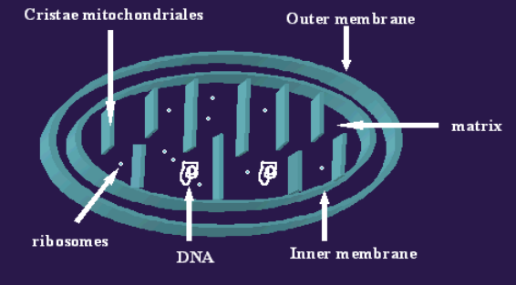
- Organelle that releases energy in the cells
- Only found in animal cells
- Produce ATP aerobin respiration

Funktionen
- Apoptosis-programmed cell death
- Glutamate-mediated exicitotosic neural injury
- Cellular proliferation
- Regulation of the cellular redox state
- Heme synthesis
- Steroid synthesis

Mitochondria in aging an cancer
- Mitochondria produce ROS cause somatic mitochondrial mutations ROS production aging of tissue
- Link between somatic mitochondrial mutations and colorectal cancer

Genetic facts
- Have their own circular DNA
- Hunderds of mitochondria/cell each ultiple copies of DNA
- Genome not packed in chromarion
- Only a few (3%) non-coding DNA
- Mitochondrial genome has an 100x higher mutation rate than the nuclear genome

Mitochondrial Inmheritance
- Inheritance only trough maternal lines (Mitochondrien kommen immer von der MUTTER !!), dh wenn Vater infiziert ist sind Kinder nicht betroffen!

Identification of Mitochondrial Mutations
- First Mutation identified in 1988
- Leber’s hereditary optic neuropathy (pointmutation): first idenrified mutation, bilateral visual loss, poor color vision
- Mitochondrial myopathies & Kearns Sayre Syndrome (Deletions)
- Mitochondrial myopathies (mt DNA duplication)

Chromosomal abnormalities (M.Stoffel)
Aneuploidies
- Aneuploid cells have an abnormal number of chromosomes
- Disturb the delicate (empfindliche) balance of gene products in cells
          - Because every chromosome contains hundereds of genes, so a loss a even a single chromosom disturps the existing equilibrum in cells
        - Just a few aneuplodi embryos are able to survive
          - Example : Trisomie

Differen types of chromosome abnormalities
- Deletions :
  - Mutation in which a part of a chromosome or sequence of DNA is missing
  - Results in loss of genetic material
  - Caused by errors in chromosomal crossover during meiosis
  - Can cause serious genetic disease
  - Different Types of deletions
    - Terminal deletion: Deletion occurs toward the end of a chromosome
    - Intercalary Deletion/Interstitial Deletion: Deletion occurs from the interior of a chromosome
    - Microdeletion: small amount of deletion
  - Example: Williams syndrom, Cri du chat syndrom

- Duplications :
  - Example : Downsyndrom (Trisomy 21)
- Translocations
- Chromoanagenesis :
  - Large numbre of complex rearrangments occur at one or few chromosomal loci in a single catastrophic event
- Reciprocal translocation
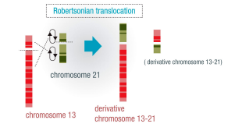
- Robertsonian translocation (duplication)
  - Bild
  - The long arm of a chromosome is attached to another chromosoem
- Inversion
- Insertions
- Chromosome instability syndromes : Group of inherited associated with chromosomal instability and breakage

Gene Therapies (M.Stoffel)
Gene theraphy is the insertion of genes into individual cells and tissue to treat disease in which a defective (defekte) mutant allele is replaced with a functional one.

What is the ideal outcome of gene therapy ?
- Replaces a mutanted gene with a healthy one
- Deactivates a gene that is not functioning properly
- Introduces a new gene in the body to help fight the diease
- Enhance the effect of a normally functioning gene
- Activates the gene that was shut during fetal life

Different types of gene therapies
- Gene replacement therapy
- Gene deactivation therapy
- Transgenesis
- Gene Enhancement therapy
- Gene activation therapy

The genes are introduced to somatic cells or to germ line cells, so there can be a somatic cell therapy or a germline therapy.

Germline Gene therapy
- A normal version of gene is inserted into germ cells
- The germcells will divide normal versions of the gene
- Zygotes are produced they habe a correct version of the defective gene passing it to their offsprins

Somatic cell Gene theraphy
- Single defective cell taken out of the individum
- A functional version of the gene is introduced in cells in labarotory
- Copies of cells with corrected gene is introduced back in patient

Vectors
Vectors are different carrier system and they are used for gene delivery in viral and non viral systems

Viral Vectors:
- Retroviruses
- Adeno viruses
- Adeno-associated viruses
- Herpes simplex viruses

Non-viral vectors
- Chemical approaches
  - Lipoplexes:
    - DNA must be protected from damage & entry in cell must be facilitaed
    - Plasmid DNA can be covered wirth lipids micelle or liposome
    - Types of lipids
      - Anionic (negativly charged)
      - Neutral
      - Cationic (positively charged)
    - Used to transfer gene into cancer cells decrase activity of oncogenes
  - Polyplexes:
    - Complexes of polymers with DNA called polyplexes
- Physical approaches:
  - Needle injection
  - Electroporation
  - Gene gun
  - Ultrasound
  - Hydrodynamic delivery

Risks associated with gene therapy
- Unwanted immune system reaction
- Targeting the wrong cells
- Infection caused by virus
- Possibility of causing a tumor

Advantages of gene therapy
- Give chance of a normal life to a baby born with genetic disease
- Give hope of healthy life to cancer patient
- For certain disease that do not have any cure except gene theraphy it could save many lives

Disadvantages of gene therapy
- The genetic testing, screening and research in finding the availability of certain gene is very controversy (bestritten)
- May increase the rate of abortion
- Costs are very high
- Cosmetic industry may monopolize the gene therapy

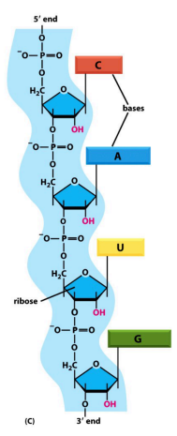
Biogenesis of mammalian small RNAs (C. Ciaudo)

RNA
- Composed of Ribonucleotides (containing ribose and not deoxyribose
- Out of four bases
  - Uracil
  - Adenine
  - Cytosine
  - Guanine
- Is single strandend
Cells produce different types of RNA’s
- mRNA : messenger RNA code for proteins
- rRNA : ribosomal RNA basic structure of the ribosome
- tRNA : transfer RNA central to protein synthesis (as adaptor)
- snRNA : small nuclear RNA function in cariety of nuclear processes
- snoRNAs : small nucleolar RNA used to process and chemically modify rRNAs
- scaRNAs : small cajal RNAs used to modify snoRNAs and snRNAs
- siRNAs : small interfering RNAs turn off gene expression
- miRNA : microRNAs regulate gene expression
- other noncoding RNAs function in diverse cell processes

How to regulate gene expression ?
- DNA Replication
- RNA Transcription
- RNA Processing
- mRNA transport
- Protein translation
          - Regulated trough small RNAs (DNA methylation and Histone modification on epigenetic level)

A small RNA can inhibite different steps of the gene expression. On the picture above we can see the inhibition of the translation. By a siRNA.
For this step this molecules/elements are required :

- RISC= RNA induced silencing Complex
- Dicer : works in the cytoplamsa of the cell
- Argonout (AGO)
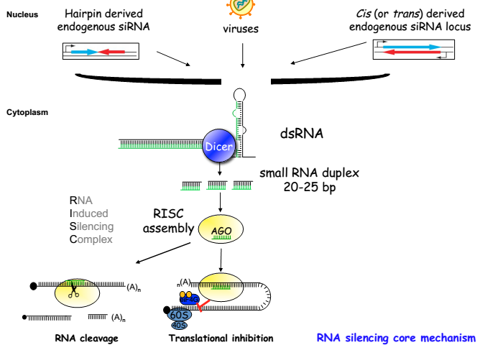
In different types of Organisms the molecules are different.

Small RNAs as ubiquitous (allgegenwärtige) regulators of gene expression in mice
- mircorRNA (miRNA)
  - endougenously expressed as stem loop structered precursor
  - coul be processed independently of Drosha
  - processed to 22-23nt mature miRNA
  - post-transcriptional regulation of transcripts
- Piwi- associated RNA (piRNA)
  - Biogenesis is Piwi dependent but Dicer indipendent
  - Processed to 26-30nt RNA
  - Supression of transposon and retro-elements in the germ line of flies and mammals
  - Regulation of gene expression in mice oocytes
- Endogenous siRNA (endo-siRNA)
  - Processed to 21-23nt
  - Derived from piRNA clusters in oocytes of mice
  - Regulation of gene expression
The small RNAs are highly regulated during early development. It’s important. In adults the most abundant small RNA are micro RNA in new born “babies” the most abundant RNA are siRNAs.

Micro RNAs in human
- About 800miRNA genes in human
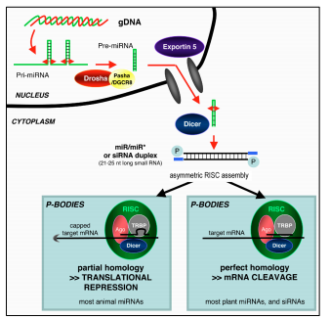
- Regulate virtually all biological processes
- Many are oncogenes or tumor supressors genes
- miRNA dysfunction many genetic disorders

Pathway:
- expressed by Polymerase 2
- Drosha & Dgcr8 recognize pri-micro RNA cuti t
- Build precursor micro RNA
- Export in cell cytoplasm by Exportin 5
- Dicer cut pre-micro RNA in small pieces
- RISC assembly
- Bind to ago
- mRNA cleavage or translation is repressed

Regulation of miRNAs Biogenesis
- Transcription
  - RNA Pol II mediated transcription porvides a major point for the biogenesis of miRNAs
- Epigenetic control of miRNAs
  - DNA methlyation
  - Histone modification
  - Imprinted loci
- Modulation of Drosha activity
  - Positive regulators : Smad protein, p53, etc
  - Negative regulators : Lin-28, nuclear factor 90/45
- Drosha independent miRNA maturation : miRtrons
- Control of diver cleavage and RISC loading
- RNA editing

PiRNAs
- In mouse : miwi
  - Miwi
  - Mili
  - Miwi2
- In drosophila : piwi
  - Piwi
  - Aubergine
  - Argonaut 3
- In human : hiwi
  - Piwi 1
  - Piwi 2
  - Piwi 3
  - Piwi 4
- Subfamily of germ-line argonautes
- Maintenance of germinal stem cells
- piRNAs bind to PIWI proteins
  - piRNAs are single stranded smaal RNas
  - most oft hem come from transposable elements
- mainly expressed in male germ lines
- differential expression during spermatogenesis

Techniques (C.Ciaudo)

Main characteristics of endogenous miRNAs
- endogenously expressed as stem loop structured precursors
- expressed as double strand RNA precursor
- Transcribed by Pol II

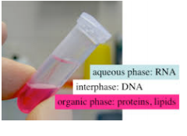
How to extract RNA ?
Trizol extraction :
There will be 3 phases
- Aqueous phase : containig RNA
- Interphase : DNA
- Organic phase : lipids
          - take the aquaeous phase, precipitate with Isopropanol centrifuge RNA pellet make a gel
          - RNA bands on gel : 23 S and 16S exactly there no smeere

Different Techniques

Reverse Transcriptase PCR (RT-PCR)
- Reverse transcriptase (viral enzyme) transcribes RNA into DNA
- Important because PCR can not be done on a single stranded DNA
- RT-PCR is used to generate cDNA
- The detection is made with fluorescent primers fluorescent nucleotided which mark specifically for some nucleotides
- After RT-PCR put primer on a agarose gel, also with ladder and control for the loading.
          - If the loading is not equal, use QPCR with these techniques the miRNA is quantified.

PCR
There are three important steps:
- Denaturation: 98°C, the temperature is increased to seperate the DNA strands.
- Annealing 48-72°C, Temperature is decreased to allow primers to base pair to complementary DNA template.
- Extension 68-72°C, Polymerase extends primer to form nascent DNA strand
These steps are repeated a number of times exponential amplifiaction of region of interest.

Northern Blot
Transfer results from agarose on a membrane by using raduiactivity to mark
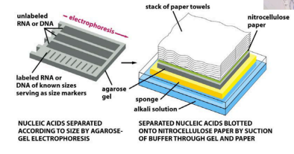
There are different northern blot :
- HMW (picture above): Heavy molecular weight
- LMW: low molecular weight: for small RNAs (picture below)
the probe is transfered on nitrocellulose paper and then radiolabeled and put in a hydrodisation oven,
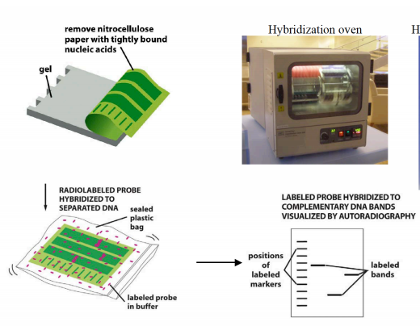

Limits of LMW:
  - Consuming a lot of time (min. 24h)
  - Rna starting quantity/Sensitivity
  - Toxicity of products used
  - Quantification

MicroRNA visualisation
- Bio-imaging of microRNAs biogenesis
  - Clone promoter region
  - Put fluorophor near to target region Dicer will cut there
- LNA in situ detection of microRNAs in whole embryos by using double 3‘-DIG labeled probe
  - Put whole embryo in probe and buffer, because embryo is still transparent we will see everything
- FISH (Fluorescent In situ Hybridization)

How to find microRNA targets ?
- Bioinformatic approaches
  - Western blot
  - Nothern blot
  - Luciferase assays : if promotor is expressed, Luciferase gets active emits light
- Analysis of RISC associated mRNAs to identify functional miRNA target interactions
  - Microarray analysis
    - Fluorescent labelling of miRNA
    - Hybridization to array of DNA-based capture probes
    - Washing and scanning of array
    - Data extraction and processing
  - Deep sequencing approaches
    - Just sequence miRNA
    - Small library
    - HITS clips : A method to identify Transcriptome-wide the binding site of RNA Binding protein

Repetition (alles nochmals erklärt) (C.Ciaudo)
Small RNA as ubiquitous regulators of gene expression in mice

Exon-Intron-Exon
          - Splicing to remove introns
          - Sometimes it removes not a intron it removes to exons then a circular RNA is formed, this rings made to sequester miRNA and can’t bind to their targets

miRNA
- siRNA : just a few examples in mammals
    - DICER :
    - Recognizes RNA
    - Recognizes 2-stranded RNA
    - Dicer cuts a lot of double stranded RNA
- piRNA :
    - proteins are differen
    - also different size
    - don’t know where they come from (don’t come from double stranded RNA)
    - no DICER involved
    - expressed in germline (oocyte, testes)
    - Pathway: Ping Pong element
      - regulate a transposable transcript

Technique
LNA :
- Important genes are stronger expressed in mRNA
- This stronger expressed genes are visible in nothern blot
- LNA is used to improbe the nothern blot sensitivity
- Improbe interaction (modifie structure oft he molecule (done by LNA))

Bioinformatic analysis after deep sequencing of small RNAs (C.Ciaudo)

omiRas
Webtool for differnetial expression of miRNAs between to conditions.
          - No local preprocessing
          - Input:
  - Raw sequencing data derived form Illumnia
  - Can handle biological replicates
- Output:
  - Lenght distribution
  - Mapping statistics
  - Qunatification tables
  - Differentially expressed ncRNAs
  - Target genes based on several miRNA-mRNA interactions

Experimental Methos in genomic analysis (C.Wolfrum)

Introduction
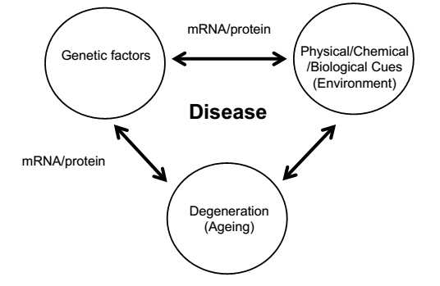
Important discoveries :
- 1676 : descirbed single cell organisms (van Leeuwenhoek)
- 1735 : Hierachial classification of species ( Carl Linnaeus)
- 1859 : the origin of species (Darwin)
- 1862 : Microorganisms responsible for contamination,heating kills microorganismsn (L.Pasteur)
- 1866 : Phenotype determined by inheritable units (G. Mendel)
- 1944 : DNA is the genetic material (Avery, MacLeod,McCarty)
- 1953 : solve structure of DNA (Watsond & Crick)
- 1955 : Complete sequence of insulin (Sanger)

Sequencing
Chemical sequencing : chemical modification of DNA followd by cleavage
Chain termination method of DNA sequencing : developed by Sanger, Diedoxy termination method, sanger method

High-troughput Methods (HTPM)
- Genomics= study of Genome
- Functional Genomics : aims to characterize and determine the function of biomolecules (mainley proteins) often by the use of high troughput technologies

Sanger method of DNA sequencing:
- The DNA sample is divided into four seperate samples (PCR reaction)
- Each of the four samples has a primer, the four normal deoxynucleotides, DNA polymerase and one of the four dideoxynucleotides (führt dazu, dass polymerase aufhört zu arbeiten) is added in a limited quantities
- The primer or the dideoxynucleotides can be radiolabeled but more often today have fluorescent tag
The chain termination method can only be used for fairly short (up to 1000 nucleotides). So longer sequences have to be fragmented. Problem reassembly.
So there are two other methods that are used for longer sequences :
- Chromosome walking
- Shotgun sequencing:
  - Can be applied to a genome of any size
  - Method:
    - Clone genome several times
    - Cut in random small pieces
    - The fragments are combined with a bioinformatic approache so that there are no gaps between them
    - Out of these the sequence is known
  - Hierarchial shotgun sequencing: Use a preordering step to reduce the complexity oft he genome (before cutting in random fragments)
  - Paired shotgun sequencing: Pairwise end sequencing (double-barrel) shotgun sequencing is another way to reduce the assembly complications. DNA is sequenced from both end yielding two short sequences. Contigs: original sequence which is reconstructed into longer composite sequences.
  - STS : Sequence Tag sites are 200-500bp DNA sequences which occur only once in a genome.

HTPM : Modern DNA sequencing
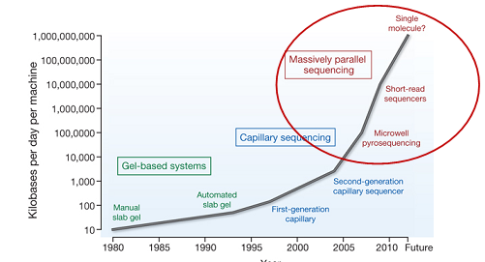
Pyrosequencing :
- During replication of DNA, addition of a dNTP releases pyrophosphate (PPi)
- PPi can be used to convert adenonsine phosphosulfate to ATP which can be used to drive luciferase activity
- Measure strand extension as it happen
- Luciferase = enzyme that emits light if ATP is present
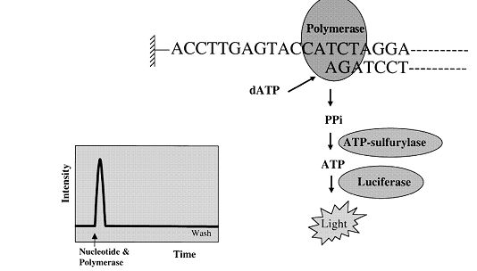
454 LifeSciences Sequencer
- Prepare Adapter Ligated ssDNA library
  - Fragment sequence
  - Single stranded
  - Put adaptors (beads on it)
- Clonal Amplifications on 28µ beads
  - Amplification of the DNA pieces that are located on bead
- Load beads and enzyme in Picotiter plate
- Perform Sequencing by synthesis on the 454 instrument
  - Add nucleotides
  - See when and in which wheel light occurs (knowing which dntp was added)

Pyrosequencing output:
Flush first A, see if light if not, another basepair. If peak we know that this basepair is there.
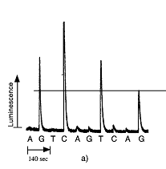 so for this sequence the baispair order is: GGCCCTTG
High troughput sequencing:
- Library preparation
- Cluster generation:
  - Flow cells, which contains eight lanes and every lane cotains two columns of tiles (Kacheln)
  - Every lane habe a dense lawn (Rasen) of defined primers that are complementary to the adaptor sequence.
  - cDNA flows trough one of these lanes so single stranded library molecuöes are randomly attached to the flow cell surface due to the complementary adaptor sequence 3’ extension begins (by polymerase)
- Denature double stranded DNA
  - The original template is washed away and the newly synthesized strand remains bound.
    - With these process you get rid of the primers
- Bridge amplification
  - Step one : Single DNA strand is forming a bridge by hybridizing the adjacent (benachbart) primer and primer is extended by DNA polymerase
  - Step two : double strand brigde is formed
  - Step three : Double strand bridge is denatured and in the end two single strands are covalently bound to the flow cell surface
- Multiple bridge generation
  - Bridge amplification cycle (steps 1-3) is repeated for each single strand until multiple bridges are formed
- Bridge denaturation and final cluster generation
  - Formed bridges are denatured and reverse strand are washed off leaving a cluster containning forward strands. With that prodcedure from move than 100 million initial single strands we obtain more than 100milion single strand clusters.
- Sequencing Reaction
  - Sequencing primers are hybridized to adaptor sequences of the single stranded DNA molecules in the flow cell
  - Sequencing Cycle : Add 4 fluorescent NTP’s & Polymerase, the incoperating fluorescent NTP is visible by fluorescent specific color.

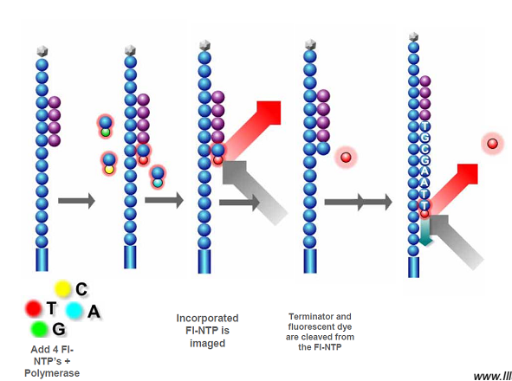

DNA Microarrays
- Composed of short DNA oligomers attached to an inert (inaktiven) substance (ex. Glass slide, nylon membrane)
- Typically contain a grid of 10⁵-10⁶ features (Spots) each with a different DNA molecule
- Fluorescently labeled DNA or RNA hybridizes to complementary probes
- Hybridized array is scanned with a laser to produce a signal for each spot
- Used for transcriptomics

Summary Sequencing
Clone-by clone | Shotgun approach | 454/NGS approach
Slower, easier to assemble | Faster, difficult to assemble | Extremly fast, short reads
Expensive | Cheaper | Cheaper gets us closer to $1000 genome

Transcriptomics
Human Genome = 24’195 genes ?!?

Transcriptome = the mRNAs expressed by a genome at any given time (1999)
The complete collection of transcribed elements of the genome (2004)

- mRNAs: 35, 913 transcriptes
- non-coding RNAs
  - tRNAs (497 genes)
  - rRNAs (243 genes)
  - snmRNAs (small non-messenger RNAs)
    - microRNAs or siRNAs (small interferring RNAs)
    - snoRNAs (small nulceolar RNAs)
    - snRNAs (small nuclear RNAs)
  - Pseudogenes

Central dogma of molecular biology
- mRNA single stranded RNA molecule
- Complementary to DNA
- Processed RNA transcript
- Carries the sequence of a gene out of the nucleus into the cytoplasm, where it can be translated into a protein structure.

The human transcriptome
- 70% of transcripts non-coding
- 79-88% have multiple transcripts

The scope (Umfang) :
- The population of functional RNA transcripts
- The mechanisms that regulate the production of RNA transcripts
- Dynamics of the transcriptome
  - Time
  - Cell type
  - Genotype
  - External stimuli

- The study of characteristics and regulation of the functional RNA transcript population of a cell or a organism at a specific time

Methods to observe the transcriptome
Focussed Experimental approaches :
- Nothern Blotting Analysis
- Real time PCR
Hightroughput Approaches :
- Closed System Profiling
  - Microarray expression profiling
- Open system profiling
  - Serial analysis of gene experssion (SAGE)
  - Massively Parallel signature sequencing (MPSS)

Stem cell Concept Introduction (A.Wutz)
There are different factors that can cause an injury :
- Infections
  - Virus
  - Bacteria
  - Metazoa
- Physical injury
  - Cuts
  - Burns
- Toxins
- Diet and nutrients
- Genetics
- Psychological influences

The body needs to be one piece to function properly and the specializied cells & organs habe to be at the right place to function correct. Body has 3.7x10¹³

Cell regeneration (cell turnover)
- Hair
- Skin
- Nails
- Internal epithelial (gut)
- Blood vessels
- Bone

Does the brain,kidney, liver and heart also regenerate ? How can we measure this?
- Mark cells in tissue and then observe the cells

- Retrospective Birth dating of cells in human : Mark ¹⁴C, how much is there, with these levels we can say if the turnover of the cells is a fast or slow process. The ¹⁴C/¹²C ratio is fixed when DNA is synthesized and gives an indication of when the cells of a particular tissue were born
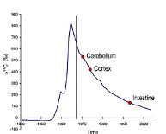

Cerebellum: slow regeneration
Cortex: a bit faster than Cerebellum
Intestine: very fast regeneration

S
So what we can say is that tissue & cell types turn over with very different rates. In homeostasis: What is lost is replaced, so if a injury is there increased turnover. But also in the brain?

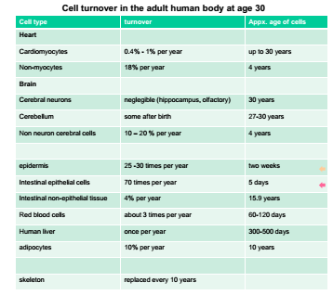
WICHTIG!!!

Cerebral Cortex neurons, heart muscle cells & inner lens cells of the eye little or no relevant replacement over life time!
- Injury in these compartents by any means could require of benefit from treatments involving some kind of cellular grafts or activation of repair pathways that regenerate cells.

Stem cells
Stem cells can divide in daughter cells but they can also differentiate. If they differentiate they first convert into a progenitor cell (the orange one) these cell looses a bit of potency, after these the progenitor cell differentiate into a specific cell (no potency anymore).
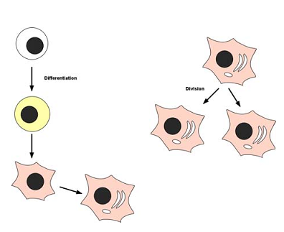
Multiple cell types can be generated from pluripotent stem cells trough the process of differentiation. During differentiation the plasticity of the cell becomes more and more restricted and progenitor cells with limited potency (multipoteny,bipotent or nullipotent) can be observed. The process of differentiation is tought of being more or less one way street and generally irreversible.

Pluripotenc: Ability of a single stem cell to develop into different cell types that make up the body.

- Concept of a cell pool that somehow persists while regenrating a different cell pool that generally is more specialized and functional
- Stem cells are seen on top of a hirachy and are not regenerated from other cells
- Stem cells are generated during development from embryonic progenitors
- Stem cell propreties
  - Self renewal
  - Ability to differentiate

Development and tissue homeostasis from the perspective of the cell
- Differentiation
- Cell death (apoptosis)
- Proliferation

Cell culture

Media supplementation
- Metabolites/C & N sources:
  - Pyruvate
  - Lactate
  - Glutamin
  - Non-essential amino acids
- Redox adjustments
  - β-mercapto ethanol
- complex and biological mixtures
  - foetal calf serum
  - bovine serum albumin
  - B27 supplement
  - N2 supplement
- Growth factors
  - FGF: Fibroblats growth factor
EGF: Epidermal growth factor
IFG: Insulin like growth factor
LIF: Leukemia inhibitory factor

Adaption of culture substrate
- Mimic the natural enviroment extracellular matrix interaction
  - Gelatine coating
  - Fibronectin coating
- Feeder cells cell adhesion and contact
  - Mouse embryonic fibroblasts
  - Stromal cell lines
- Co-culture with supportive cells growth factors
  - Perioneal macrophages
  - MEFs expressing cell surface signalling molecules
- 3D culture semisolid media cell-cell contact and extracellular matrix interaction
  - Methycellulose
  - Matrigel
  - Support structure (filters,beads)

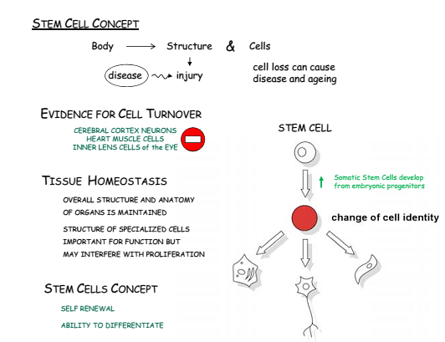

Early Embryo Stem Cells (A.Wutz)
Stem cells of the early embryo :
- Early embryogenesis
- Embryonic stem cells
  - Transcriptional control
  - LIF signaling: leukemia inhibitory factor, interleukin 6 which affects cell growth by inhibiting differentiation
  - Dominace oft he Es phenotype
- Embryonic germ cells
- Trophoblast Stem cells
- Extra-embryonic endoderm stem cells

Relatively simple structure, an embryo culture is possible, contains cells with greatest developmental potential.

Mouse model
The mouse as an experimental model for early development.
Embryonic stem cells can be established out of mouse embryos.
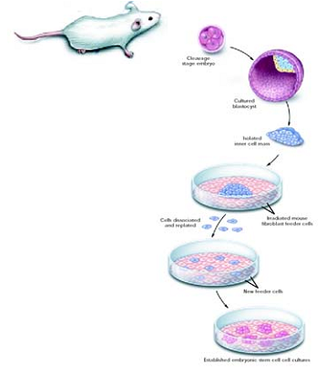

In Mouse:
ESC (embryonic Stem cells) proliferate continuously, maintain a stable karyotype and the potential to generated cells of the mouse embryo including the germline.
ES cells can be genetically modified and used for generation of transgenic or mutant animal model.

Defining properties of an embryonic stem cell
- Derived from the inner cell mass/epiblast of the blastocytst
- Capable to undergo a unlimited number of symmetrical divisions without differentiating
- Exhibit and maintain a stable, full (diploid) normal complement of chromosomes
- Capable of integratin into all fetal tissues during development. Derived from all three germ layers of the embryo
- Clonogenic : That is a single ES cell can give rise to a colony of genetically identical cells or clones, which have the same propreties as the original cell.
- Oct-4 : Transcripiton factor, which activates/inhibits a host of target genes and maintains ES cells in proliferative, non-differentiating state.
- ES cells lack the G1 checkpoint in cell cycle. They spend the most of the time in the S-phase.
- No X inactivation as in somatic cells.

Differentiation of embryonic stem cells
There are two different components that play an important role in in vitroe protocols:
- Selection: removal of unwanted cell types to obtain pure cell population
- Direction : Differentiation with inductive signals into specific cell types

The ESC stem cell can be maintained in culture indefinetely, in the embryo they exist only for a very limited time. Structures of the embryo can NOT be regenreated from these stem cells.

Regneration in animals (A.Wutz)
There are animals that can regenrate themself:
- Hydra
- Planiaria: Can but in a mixer can regenerate
- Salamander : can regenerate limbs
Big question : Why aren’t humans able to regenerate themself ?

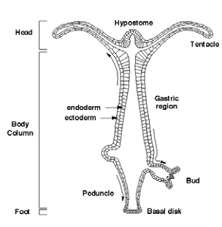
Hydra
- Freshwater Hydrozaan belongs to Cnidaria
- Lost medusa stage of life cycle
- Can be considered pedomorphic organism
- Has an intelligent gut
- Very simple organism

The Hydra have different mechanisms to regenerate:
- Buddig generate new hydra
- Regeneration cut hydra two hydras develop
- Reaggregation : Put Hydra in eppi (destroy it) new hydra develops
- Sexual development

Pathways
- Wnt Pathway:
Maintaining and re-establishing apical organizer activity
- MAPK pathway :
Triggering head regeneration
- BMP pathway :
Axis patterning
- FGF pathway :
Bud detachment
- Notch pathway :
Differentiating interstitial lineages

Intestinal epithelium
- Paneth cell : long live, structurally important
- Columnar cell : absorb nutrients
- Goblet cells : Mucus production
- Endocirne cells : Hormones

Lgr5
- Crypt expressed gene
- Receptor for R-sponding
- Potentiates Wnt signaling but inactivate of its own
- Function only in combination with Wnt (R-spondin and Wnt to be active)
To identify the descendants (nachkommen) of Lgr5 cells, use Cre/Ioxp system.The CRE recombinase is activated form the lgr5 cells Iox sited cut away β-Galactosidase

Stem cell niche
Located in Paneth cells.
- Nothc signaling is required for Math 1 repression. (Math 1 important for specifies secretory fate)
- Wnt signaling is required for proliferation
- C-myc & cycline D1 are wnt targets
- Lrg5/Lrg4 : receptors for Rspondin (redundant), double deletion results in loss of proliferation
- BMP2 & BMP4 are expressed in the mesenchyme of the villus ( so there BMP signaling active)
- In crypts and mesenchyme around the crypte BMP inhibitors (Noggin) are active
Disruption of the singnaling can lead to cancer, mutations in BMP signaliung observed in juvenile polyposis patients, APC mutations or activationg Wnt mutations in colon cancer.

Cells in Inestinal epithelium
- Paneth cells :
  - Slow turnover (8weeks)
  - Secrete bacteriocidal products
  - Provide essential niche signals
- Lrg5 stem cells
  - Divide symmetrically once per day
  - Compete (konkurrieren) for limiting niche signals
Restriction of stem cell number by neural competition at the stem cell population level (for surface contact with paneth cells).

The hematopoietic system
- Hematopoietic stem cells (HSC)
  - Development of blood system
  - Isolation and characterisation of HSCs
  - The haematopoietic lineage
  - The bone marrow micorenviroment
  - Erythropoiesis
  - Lymphoid system

Jacobsen’s radiation protection experiments:
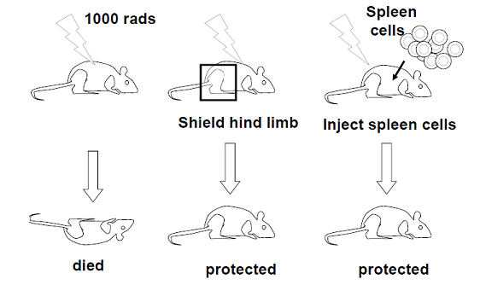

Hemapoteic system:
- Ontogeny oft he haematopoietic system:
  - Activation of primitice hematopoiesis and vasculogenesis in the developing yolk sac
  - Ihh is secreted activates expression of BMP 4
  - BMP feeds back activating different genes
  - Formation of hematopoietic and vasculature stem and progenitor cells.
  - Intra-aortic hematopoietic clusters form in the floor oft he dorsal aorta
  - This cluster express surface antigens and cytoadhesion moleculse
  - Subaortic mesenchyme expresses cytokines,chemokines and has the features of vascular smooth muscle.
  - Colonization of the embryonic liver of the mouse embryo with hematopoietic stem cells is completed 13.5 day
  - After birth the bone marrow becomes the primary site of hematopoiesis.
- Hematopoietic stem cells at very different sites in body
  - Yolk sac
  - First embryogenesis: AGM (Aorta-gonad-mesonephon)
  - placenta
  - 13.5 dpc: liver
  - After birth: Bone marrow

- Steady state: the blood stem cells are arested trough different factors

Erythropoieses:
Development of erythrocytes. Developed from proerythroblast. Nucleus gets smaller and cytoplasm becomes basophilic (basophilic erythroblast). The cell itself gets smaller and the cell begins to produce haemoglobin (cytoplasm attracts basic and eiosin stains) cell then called polychromatophilic. If the cytoplasm gets more eosinophilic the cell is called orthochromatic erythroblast. After this the cell extrude (ausstossen) their nucleus (enter the circulation as a reticulocyte. If the reticulocyte looses the polyribosome the cell becomes a mature red blood cell.
- Proerythroblast
- Basophilic erythroblast: nucleus smaller and cytoplasm basophilic
- Polychromatophilic: cell gets smaller, produce hemoglobin
- Orthochromatic erythroblast: cytoplasm gets more eosinophilic
- Reticulocyte : extrdue (ausstossen) nucleus
- Red mature blood cell : no polyribosomes

Reprogramming and plasticity (A.Wutz)
Strategies to reprogramming cells:
- Mammalian cloning by nuclear transfer
- Reprogramming by ES cell fusion
- In vitro reprogramming strategies
- Induced pluripotent stem (iPS) cells

Cloning
Sheep cloned by nuclear transfer from a cultured cell line.
- Mature oocyte arrested at metaphase II or meiosis (high MPF activity chromosome condensation)
- Removal of metaphase chromosomes avoid activation of oocyte, inhibits actin filament formation and allows oocyte manipulation
- Verification of removal of chromosomes by Hoechst staining
- Activation of oocyte cytoplasm by Ca²⁺ MPF low
- A donor cell is placed undet the zona pelucida in contact with the oocyte cytoplast
- Fusion of the donor cell with oocyt cytoplast.

Therapeutic cloning strategy;
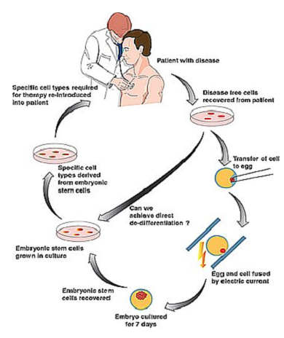
- Avoids the production of cloned organisms
- Pluripotent NT-Es cells are used to prepare autologous cellular grafts
- Resulting ES cells are differentiated into blood cells and transplanted by tail vein injection
- Problems arise with the attempt to differentiate NT-ES cells into blood stem cells and graft rejection
- HoxB4 expression to to functionalise ES derived HSCs – still low level engraftment (anwachsen)
- NK cell ablation (ablösung) in the recipiet to avoid rejection due to low MHC of ES derived transplant

- Provides immunologically matched cells for tissue repair
- Accessible to everybody
- But need a reliable source of oocytes

Strategies to induce epigenetic reprogramming
- Nuclear transfer
- Cell fusion
- Cell extract
- Cell explanation

Minimum number of factors required for iPS cell generation :
- Oct3/4 : tightly regulated transcriptional factor, associated with a large number of targets of pluripotency maintenance
- Sox2 : transcription factor, necessary for embryonal development, prevent ES cell differentiation
- C-myc : takes part in broad variety of cellular functions
- Klf4: Can acta s tumorsupressor an das oncogene

To forces cells to change lineages, different factors are needed, depending on “input” cell and cell amount.

Stemcell technology and application (A.Wutz)

The body requires specialized cell types. All cells from one fertilized egg & same genome changes into various tissues. Plasticity during development.

Body plan:
Regulation of cell identity
Cell number increase → Proliferation
In mammals this processes are tighly linked.

Body maintenance:
Over a long period of time → lifertime
Cells are constantly replaced, example skind & intestinal epithelia

HSC:
Must be maintained over the lifetime of a organism, because makes all blood lineages
T-cells
B-cells
Red blood cells
Platelets
If maintenance is compromised → loss of blood system Anaemia

Concept of pluripotency

Embryonic stem cell can differentiate in different cells unrestricted differentiated
HSC’s are restricted can “just” do different blood cells
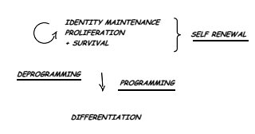

Technological applications from stem cell research
- Umbilical cord blood as a source of stem cells
  - 30-50ml of cord blood can be obtained at birth
  - These blood samples contains different cells
  - Freeze the samples
  - If you nedd it later, take it out
  - Can be useful for Leukemia, diseases of the blood system

The amount of mobilized HSC’s which are in the cord blood sample depends on time and how much cord blood you take.
Important: detection of hematopoietic stem cells and progenitor, so after 6 weeks of transplantation check if they are still alive.
- Using induced pluripotn stem cells to model human disease
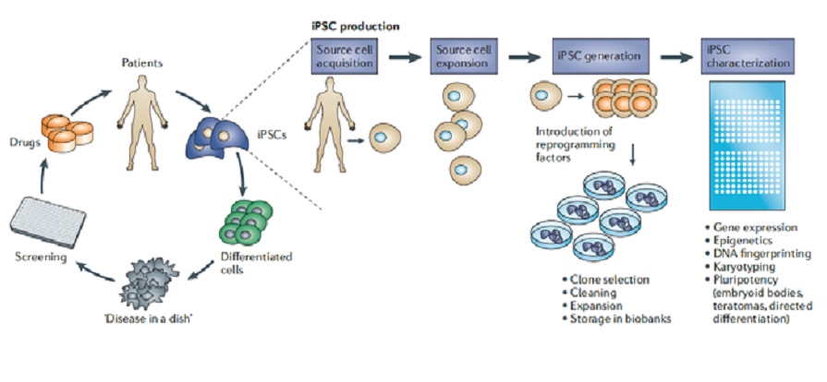

There are a lot of different cell types and methods to derive human iPS cells!
There are also different humanic disease’s in which iPSC’s have been derived from embryos of patients
  - Parkinson
    - Molecular defect: Unknown of mutations in LRRK2 or PINK1
    - Phenotype: Impaired mitochondrial function in PINK1-mutated dopaminergic neurons, corrected by lentiviral expression of PINK1, sensitivity to oxidative stress in LRRK2-mutanr neurons.
  - Rett syndrome
    - Molecular defect: Mutation in MECP2
    - Phenotype: Decreased numbers of differentiated cells and expression of cellular sress markes

The Rettsyndrome is a postnatal neurological disorder that affects 1/10000 females. Symptoms: stereotypic hand movements, impaired locomotion and communication. Mutations in the methyl CpG binding protein 1 (MeCP1) gene are cause of typical form

Rett syndrome
Studying defects of neurons or progenitors from human RTT iPS cells identification of cause of disease.
Mouse models for exploring disease aspects and treatments.
Mouse model:
- MeCP2 null mutation in mice
  - Rescued by a transgene that expressed MeCP2 cDNA under control of Tau promoter (specifically active in neurons) symptoms are restored, so we can say the suggesting defect in in neurons
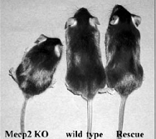

MeCP2 is X-linkes ind human & mouse human patients are predominantly females (men dies before birth)
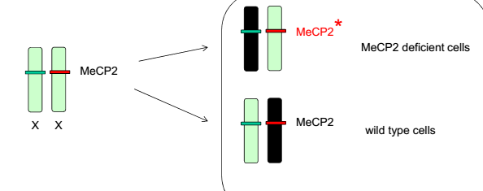
In mouse model: hemizygous males or homozygouse females (loss of function in all cells).
Now there is a new strategie, reactivation of MeCP2 from the inactive X Chromosome, don’t known yet but maybe use neurons from RTT iPS cells to identify compounds that can reactivate MeCP2.

Parkinson
Parkinson’s patients suffer a progressive loss of dopamine secreting neurons nigro-stratial neurons (in the middle of the brain). So now there are some developing therapeutic strategies for Parkinson disease:
- Production of human dopamine secreting neurons of progenitors from human ES or iPS cells
- Using human ES or iPS cells for understanding the development of dopamine secreting neurons and identify potential compounds that can facilitate survival or regeneration

Disease mechanisms – open questions (A.Wutz)
Changes in the genetic or epigenetic makeup of cells can drive tumor development
- Generally the body is protected by tumor-supressive mechanisms
- More than one hit is needed
- The cells that initiate tumorgenesis need to be around for a long time and accumulate hits (likely proliferative enable s the accumulation and hence statistical chance of hits.)

Chronic myeloid leukemia (CML)
- Caused by translocation between chromosome 9 and 22 leading to the fusion of the B-cell receptor BCR gene and the Abelson (abl) kinase gene
- Results in a constitutive BCR-ABL-kinase
- Tri-phasic disease progressively develops
  - Bening chronic phase (4-7 years): BCR-ABL is the only genetic aberration
  - Accelerated pahse which ends in a blast crisis after 6-9 months
    - Blast crisis is accompanies with additional genomic changes including trisomy 8 or 17
  - CD43 + BCR-Abl+ cells can initiate CML upon transplantation tumor initiating population

Treatment:
Treatment with kinase inhibitors specific for BCR-abl
- Rapid disease regression but relapse mainly due to escaping mutations in BCR-Abl gene product
- Subsequent treatment with additional inhibitors targeting mutated kinase is becoming feasible (durchführbar)

How can the tumor relaüse after regression?
If kinase inhibitor treatment is discontinued, immediate relapse of the disesase often with immediate blast crisis can be observed. A reservoir of tumor initiating cells survived treatment and can evolve into kinase inhibitor resistant tumor tumor stem cells

Strategies for targeting tumor stem cells
- Mechanisms of escape?
- CD34+ BCR-Abl cells could not require kinase activity
- Drug is not taken up or eliminated from cells
- Quiescence (Ruhe) prevents cell death

- Differentiation therapy: Induction of tumor stem cell differentiation can eliminate stem cell pool or make cells sensitive to drug treatment

Arise of cancer stem cells
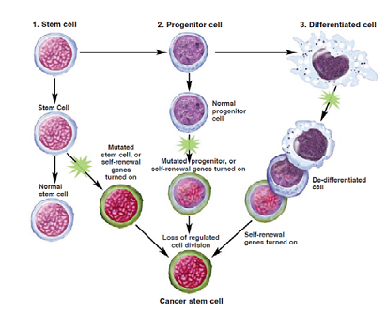
Transplantation assay: Measures tumorigenic potential, the outcome depens on the environment into which tumor cells are transplanted, also the immune.status of the recipient affects the tumor engraftment rates.
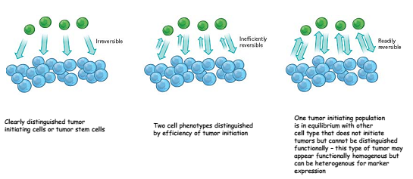

Factors that contribute to tumor initiating cell phenotype
There are genetic and non-genetic (epigenetic) factors
- Epigenetic components:
  - Chromatin modifications
  - Regulatory factors (transcription factor network)
  - Small RNAs
  - Cell signaling state
Teratoma is the only known tumor that is exclusively formed out of epigenetic origin

Metastatic disease
Additional requirements on top of angiogenesis, survival and deregulated proliferation control.
Tumor initiating cells need to aquire a migratory potential, emigrate from primary tumor, distribute mainly trough blood or lymph vessels to distant metastatic sites, home to and invade metastaic sides

Metastatic tumors represtena very independent cell population. That is largely free from organ and tissue specific proliferation and differentiation control.
These cells become very different to normal body cells and might be recognized by the immune system.
Tumor immunity often is subverted (umstossen) by adaptions of tumor cells.

Clonally transmissible tumors:
- Devil facial tumor disease (DFTD)
  - Affects Tasmanian devils an threatens extinction
  - Tasmanian devisl are marsupial carnivores
  - Restricted to island of Tasmania
  - Primary tumors affect face,neck and mouth and lead to death within a month
  - Transmitted by biting
  - Tumors are known to metastasize
  - MHC molecues diversity is low in devils relatedness might prevent rejection of DFTD cells
- Canine transmissible venereal tumor (CTVT)
  - Affects dogs
  - Sexually transmitted
  - Affects mainly genital regions
  - Phases:
    - Progressive growth
    - Stable phase with markedly slower tumor growth
  - Decay (Auflösung) of mitochondrial function in tumor cells over long periods of time

These tumors could provide precious models for metastatic processes. Tumors can also be transmitted in immune suppressed transplant patients. Immune evasive (ausweichend) strategies of these tumors might also provide a potential route to strategies for avoiding graft rejection

A stem cell perspective of tissue architecture (A.Wutz)
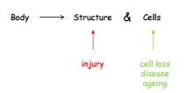
Diseases:
- Liver failure (hepatitis virus, alcohol)
- Heart attack
- Diabetes type 1
- Kidney failure
- Stroke

The promise of stem cell research:
- Identify drug targets and test potential therapeutics
- Study cell differentiation
- Understanding prevention and treatment of birth defects

Liver can regenerate, do different experiments with liver tissue. Then the regenerated liver tissue recapitulates organ function

Delivering stem cells to the heart
Approaches include intravenous injection and direct infusion in coronary arteries (blood flow restored) . Stem cells often directly injected into the ventricular wall. Success of these methods remains limited 90% of transplanted cells die shorthly after implantation because of physical stress, myocardial inflammation and myocardial hypoxia.

Cells injected into the heart:
- Cardiomyocytes
- Bone marrow stromal cells
- Endothelial cells
- Umbilical cord blood cells
- CD34+ peripheral blood cells
- Skeletal myoblasts
- Maybe just placebo don’t known how these injection of these cells should help

Heart development
- Cardiac mesoderm
- Primary and secondary heart field
- Cardiac neural crest contributes the outflow tract
- Cardiac progenitors
  - Cardiomyocytes
  - Smooth and cardia muscle cells
  - Endothelial cells

How to repair the brain?
- Difficult
- Learned a lot how connected how could we restore all these things?
- Transplated neurons have functional characteristics

Molecular mechanisms of Cell differentiation (A.Wutz)
Transdifferentiation:
- Can be induced by transcription factors (different factors different cells)
  - iPSC cells: Oct4,Sox2,Kfl4,c-myc
  - Dopaminergic neurons: Asc1,Lmbx1b,Nurr1
  - Etc.
- Conversion from one differentiated cell in another differentiated cell

Transcripton factors cross antagonism
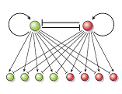
Also the factors play an important role in the self renewal or in the exit from pluripotency and entry into differentiation. So transcription factors acts as guide to programming cell type.

Antagonistic transcription networks underly stable outcomes of differentiation. Mutually (gegenseitig) antagonistic factors are apparently co-expressed in common progenitors.
- Example: PU.1 and GATA1 Antagonism in myeloid and erythroid differentiation

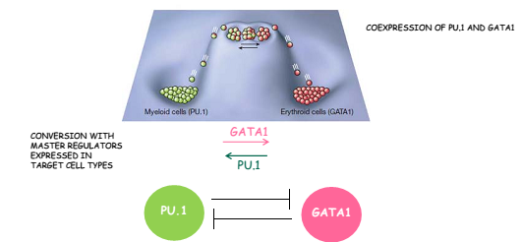

The pluripotent state is a balance of antagonistic transcripton networks specifiying different lineages.
The balanced antagonistic transcription networks can be induced to change in any directions of lineage restriction. Stable transcription networks: The balance is fully swung to one side.

Modelorganism in ageing research (M. Ristow)

Some defintions
- Ageing: refers to the increased impairment of physiological function with age (ex. Deterioration (rückgang) in age-specific components of fitness.
- Ageing is characteristed by exponential rise in age-specific death rate (Gompertz’s Law) and a comcomitant decline in reproductive output
- Senesccence is the technical term for the process of ageing (refers to changes in an organism’s biological function after maturity is reached and may occur on both a cellular and organismal level)
- Lifespan: Maximum number of years an individual can live is species-specific
  - Max. lifespan of human species: 122 years
  - Lifespan also depens ond genetic (60%) and environmental factors (30%)
- Life expectany: Length of time an individual can expect to life, these term is characteristic of specific populations

Mechanisms of ageing
- Evolutionary: “Why do we age”
  - Mutation accumulation theory
  - Antagonistic Pleiotropy Theory
  - Disposable Soma theory
- Physiological: “How do we age”
  - Programmed theories of ageing
    - Changes in gene expression concerning repair enzymes, hormonal levels, immune system function,etc
    - Immunological Theory
    - Endocrine theory
  - Stochastic (Damage based) theories of ageing
    - Accumulated damage as a result of ongoing, imperfect biological processes.
    - Free radical theory
    - Rate of living-Hypothesis
    - Telomere Theory

Modelsystems
Longevity Mutants in C.elegans: Treat cells with EMS (mutagen for generating point mutations) . So cells produce more generations. The replicas show an increased lifespan. Look at point mutation that are responsible for these longlvity.

Orchestrate (Manipulierte) model organisms to narrow down candidates for tests in higher organisms:
- Search for Yeast Longlivity and Worm longlivity genes, the ones that “überschneiden” are strong candiadate for mammalian aging genes

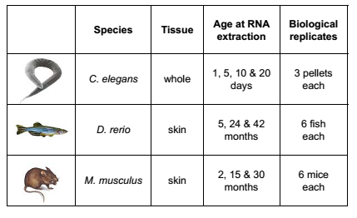
Modelorganism single cell:
- Example:
  - Yeasts
  - fibroblasts
- Fast growing

Sensescent fibroblasts: Cells stop dividing after ~45 population doublings, determined by telomere length

Yeast
- Size 3-4 µm
- Reproduction: budding
- Lifespan: chronological (~15 days), replicative (40 generations)
- Culturing: liquid glucose rich media (SCD medium),agar plates

Replicatibe life span: refers to the number of faughter cells produced by a mother cell prior to senescence suitable model for the aging of mitotically active cell types

Chronological life span: Measures the length of time a yeat cell can survive under non-proliferative conditions models the aging process of post-mitotic cell types

C.elegans
- Size: 1mm
- Culturing: agar plates, food: E.coli
- Post-mitotic: constant 959 somatic cells
- Lifespan: ~30 days
- Lifecycle: 2.5 days
If bad conditions worm can enter a dauer larva for several months, the worm can also be frozen.
Every gene of the worm I known, so mutations for every single gene mutations can be done.
A mutation in a single gene can substanitially increase lifespan mutations in genes encoding an insulin/IGF-1 signaling pathway
Age-1 (PI3 Kinase)
Daf-2 (Insulin-/IGF-1-Receptor): resistant to insulin, in worm increased lifespan in human disease (diabetes)

Drosophila melangolaster
- Size: 2-3 mm
- Lifespan: 60days
- Lifecycle. 14 days
- Mainly postmitotic
- Culturing: tubes with culturing media and agar on the ground
Genetics:
- X/Y gonosomes, 3 autosomomes
- ~15000 genes
- Shares 70% wth human genes
- Sex determination dependen on ration X:A

Chico/IRS (insulin involved genes) KO extends lifespan
Sirtuin overexpression extends also lifespan

African killifish N. furzeri
- New model for ageing (purposed in 2005)
- Annual fishes of the genus nothobrachius
- Max. lifespan limited to several months
- One of the shortes-lived vertebrats
- Eggs can survive for several years in dry mud (diapause)

There are differences in aging phernotypes between different strains:
- GRZ stain: max. lifespan 12-16 weeks, dry habitat
- MZM-0403 strain: max. lifespan 25-32 weeks, humid habitat

Mouse (mus musculus)
Genome:
- 20 chromosomes
- ~25000 genes (1% coding sequence)
- 95% DNA coding sequence identity with humans
Reproduction:
- Sexual maturity after 4 weeks
- Extrus cycle frequency every 4-5 days
- Gestation average: 19-21 dasy
- Reproductive lifespan of a female approaches 2 years In some strains
- Lifespan: 1.3-3 years

There are different mutations in mouse genes that increases lifespan and other that shorten lifespan
- Increase: Ghr,Irs1, Irs2
- Decrease: Bub1b, Kl

Rhesis Maqaques (Macaca Mulatta)
- Close to humans anatomically & physiologically
- Relatively easy maintenance in captivity, wide availability
- Used extensively in medical and biological research

Calorie restriction and ageing
McKay postulated that previous studies had confounded a reduced calorie diet with malnutrition and starvation, and thus giben unreliable results.
McCay’s experiments:
Feed rats a calorie-reduced diet rich in vitamins and minerals.
- Calorically restricted male rats lived 75% longer than controls. No differences for female rats

Limited food intake without causing nutritional deficiencies
Until recently the only intervention known to results in a consistent positive cross species effect on lifespan
- Lower plasma glucose and IGF-1 level
- Protection against autoimmune disorders
- Elevated levels of apoptosis in tumors
- Reduced angiogenesis
- Postponed or attenuated onset of cancer, immunosenescence and inflammation
- Delayed onset of other age-related diseases

Calorie Restriction in humans (M.Ristow)

The Valljo study
- 120 men
  - 60 participant in the CR group recived an average of 1500kcal per day for 3 years
  - Other recifed ad libitum food
- Analysis conducted several years later indicated that death rate tended to be lowered in the CR group

Calerie study
Randomized multicentered trial currently underway in the US to study the effects of prolonged calorie restriction on healthy human subjects

Calerie 1
Effects of 6 months calorie restriction, with or without exercise in overweight, nonobese (BMI 25-30) men and woman

Calerie 2
Designed to study the physiological effects of caloric restriction in normal weight and slightly overweight individuals (BMI 22-28)

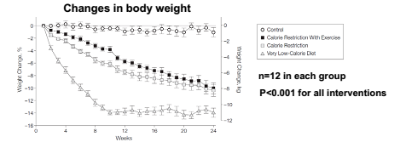
First results: Calorie restriction (also just short duration) reduction in risk of age-related diseases, effects of lifespan unknown
Calorierestriction affects insulin pathway

Calorie restriction mimetics (Nachahmung)

Resveratrol
- Natural polyphenol produced naturally by several plants
  - Red grapes contained in red wine
  - Roots of japenese knotweed
- Early reports found that it increased the lifespan of modelorganisms (not in mouse & rats) but in S.cerevisiae.
  - Acting trough SIRT1 activation

Rapamycin
- Has potent antitumor & immunosuppressive propreties
- In yeast TOR1 & Tor2
- In mammalian cells, rapamycin binds and inhibits a serin threonine kinase TOR (mTOR)
    - There is also mTOR1 & mTOR2

Rapamysin extends murine lifespan but has limited effects on aging

Metformin
- Oral antidiabetic drug
- Type 2 diabetes
  - Reduced blood sugar
- Cancer prevention

If started early in life, metformin treatment increases life span and postpones (zurückstellen) tumors in female SHR mice

Growth Hormone Axis and Ageing

Laron Syndrome
- Autosomal recessice disorder characterized by an insensitivity to growth hormone (GH), caused by a variant of the growth hormone receptor
- Abnormally short stature (dwarfism), other symptoms:
  - Prominent forehead
  - Depressed nasal bridge
  - Underdevelopment of mandible (unterkiefer)
  - Truncal obesity

Insuling/IGF-1 Signaling
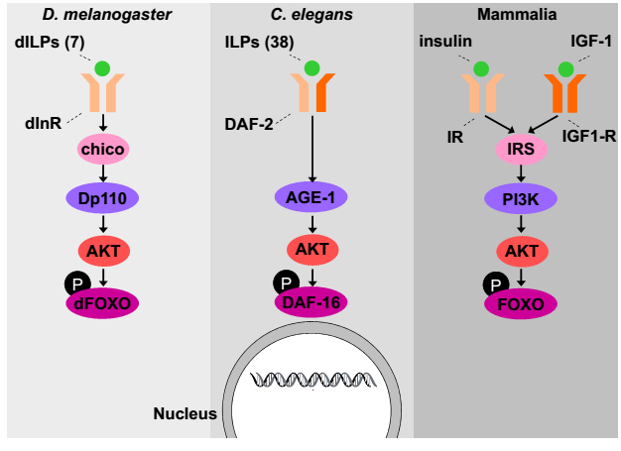
In c.elegans:
Das-16 (same a sFOXO in mammalians): Mutations in daf-16 ameliorate (verbessern) the effects of daf-2 mutation on life span meaning that functioning daf-16 is required for extend lifespan
- Genes induced daf-2 mutants: repressed in daf-16 RNAi. Candidates for genes that extends lifespan
- Genes repressed in daf-2 mutants: induced in daf-16 RNAi. Candiated for shortening lifespan

In humans:
Genetic association studies in human
- By comparing the frequency of genetic variants in cases (long-lived individuals, nonagenarians (90 jährige), or centenarians (100 jährige) and unrelated controls (elderly individuals)
- Association studies evaluate the correlation between a genetic variation and a particular trait e.g. longevity

mTOR pathway
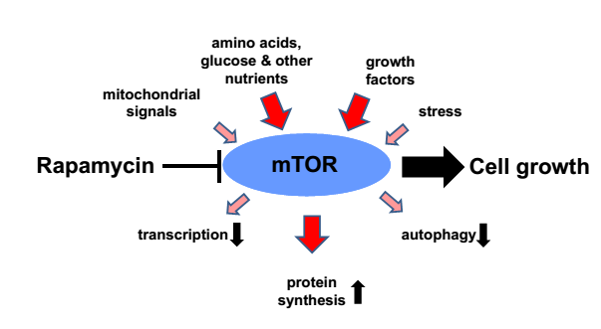
mTORC1:
- Potently regulated by rapamycin
- Regulates translation, cell growth regulation
- Main substrates S6 kinase & 4E-BP1
mTORC2:
- Acutely resistant towards rapamycin
- Regulates Actin reorganization, survival
- Main substrate AKT, SGK1,PKCa

Protein homeostasis (Proteostasis)
The protein homeostasis in disturbed in ageing and disease (ex. Alzheimer)
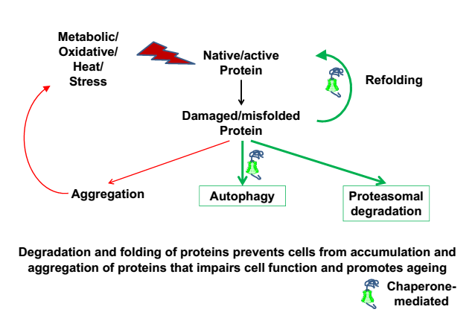

Protosomal degradation
- Damaged/misfolded proteins tagged with ubiquitin as signal for degradation
- Proteasomal degradation is involved in molecular signaling
- Proteasome degraded proteins under high ATP consumption
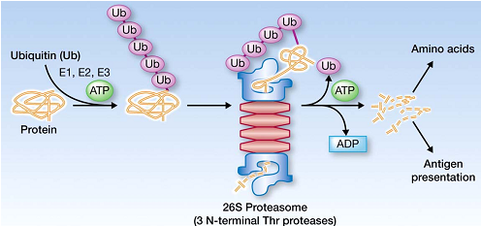
Proteasome regulates aging of long-lived muatnts
- Cul-1 (ubiquitin E3 ligase) partially mediates the life span extending effect of long-lived daf-2 (insulin receptor) mutants.

Autophagy
- Macroautophagy: mediates lifespan extension in long-lived mutants
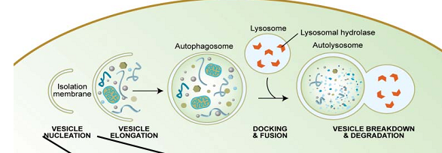
- Chaperone-mediated autophagy
- Microautophagy

Histonemodification
Acetylation regulates transcription
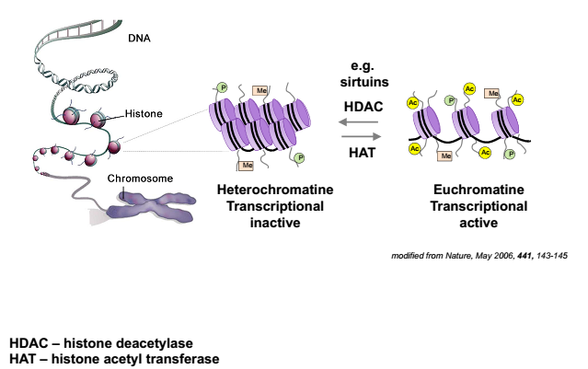

Biological functions of protein acetylation
- Histones:
  - Chromatin remodeling
  - Transcriptional activity
  - DNA replication
  - DNA repair
- Non-histone proteins
  - Protein interaction
  - DNA binding
  - Stability
  - Localization

HDAC: example situin

Telomeres in ageing
Telomeres are repetitive DNA sequences and at the end of the chromosoems.
Telomeres shorten by about 50-150 base pairs at each division, because conventional polymerases cannot replicate the end of linear DNA

Telomerase:
Enzyme, which is able to repair shortened telomers. Somatic cells (but NOT germ cells and many tumor cells) have very low telomerase activity

- No correlation between telomere length and lifespan (humans have shorter telomers than mice)
- No correlation between telomere length and a person’s age
- Telomers do not shorten in post-mitptic tissue, but cells undergo senescence

Replicative Senescene is a block to tumor formation
Fibroblast in culture undergo a limited number of cell divison Hayflick limit
The Hayflick limit is triggered by a variety of stresses:
- Loss of telomeres
- DNA damage and activation on DNA damage response (DDR)
- De-repression of cyclin-dependent kinase inhibitor

Expamsion of Life-Span by Introduction of Telomerase into Normal Human cells:
Telomerase-negative normal human cell types were transfected with vectors encoding the human telomerase catalytic subunit (hTERT).
- Telomere lengthening in hTRT+ normal cells
- Telomerase expression increases cell life span
- Telomerase expression shows reduced staining for beta-galactosidase (aeging marker)

Telomeres and Ageing in mouse model
mTERC-/- mice lack the RNA component of the telomerase holoenzyme progressive shortening of telomeres.
Later generation lower lifespan

Telomeres and Ageing – link to mitochondrial function
- Telomere diysfunction decreases mitochondrial mass and energy production
- PGC-regulated genes and networks are repressed in telomere dysfunction tissue
  - P53 deficiency partially rescues the transcriptional regulation of PGC-1α/β and mitochondrial DNA copy number and also rescues the gluconeogenesis

Diseases

The progerias
A disease characterized by symptoms of premature aging
Inheritance: both autosomal dominant and autosomal recessice cases have been reportet, but the most cases are autosomal dominant
Caused by mutations in the lamin A gene

Symptoms:
- Slow growth, dwarfism
- Lack of haur
- Dirsproportionaly large head
- Lipodystrophy
- Incomplete extension at the knees and elbows indicating stiffness of joints
- Coronary artery disease
- Generally a senile appearance

Model of ageing?
Differences between progeriass and aging:
- Males do not develop prostate problems
- No increased risk of cancer
- High blood pressure is rare
- No Alzheimer or mental degeneration

Theories
Metabolsim correlates inversely with life expectancy rate of living Hypothesis

Free radicals produced from metabolism as reason for aging free radical theory of aging
But there is the naked mole rat, high oxidative damage but long living!

Aging is nearly universal but there are some exceptions:
- Bacterias don’t age
- Hydras also do not appear to age
- Also red sea urchin are still fertile at 200+ years

AMP-dependent kinase
Most important energy-sensor on cellular as well as on organism level
Has 3 subunits
- One catalytic (alpha)
- Two regulatory (beta & gamma)

AMPK is involved in many metabolic pathways and also in glucose and lipid metabolism in liver, muscle and adipose tissue.

Energy homeostasis (M.Ristow)
- Energy balance: stable body weight
- Positice energy balance: weight gain
- Negative energy balance: weight loss

Definitions
Energy balance= the balance in the body between the amount of energy consumed and expended

Energy intake = the caloric or energy content of food procided by the sources of dietary energy

Energy output= the use of calories or energy for basic body functions, physical activity and processing of consumed foods

Basal metabolism= metabolic expenditure (Aufwand) during essential biological processes

Basal metabolic rate (BMR): metabolic rate at rest following sleep (no food > 5h)
- Males=1kcal/min
- Women=0.8kcal/min
There are differen factors that can influence the BMR:
- Age
- Height
- Growth
- Fever
- Stresses
- Etc.

Energy sources
- Carbohydrates
- Fat Macronutrients
- Protein
- Water
- Cholesterol
- Nucleic acids
- Minerals
- Trace Elements Micronutrients
- Vitamins

Quantifying energy Expenditure
- Doubly labeled water: The human drinks water containing atoms of ¹⁸O and ²H, the oxygen isotope is excreted as H₂O and CO_{2.} The hydrogen isotope can only be excreted as H₂O
- Indirect Caliometry: CO₂ production (breath) is directly measured

RQ= Respiratory Quotient = CO₂ produced / O₂ consumed

BMI = Body Mass index = Actual weight [kg] /(height [m])²
Broca weight= body length [cm] – 100
Broca Index= Actual weight / Broca weight

Methods to quantify body componsition
- Computerized tomography (CT)
- Nuclear/ Magnetic Resonance Imaging (NMR=MRI)
- Dual Energy X-Ray Absorptiometry (DEXA)
- Body Pletysmography (Bod-Pod)
- Hydro-Densitometry
- Fatfold measurement
- Bioelectrical impendance

Men & women have differend body shapes & fat distribution
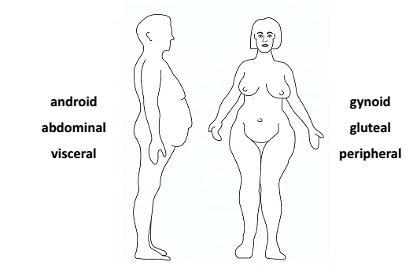
There are white and brown fat:
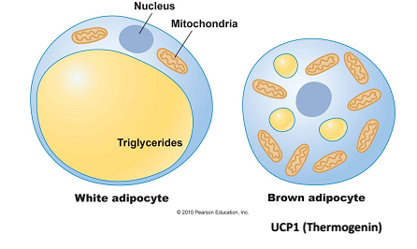
The brown adiopocytes contain UCP1 a protein. UCP generates heat. Not sure if adults have brown adipocytes

Intake
Regulation of intake:
- Hunger: Promotes eating: Physiological desire
- Satiation (Sättigung) : Signals to stop eating
- Satiety (Übersättigung): Lack of hunger
- Appetite: Psychological desire

The intake is regulated by internal factors
- Digestive organ function
- CNS functions
- Conditions such as anorexia nervosa, trauma or infection
- Temperature
- Drug effects
- Metabolic influences (hormones, NT)
And also by external factors:
- Social situation
- Time of the day
- Sensory propreties of food
- Cultural bacjground
- Environment: social & climatic

Regulation of energy storage
Leptin signals to the brain that the body does not need any more food!

Circadian control (C.Wolfrum)

Circadian rhythm biology
- Circadian rhythms generated from superchiasmatic nucleus (SCN) of hypothalamus
- Signals from SCN modulate daily rhythms in sleep and alertness
  - Core body temperature
  - Secretion of cortisol & melatonin
- Intrinsic rhythm of clock slightly longer than 24 hours
  - Synchronization occurs to 24h schedule using external cues

- Photoreceptors in Retina important signal collectors

Core body temperature:
Drop in temperature associated with stability in sleep:
There are three dips (Abnahme):
- 8pm-12am
- 3-5am
- 1-4pm

Melatonin secretion:
- Increases in levels around 8pm
- Levels peak at 3am and begin to decreas
- Lowest levels just around awakening

SCN
SCN produces a rhythmic message: the firing rate determines the time rhythmicity. Each SCN cell is a small clock, so every cell acts alone but they are synchronizes.

What occurs in the cell?
Important genes:
- Bmal
- Clc
- Per
cryy
perr
- cry

perr
clc
cryy
Bmal
perr
clc
cryy
Bmal
perr
clc
cryy
Bmal

- 2) 3)

- Per & cry: inhibitors of clc and Bmal
Clc & Bmal: activator, if free per & cry synthesized, and can be imported into nucleus, if Bmal is inhibited no more per/cry synthesis
- Day: CK1 gets active trough light ( inhibits per) so per gets phosphorylated and degraded trough the day
- In the night CK1 is no longer active, so Bmal can synthesize new per/cry and this can be imported to the nucleus. And the cycle can start new.

Clockgenes in human & flies
- Period: Per1,2,3
- Cryptochrome: Cry1,2
- BMAL (Brain and Muscle aryl hydrocarbon receptor nuclear translocator (ARNT)-like 1: BMAL 1
- Clock: clock
- Casein kinase 1 delta/epsilon: CK1δ/ε
- Timeless: has been identified in mammals but function is unknown

Genetic variation in circadian rhythm within populations
- Delayed sleep phase syndrome (DSPS,owls)
  - 7% of population
  - Longer clock
  - Maybe due to hyperactive CK1 per degradaded
- Advanced sleep phase syndrome (ASPS: early birds)
  - 0.2% of population
  - Shorter clock
  - Per dosen’t get phosphorylated (less efficient)
- Non-24h-sleep-wake syndrome

Paper discussion see notes andrea

Mechanical injuries and therapies (M. Zenobi)

Arthritis
Two main types of arthritis:
- Osteoarthritis (OA)
- Rheumatoid arthritis (RA)

RA is autoimmune disease affecting multiple joints, OA is a multifactiroal and mechanically induced

Oseteoarthritis
Local factors:
- Weight
- Injury
- Occupation
- Developmental abnormalities
- Knee laxity
Systemic factors:
- Genetic susceptibility
- Racial differences
- Gender
- Metaboli/endocrine disorders

Ostheoarthritis often begins with a mechanical insult to the cartilage
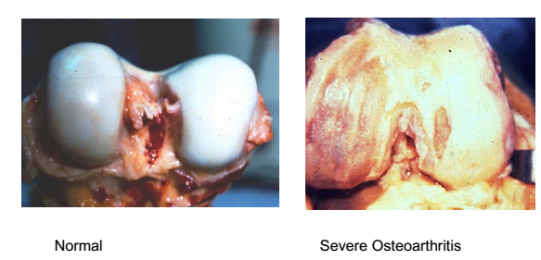
Symptoms:
- Cartilage degradation
- Inflamed joint capsule
- Osteophytes (little “knochenvorsprünge) which reaches the tissue
- Pain&stiffness in affected joint

Cartilage
- Bear (tragen) loads
- Absorbs mechanical shock, spread (verteilen) load
- Provide joints with excellent frictional, lubrication (Fettung) and wear characteristics

Cartilage structure
Gradients in healthy articular cartilage
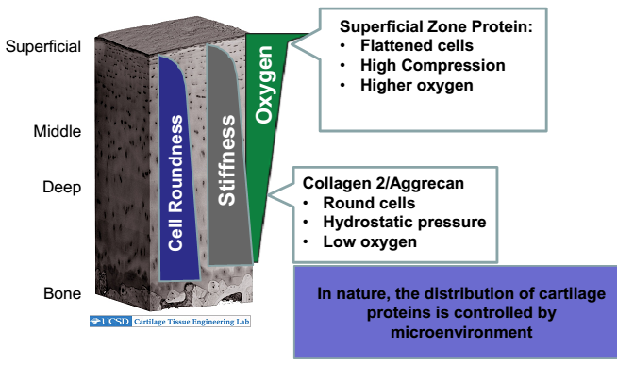
Superficial zone:
- Collagen parallel surface
- Chondrocytes elongated
- Lubricin responsible for low friction
- 80% water content, softest layer

Indermediate Layer:
- Collagen unorganized
- Chondrocytes are spherical

Deep layer:
- Collagen vertical
- Chrondrocytes are spherical, in columns
- Low water content (65%), stiffest layer

Tidemark:
- Calcified cartilage
- Oxygen and nutrient barrier to above cartilage

Cartilage nutrition
How does cartilage get nutrients?
- No blood vessels
Diffusion:
- Synovial fluid
- Only very small molecules
- Slow diffusion rates (10sec-1hour)

Cartilage ECM
20%
- Collagen Type 2:
  - ECM protein
  - Holds all together
  - Degredaded by Matrix metalloproteinases (MMPs)
- Aggrecan:
  - ECM molecule
  - Huge molecule
  - Proteoglykanc
  - Aggrecanases cleave aggrecan there are several side one side tha results in functional loss!
  - Aggrecan attracts water
    - Osmotic pressure – ions Na⁺,Ca²⁺ attracted to neutralize negative charge
    - Electrostatic repulsive forces between fixed negative charge
- Swelling pressure of cartilage

Water content
- High water content
- Water doesn’t flow easily low permeability
- High water content and low permeability provides compressive strength

What is good and what worse for cartilage?
Load, deformation, stress, strain
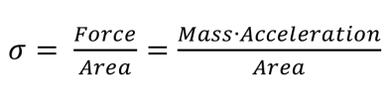

Stress:

Experiments:
- Human studies (MRI): before and after exercises
  - Physiologic levels of load decrease cartilage thickness but tissue fully recovers
- Animal running studies
  - Intensive running: Intensive running causes permanent cartilage damage
- In vitro studies

Molecular mechanisms of injury (M.Zenobi)
Excessive mechanical loading causes direct damage:
- Production of matrix fragments
- Cell nercrosis
Both injuries results in an increase in inflammation and matrix breakdown.

But how do these matrix fragments increase the inflammation?
They do this by Damage associated molecular patterns (DAMPs) which bind to pattern recognition receptors (PRR), which are the most common Toll-like receptor activation of NFkB thes essential pathway of inflammation and matrix degradation. The targets of NF-kB are:
- MMPs
- Aggrecanases
- Inflammatroy cytokines

The mechanical damage caused to cartilage tissue results in matrix fragments (DAMPs) which can induce expression of proteases to further break down the matrix. The weakened matrix is more susceptible to further mechanical damage, continuning the downward spiral.

Cartilage damage can also be induced by:
- Increase pressire increases cell death
- Mechanical injury necrosiss & apoptosis
- Reactive oxygen species (ROS)
  - Oxidative stress: an imbalance between pro-oxidant and anti-oxidant systems
    - Increase: Injury, Inflammation, drugs & xenobiotics, UV, Radiation, Metals
    - Decrease: Anti-oxidase enzymes: Super oxid dismutase, Catalase, anti-oxidant vitamins, metal sequestration

Superoxid dismutase (SOD)
- SOD3 knockout cuases more severe OA in mice
- SOD3 gene transfer reduced severity of OA

Therapies against OA:
- Loose weight
- NSAIDS
- Anti-oxidant (in joint)
- Blocking toll-like receptors
- RNA knockdown of IKK or NFkB
- Inhibitor of ubiquitin
- Apoptosis inhibition
- Blocking of NFkB/ DNA binding

