Cell Biology Summary
FS2021
By JM

I tried to summarize it as densely as I could by focusing on the parts that are relevant in my view. Therefore I don’t guarantee for completeness. I recommend watching the lectures, looking at the complete study material and using my summary afterwards. I’ll provide the summary as a word document so you can easily make adjustments if you want to.

I didn’t manage to fully summarise the Kovacs part.

Nevertheless, I hope that the summary helps you to better understand the topics.

Best wishes :)

Cell Biology 2021 JM
U. Suter
Human brain
- ~85 billion neurons and ~85 billion glia cells
  - Ratio can change locally
- ~150’000 km myelinated fibre length
- 2% of body mass, 20% of resting energy consumption
CNS (central nervous system)
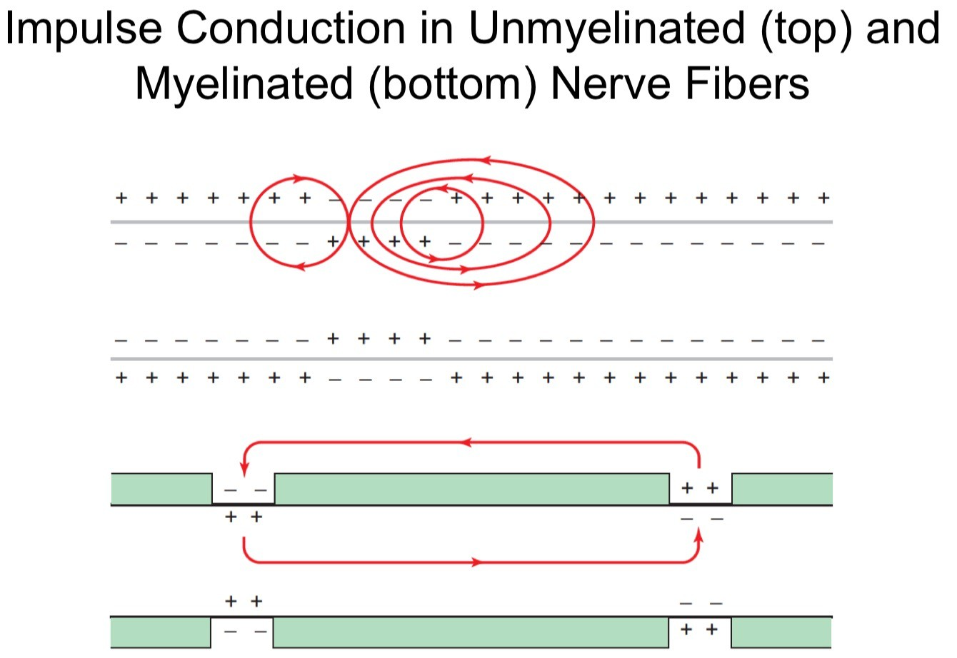
- Brain + spinal chord
- Transports and processes information
- Myelinated by oligodendrocytes (which form usually 20-60 internodes)
- White matter is dominated by myelinated axons
- Gray matter is dominated by neuronal cell bodies
PNS (peripheral nervous system)
- Connections of CNS to peripheral organs
- Transports information
- Myelinated by Schwann cells (which form usually only one internode)
Myelin
- Increase transmission speed ~100 fold (up to 100m/s)
  - Electrical insulator based on high resistance (charge cannot pass the myelin) and low capacitance (myelin cannot be charged). This is why you can’t just place the sodium channels 0.5mm apart because the depolarisation intensity would decline way too fast and couldn’t depolarize the next set of sodium channels
  - Speed is not everything, timing is more important
- Metabolic and trophic support of axons
  - Oligodendrocytes (export via MCT1) produce a lot of lactate which is the main energy substrate of axons (import via MCT2)
  - If axon is active (higher energy demand), glutamate levels rise which is sensed by NMDA receptors on oligodendrocytes -> more glucose uptake of oligodendrocyte (via GLUT1) -> more lactate to axon or astrocytes for storage
    - Why lactate? Hypothesis is that glycolysis is not very efficient, especially if space is rare, therefore the axons with high energy demand can focus on the krebs cycle and oxidative phosphorylation and the mature oligodendrocytes have lower energy demand and glycolysis is mostly sufficient
    - Not much known about the energy metabolism of unmyelinated axons. The only thing that is known is that they are more susceptible to metabolic changes than myelinated axons
- Regulation of neuronal network (changes in velocity, learning, plasticity of myelin -> dynamic system which reacts to environment -> evolutionary advantage)
- Mostly postnatal (only brain stem is myelinated prenatal because it is such a conserved system and therefore low in plasticity)
- Large amount of lipid and protein production required for myelination (70% lipids, 30% protein), many important proteins like:
  - SREBP1(TF) & FASN (enzyme for fatty acid synthesis)

  - SREBP2(TF) & squalene synthase (enzyme for cholesterol synthesis)
- The red arrows show the flow of action currents in local circuits into the active region of the membrane. In unmyelinated fibres, the circuits flow through the adjacent piece of membrane; in myelinated fibres, the circuit flow jumps to the next node. Current loses intensity due to diffusion and has to be “recharged” at next node of Ranvier -> limits length of internodes
- Myelination is plastic
  - Innate myelination during development, adaptive in adult
  - Many axons which are not fully myelinated
  - Learning increases myelination and myelin thickness
    - Neural activity modulates myelin adaptation which feeds back
    - MRF (TF for de novo myelination) KO mice were significantly worse in learning new motor skills (reduced amount of new oligodendrocytes/myelin without affecting the pre-existing)
Oligodendrocyte maturation in CNS
A. Proliferation and migration of OPC’s (oligodendrocyte precursor cells)
F. F-actin (actin filament) predominates at the front of the membrane to which the CNPase (in CNS and PNS) binds which keeps the myelin membranes apart (inflation). It gets depolymerized into G-actin (soluble monomer), MBP (myelin basic protein) concentration increases which leads to deflation.
E. compaction (extrusion of cytoplasm), Schmidt-Lanterman incisures are transport channels which reach through the whole myelin sheath.
A-E. Oligodendrocytes go through the whole cellular respiration because they need a lot of resources and energy for myelination
F. Mature oligodendrocytes can survive mainly by glycolysis and focus on producing and transporting lactate to the axons

Myelin compaction
 | Intracellular | extracellular
CNS | MBP (positively charged) attaches to negatively charged membrane and zippers the two opposing membranes together | unclear
PNS | MBP (positively charged) attaches to negatively charged membrane and zippers the two opposing membranes together | P0 (protein 0, Immunoglobulin-like cell adhesion molecule, cholesterol-dependent), transmembrane protein which hold the extracellular part together
- Cytosolic part = major dense line
- Extracellular part (white) = intraperiod line

Peripheral nerve structure
- Endoneurium = Schwann cells, axons, macrophages, blood vessels, fibroblasts, …
- Fascicle = endoneurium & perineurium
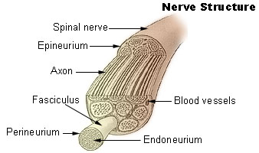

Internode & node of Ranvier architecture
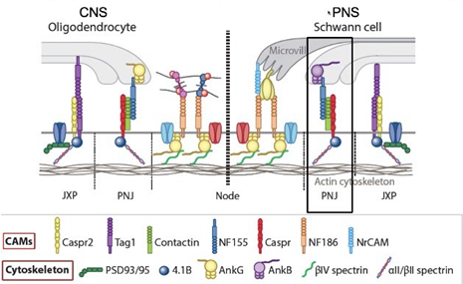

- Juxtaparanode (JXP) = “normal” part of internode containing the potassium-channels
- Paranode (PNJ) = area where axon is tightly linked to myelin which restricts the movement of sodium channels to the node of Ranvier. Two transmembrane proteins (Caspr from axon and NF155 from myelin) connected via contactin. Caspr via 4.1B and NF155 via AnkB or AnkG intracellularly linked to cytoskeleton.
- In MS (overall slower nerve conduction) due to:
  - nodes get elongated due to loss of NF155, current leakage into juxtaparanode
  - nodes and paranodes elongated with redistribution of Potassium-channels into paranode
  - myelin retraction -> mixing of ion channels

Myelin thickness
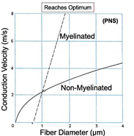
- Myelin thickness roughly proportional to axon diameter -> optimized conduction
- PNS threshold = 1µm
- >1µm = myelinated
- <1µm = not myelinated
- CNS threshold = 0.4-0.8µm
- Larger diameter = faster nerve conduction
- Above threshold easier to myelinate than to further increase the diameter
  - Body size (nervous system would take up too much space)
  - Energetically unfavourable (way more ions to pump -> higher ATP consumption)
- Too thin and too thick(unstable, but unclear why) myelin reduces conduction velocity
- In PNS not always optimal myelin thickness -> new level of network regulation
Schwann cell development
- Neural crest cells associate with axons -> Schwann cell precursors engulf bundle of axons
- If axon has a big enough diameter, myelination starts -> pro-myelinating Schwann cell -> fully myelinated (myelinating Schwann cell)
- If the axon’s diameter is too small -> non-myelinating Schwann cell -> formation of remak bundle
Axon <-> Schwann cell communication
- Axons produce Neuregulin 1 type III (membrane-bound which influences the Schwann cells (alive, proliferation, myelination)
  - BACE1 is a positive regulator of myelination, TACE is a negative regulator of myelination, both are axonal membrane bound proteins which cleave NRG+ type III differently
- Schwann cells express ErbB2 and ErbB3 which are transmembrane Neuregulin 1 receptors. Upon binding they dimerize, auto- and cross-phosphorylation -> recruitment of PI3K which phosphorylates PIP2 to PIP3 which recruits Akt and PDK1 to the membrane. PDK1 activates Akt by phosphorylation which drives myelination
  - ErbB2 knockouts are hypomyelinated
  - PTEN is a tumor suppressor (phosphatase) which catalyses the reaction of PIP3 to PIP2 and therefore decreases myelination. Dlg1 stabilises PTEN.
  - NRG1 type III also increases Dlg1 to control myelin thickness
- Bigger axon diameter -> more surface area -> more NRG1 type III -> induces a stronger response in Schwann cell

Regulation of myelin thickness in PNS
mTOR = mammalian target of rapamycin
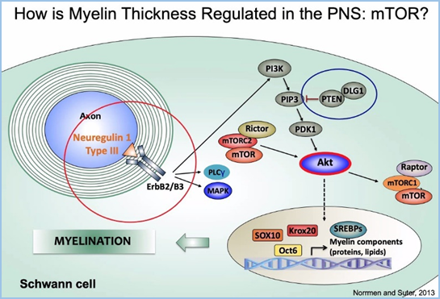
- mTORC2 works upstream of Akt
- mTORC1 works downstream of Akt and activates anabolism (activation of lipid and protein synthesis -> myelin production, inhibition of autophagy, lysosome biogenesis) if enough resources are available
  - Raptor knockout leads to hypomyelination
- mTORC1 is activated by the PI3K-Akt pathway as well as by the ERK 1/2 pathway which are both activated by respective growth factors
- High AMP:ATP ratio (signal for low energy) inhibits mTORC1
- PTEN knockout -> hypermyelination
Charcot-Marie-Tooth disease (CMT)
Disease of the PNS, loss of myelination due to genetic causes which lead to the signals targeting the muscles being incomplete or totally missing -> muscular degeneration
Different diseases:
- Duplication of PMP22 gene(peripheral myelin protein, function not fully understood) ->Too much PMP22 leads to demyelination (CMT1A)
  - PMP22 antisense oligonucleotide
  - Targeted PMP22 TATA box editing -> less transcription
- Deletion of PMP22 gene -> hypermyelination(Hereditary Neuropathy with liability to pressure palsies (HNPP))
  - Niaspan -> activates TACE which cleaves NRG1 type III -> downregulation of mTOR pathway
- CMT1B caused by mutation in MPZ gene (myelin protein zero) which leads to elevated sequestering of misfolded MPZ protein. Loss of myelinated axons without demyelination
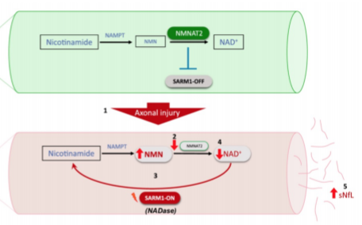
- In CMT2 an axon has somehow impaired axonal transport -> less NMNAT2 in distal regions -> less NAD+ -> bioenergetic crisis within axon -> axonal collapse (sNfl (serum Neurofilament light chain) secretion as biomarker)

  - Axonal transport is crucial for health of axon
    - Cell body to synapse: anterograde transport mainly done by kinesin
    - Synapse to cell body: retrograde transport mainly done by dynein
    - WldS mutation generates a stabilising protein for NMNAT2 which leads to delayed distal axonal degeneration upon injury
Myelinating and non-myelinating Schwann cells can also de-differentiate after injury and become a repair Schwann cell (bungner, special gene expression)
- De-differentiation
- Recruitment of macrophages to help clearing myelin and axonal debris
- Secretion of GF’s
- Soluble NRG-I helps for accurate remyelination
- CSPGs (Chondroitin sulfate proteoglycans) normally inhibit regeneration but are degraded by MMPs (matrix metalloproteinases)
Injury in CNS (no regeneration):
- Debris clearing very slow
- Oligodendrocytes inhibit regeneration
- No degradation of CSPGs
Multiple Sclerosis (MS)
Inflammatory autoimmune disease of CNS (predominantly white matter) causing demyelination (slower signal transmission and loss of axonal support by oligodendrocyte)-> can cause several symptoms depending on area of demyelination.
Primary cause is unknown, two hypothesis:
- Outside in model: cause outside of CNS, begins with activation of myelin specific T cells by a myelin mimic epitope expressed on pathogenic virus or microbe
- Inside out model: triggered by neurodegenerative event that starts to affect myelin
The course of the disease is mostly:
- Relapsing-remitting MS (RRMS) where symptoms come and go (spiking disease progression)
  - Dominated by inflammation and damaged blood-brain barrier (T cells fight oligodendrocytes and secrete pro-inflammatory signals)
    - Lymphocytes roll on vessel endothelium mediated by selectin. Upon integrin activation of lymphocytes, migration into inflamed tissue
    - Inflammation damages axonal mitochondria and myelin -> axonal energy shortage -> redistribution of Sodium-channels (due to loss of myelin) -> increase in intracellular sodium concentration -> more ATP required to remove excess sodium -> activation of sodium/calcium pump -> intracellular calcium concentration rises, activates proteases and triggers axonal degeneration
- Secondary progressive phase (SPMS) where the disease-progression is linear
  - Dominated by axonal degeneration

Amyloid precursor protein (APP, function currently unknown) as biomarker for local axonal damage. APP is transported in axons and accumulates if axon/axonal transport is damaged.
Oligodendrocyte death results in immune-mediated CNS demyelination.
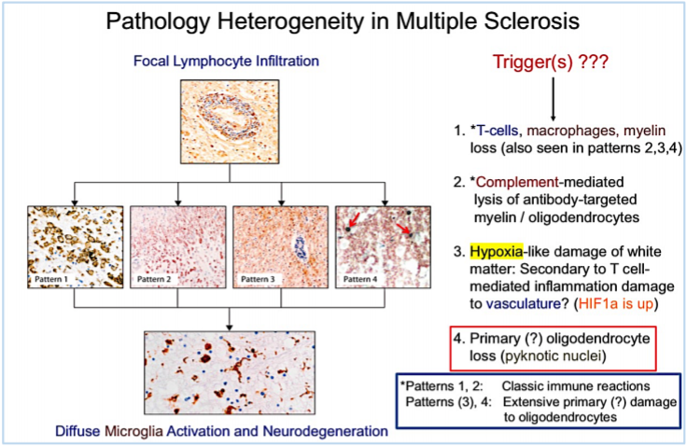
2. KIR4.1 is a transmembrane potassium channel protein expressed by oligodendrocytes. It is a antibody target (not MS-specific) which can lead to oligodendrocyte-degeneration if degraded.
3. HIF1α (Hypoxia induced factor, TF) impairs oligodendrocyte differentiation and therefore inhibits (re)myelination
Blood-brain barrier (BBB)
- Consists of endothelial cells (stabilised by pericytes) and astrocytes.
- Protect the brain from threats circulating in the blood stream.
- Stronger tight junctions less transcytosis and fewer leucocyte adhesion molecules than in blood-tissue barrier.
  - Major challenge for drug development to enter the CNS.
  - In aged mice, non-specific transcytosis increases and receptor mediated transcytosis declines, overall protein import is decreased
Treatment strategies
MS-drugs used today (main effects during RRMS because there is less inflammation in SPMS ):
- IFN-β (Interferon β, cytokine) increases anti-inflammatory and reduces pro-inflammatory cytokines
- Fingolimod restrains some lymphocytes in lymph nodes which decreases the total amount of lymphocytes entering the CNS
- Natalizumab blocks CNS entry of lymphocytes through blood-brain barrier
- Autologous hematopoietic cell transplantation (stem cell harvesting, wipe out patients immune system, insert corrected stem cells)
- Ocrelizumab targets and depletes B cells (most important drug)
Remyelination
Always in combination with anti-inflammatory drugs.
Main remyelinating cells would be adult OPCs (Oligodendrocyte precursor cells) but they cannot differentiate into oligodendrocytes in MS.
- Clemastine promotes the differentiation of oligodendrocytes.

Animal Models for MS
- GWAS show that genetic aspects of the immune system correlate with MS
- Initial trigger unknown, therefore models have to be triggered using e.g. neuroinflammation
  - No initial trigger models
- Experimental autoimmune encephalomyelitis (EAE) is a neuroinflammatory disease in animal models, comparable to MS. It is caused by the injection of several proteins. Also called effector based models.
Mouse model with temporally inducible (CreLoxP system, Tamoxifen (metabolised within a few hours) -> ERT2 activation -> Cre activation -> removal of STOP cassette) oligodendrocyte death (in adult stage)
- Can be analysed in vivo using microscopy (glass slide in skull)
- Massive loss of myelin
- Innate immune system activation in CNS
- Independent of adaptive immune system!
  - RAG1 KO (important for proper T and B cell development) shows no difference in pathology compared to WT
Brainbow mice for specifically following certain cells:
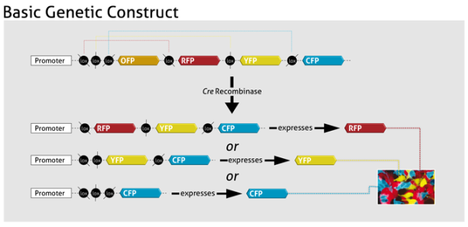
Zebrafish in PNS research
Short generation time, easy to modify genetically, inexpensive, transparent during development (live imaging)
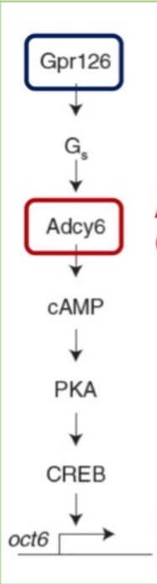
- PrP’s (prion protein) get secreted by axons which interact with Gpr126 (G-coupled receptor) of Schwann Cells which ultimately induces myelination
- Also axonal Gpr126 which is important for maintenance of myelination
- Mad Cow disease (abnormal behaviour, trouble walking, weight loss, incurable and invariably fatal, only in cows) caused by misfolded PrP’s which upon physical contact with normal PrP’s, they refold to match the misfolded ones

Wutz
Mouse
Relatively similar placental development of rodents and primates.
Common laboratory mouse strains are a mixture of Mus musculus domesticus and Mus musculus musculus (a lot of inbreeding).
Embryonic development 19-21 days, independent at week 3, sexually mature at 6 weeks and reproduction at around 8 weeks of age.
Mouse embryo development
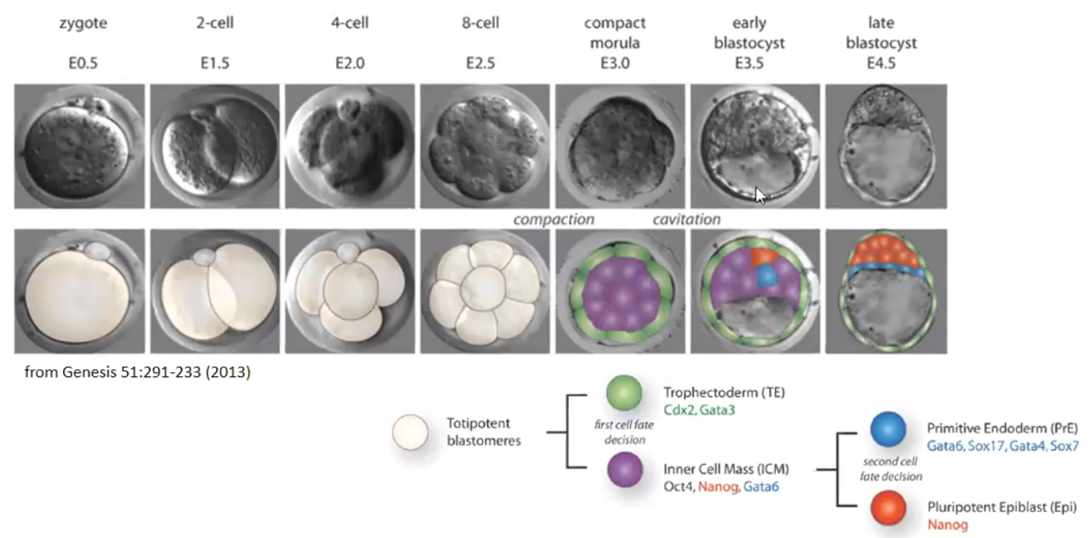
Development can be characterised using time (E5 = day 5 post-fertilization equivalent to 5 dpc =days post conception) or by developmental hallmarks using the Theiler stages (TS) because different embryos with the same age can vary in developmental progress.
- Fertilization of the oocyte in the oviduct -> zygote, which starts cell division under the control of maternal RNA and proteins stored in the ooplasm (no initial cell growth, leading to smaller daughter cells called blastomeres). The zygotic genome becomes active (especially the DUX genes which promote embryonic genome activation (EGA)) during cleavage stages (2 or 4 cell embryo)
- The blastomeres don’t grow in size -> low energy demand -> high ATP:ADP ratio -> inhibition of PFK (phosphofructokinase) which is a key enzyme of glycolysis(F-6-P -> F-1,6-P) -> low glycolysis rate
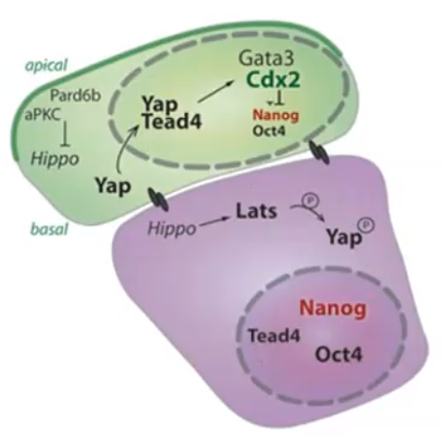
- During compaction, the blastomeres start to express E-cadherin to form strong cell-cell adhesions (Ca²⁺ dependant) -> epithelial layer on the outside (trophectoderm)
- First cell fate decision -> trophectoderm (polar) and ICM (apolar) facilitated by Hippo and Notch signalling (both membrane bound).
Trophectoderm fate | ICM fate
Angiomotins (Amots) recruited to apical membrane and prevented from reaching the adherens junctions -> no phosphorylation | Amots recruited to adherens junction -> phosphorylation
Notch active | Notch inactive
Cdx2 expression | Cdx2 not expressed
Hippo inactive | Hippo active
Nanog not expressed | Nanog expressed
Gata6 not expressed | Low Gata6 expression

  - Also some stochastic factors (Notch signalling either on or off) followed by cell sorting (migration or change in cell fate due to pluripotency)
  - Pluripotent stem cells can be taken from the ICM and kept in culture
    - Can be modified and put back into a blastocyst to form chimeric embryos (mixture of original and modified ICM) or even fully functional embryos (whole ICM exchanged) -> proof that ICM cells are pluripotent
- ICM secretes a lot of FGF4 which induces proliferation of the polar trophoblast (first growth in size of the embryo -> higher energy demand -> more glycolysis)
- Second cell fate decision, ICM -> primitive endoderm and epiblast
Primitive endoderm fate | Epiblast fate
High Gata6 | Low Gata6
Low Nanog | High Nanog
Low Oct4 | High Oct4
  - Again some stochastic factors followed by cell sorting (migration) or even cell death
  - Blastocyst already has a symmetric axis from the ICM to the blastocyst cavity called the embryonic-abembryonic axis
- E4.5: Blastocyst breaks through zona pellucida (proteases/hydrolyses and expansion of the blastocoel cavity by active import of sodium-ions followed by osmotic water influx through aqua porins) followed by its implantation into uterus
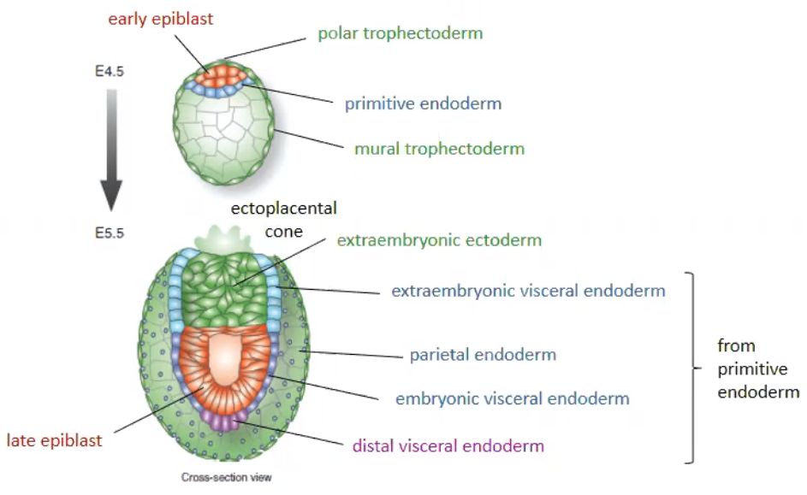
  - Fun fact: Embryo can arrest development at blastocyst stage (e.g. if mother is underfed) for up to 10 days
proximal
distal
- Polar trophoblast grows to the outside (connection to endometrium) and into the blastocoel (extraembryonic ectoderm, Cdx2 expression)
- Primitive endoderm grows along trophectoderm and forms extraembryonic visceral endoderm, parietal endoderm, embryonic visceral endoderm and distal visceral endoderm
Epiblast grows and forms late epiblast (the blastocyst is now called egg cylinder)

E5:
- Epiblast cells are in direct contact with their neighbours through E-cadherin tight junctions
- Epiblast cells are not polarized
- Auto- and paracrine FGF4 signalling
E5.5:
- Extraembryonic ectoderm produces BMP4 (bone morphogenetic protein 4, belongs to TFG-β family, activating Smad-signalling). Embryonic visceral endoderm produces survival factors that only the first layer of epiblast cells receive. The inner epiblast cells will degenerate -> formation of proamniotic cavity
- The epiblast cells in direct contact to the embryonic visceral endoderm are now a polarised epithelium
- Auto- and paracrine FGF5 signalling (molecular marker of late epiblast), a lot of Nodal signalling in late epiblast
- Extraembryonic ectoderm continues to produce BMP4 which is inhibitory towards nodal signalling
- Light green patch on top is called ectoplacental cone (connects with endometrium)
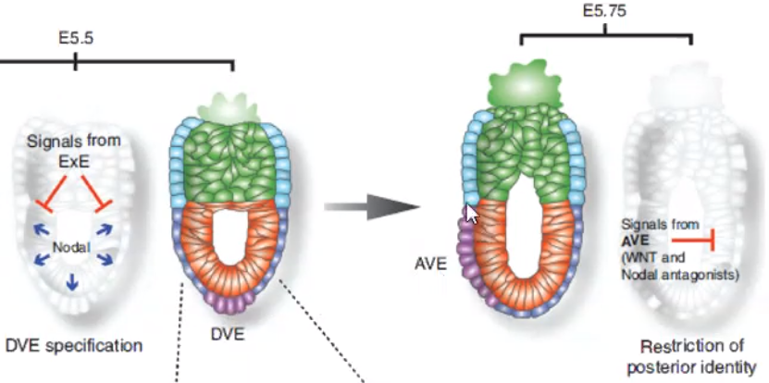
Anterior Posterior

- Proximal(high)-distal(low) BMP4 gradient by diffusion -> proximal(low)-distal(high) nodal signalling, embryonic visceral endoderm (called distal visceral endoderm, DVE) has highest nodal signalling and thickens (upregulation of Lefty1 (TF), inhibits nodal signalling)
- DVE starts to influence visceral endoderm cells in vicinity to adopt a similar function -> anterior visceral endoderm (AVE)
  - Not a lot of migration happening, mainly re-specification
  - Not clear how a side is picked
  - Symmetry-breaking event -> establishment of anterior-posterior axis
  - AVE still inhibits nodal signalling in a gradient and helps defining posterior end (hypothesis is that there is also an intrinsic signal of the posterior end that promotes nodal signalling)
    - Posterior end not visibly different
    - Posterior end forms even in mutants without DVE/AVE -> anterior-posterior definition is redundant
- Epiblast cells are still pluripotent at this stage (exception: cannot make germ cells)

Gastrulation (formation of three germ layers)
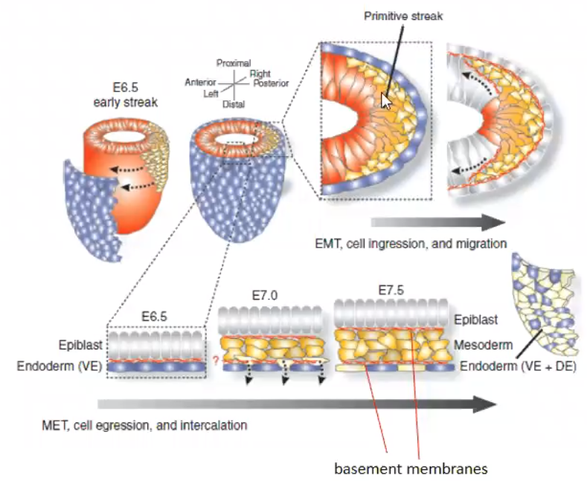
- Major Wnt-signalling (high Wnt3 concentrations) starts in visceral endoderm of posterior end and spreads to the epiblast -> formation of the primitive streak which will expand along the posterior-anterior axis
- Formation of mesoderm cells which undergo EMT (epithelial to mesenchymal transition, loss of adhesion), get depolarised and migrate between epiblast and basement membrane of visceral endoderm
  - Also formation of basement membrane between epiblast (ectoderm) and mesoderm
- Formation of endoderm cells by progenitor cells from the posterior epiblast which migrate through mesoderm and start to replace the visceral endoderm cells
  - The visceral endoderm cells also acquire characteristics from the epiblast-derived endoderm cells -> the whole outer layer changes (in the schematic from blue to yellow(definitive endoderm))
  - Definitive endoderm formation from two different pathways -> redundancy (crazy because endoderm and epiblast cells get separated during early development but are still potent enough to give rise to the same structure)
    - Evolutionary beneficial because with the ability to re-specify, you can compensate for developmental issues
- Ectoderm will form from the non-gastrulated (anterior) epiblast and will induce the neural folds
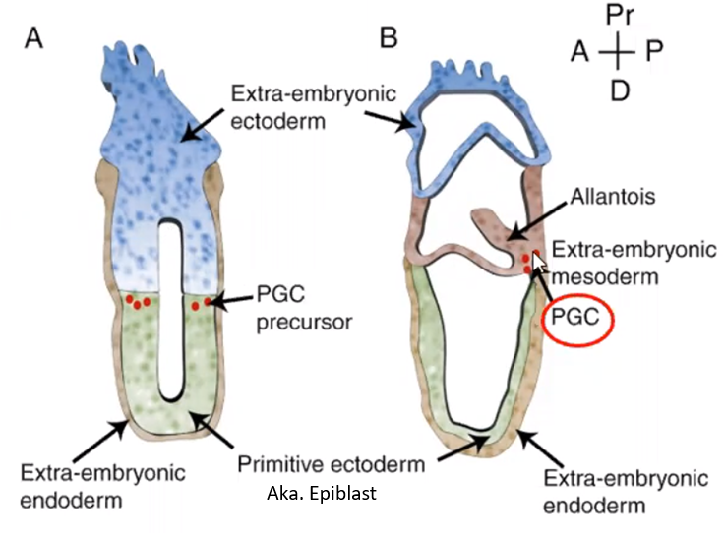

- Proximal part of epiblast also gives rise to primordial germ cells (PGCs, pluripotent, Oct4 positive), induced by BMP4 which is produced my extraembryonic ectoderm
  - PGCs can be taken and cultured to form stem cell lines
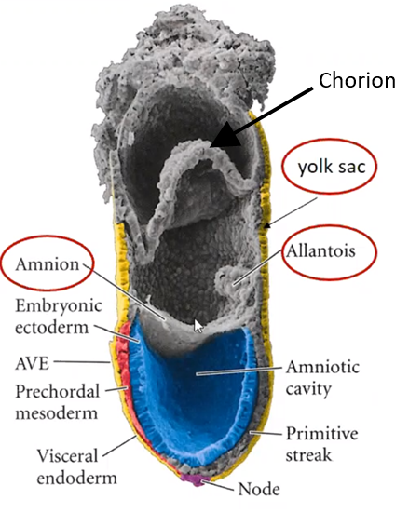
  - PGCs migrate to the posterior part of the epiblast and meet in the newly formed extraembryonic mesoderm (primarily leaving the embryo)
  - After successful gastrulation, they will migrate along the definitive endoderm to the gonads -> differentiation into germ cells
- Amnion (amniotic membrane) forms by lateral outgrowth of ectoderm, will closely surround developing embryo
- Yolk sac is surrounded by amnion (distal), meso- and endoderm (lateral) and chorion (proximal) and will provide nutrients to the developing embryo
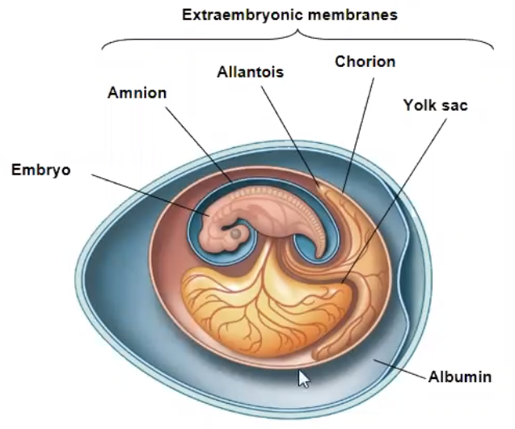
- Allantois is a mesoderm-derived (at posterior pole) sac. Will fuse with chorion to get a connection to the placental tissue (lethal at ~E9.5 if not correctly connected), which helps the embryo with gas exchange and removal of liquid waste
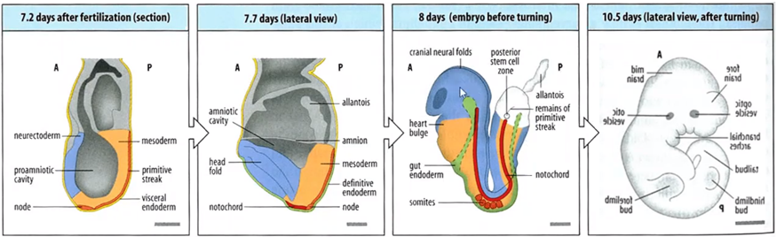
- Rodent embryos will turn between E8 and E9.5 (not seen in any other embryos)
- Relative constant formation of somites (early segments along anterior-posterior axis, form simultaneously with the propagation of the primitive streak) can be used to accurately define developmental stages (~E9-E13)
- Somites give rise to myocyte (muscle cells) buds (~E11) followed by interdigitation (formation of «fingers and toes» by targeted apoptosis) between E12.5 and E14.5
- Reprogramming of somatic cells by experimental expression of Oct4 in combination with Sox2, Klf4, and c-Myc induces pluripotent potential (iPSCs, induced pluripotent stem cells)

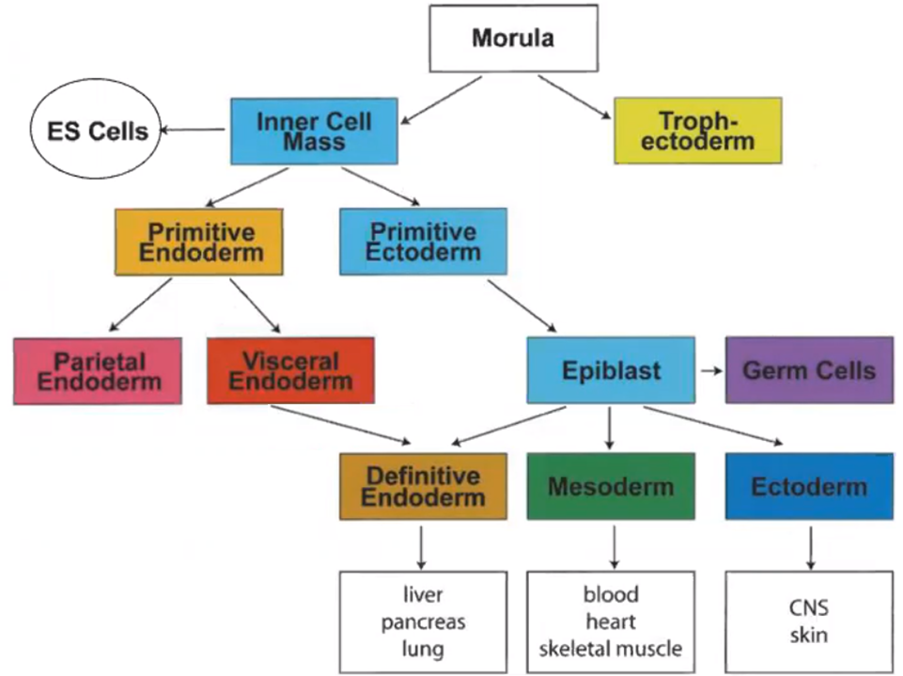
Chicken development
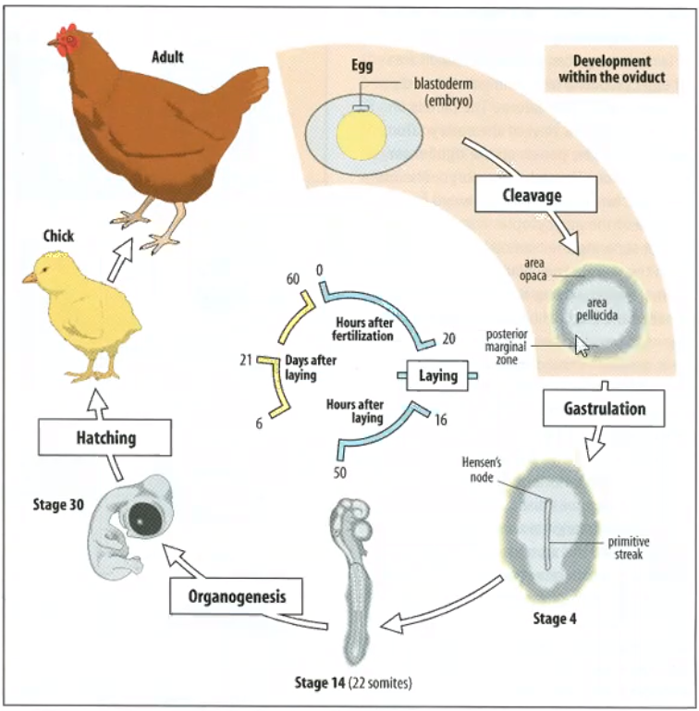
- Cell division only at blastoderm which leads to formation of blastodisc (easily accessible by opening of egg shell and removal of blastodisc)
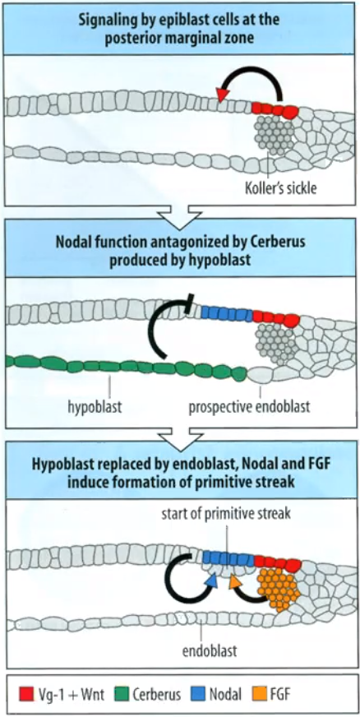
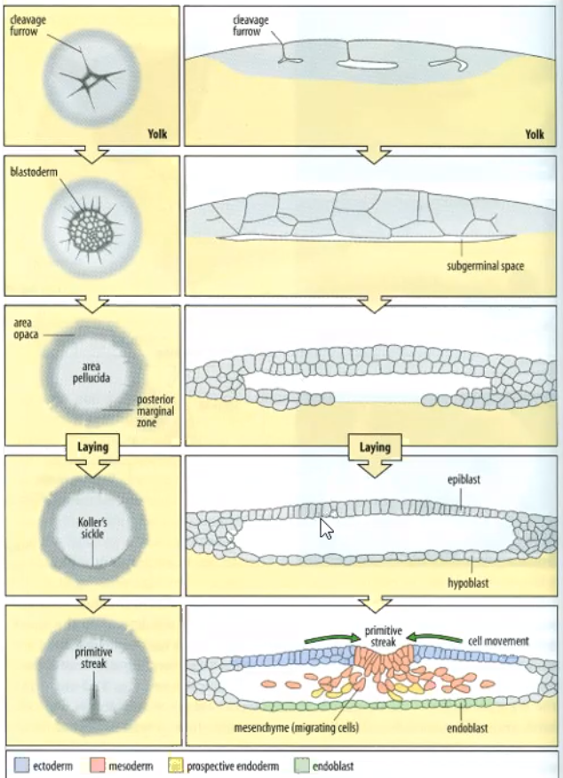
- Very similar signalling compared to mouse development
- Displacement of inhibitory hypoblast to anterior part leads to primitive streak formation at posterior marginal zone

Human development
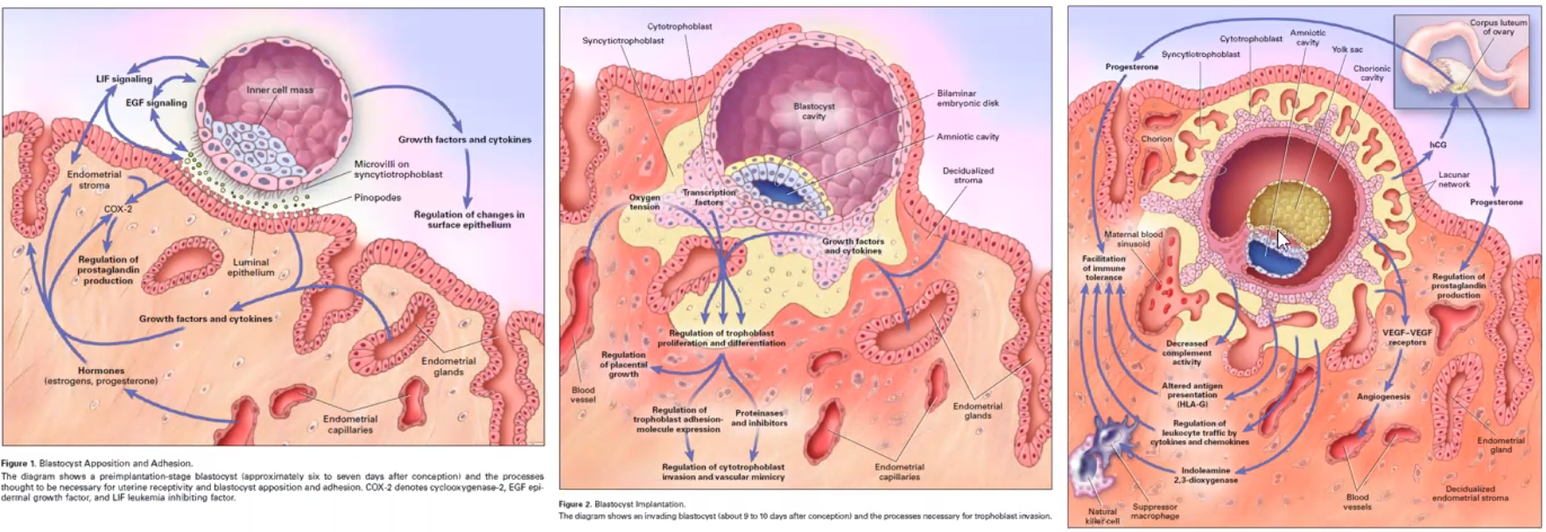
- Very similar to mouse development
- Epiblast cavity forms earlier than in mice
- Epiblast(blue)-hypoblast(yellow)-bilayer
- Planar gastrulation (comparable to chicken)
- Human blastocyst-derived embryonic stem cell lines require other growth conditions than mouse blastocyst-derived stem cell lines
  - More similar to mouse epiblast-derived stem cell lines
Ectoderm development
Ectoderm derives from epiblast
Development similar in mouse and chicken
Mesoderm has inductive functions
- Anterior ectoderm (characterised by inhibition of AVE functions via Lefty1) forms anterior part of neural tube
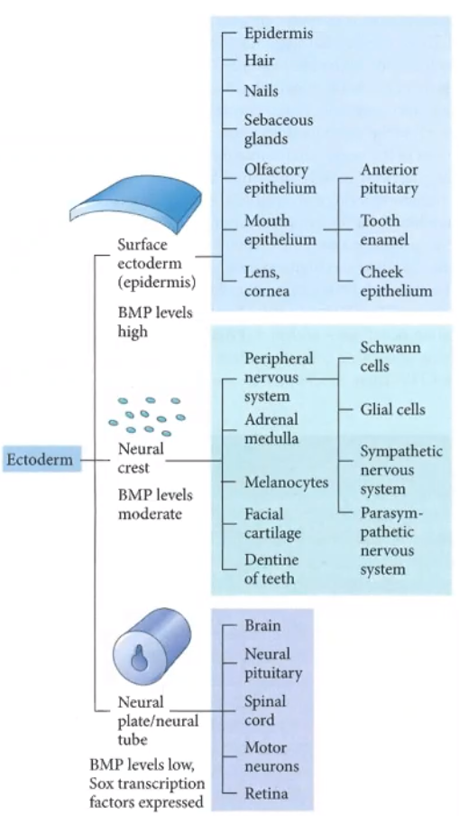
- Posterior part of neural tube also generated from ectoderm tissue (proximal elongation by de novo ectoderm formation along the posterior endoderm
- Neuroectoderm forms with low BMP and high FGF levels
- Notochord formation starts in the node and goes along the anterior-posterior axis as part of the prechordal mesoderm which is dorsal of the ectoderm
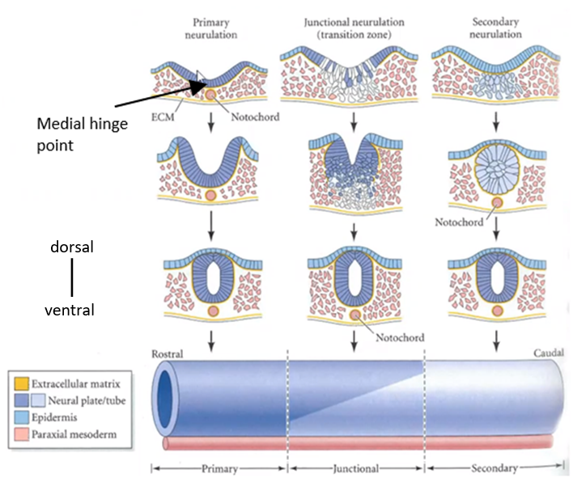

Rostral-Caudal = Anterior-Posterior
Neural tube forms differently in anterior and posterior region

- Neurulation from the hindbrain and the spinal cord is HOX-gene-controlled
- Primary neurulation (anterior): induction of neural groove and pinch off to form neural tube and closure of surface ectoderm (epidermis)
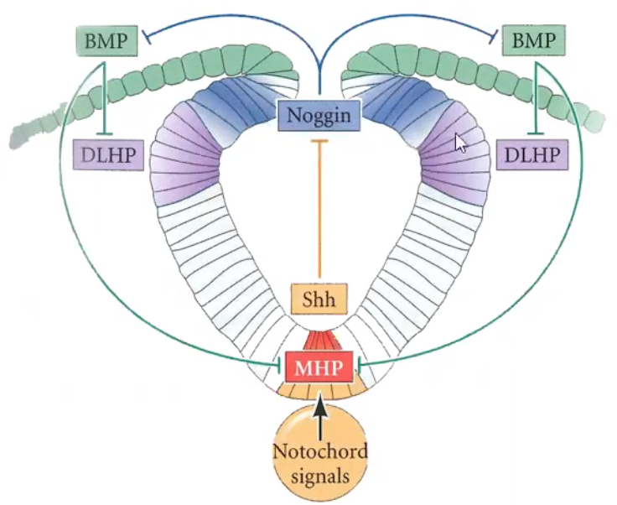
  - High sonic hedgehog (Shh) and low BMP at medial hinge point (MHP, ventral) -> constriction on apical (dorsal) site of the cells -> formation of V-shape
  - Low Shh, high BMP in dorsal region
  - Dorsolateral hinge point (DLHP, where Shh and BMP reach a minimum)
  - Noggin is a BMP inhibitor
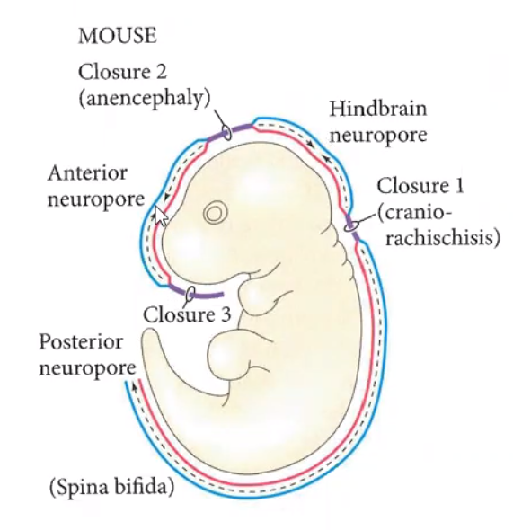
  - Degree of bending antiproportional to level of BMP
  - Cells are already somewhat differentiated but are still able to re-differentiate if necessary
  - Neural tube closure (Noggin-dependant) happens at three regions first and then progresses in a zipper-like fashion in both directions
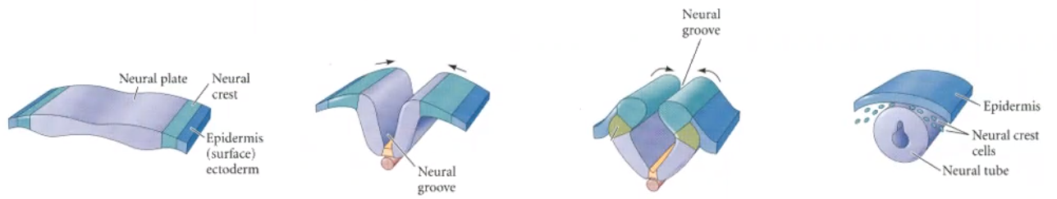
    - Folic acid deficits lead to problems with neural tube closure
  - Neural tube separation is cadherin-dependant
    - Surface ectoderm (epidermis) expresses E-cadherin
    - Neuroectoderm expresses N-cadherin
    - Transition region (neural crest) expresses both for stability and upon neural tube closure, it stops expressing cadherins -> gets mesenchymal and migrates away (guided by somites) -> neural tube and surface ectoderm will find their respective partner and complete neural tube separation
- Secondary neurulation (posterior): adaption of mesoderm cells upon encounter with newly forming neural tube which progresses posteriorly, aggregation and lumen formation
  - Most of the in vitro de novo neural tissue comes from secondary neurulation because it’s easier to carry out
- Further functional differentiation by signalling gradients (BMP and Shh, dorsal-ventral)
- Signalling gradient along anterior-posterior axis (retinoic acid(RA) and FGF/Wnt)
  - RA important in somite-formation
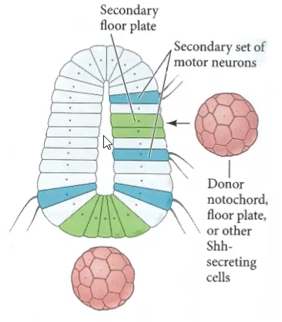
- Secondary artificial notochord (or any other Shh source) induces second floorplate accompained by additional motor neurons
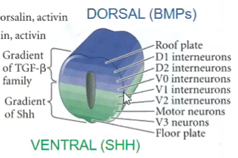

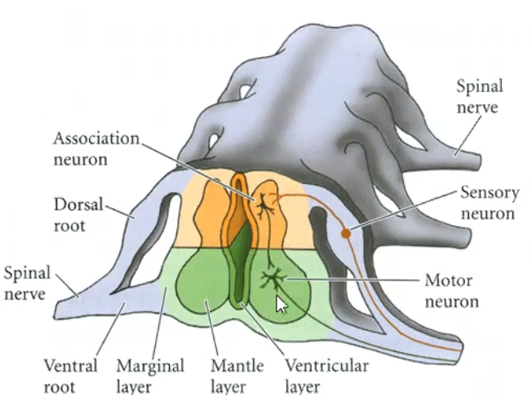
Spinal cord development:
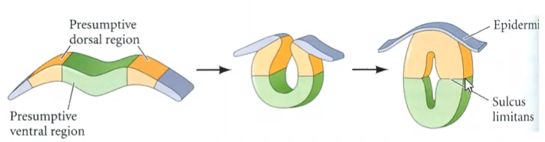
- Already subdivided in future dorsal (sensory input) and ventral (motor output) regions. Separated by sulcus limitans.
  - Cell body of sensory neurons reside in the dorsal root (PNS) and are derived from neural crest cells
  - Motor neurons are generated in and part of the CNS
  - Lateral outgrowth is somite-guided (grows through anterior part of somites -> somite-segmentation)
Brain development
Everything with segments is HOX-gene induced (spinal cord and hindbrain)
Midbrain and forebrain aren’t HOX-induced (signalling gradient dependant)
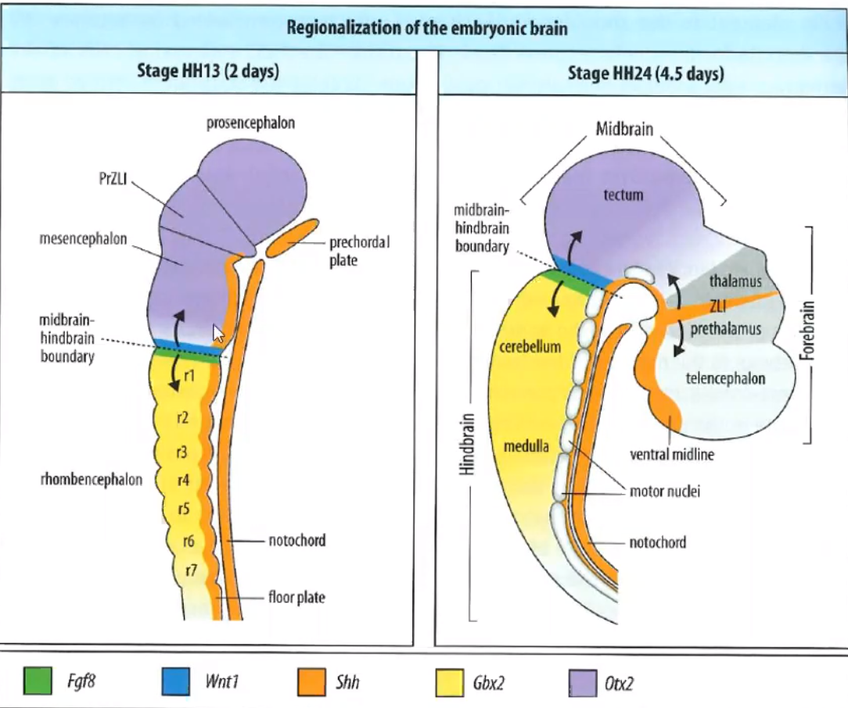
Forebrain:
- Development of zona limitans intrathalamica (ZLI) which further specifies the formation of certain brain regions
Midbrain:
- Formation of the tectum caused by Wnt signalling
Midbrain-hindbrain boundary:
- Anterior/cranial Wnt signalling
- Posterior/caudal FGF signalling
Hindbrain:
- Subdivided in rhombomeres which will give rise to the cerebellum, pons and medulla oblongata
Neural crest cell development
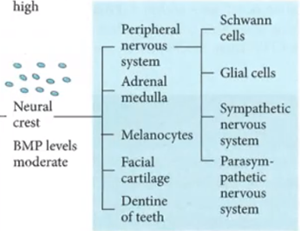
- Require medium BMP levels
- Express SOX10 as a TF (marker)
- Development depending on location (HOX genes)
- Forms facial cartilage (Knorpel) and part of the skull

Surface ectoderm development
- Specification in the head region in so called cranial placodes (ectodermal thickenings) which will lead to the formation of eyes, ears, …
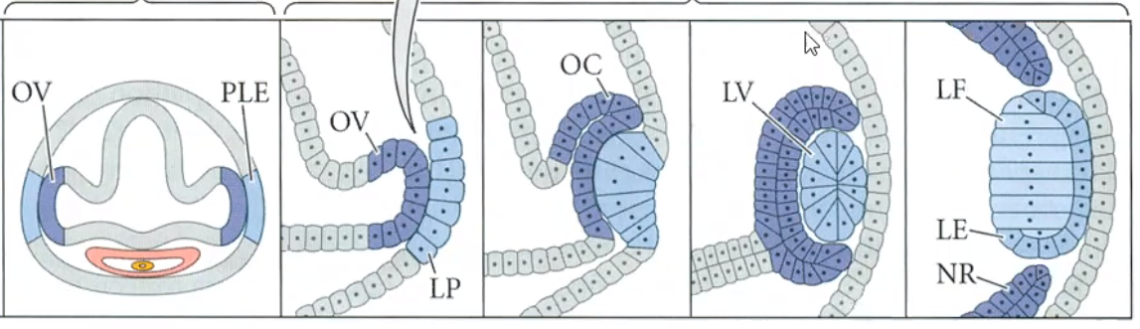

  - Wnt signalling is very important for symmetry, if completely inhibited -> cyclopia (only 1 eye and facial dysmorphia)
  - Photoreceptor cells of the eye form toxic by-products and have to be partially phagocytosed which is done by the retinal pigment epithelium (RPE)
    - RPE can get lost with age (not replaced by proliferation, only surgically by donor-RPE or in vitro RPE-generation from human stem cells) -> age-related macular degeneration which can lead to blindness
- Biggest part of surface ectoderm will from the epidermis by proliferation. Original surface ectoderm will form stratum basale.
  - Signals via Notch to the stratum spinosum which is important for differentiation
    - Doesn’t signal via Delta (which would give a feedback), signals via Jagged-proteins which only cause a forward signal
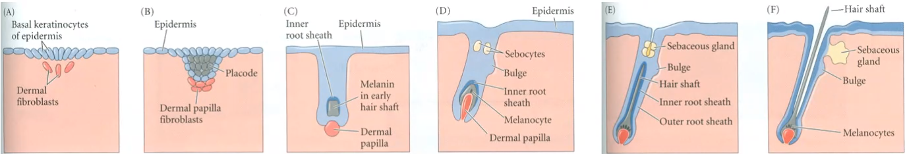
- Hair growth and hair functions(Physical protection, Prevention of heat loss, Facial expressions, Sensory input)
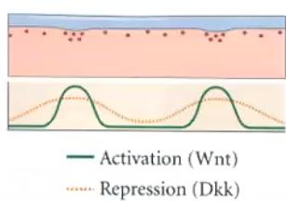
  - Dermal fibroblasts develop with a regular spacing into dermal papilla fibroblasts which induce the growth of a hair follicle and stay in contact with the hair throughout its cycle
    - Random clustering dermal cells start producing Wnt and Dkk (Dickkopf). Dkk is more diffusable and if Wnt > Dkk -> hair follicle
    - Fibroblast type determines hair type

Mesoderm development
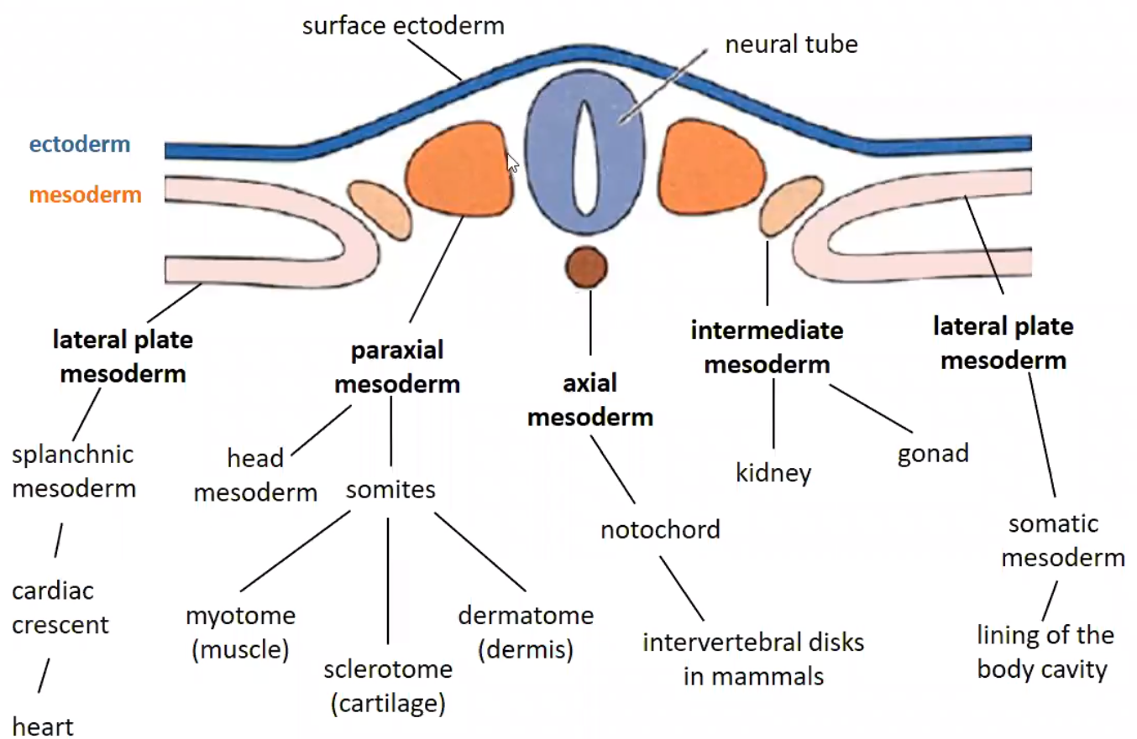
Axial mesoderm:
- Development of notochord (not present anymore in adult body, gets remodelled) along anterior-posterior axis
Paraxial mesoderm:
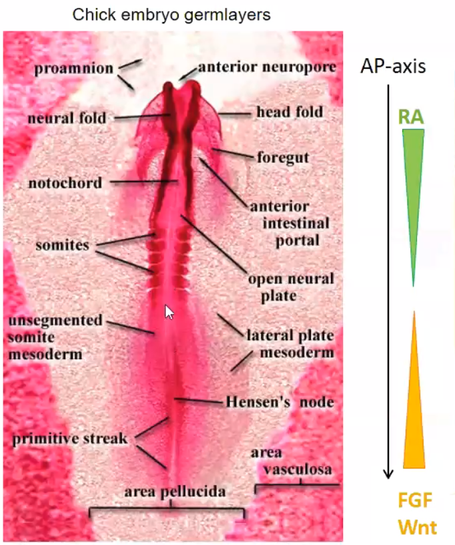
- Segmentation of somites very regularly (one “structural plan”) and differentiation facilitated by different HOX gene clusters
  - lower-numbered HOX genes are anteriorly active
  - Somites not present anymore in adult organism, get remodelled by different signals into muscle (myotome), cartilage (sclerotome), dermis (dermatome) and bones
    - Bones form from anterior part of posterior somite and posterior part of anterior somite
- Opposing and antagonistic signal gradients of RA (anteriorly high) and Wnt/FGF (posteriorly high)
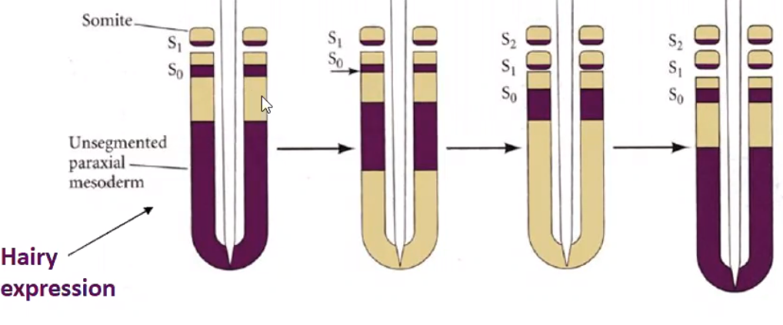
- Region between somites and node is called presomitic mesoderm and is already somewhat regularly structured (not visibly) if it enters the influence of RA at so called determination front
- Hairy expression (chicken, in mouse it’s called Hes1) caused by Notch but also represses Notch. Travels along anterior-posterior axis with higher velocity in posterior part and leads to pinching off of anterior somites in a regular fashion (Notch and Hairy/Hes1)
  - Oscillation of signalling, most likely also oscillation of Wnt and FGF
- No somite formation in the very axial mesoderm region -> head mesoderm

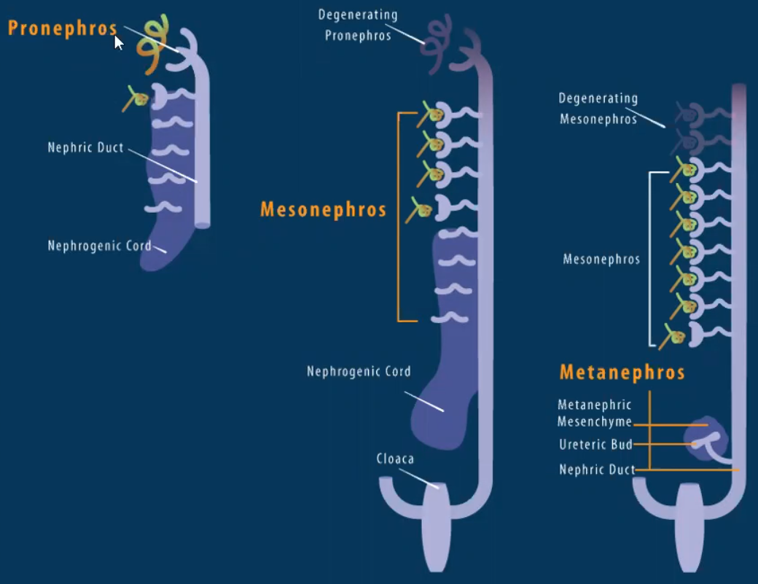
Intermediate mesoderm:
- Formation of gonads and kidney
  - Anterior formation of pronephros and nephric duct which extends posteriorly and leads to the fusion of side ducts to the nephric duct
    - Pronephros will degenerate
  - Mesonephros are contributing to the male reproductive ducts, the rest will degenerate in mammals
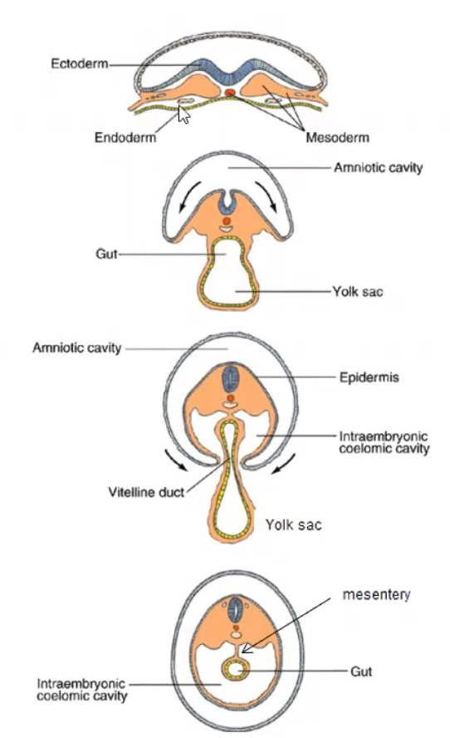
  - Metanephros arise posteriorly of mesonephros and will develop into functional kidney
Lateral plate mesoderm:
- Somatic part -> Left and right joins ventrally and forms lining of body cavity and ventral epidermis
  - At the end, there is a dorsal-ventral stacking of neural tube, notochord and gut and lateral plate mesoderm derived epidermis (schematic from chicken embryo)
- Splanchnic part -> heart and lung
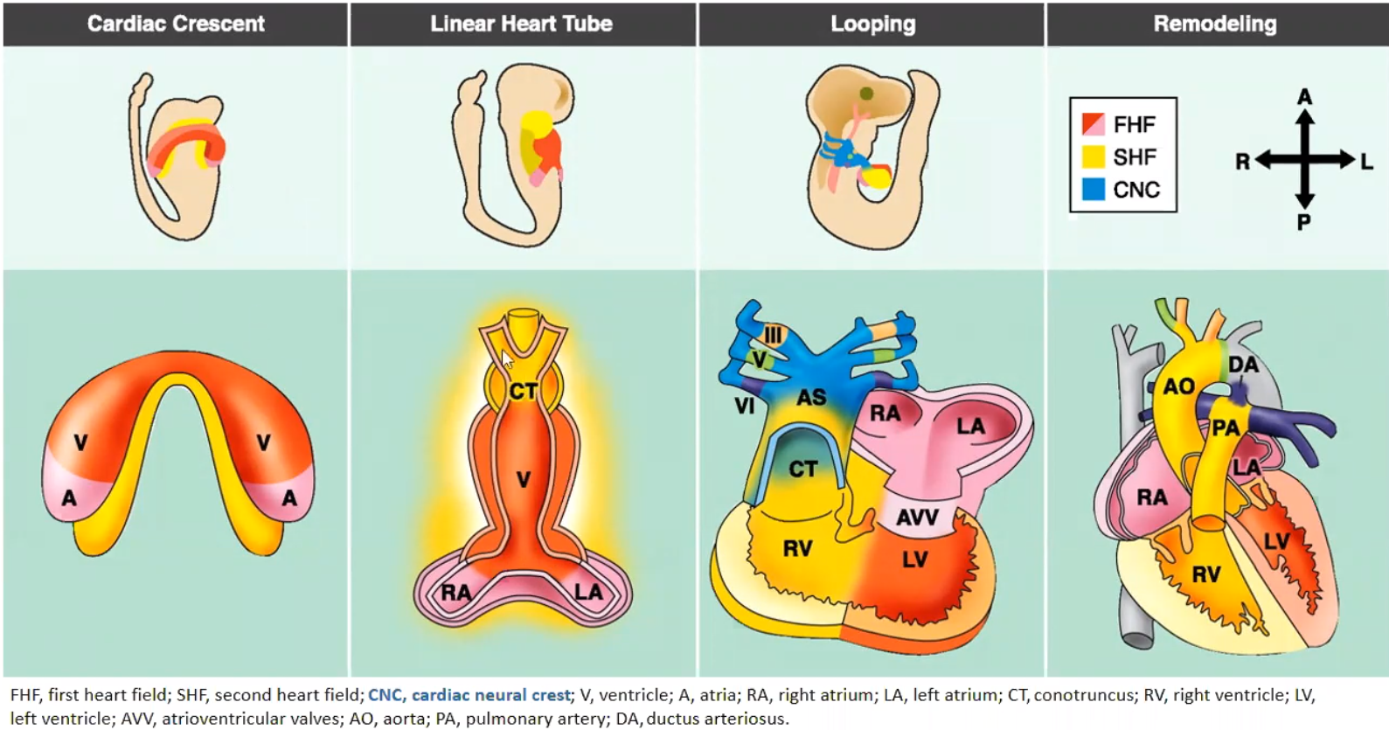
  - Heart starts developing at the left and right and gets fused together upon lateral plate mesoderm fusion.
  - Initially formation of two tube-like structure called first (will form left ventricle) and second (will form right ventricle) heart-field
  - Fusion ends up in single-chambered heart structure (E9.5, functioning placenta and diffusion is not enough anymore to transport nutrients -> heart has to start pumping in an immature form -> also big remodelling of blood vessels during later development)
  - Structure “folds” and remodels
  - LA already connected to LV and RA joins RV

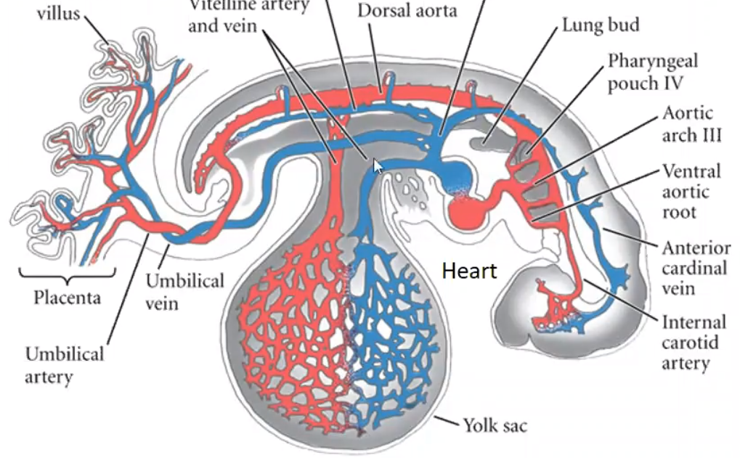
  - Chicken and human embryonic vascular system highly branched in yolk sac
  - Mouse and human embryonic vascular system highly branched in placenta
  - Very poor prenatal blood flow in lungs which changes abruptly after birth (prenatally, the two heart atriums are connected and work together for the placental circuit, they get separated after birth upon increase of blood pressure)
Endoderm development
Will form the gut epithelium and is surrounded by splanchnic mesoderm which will later form connective tissue, muscle and blood vessels

- early separation of trachea as a side-bud
  - Surrounding mesenchyme dictates what kind of epithelium will be generated. High Wnt signalling in proximity of trachea which leads to the formation of cilia. Inhibited Wnt in oesophageal proximity
- Liver and pancreas mainly derived from foregut endoderm
  - Liver formation induced by signals (BMP and FGF) from the developing heart
  - Pancreas development initiated by Pdx1. Develops from two separated ducts (ventral and dorsal) which fuse by rotation of ventral duct to dorsal duct
- Pharynx will also give rise to auditory tube and several glands
- Different expression of TF’s along the intestinal tract leads to specification

Amnion | Membrane between yolk sac and epiblast which will surround and be closest to the developing embryo
Anterior-posterior | Head-tail
Basement membrane | Membrane originally separating epiblast and visceral endoderm, later separating epiblast/mesoderm and mesoderm/visceral endoderm
Blastocoel | Aka. blastocyst cavity, fluid-filled, it permits cell migration during gastrulation and prevents the cells beneath the blastocoel from interacting prematurely with the cells above the blastocoel.
Blastocyst | Consists of the blastocoel, embryoblast and trophectoderm
Blastomere | Daughter cells of zygote (smaller in size)
Chorion | Membrane proximal of yolk sac and will be the outermost membrane around the embryo
Dorsal-ventral | Back-belly
Egg cylinder | Arises from blastocyst at around E5
(extraembryonic) Ectoderm | Doesn’t contribute to the embryo but will form part of the placenta
Ectoplacental cone | Structure at the proximal end of the embryo which connects it with the endometrium
(anterior visceral) Endoderm | Visceral = “die Eingeweide betreffend”, former distal visceral endoderm
(definitive) Endoderm | Gets formed from epiblast-derived cells and visceral endoderm cells during gastrulation, will give rise to gut epithelium
(distal visceral) Endoderm | Most distal part of embryonic visceral endoderm (DVE)
(embryonic visceral) Endoderm | Surrounds the late epiblast
(extraembryonic visceral) Endoderm | Surrounds the extraembryonic ectoderm
(primitive) Endoderm | Name for hypoblast in mice, arises from ICM, forms extraembryonic visceral endoderm, parietal endoderm, embryonic visceral endoderm and distal visceral endoderm
Endometrium | Gebärmutterschleimhaut
Epiblast | Aka. Primitive ectoderm, pluripotent, gives rise to several structures
Hypoblast | Name for primitive endoderm(mice) in other species like chicken or human
Inner Cell Mass (ICM) | Aka. Embryoblast, will give rise to the primitive endoderm and epiblast
Morula | E3 (16, 32, 64 cell stage), first adhesions
Primitive streak | Gives rise to bilateral symmetry, determines the site of gastrulation and initiates germ layer formation
Proamniotic cavity | Cavity which forms inside the epiblast upon epiblast maturation
Somite | Set of bilaterally paired blocks of mesoderm that form along the anterior-posterior axis
(mural) Trophectoderm | Trophectoderm without polar trophectoderm
(polar) Trophectoderm | Trophectoderm cells in contact with ICM which are responsible for adhesion of blastocyst to endometrium and formation of extraembryonic ectoderm
Trophectoderm (TE) | Cells which form the outer layer of the blastocyst, provide nutrients to the embryo and develop into a large part of the placenta, don’t directly contribute to the embryo, after gastrulation continuous with ectoderm
Yolk sac | Originates from endoderm and covered by extraembryonic mesoderm membrane, will provide nutrients to developing embryo
Zona Pellucida | A glycoprotein layer surrounding the plasma membrane of mammalian oocytes
Zygote | Fertilized oocyte (1 cell)

S. Werner
Growth Factors (GF’s)
- Produced by almost every cell
- Crucial for cell survival (default: apoptosis)
- Usually small, secreted peptides
- Active at very low concentrations (nano- to picomolar)
- Regulate proliferation, differentiation, survival and migration
- Cellular response depends on (combination of) ligand, receptor, cell type
Cytokines
- Larger family of signalling molecules including GF’s

Receptor Tyrosine Kinase (RTKs)
- Extracellular ligand binding domain (Ig-like or cysteine-rich)
- Intracellular tyrosine-kinase domain (Y-kinase)
- Mostly monomers
- Binding of ligand leads to di- or polymerization
  - Ligand itself is a dimer (PDGF)
  - Ligand bound by proteoglycan which acts as a scaffold (FGF)
  - Juxtracrine signalling (ligand is cell-surface bound, ephrins)
    - Ephrins have bidirectional signalling (behaviour of signalling and target cell is altered)
- Some receptors can also form heterodimers which bind different ligands
- Y-kinase cross-phosphorylates and can phosphorylate downstream signalling molecules
  - Certain proteins are recruited to the membrane and can bind to the RTKs using p-Tyr-specific binding domains like SH2 (src homology domain 2) or PTB (phosphotyrosine binding domain)
  - Loss of function mutation in either tyrosine kinase domain leads to prohibited signal transduction
Phospholipase-C-γ (PLC- γ) Pathway
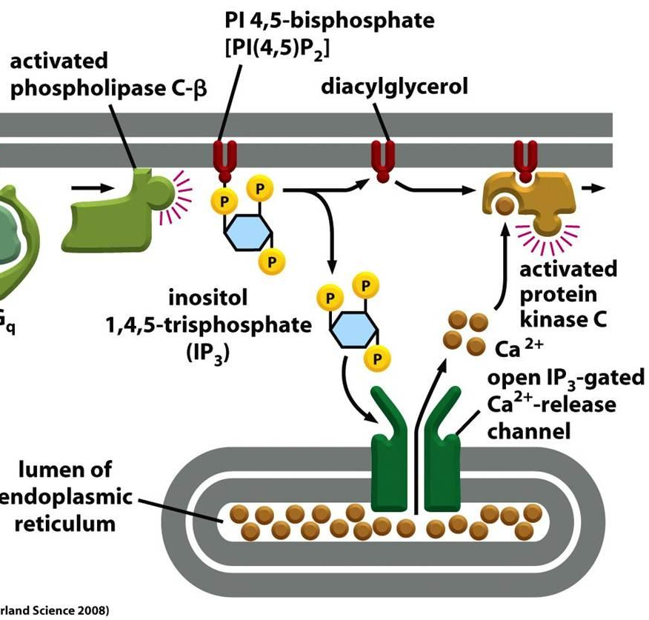
- PLC- γ gets phosphorylated by phosphorylated RTK
- Cleaves PIP₂ (phosphatidylinositol 4,5-bisphosphate) releasing IP₃ (inositol 1,4,5-trisphosphate) and leaving the two fatty acid chains as DAG (diacylglycerol) in membrane
- IP₃ increases intracellular Ca²⁺ concentration by opening channels in cellular and ER membrane which leads to passive influx of Ca²⁺
- Ca²⁺ and DAG activate PKC (protein kinase C)

Phosphatidylinositide-3-Kinase (PI3K) Pathway
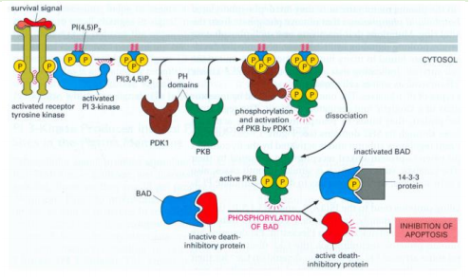
- Gets recruited by RTKs and binds using regulatory subunit
- Catalytic subunit mainly phosphorylates PIP₂ at position 3 to generate PIP₃
  - PTEN is a phosphatase which catalyses the backwards reaction (PIP₃ to PIP₂)
- PDK1 and PKB (also called Akt) bind to PIP₃
- PDK1 (now in close proximity to PKB) phosphorylates PKB which has many downstream effects like: (often overexpressed in cancer, PTEN therefore a tumor suppressor)
  - Prevention of apoptosis
    - PKB phosphorylates (inhibition) BAD which releases active death-inhibitory proteins
  - Initiation of translation
  - Increase of glucose metabolism via
    - GLUT4 transcription
    - Stimulates glycolysis by phosphorylating (activating) phosphofructokinase 2
    - Enhances glycogen production by phosphorylation (inhibition) of glycogen synthase kinase 3 which usually inhibits glycogen synthase

MAP kinase signalling pathway
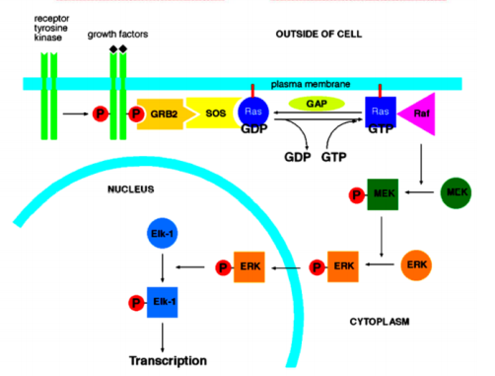
- Grb-2 (growth factor receptor binding protein 2) binds to phosphorylated RTKs
- SOS, which is a membrane-bound Ras GEF (guanylate exchange factor) binds to Grb-2

- Ras is being activated by SOS which exchanges Ras-bound GDP for GTP
  - Ras can be inactivated by dephosphorylation (GTP -> GDP) catalysed by GAP (GTPase activating protein)
    - Defects in GAP or Ras can lead to the inability to hydrolyse GTP -> oncogenic hyperactivity of Ras
- Active Ras can bind to Raf (MAP-kinase-kinase-kinase)
- Raf phosphorylates in an ATP-dependant reaction MEK (MAP kinase-kinase)
- MEK phosphorylates in an ATP-dependant reaction ERK (MAP kinase)
- ERK translocates into the nucleus where is phosphorylates Elk-1 which is a transcription factor (TF).
Adaptation of the cell to GF’s
Prolonged GF-exposure reduces cellular response (reversible) by:
- Receptor sequestration (receptor endocytosed in endosome, can later be recycled)
- Receptor downregulation (receptor endocytosed in lysosome -> degradation)
  - C-cbl is a ubiquitin ligase which targets RTKs and monoubiquitylates them -> degradation
    - C-cbl inhibited in cancer
- Receptor inactivation (intracellular blockage)
- Inactivation of signalling protein (intracellular blockage downstream of receptor)
- Inhibitory proteins (which downregulate downstream signalling)
PDGFs (Platelet-derived growth factor)
- several ligand isoforms
- receptors are α- or β-chain and exist as homo- or heterodimers
- important in development and wound healing
- if wrongly expressed can lead to fibrosis, atherosclerosis and cancer
- Antagonists
  - PDGF aptamer (DNA molecule, binds to β-receptor, specific, expensive, hard to administer)
  - STI571 (Gleevec, inhibits PDGFR’s, not highly specific, cheap, easy to administer)
- receptors have huge number of phosphorylation site and therefore many downstream effects
  - mitogenic (proliferative, via Src, Ras/MAPK, PLC-γ)
  - migration (actin reorganisation and chemotaxis, via PI3K/Rho)
  - Survival (via PI3K/Akt)
H₂O₂ (hydrogen peroxide, one of several ROS’s) signalling
- PDGF stimulation elevates intracellular H₂O₂
- PI3K activates Rac which activates NADPH oxidase located in the plasma membrane (O₂ -> O₂^{.-}), O₂^{.-} = superoxide
- Superoxide dismutase (O₂^{.-} -> H₂O₂)
- Depletion of H₂O₂ inhibits PDGF receptor signalling including MAPK activation, DNA synthesis and cell migration

Determination of intracellular ROS levels
DCF
- H₂DCF in cell. If ROS present, H₂DSF -> DSF which is fluorescent
- Not specific for one type of ROS
HyPer
- Yellow fluorescent protein attached to OxyR (E. coli protein) which is H₂O₂ sensitive
- Undergoes conformational change upon H₂O₂-interaction which increases emission at 500nm which can be monitored
- Detects H₂O₂ fairly specific
Immune Cells
- H₂O₂ can act as “chemokine” and is produced at the wound site where it attracts immune cells

Epidermal growth factors (EDF’s)
Receptors and ligands
Receptors can form homo- or heterodimers.
- EGF receptor aka HER1
  - Bind EGF, heparin-binding EGF (HB-EGF), TGF-α and a lot of other molecules
- ErbB2 aka HER2
  - No ligand of homodimer found yet -> relies on being part of a heterodimer
- ErbB3 aka HER3
  - Heregulins 1 and 2
- ErbB4 aka HER4
  - Heregulins 1, 2 and 3

Ligands are normally membrane-anchored and can act in a juxtracrine manner or are involved in cell-cell adhesion. Can also be proteolytically cleaved and act auto- or paracrine.
Homodimers have often very weak signalling but if they form a heterodimer with HER2 and bind their own EGF, the signal is potent due to:
- Slow ligand dissociation
- Not very ligand specific
- Slow endocytosis
- Rapid recycling
  - c-Cbl binds to certain phosphorylated tyrosine which leads to degradation in lysosome. Homodimer is stable in endosome (pH=5.5) which leads to degradation. Heterodimer is unstable, c-Cbl dissociates and the heterodimer gets recycled.

Role of HER2 in cancer
- HER2 overexpressed in 30% of all mammary carcinomas
- Overexpression in mice leads to increased malignancy, increased metastasis and increased resistance to chemotherapy
- HERCEPTIN is a humanised (regarded as “self”) monoclonal (one specific target antigen) antibody which binds to HER2 and blocks the receptor site
  - HERCEPTIN normally used in advanced breast cancer but a rapid resistance is probable -> start treatment at earlier disease-stages
  - Riskiest side effect is cardiotoxicity but still better than breast cancer

Antibodies against EFGR
- Often overexpressed in colon cancer
  - Erbitux is a monoclonal antibody against EGFR but only works with a wild-type Ras.
- Inhibitors of EGFR tyrosine kinase which works especially in patients with activating EGFR mutation
EGF knockout phenotypes in mice
Phenotype always depends on genetic background (strain)
- EGF receptor knockout
  - Several defects in skin, intestine, pancreas, tooth, eyelid, other strain was prenatal lethal
- Natural EGF receptor point mutation
  - Curly hair, same in TGF-α-knockout
Virus-EGF’s
There are viruses that produce EGF-like growth factors which are not required for viral replication but enhance virulence and stimulate cell proliferation and migration
Methods to analyse GF-function
Molecular level
- Analysis of intracellular signalling cascades
Transcriptional level
- Analysis of GF-related gene expression
Phenotypic level
- Analysis of cell proliferation
  - Counting at several time intervals
  - Add radioactive thymidine and measure incorporated radioactivity
- Analysis of cell migration
  - Put them left and right of a plate and measure the time until they reach each other (inhibit proliferation to make sure that only migration is taken into account)
- Analysis of cell survival
  - TUNEL staining, visualization of 3’ends of DNA which increases if apoptotic
  - MTT assay (quantitative colorimetric assay), the dye MTT (yellow) is added to the cells, the ones who are metabolically active express enzymes that reduce MTT to formazan (violet)
Generation of transgenic or knockout mice

Angiogenesis
Vasculogenesis:
Mostly during early development, de novo formation of vessels from stem cells
Angiogenesis:
during late development, sprouting from pre-existing vessels
Physiological angiogenesis:
- Menstrual cycle
- Hair cycle
- Fat deposition
- Muscle growth
- Wound healing
Pathological angiogenesis (many more):
- Cancer
- Heart ischemia (restriction in blood supply)
- Mostly linked to either excessive or insufficient angiogenesis
  - Induce or inhibit angiogenesis

Different steps in angiogenesis
- Angiogenic signal (inflammation, hypoxia)
- Degradation of ECM (e.g. by matrix metalloproteases (MMP))
- Proliferation/migration of endothelial cells
- Contact to ECM
- Lumen formation
- Stabilisation by pericytes and SMC’s
VEGF (Vascular endothelial growth factors)
Ligands:
- VEGF-A
  - Induces sprouting, increases vascular permeability, induces survival of blood cells and can also stimulate lymphangiogenesis
  - VEGF-A production is highly driven by hypoxia (high altitude training leads to angiogenesis)
    - Activation of hypoxia-inducible TF (HIF) which activates VEGF-A production
    - Produced by fibroblasts, epithelial cells, tumor cells and acts on endothelial cells (mostly paracrine)
  - Heterozygous mice die prenatal due to severe abnormalities in cardiovascular system
- VEGF-B
- VEGF-C
  - Knockout shows complete absence of lymphatic vessels
- VEGF-D
- VEGF-E (produced by a virus)
- VEGF-F (in snake venom)
- PLGF (placenta growth factor)
Receptors:
- VEGFR1 and VEGFR2 (homo- or heterodimer)
  - VEGFR1 knockout -> lethal during embryonic development due to excessive endothelial proliferation
  - VEGFR2 knockout -> lethal in utero -> no differentiation of endothelial cells
- VEGFR3 mainly expressed on lymphatic endothelial cells -> lymphangiogenesis
  - Mutations or removal of lymph nodes can cause lymphedema
Angiopoietins
Also important for angiogenesis
Ligands:
- Ang1
  - Binds to Tie2 and stabilises vasculature
- Ang2
  - Antagonist of Ang1/Tie2 interaction
  - Expressed at sites of vessel remodelling
Receptors:
- Tie1
  - Doesn’t bind a ligand alone -> can form a heterodimer with Tie2
- Tie2
  - Binds Ang1 and homodimerizes -> stabilisation of vasculature
  - Inhibited by Ang2 -> destabilisation of vasculature

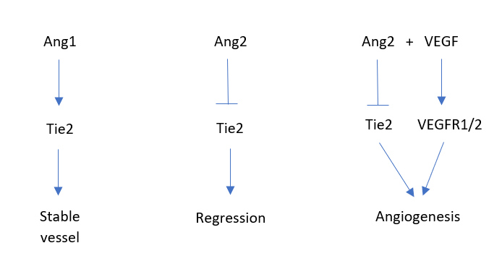
Angiogenesis:
- Ang2 binds to Tie2 and destabilises vessel
- VEGF gets expressed and induces endothelial growth
- New formed vessel secretes PDGF which attracts pericytes to stabilise the vessel (trophic and by the production of Ang1) (paracrine loop)
Ephrins
- 8 ligands which are transmembrane proteins (GPI anchor) -> juxtacrine (bidirectional)
- 14 receptors (RTK’s, homo- or heterodimers)
- Stimulate migration, cell-cell and cell-ECM attachments
- Don’t stimulate proliferation
Tumor angiogenesis
- Diffusion of oxygen and nutrients reaches a distance of 0.2-0.4mm (limited tumor growth)
  - Further growth relies on angiogenesis (angiogenic switch turned on if pro-angiogenic factors > angiogenesis inhibitors)
  - New blood vessels also used for metastasis
Induced by:
- Hypoxia
- Inflammatory cytokines
- Oncogenes
- ROS
Everything leads to the expression of VEGF
- Survival, proliferation and migration of endothelial cells
- Recruits endothelial progenitor cells from bone marrow (vasculogenesis)
- Recruits inflammatory cells
Components of tumor microenvironment:
- Fibroblasts
- Vascular and lymphatic endothelial cells associated with pericytes and SMC’s
- Immune cells (macrophages, neutrophils, T cells, B cells, mast cells)
  - Help by production of VEGF, other GF’s for tumor cells or produce MMP’s to digest ECM
Anti-angiogenic tumor therapy
Observation: Frequent metastasis after removal of primary tumor
Hypothesis: Primary tumor produces factors that inhibit growth of metastasis (don’t clear why) -> discovery of angiostatin

Angiogenesis inhibitors
MMP inhibitors:
- TNF-70
- Thalidomide (pregnant women used thalidomide against pain leading to many embryos without proper limbs because formation of limbs requires angiogenesis)
Endogenous inhibitors:
- Angiostatin
- Endostatin
  - Naturally occurring fragment of type XVII collagen
  - Inhibits several angiogenic factors
  - Expensive production and critical dosing (low concentrations more effective than high)
- Ang2
- IL-12
- Interferon-α
Biological antagonists:
- VEGF antibodies (Avastin)
  - Humanised monoclonal antibody
  - Many side effects like bleeding, hypertension, holes in colon, impaired wound healing, kidney damage
  - Endothelial cells become resistant (use other factor e.g. FGF2)
- VEGF antisense RNA
- VEGFR inhibitors
- soluble VEGFR’s and Tie2
VEGF antagonists may increase tumor growth due to:
- recruitment of bone marrow derived pro-angiogenic cells (e.g. macrophages and vascular progenitor cells)
- Other angiogenic factors (e.g. FGFs, ephrins or angiopoietins) are frequently upregulated)
  - New strategy: combined blockage of VEGF and FGF
Drugs targeting VEGF and FGF:
- SUTENT
  - Inhibits VEGFR1-3, PDGFR
  - Inhibits angiogenesis, reduces vessel stabilization by pericytes and inhibits some tumor cells directly
- NEXAVAR
  - Inhibits VEGFR2, PDGFRβ and Raf (MAP kinase-kinase-kinase) kinase
  - Inhibits angiogenesis and some tumor cells directly
- MACUGEN
  - Used for angiogenesis in the eye which leads to wet dorm of macular degeneration
  - Injected directly into the eye
  - Prevents excessive angiogenesis and vascular leakage in the eye
- RANIBIZUMAB
  - Also used against excessive angiogenesis in the eye
  - Humanized antibody fragment

Lymphatic system
- Collects extravasated bloodless fluid from the tissue and transfers it as lymph via the collecting lymphatic vessels and thoracic duct back into the venous blood circulation
- Immune functions by transporting white blood cells and APC’s to lymphoid organs
- Lined by endothelium and surrounded by SMC’s but lower pressure -> lower flow
- Discontinuous (lack of inter-endothelial junctions) -> permeable for interstitial fluid and cells
- Impaired lymphatic drainage -> lymphedema
Lymphangiogenesis in cancer
Many tumors contain functional lymphatic vessels, in particular in the periphery of the tumors
- Tumors can also spread via lymphatic vessels
- VEGF-C (promotes lymphangiogenesis) overexpression in mouse tumors increase rate of metastasis
  - Inhibition of VEGF-C, VEGF-D or VEGFR3 can be used to suppress tumor formation and metastasis in mouse models
Therapeutic angiogenesis
If not enough angiogenesis
- GF’s or gene transfer of growth factor gene
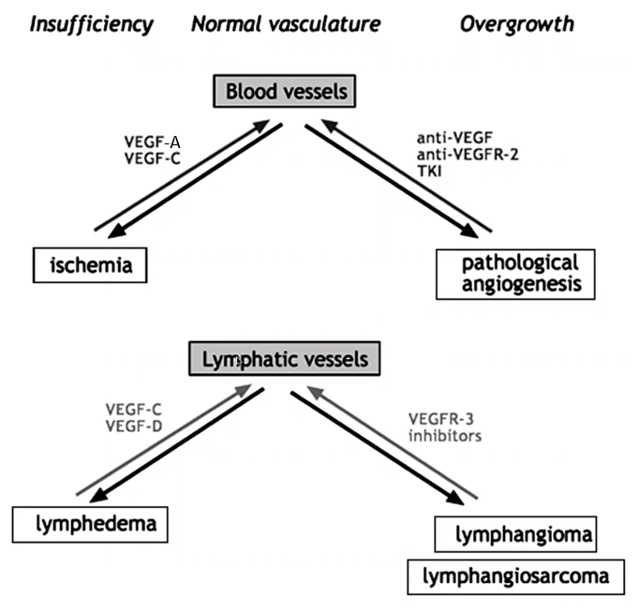

Angiogenesis assay
In vitro tube formation on Matrigel
- Coat wells with Matrigel (mixture which resembles basal membrane)
- Seed endothelial cells on Matrigel surface
- Add potential angiogenesis factor or inhibitor
- Count capillary tubes within certain timeframe
- No animals needed
Aortic ring assay
- Cut aorta of rodent into 1mm rings and embed them in agarose and culture medium (angiogenic factors or inhibitors)
- Examine after certain time point
In vivo Matrigel plug assay
- Mix Matrigel with angiogenic factor or inhibitor
- Inject cold liquid Matrigel subcutaneously (under skin) into mice
- Matrigel solidifies and vessels from skin can penetrate Matrigel plug
- Count vessels after certain timepoint

Sponge-Matrigel assay
- Matrigel without test substance injected into mouse
- Sponge or tissue fragment inserted in plug (potentially also a small tumor) containing substance of interest
- Monitor vessel formation
Chorioallantoic membrane (CAM) assay
- Tissue with test substance is placed directly on membrane below chicken egg shell at day 7-9 of development
- Re-incubation and scoring of vascularization later on
Rabbit/Mouse cornea assay
- Cornea normally avascular
- Make a pocket in the cornea and introduce test substance with a sponge and monitor vascularization
Fibroblast growth factors (FGFs)
- Mitogens (activate mitosis -> proliferation) of fibroblasts and other cells
- Divided in many subfamilies
- Discovered by purification, cancer studies (oncogenes) and PCR(due to homologies)
- Most of them bind to heparin (GAG), which acts as scaffold for signal transmission
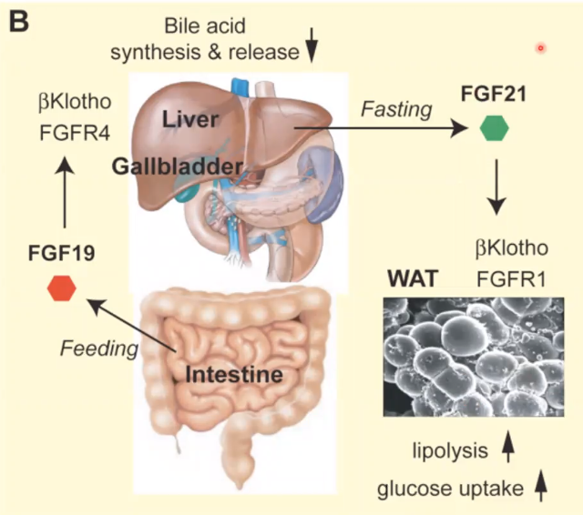
  - FGF19 and FGF21 are endocrine FGF’s (both responsible for energy homeostasis) with reduced affinity for heparin, they require the co-receptor βKlotho for binding to the FGFR’s
- FGF7 (also called KGF (keratinocyte growth factor)) produced by fibroblasts acts as a paracrine GF and binds to FGFR2IIIb on endothelial cells
  - Protects different endothelial cells (bladder, lung, gastrointestinal tract) by increasing mucosal thickness
  - Often given before and/or chemotherapy to reduce coleteral damage on different mucosas
    - Also protects keratinocytes from UV radiation, ROS and stabilises hair follicles
- Huge variety in FGF knockout mice, redundancy in subfamilies
  - FGF-5 KO has long hair, negative regulator of hair growth
  - FGF 10 KO has no limbs and dysfunctional lungs -> death after birth
    - Mesenchymal fibroblasts produce FGF10 which acts paracrine on endothelial cells of ectoderm (FGFR2IIIb) which leads to outgrowth. The endothelial cells produce FGF8 and stimulate more FGF10 production in fibroblast (FGFR2IIIc) (double paracrine mechanism)

  - FGF23 KO have multiple signs of premature aging (lower bodyweight, fragile bones)
    - Important in vitamin D metabolism and phosphate homeostasis
    - FGF23 has low binding affinity for the FGFR and therefore needs the transmembrane protein αKlotho (co-receptor)
- FGF11-14 (FGF homologous factors)
  - Cannot bind to FGFRs due to structural changes
  - Are not secreted
  - Bind intracellularly to voltage-gated ion channels -> mostly leads to delayed channel inactivation
Fibroblast growth factor receptors (FGFRs)
FGFR1-4
Classical RTK’s which can be altered by alternative splicing to change ligand binding specificity
- FGFR1/2 KO die prenatal
  - Conditional FGFR1/2 KO in keratinocytes leads to hair loss after first hair cycle, impaired epidermal barrier function (-> inflammation and epidermal thickening) and enhanced transepidermal water loss
    - Epidermis consists of cornified envelope and tight junctions which normally regulates water loss and invasion of pathogens ad allergens
- FGFR3/4 KO survive but have major defects
- Activating mutation in FGFR3 (negative regulator of bone growth) can lead to Achondroplasia (short bones)
- FGFRs often mutated in cancer
Transforming growth factor β (TGF-β)
TGF-α and TGF-β are very different
TGF-β is part of a large family of GF’s
- Three isoforms in mammals (TGF-β 1-3)
- Inhibit proliferation of most cells
  - Mutations in TGF-β-pathway frequently found in cancer
  - Exception: proliferation of fibroblasts and Schwann cells gets stimulated by TGF-β
    - Often over-expressed in fibrotic disease
- Anti-inflammatory
- Inhibits autoimmunity
- Biologically active as homodimers
- Rich in cysteine (1 for dimerization, rest for intramolecular disulfide bridges)
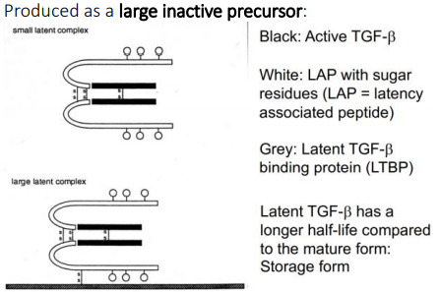

- TGF-β is bound to LAP (latency associated peptide) -> small latent complex
- LAP can be bound to LTBP (latent TGF-β binding protein) -> large latent complex
  - Latent TGF-β has a longer half-life (used for storage)

Activation of TGF-β
- Low pH
- Proteinases (cleave LAP from TGF-β)
- Mechanical tension on cell/tissue
- ROS
TGF-β Receptors
- Type I and II receptors get always heterotetramerised by dimeric ligand. Type II phosphorylates type I intracellularly and type I transduces the signal.
  - Important: They aren’t RTKs, they are receptor serine-threonine kinases
- Type III receptor (Betaglycan) doesn’t transduce a signal and is incorrectly named receptor. Binds ligands and presents it correctly to type I and II.
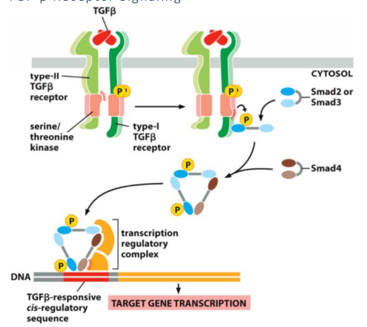

- Smad2/3 are so called R-Smads (receptor Smads)
- Smad4 = nuclear Smad
- R-Smads and Smad4 associate and act as TF in the nucleus
- Inhibitor Smads (Smad6/7) inhibit R-Smad-phosphorylation and association with Smad4 (not shown in schematic)
- Smads get transported out of the nucleus, ubiquitinated and degraded
TGF-β in cancer
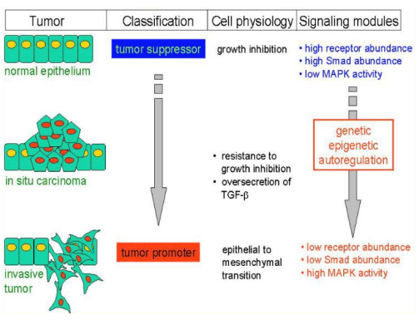
- Initially, TGF-β acts as a tumor suppressor due to growth inhibition
- Cancer can get resistant to TGF-β signalling and therefore more susceptible to growth promoting pathways (MAPK)
- Somehow TGF-β-overproduction also stimulates MAPK
  - Promotes differentiation of fibroblasts into myofibroblasts
  - Promotes angiogenesis
  - Activates macrophages -> MMP production
  - Inhibits T-cells
- Epithelial to mesenchymal transition (loss of cell-cell adhesion)

P. Hiebert
ECM (extracellular matrix) can be called matrisome which consists of the core matrisome (collagens, ECM glycoproteins, proteoglycans) and matrisome-associated factors (ECM-affiliated proteins, ECM regulators, secreted factors)

ECM components
Collagens
- Most abundant protein in mammals
- Several different isoforms (Collagen fibrils are typically heterotypic)
- Triple helical domain, Gly-X-Y repeats (usually X=proline, Y=hydroxyproline)
  - Structural and signalling functions
ECM Glycoproteins
- E.g. fibronectin
  - Cell adhesion, signalling, storage and release of GF’s (Controls spatio-temporal distribution of GF’s)
Proteoglycans
- Heavily glycosylated proteins
- Long , unbranched glycosaminoglycans (GAGs)
- Attached to cell surface, within ECM or rarely within cell
  - Water retention (regulation of osmosis)
  - Structural and signalling functions
ECM-affiliate proteins
- Structurally of physically affiliated to ECM
ECM regulators
- Remodelling of ECM (cross-linking, degradation )
Secreted factors
- GF’s, cytokines

ECM functions
- Provides structure and shape
  - Adhesive substrate for other cells
  - elasticity
- Direct interactions with GF-receptors
- Secretes and stores GF’s
- Homeostasis (balance between ECM synthesis and degradation by proteases (MMP’s) and protease inhibitors (TIMPS)

ECM-homeostasis-associated diseases
Fibrosis (more synthesis than degradation)
- High TIMPS, low MMP’s
- Activated fibroblasts by TGF-β, ROS, mechanical tension
- ECM is cause and effect of fibrosis
Cancer
- ECM gets remodelled to tumor microenvironment
  - Tumor cells, endothelial cells, immune cells, ECM
- Cancer-associated fibroblasts
  - Differentiation (activated TF Nrf2) triggered by DNA damage, TGF-β, ROS, IL-1, IL-6, …
  - Senescence-promoting ECM, release of GF’s, cytokines, promotion of epithelial proliferation

ECM-therapeutics
- Current fibrosis treatment
  - IPF’s that inhibit GF’s or GFR’s
  - Targeting TGF-β-mediated SMAD signalling
  - Targeting ECM cross linking to make proteases more effective
  - Encourage protease-secretion by macrophages and fibroblasts
  - Reduce ROS-synthesis by inhibiting NAD(P)H oxidase using apocynin -> less myofibroblasts, less release of ECM-stored GF’s, less TGF-β-synthesis, more active MMP’s, destabilizing collagen
- Addition of ECM proteoglycans
  - Lubricating cartilage (Knorpel) surface
- Regulation of TF’s

ROS
ROS have many functions which can be harmful or beneficial depending on the context via multiple mechanisms.

M. Schäfer (Wound healing)
Tumors are wounds that do not heal
Skin functions:
- Protection (UV, chemicals, pathogens, physical assault, …)
- Regulation of body temperature
- Barrier against water loss
- Sensory organ (pressure, pain, temperature, …)
Skin organisation
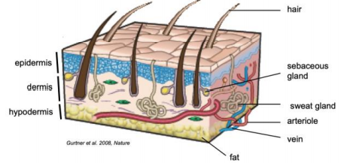
Epidermis:
From outside to inside:
- Stratum corneum: tightly anchored, flat keratinocytes without nucleus (metabolically active)
- Stratum granulosum: cells containing lamellar bodies filled with lipids (which they secrete whilst proceeding to the stratum corneum -> protection against water loss), tight junctions as second barrier
- Stratum spinosum: linked with desmosomes and contain a lot of macrophages (Langerhans cells), both as additional lines of defence
- Stratum basale: Melanocytes producing melanin which accumulates on top of nucleus to protect DNA from UV, stem cells linked by desmosomes underneath melanocytes (stem cell daughter cells turn into transient amplifying cells which are highly proliferative and migrate upwards whilst differentiating due to changing pH and calcium concentration)
- Basal lamina: barrier towards underlying tissue

Dermis
Loose and dense connective tissue
- Fibroblasts: synthesize ECM and collagen
- Immune cells (T cells, macrophages, neutrophils)
- Endothelial cells: form the endothelium of blood and lymphatic vessels
- Cutaneous nerves: sensory innervation
- Smooth muscle cells (SMC): erector pili muscle and surround vessels

Wound healing stages (overlapping)
- Inflammation (1-3 days)
  - Blood clot formation
Damaged blood vessel leads to the binding of blood platelets to the interstitial connective tissue. Upon binding, the platelets degranulate (Thrombin, TGF-β, PDGF(platelet-derived GF), VEGF(vesicular GF)) and attract more platelets and are now able to bind fibrinogen (bound form = fibrin) which expands the clot in three dimensions) Immune cells migrate to target site.
The cloth functions as protection against invading microorganisms, as matrix for migrating cells and as reservoir for cytokines and growth factors.
  - Invasion of immune cells
Vasodilation and increased vessel permeability.
Neutrophils arrive due to their large abundance first and have two main functions:
- Destroy bacteria (phagocytosis, ROS)
- Secrete pro-inflammatory cytokines (activation of macrophages, keratinocytes and fibroblasts)
Neutrophils become senescent rather quickly or get phagocytosed by macrophages.
Macrophages arrive at the injury and:
- Fight microbes (ROS, NO, phagocytosis)
- Promote angiogenesis
- Secrete GF’s and cytokines
- Wound debridement (Wundausscheidung)
- ECM synthesis
- Proliferation (3-15 days)
  - Re-epithelialization
- Keratinocyte (activated by several GF’s) migration (facilitated using collagenases to digest ECM, loss of desmosomes, actin remodelling to enable movement) and proliferation
  - Formation of granulation tissue
- Fibroblasts (activated by PDGF and TGF-β)produce large amounts of ECM (fibronectin, laminins, collagen)
- VEGF and bFGF (basic fibroblast GF) stimulate neovascularization (proliferation and migration of endothelial cells)
- Fibroblasts under mechanical tension lead to differentiation into proto-myofibroblasts which synthesise smooth muscle actin and lead to mechanical wound contraction.

- Remodelling (7-18 days)
- Epithelium -> Epidermis, Granulation tissue -> Dermis
- Collagen secretion of fibroblasts, formation of larger collagen bundles also by collagen catabolism (facilitated by Matrix metalloproteinases (MMP))
- Regression of capillaries
- Apoptosis of fibroblasts and myofibroblasts

Healed skin is neither aesthetically nor functionally perfect
- Loss of hair follicles and sweat glands
- Reduced tensile strength

Fetal wound healing is better due to no risk of infection

Diabetic foot ulcer
Chronic wound that fails to heal
Basically everything doesn’t work as intended.
High blood glucose can alter ECM proteins and lead to several impairments.
- Reduced migration and proliferation of keratinocytes and fibroblasts
  - Reduced secretion of GF’s by macrophages, reduced response to GF’s, early senescence
- Low NO
  - Reduced angiogenesis
  - Reduced collagen production
- Disturbed ECM formation and remodelling
  - Upregulation of MMP’s
- Reduced innervation (nerve formation)
Excess cells can be removed by surgery, infection can be treated, correction of perfusion by high oxygen supply and negative pressure.

Parallels between wound healing and cancer
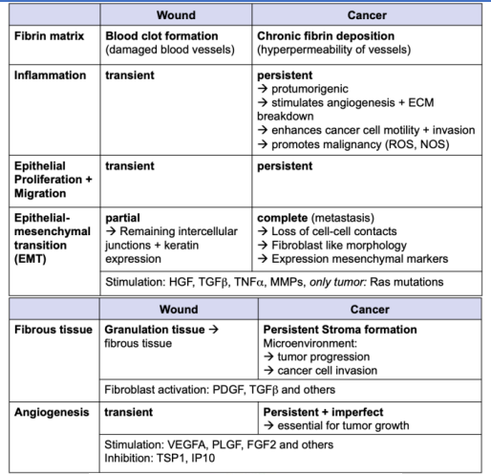

Gehart
Tissue regeneration
Homeostasis:
- Replace damaged cells and maintain tissue function
  - A human body produces ~5Mio. Cells/s whereof the majority is generated in the hematopoietic system
- Prevent damage accumulation
- Enable tissue adaptation to changing conditions
Injury
- Re-establish barrier function towards outside
- Re-establish internal separation
- Re-establish organ function
Adult tissue stem cell
- Undifferentiated but can produce differentiated offspring (multipotent, limited to their tissue type)
- Quiescent (divides usually rarely to minimise risk of genomic damage by replication or whatever)
- Life-long contribution to tissue
- Ability to self-renew (asymmetric cell division)
- Reside in a stem cell niche which helps regulating the lifecycle, protect and control the total number of the stem cells
- Constitutive tissue stem cells
  - Stem cells that are constantly present and dividing (intestine)
- Facultative tissue stem cells
  - Only appearing and dividing on demand (liver)
- Stem cells which could not be replenishable from a non-stem cell source would be highly susceptible to any kind of damage. Loss of stem cells would lead to severe problems and therefore the ability to de-differentiate evolved.
  - Huge problem for cancer treatment
- With differentiation, specialisation increases but potency decreases
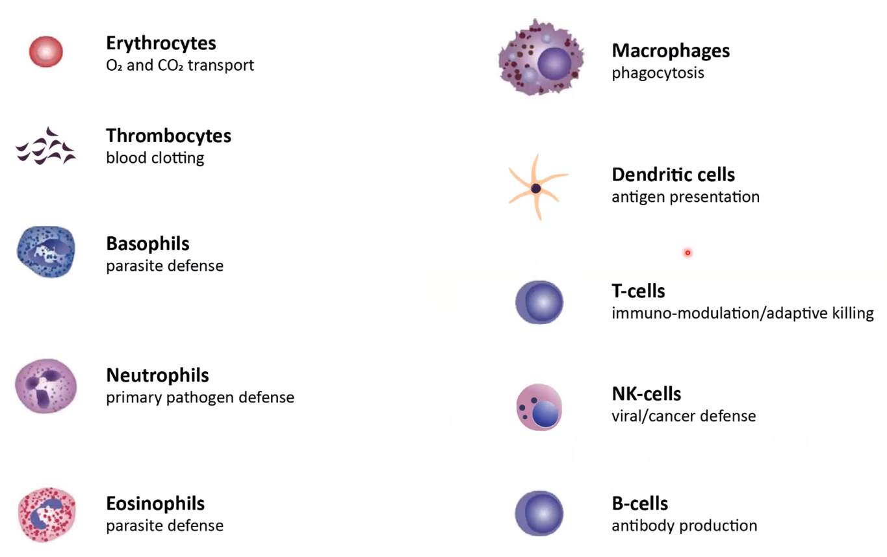
- Hematopoietic system
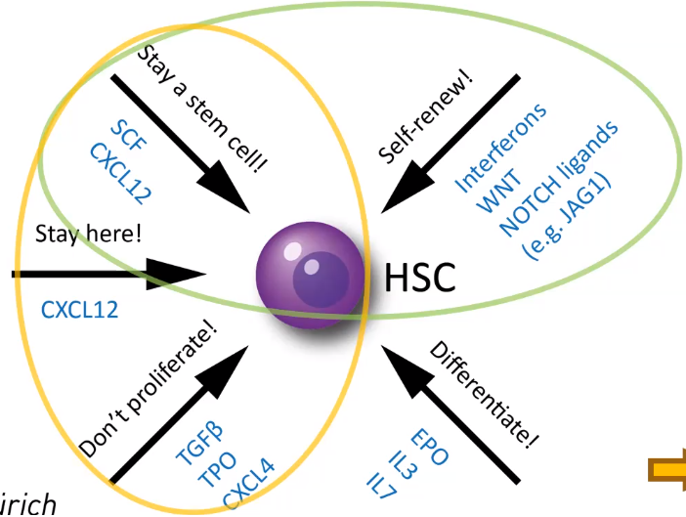
- Hematopoietic stem cells (HSC’s, reside in red bone marrow) produce a large variety of differentiated cells (red and white blood cells)
  - Sinusoidal endothelial niche -> proliferation
  - Megakaryocyte (thrombocyte progenitors) niche -> quiescence
- Long term HPC’s (LTHPC’s) remain mostly quiescent unless stimulated by acute regenerative need
  - Produce transit amplifying cells (TA’s) which rapidly and exponentially divide

Intestine
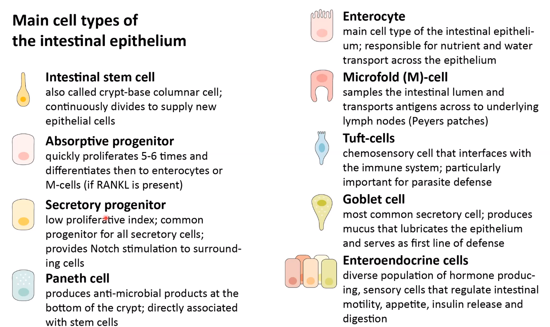
- Intestinal epithelium renews every 4-5 days
  - Proliferation in crypts
  - Apoptosis at the villus tip
- Absorptive progenitor ≈ TA cell
- Absorptive progenitors > secretory progenitors

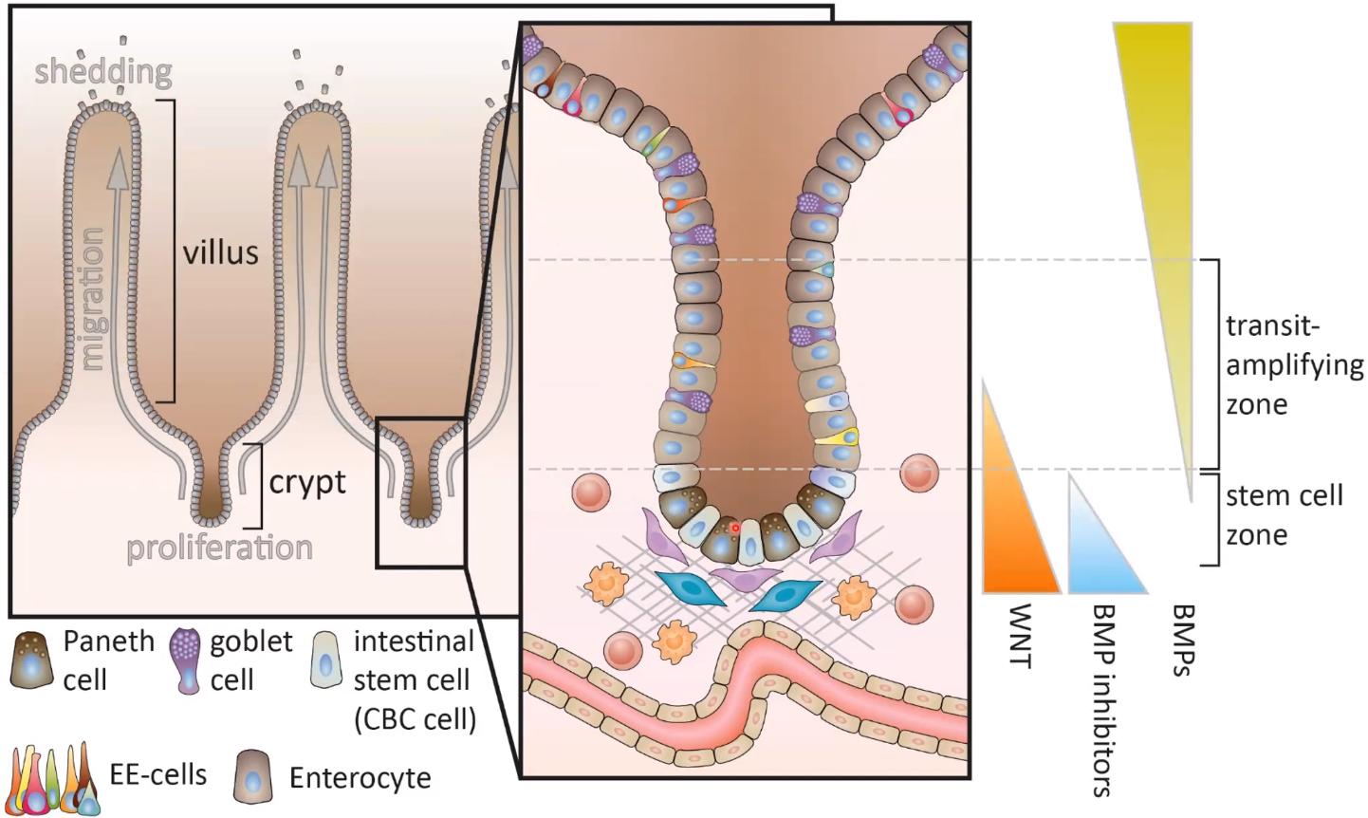

- Paneth cells produce Notch, EGF and Wnt (only in mice)
- Mesenchymal cells produce EGF, Ent, RSPO (Rspondins, Wnt potentiator) and inhibit BMP
- Intestinal stem cells can be primarily destroyed by diptheria toxin but replenish from non-stem cells 48h after toxin dose without any harm to the tissue.
  - Constant diptheria toxic dose leads to stem cell depletion, loss of villi and endothelial functions.

Hair follicle
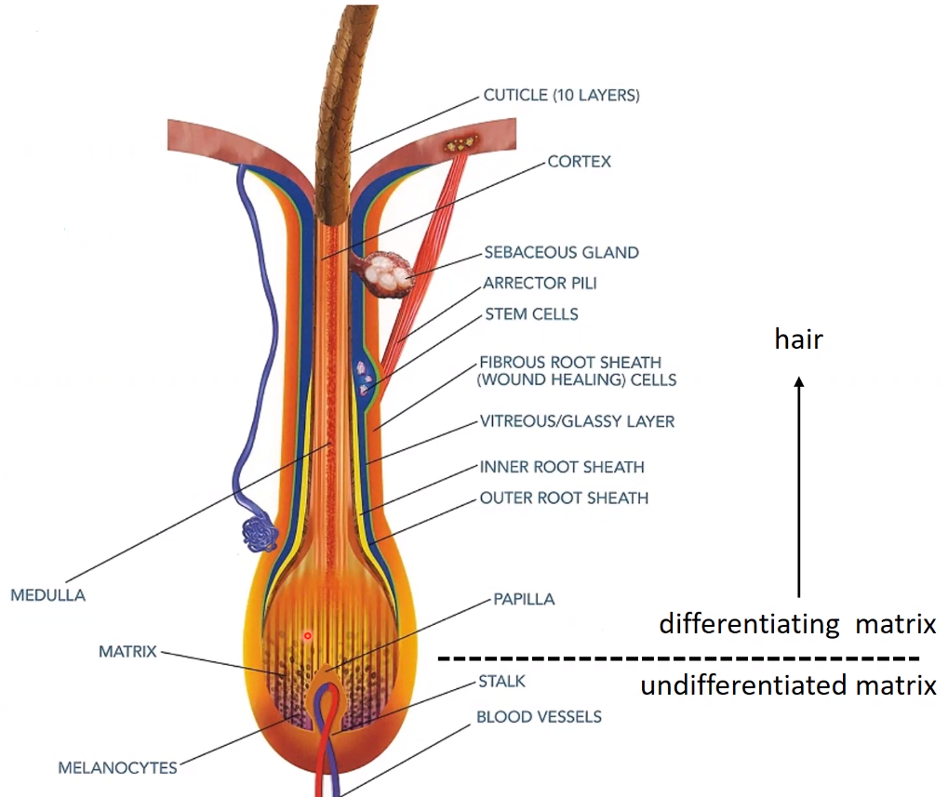
- Medulla in the middle surrounded by the cortex surrounded by overlapping cuticle cells
  - Produced by the matrix (TA cells) at the bottom of the hair
    - Differentiating cells are called trichocytes
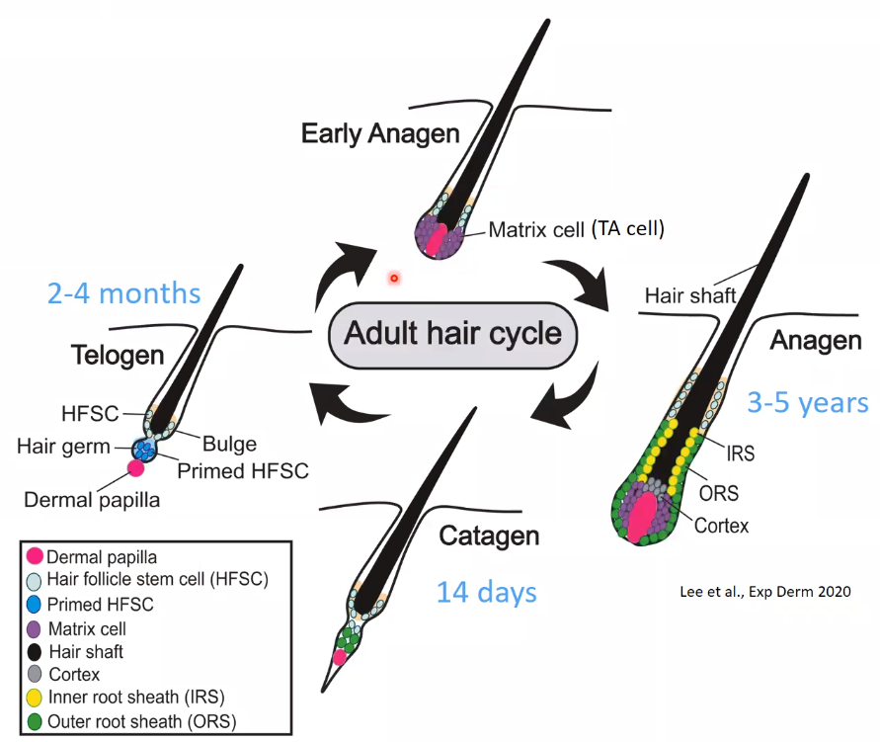
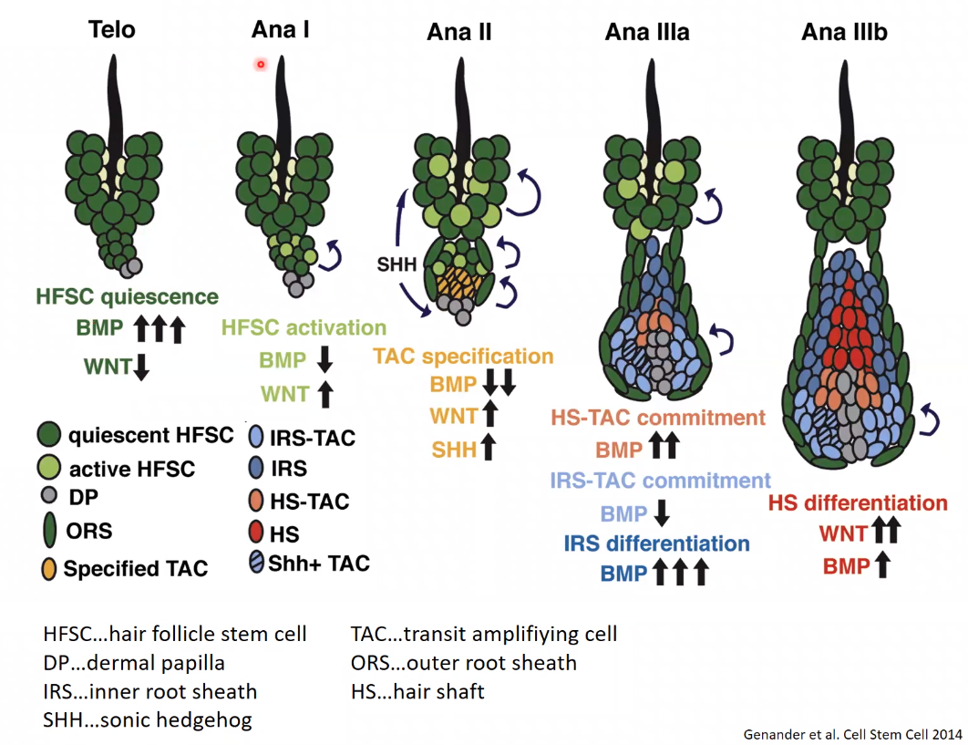
- Stem cells in the middle of the subcutaneous part of the hair (called bulge, don’t contribute to hair growth)
- If hair degenerates, the bottom end reaches the bulge and induces new hair cycle
  - High BMP levels (from bulge stem cells, fibroblasts and adipocytes) keep hair follicle stem cells (HFSC) quiescent
  - Initiation of telogen-anagen-transition by dermal papilla and adipocyte progenitor cells via FGF and PDGF. HFSCs start to express Wnt which stimulates the release of BMP inhibitors which activates further HFSC to produce TA cells and start the new anagen phase
  - TA cells produce sonic hedgehog (Shh) which leads to even further BMP inhibition and also stimulates growth and elongation of the new root
  - At Ana IIb, the HFSC’s are pushed so far away of the BMP inhibitors, that they get quiescent once again

Mammary gland
- Ductal luminal cells (luminal cell)
  - Line the inside of the milk-transporting duct
- Alveolar secretory cells (luminal cell)
  - Secrets most components of breast milk
  - Often have two nuclei
    - For high nutrient production and output
- Myoepithelial cells (basal cell)
  - Surround ducts and alveoli and constrict to move the milk (major force during breastfeeding)
- Luminal/basal cells normally produced by unipotent luminar/basal progenitor stem cells
  - There are multipotent stem cells (mammary stem cells, MaSC’s) which can give rise to luminal and basal progenitor stem cells but they are usually quiescent
    - Cross talk via Notch to macrophages which express Wnt
    - Fibroblasts and ductal luminal cells also produce Wnt and influence MaSC’s
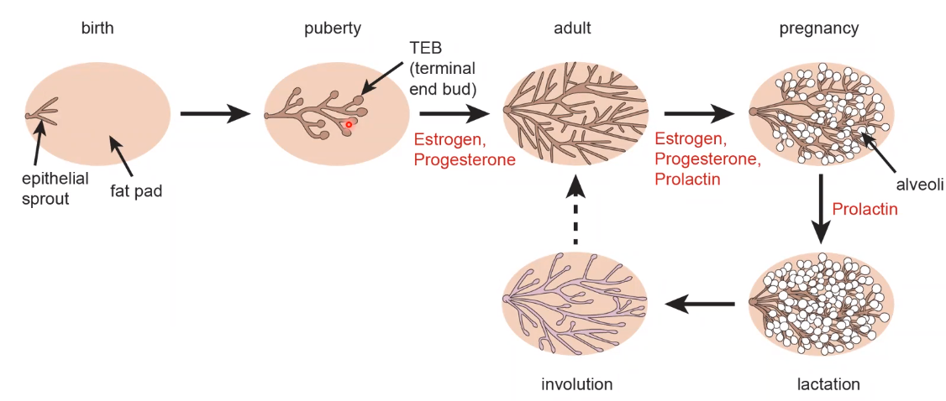

- During puberty, growth of ducts at around 0.5mm/day (very fast)
- Upon pregnancy, massive alveoli generation
- After weaning (abstillen), 80% of the epithelial tissue is lost within 3 days
Signalling summary
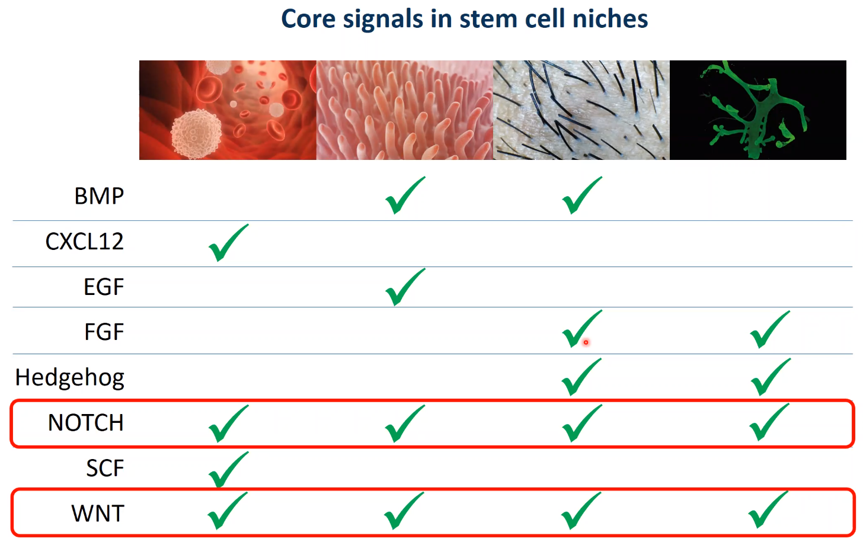

Wnt-signalling
- Short range signal -> clear area of action
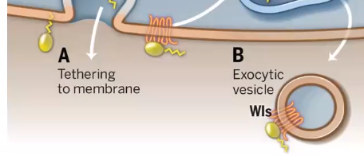
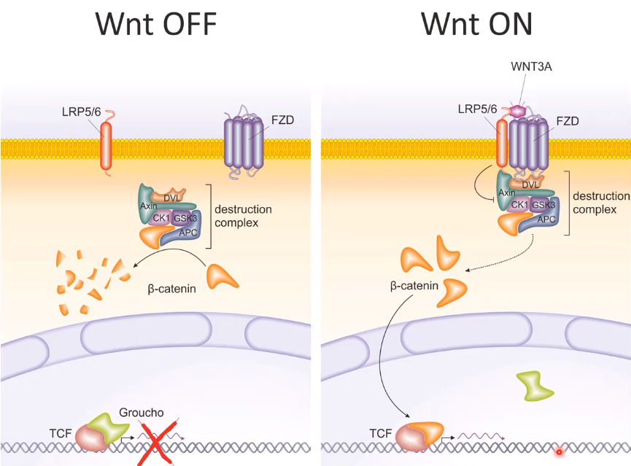
  - By attachment of lipid to the Wnt protein, it is either membrane bound, bound to Wls protein which is membrane bound or part of an exocytic vesicle
- Wnt protein binds to Frizzled (FZD) and LRP which transduce the signal.
- Normally, RNF43 or ZNRF3 ubiquinate active FZD which then gets endocytosed -> short Wnt signalling
- Rspondin can bind to Lgr’s which then binds RNF43 or ZNRF3 followed by endocytosis -> significantly longer Wnt signalling
  - Lgr’s as general stem cell marker
Consequences of TCF KO (no Wnt signalling) in intestine:
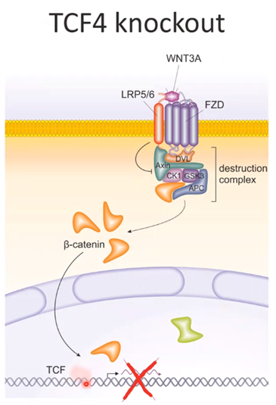
- At first, proliferation in crypts stop
- Crypts start to degenerate
- Epithelial function lost within a week

Consequences of APC mutation (constant Wnt) in intestine:
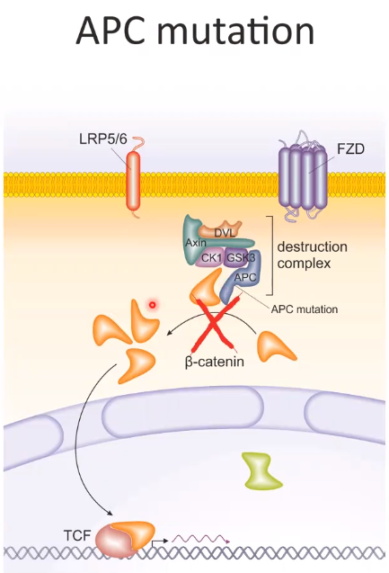
- increased cell proliferation
- induction of tumor growth

Notch signalling
Acts paracrine, Notch ligand (DLL1, DLL4, Jagged1) on one cell and Notch receptor (Notch extracellular domain (NECD) and Notch intracellular domain (NICD)) on the other
- The interaction causes mechanical tension which leads to proteases being able to cut the NICD which acts as a TF -> transcription of:
  - HES-1
    - inhibits p27KIP1 and p57KIP2 which are cell proliferation inhibitors
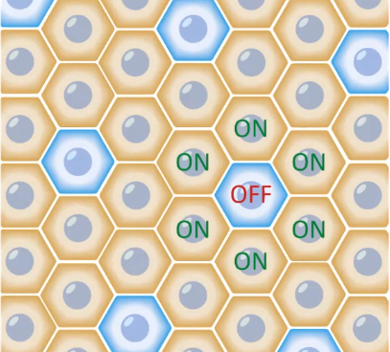
    - inhibits ATOH1 which would drive the expression of Notch ligands -> the cell with active Notch signalling will not produce Notch ligands to activate neighbouring cells -> stable ON:OFF ration of ~6:1
OFF = ligand expression -> no Notch signalling
ON = receptor expression -> Notch signalling
  - Myc
    - activates cell proliferation directly
  - BD-2
  - Cyclin D1
Consequences of Notch signalling blockage in intestine:
- Loss of stem cells
- Villi collapse
- All the cells are turning into secretory cells (goblet cells)
Liver
- Low homeostatic turnover
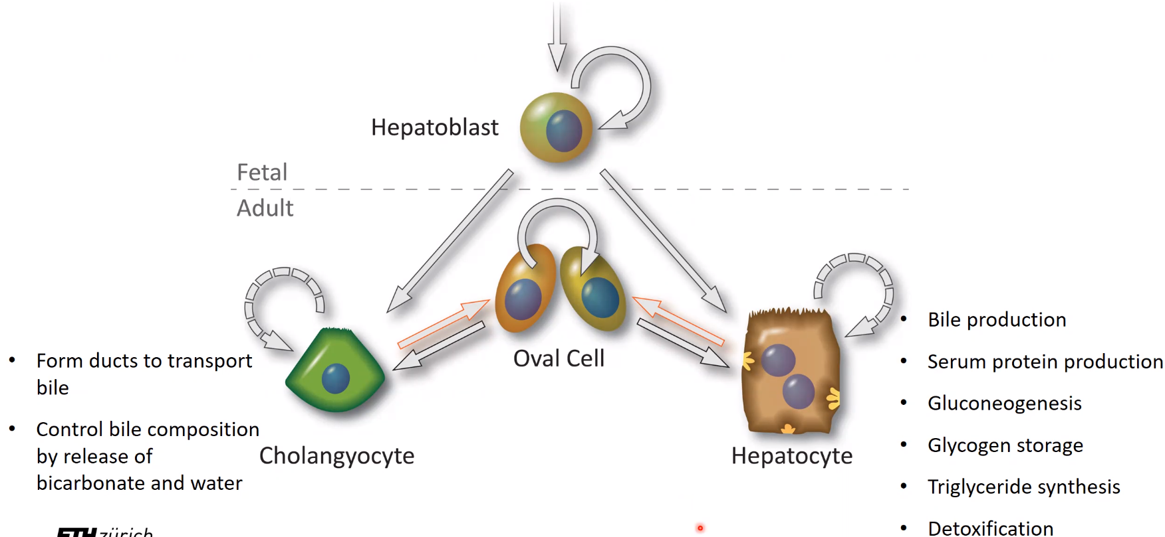
- If the liver is damaged, cholangyocytes and hepatocytes proliferate and regenerate the damaged tissue. They can even restore the others by de-differentiating into oval cells and then re-differentiation.
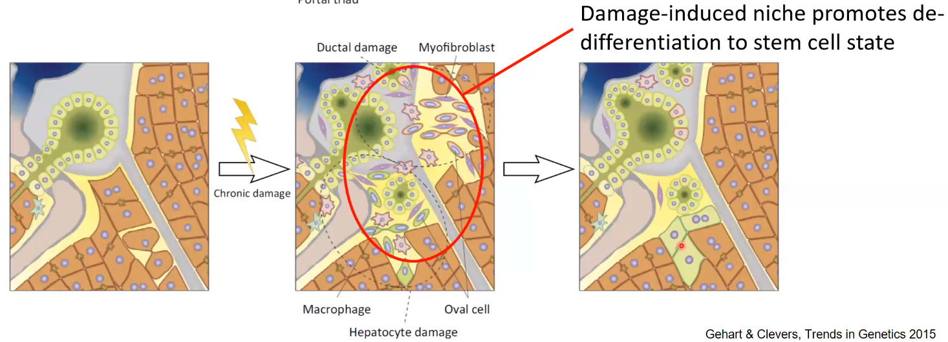

- Macrophages produce Wnt signals and myofibroblasts produce Jagged1.

How to identify stem cells
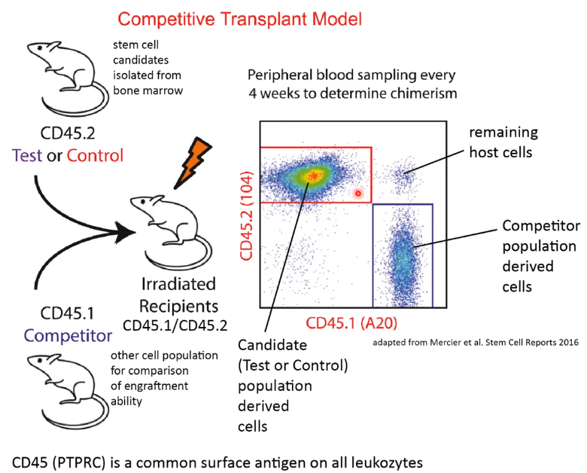
- CD45 slightly different in both donor mice (can be detected by specific antigen)
- Recipients hematopoietic stem cells get destroyed and CD45.1 (comparison) and CD45.2 (stem cell candidates) gets transplanted
- After some time, the relative content can be analysed
Quiescence check
Check for quiescence by adding radioactive nucleotides to the cells of interest (pulse phase). After the pulse, the signal will dilute with every cell division .If the cells are quiescent, the signal will be therefore slowly diluted (chase phase).
Lineage tracing
By the introduction of a heritable genomic market, all progeny can be visualised
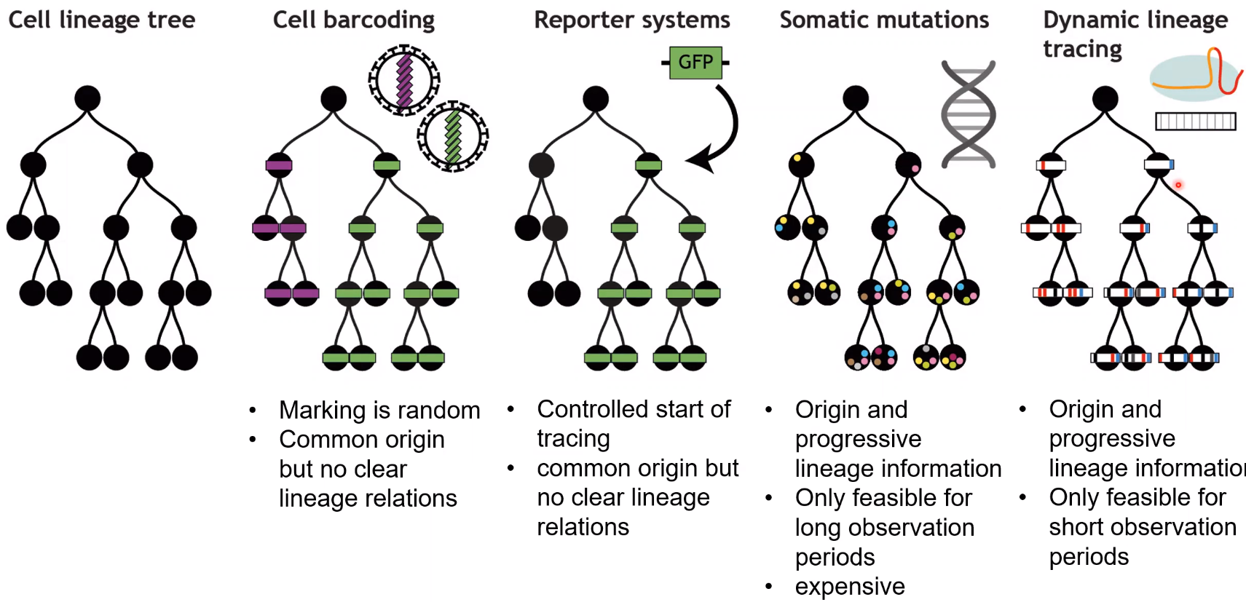
Barcoding:
- Done using viral vectors
Reporter system:
- Expression of certain label
Somatic mutations:
- Using naturally occurring mutations for lineage tracing via whole genome sequencing of every cell
Dynamic lineage tracing:
- Same principle as wit somatic mutations but the mutations are artificially generated using Crispr. Very high mutation rate makes it difficult for longer observations

- Can also be done with the Cre-LoxP system. Cre fused to ERT2 which only permits entrance into nucleus upon tamoxifen binding. Tamoxifen can be given to the animal and activate the recombination and in this case, activation of a cellular marker.
  - Brainbow mice. If made in intestine, first, there is a mess of colours. After some weeks, every crypt gets populated by one type of stem cell/colour (“survival of the fittest”, some stem cells get damaged and get replaced by healthier, replicative fitter stem cells (unless there is a mutation which increases replicative fitness) -> motion of healthy stem cell population)
Differentiation analysis
In vitro
- Needs in vitro stem cell culture and spontaneous or inducible differentiation
- Comparably easy to access and analyse
- Not sure if it resembles in vivo situation correctly
Single cell sequencing
- RNA analysis of many cells -> many transcriptomes which reflect the stages of differentiation -> pseudotime analysis tries to bring them into order
  - Requires a lot of data
  - Algorithms are not perfect
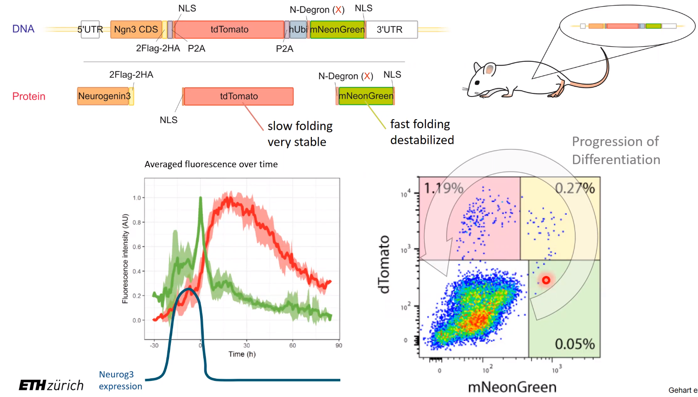
- How to study rare and highly diverse cell populations?
  - In course of differentiation, cells of interest normally express neurogenin3 but here also tdTomato and mNeonGreen
    - By measuring the light of a single cell, you can calculate back in time when the cell differentiated and by combining it with the data from the transcriptome analysis, you can make a differentiation diagram (lineage tree).
    - By looking at the transcriptome of cells at the branch points, you can identify potentially important TF’s and generate KO’s to investigate their phenotype.
  - What they found out in this study was that the intestinal epithelium is highly plastic. Differentiation, de-differentiation and trans-differentiation (one specialized cell directly into another)
    - BMP controls trans-differentiation meaning that as soon as the cells leave the crypt, they are likely to transdifferentiate

Organoids
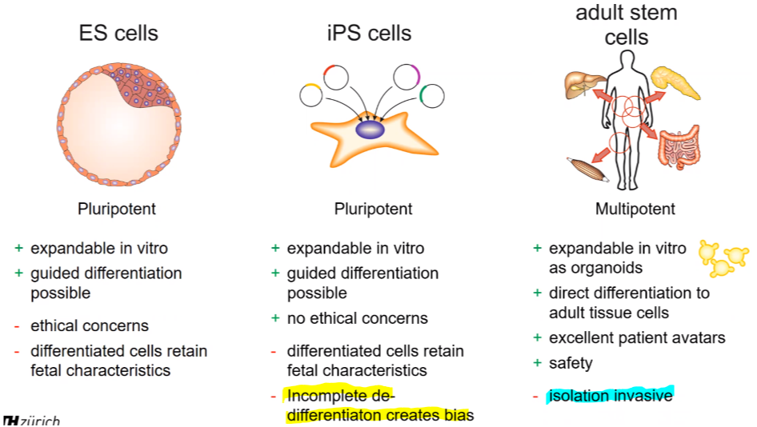
It’s possible that two iPS cells with different origins are still different even though they should be the same.
To get some e.g. liver stem cells, you have to get a piece of liver.
Organoids are miniaturized and simplified versions of organs produced in vitro (3D) that show realistic micro anatomy and function.
Intestine-organoid-generation:
- Remove stem cells from tissue
- Grow them in Matrigel (needs to resemble the mesenchymal signalling part, signalling Paneth cells will be generated from the stem cells)
  - Add EGF, BMP inhibitor, Rspondin
Mammary organoids:
- Organoid derived from basal progenitor cells can form basal and luminal cells
- Organoid derived from luminal progenitor cells form mostly luminal cells
  - Basal progenitors are more potent and can produce milk
Main applications of organoids:
- Disease modelling
  - Stem cells of a patient can be gathered (maybe with a genetic disorder), cultured and studied
  - Take colon organoids and add different bacteria to the media to gather information about their interaction
- Pharmacological screens
  - Cystic fibrosis caused by malfunction (many possible loss of function mutations) of the chloride channel CFTR
    - Organoids can be treated with several drugs and combinations to somewhat restore the WT phenotype -> personalized medicine
- Regenerative medicine
  - Transplantation of organoids to restore damaged organ (successful mouse trials)
- Cancer research
  - Organoids can also be derived from tumour stem cells (tumoroids)
    - Expensive, slow and difficult to upscale
  - Healthy stem cells can also be turned into tumoroids
    - inducing mutations and check for their importance

Kovacs
- Oxygen first generated as side product of photosynthesis. Later species evolved to use oxygen and glucose for their energy metabolism
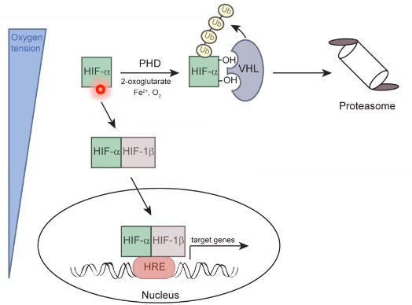
- Aerobe organisms have a higher number of metabolic reactions than anaerobic organisms (similar core pathways
Oxygen sensing
- Under normal oxygen conditions, HIF-α (hypoxia inducible factor, TF) gets degraded by the proteasome
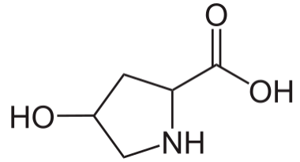
  - PHD (also called EGLN) hydroxylates two prolines (oxygen dependent) of α-subunit which can then be recognised by VHL (E3 ligase)
    - If you mutate these prolines there will be constant HIF-α signalling
- Hypoxia (low O₂ levels) lead to the activity of HIF-α
  - Composed of α-subunit (oxygen regulated) and β-subunit (HIF-1β). They bind to HRE (hypoxia response element) in nucleus and alter transcription
- HIF-α has three isoforms:
  - HIF-1α is more or less ubiquitous
  - HIF-2α is more cell specific and has an overlap in target genes with HIF-1α (bind core region (4 specific nucleotides) which is conserved and neighbouring nucleotides can vary)
  - HIF-3α is poorly understood
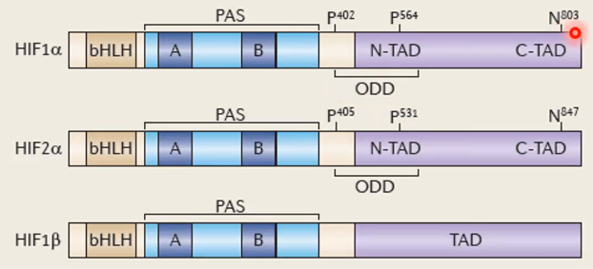
  - bHLH (basic helix-loop-helix) for DNA binding
  - PAS for dimerization
  - ODD (O₂-dependent degradation domain) with the two hydroxilatable prolines
  - Asparagine (N) at C-terminal domain can also be hydroxylated by FIH and prevents association with other transcriptional co-activators
- HIF-α signalling supports all hallmarks of cancer

- HIF-α can also be stabilised under non-hypoxic conditions by pseudohypoxia
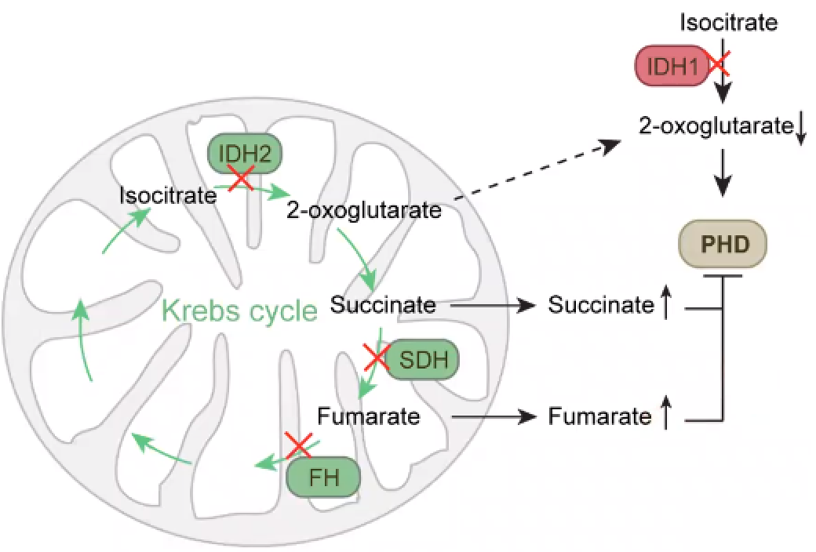

  - Loss of function mutation in SDH or FH can increase Succinate and/or Fumarate levels which inhibit PHD
  - Gain of function mutation in IDH1 and/or IDH2 lead to them producing 2-hydroxyglutarate (2HG)which leads to decreased levels of 2-oxoglutarate(α-ketoglutarate) which normally activates PHD
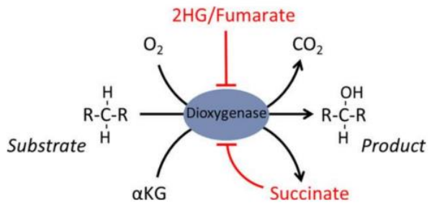
    - IDH inhibitors are approved drugs to treat certain cancers
- PHD and FIH are dioxygenases with are dependent on O₂, Fe²⁺, and 2-oxoglutarate (αKG) to hydroxylate target substrate
  - If you treat cells with iron chelators (bind Fe²⁺) you would inhibit PHD and FIH
  - Red metabolites also called onco-metabolites
  - 2HG also inhibits TET2 and KDM which are responsible for DNA (TET2) and histone (KDM) demethylation -> hypermethylation (stem cell-like state, methylation of tumorsuppressor genes)
  - 2HG has two forms:
    - R-2HG
    - S-2HG
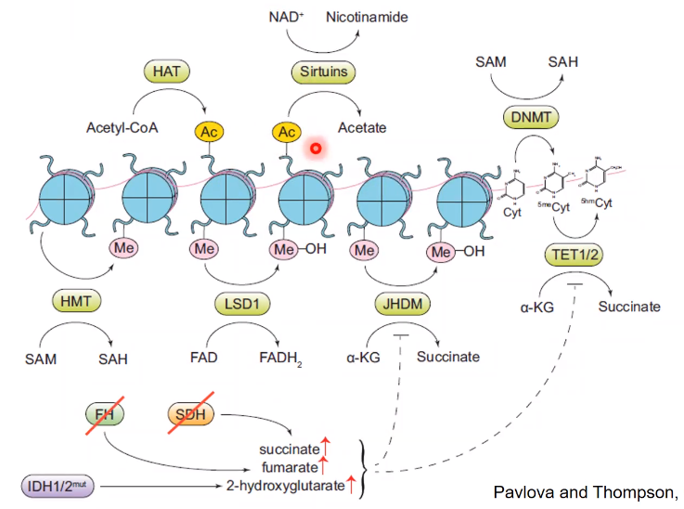
- HAT (histone acetyl transferase) acetylates histones -> better accessibility
- Sirtuins remove acetylation and need NAD⁺

- Liver has an oxygen gradient (from portal triad (high) to central vein (low)) which influences metabolism of the different regions
  - Reactions near the portal triad more dependent on oxygen
  - High fat or high sucrose diet causes hypoxia near the central vein
- Fast growing tumour will also experience hypoxia in its core and has to adapt by e.g. angiogenesis or autophagy
- Cancer cells will change their metabolism (more glucose uptake and anaerobic, lactate-producing fermentation (Warburg effect))

