Molecular Disease Mechanisms Summary
FS2021
By JM

I tried to summarize it as densely as I could by focusing on the parts that are relevant in my view. Therefore I don’t guarantee for completeness. I recommend watching the lectures, looking at the complete study material and using my summary afterwards. I’ll provide the summary as a word document so you can easily make adjustments if you want to.

The Kopf part was inspired by the summary provided by Carmen Joder. The Gahlon and Wolfrum part were mainly done from scratch.

To give you an impression of the exam, I gathered most of the exam questions with incomplete answers from the 2021 exam at the end of the document.

Best wishes :)

Short immune system summary
Granulocytes include basophils, eosinophils, and neutrophils. Basophils and eosinophils are important for host defense against parasites. They also are involved in allergic reactions. Neutrophils, the most numerous innate immune cell, patrol for problems by circulating in the bloodstream. They can phagocytose, or ingest, bacteria. Neutrophils accumulate within minutes at sites of local tissue injury. They then communicate with each other using lipid and other secreted mediators to form cellular "swarms." Their coordinated movement and exchange of signals then instructs macrophages and monocytes to surround the neutrophil cluster and form a tight wound seal.

Mast cells also are important for defense against parasites. Mast cells are found in tissues and can mediate allergic reactions by releasing inflammatory chemicals like histamine.

Monocytes, which develop into macrophages, are found in the bloodstream and in tissues. Macrophages are named for their ability to ingest and degrade bacteria. Upon activation, monocytes and macrophages coordinate an immune response by notifying other immune cells of the problem. Macrophages also have important non-immune functions, such as recycling dead cells, like red blood cells, and clearing away cellular debris. These "housekeeping" functions occur without activation of an immune response.

Dendritic cells (DC) are an important antigen-presenting cell (APC), and they also can develop from monocytes. Antigens are molecules from pathogens, host cells, and allergens that may be recognized by adaptive immune cells. APCs like DCs are responsible for processing large molecules into "readable" fragments (antigens) recognized by adaptive B or T cells. However, antigens alone cannot activate T cells. They must be presented with the appropriate major histocompatiblity complex (MHC) expressed on the APC. MHC provides a checkpoint and helps immune cells distinguish between host and foreign cells.

Natural killer (NK) cells have features of both innate and adaptive immunity. They are important for recognizing and killing virus-infected cells or tumor cells. They contain intracellular compartments called granules, which are filled with proteins that can form holes in the target cell and also cause apoptosis. It is important to distinguish between apoptosis and other forms of cell death like necrosis. Apoptosis, unlike necrosis, does not release danger signals that can lead to greater immune activation and inflammation.

Through apoptosis, immune cells can discreetly remove infected cells and limit bystander damage.

B cells have two major functions: They present antigens to T cells, and more importantly, they produce antibodies to neutralize infectious microbes. Antibodies coat the surface of a pathogen and serve three major roles: neutralization, opsonization, and complement activation. Neutralization occurs when the pathogen, because it is covered in antibodies, is unable to bind and infect host cells. In opsonization, an antibody-bound pathogen serves as a red flag to alert immune cells like neutrophils and macrophages, to engulf and digest the pathogen. Complement is a process for directly destroying, or lysing, bacteria.

Antibodies are expressed in two ways. The B-cell receptor (BCR), which sits on the surface of a B cell, is actually an antibody. B cells also secrete antibodies to diffuse and bind to pathogens. The activated B cell responds by proliferating and secreting antibodies (it is then called a plasma cell), essentially the BCR but in soluble form.

Every antibody is unique, but they fall under general categories: IgM, IgD, IgG, IgA, and IgE. (Ig is short for immunoglobulin, which is another word for antibody.) While they have overlapping roles, IgM generally is important for complement activation; IgD is involved in activating basophils; IgG is important for neutralization, opsonization, and complement activation; IgA is essential for neutralization in the gastrointestinal tract; and IgE is necessary for activating mast cells in parasitic and allergic responses.

T cells have a variety of roles and are classified by subsets. T cells are divided into two broad categories: CD8+ T cells or CD4+ T cells, based on which protein is present on the cell's surface. T cells carry out multiple functions, including killing infected cells and activating or recruiting other immune cells.

CD8+ T cells also are called cytotoxic T cells or cytotoxic lymphocytes (CTLs). They are crucial for recognizing and removing virus-infected cells and cancer cells. CTLs have specialized compartments, or granules, containing cytotoxins that cause apoptosis, i.e., programmed cell death. Because of its potency, the release of granules is tightly regulated by the immune system.

The four major CD4+ T-cell subsets are TH1, TH2, TH17, and Treg, with "TH" referring to "T helper cell." TH1 cells are critical for coordinating immune responses against intracellular microbes, especially bacteria. They produce and secrete molecules that alert and activate other immune cells, like bacteria-ingesting macrophages.

TH2 cells are important for coordinating immune responses against extracellular pathogens (parasites), by alerting B cells, granulocytes, and mast cells. TH17 cells are named for their ability to produce interleukin 17 (IL-17), a signaling molecule that activates immune and non-immune cells. TH17 cells are important for recruiting neutrophils. Regulatory T cells (Tregs), as the name suggests, monitor and inhibit the activity of other T cells. They prevent adverse immune activation and maintain tolerance, or the prevention of immune responses against the body's own cells and antigens.

Cytokines are small proteins with diverse functions. In immunity, there are several categories of cytokines important for immune cell growth, activation, and function.
Interleukins, which come in over 30 varieties, provide context-specific instructions, with activating or inhibitory responses. Chemokines are made in specific locations of the body or at a site of infection to attract immune cells. Different chemokines will recruit different immune cells to the site needed. The tumor necrosis factor (TNF) family of cytokines stimulates immune-cell proliferation and activation. They are critical for activating inflammatory responses. TNF blockers are used to treat a variety of disorders, including some autoimmune diseases.
Toll-like receptors (TLRs) are expressed on innate immune cells, like macrophages and dendritic cells. They are located on the cell surface or in intracellular compartments (NOD receptors) because microbes may be found in the body or inside infected cells. TLRs recognize general microbial patterns, and they are essential for innate immune-cell activation and inflammatory responses.
B-cell receptors (BCRs) and T-cell receptors (TCRs) are expressed on adaptive immune cells. They are both found on the cell surface, but BCRs also are secreted as antibodies to neutralize pathogens. The genes for BCRs and TCRs are randomly rearranged at specific cell-maturation stages, resulting in unique receptors that may potentially recognize anything. Random generation of receptors allows the immune system to respond to unforeseen problems. They also explain why memory B or T cells are highly specific and, upon re-encountering their specific pathogen, can immediately induce a neutralizing immune response.

Major histocompatibility complex (MHC), or human leukocyte antigen (HLA), proteins serve two general roles. MHC proteins function as carriers to present antigens on cell surfaces. MHC class I proteins are essential for presenting viral antigens and are expressed by nearly all cell types, except red blood cells. Any cell infected by a virus has the ability to signal the problem through MHC class I proteins. In response, CD8+ T cells (also called CTLs) will recognize and kill infected cells. MHC class II proteins are generally only expressed by antigen-presenting cells like dendritic cells and macrophages. MHC class II proteins are important for presenting antigens to CD4+ T cells.

MHC proteins also signal whether a cell is a host cell or a foreign cell. They are very diverse, and every person has a unique set of MHC proteins inherited. As such, there are similarities in MHC proteins between family members. Immune cells use MHC to determine whether or not a cell is friendly. In organ transplantation, the MHC proteins of donors and recipients are matched to lower the risk of transplant rejection.

Differentiation steps are regulated by transcription factors responding to signals from the environment
Production of ≈ 10¹¹ cells every day (same death-rate)

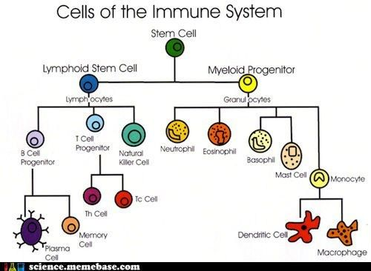
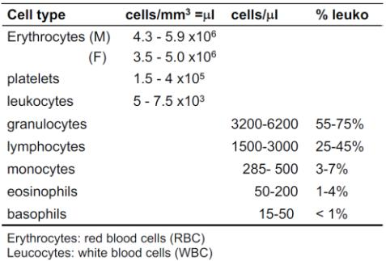

Memory” turned out to be a product of epigenetic changes that last -> changes take place in precursor cells, which can be passed on to daughter cells
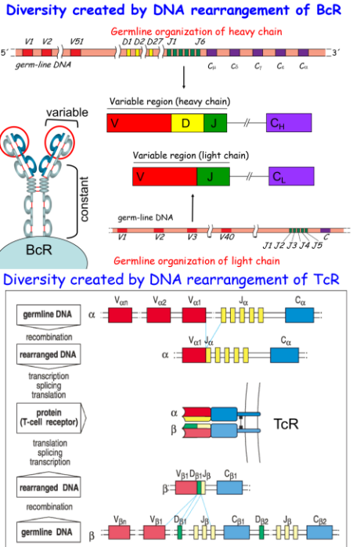

V=variable, D=diversity, J=joining
Huge diversity from rearrangement(polygeny) and being heterozygous (polymorphism).

- T and B cells recognize discrete sites on the antigen: antigenic determinants or epitopes (Epitopes are the immunologically active regions in an antigen)
- T cells recognize processed antigens (peptides of processed proteins) presented by self MHC molecules

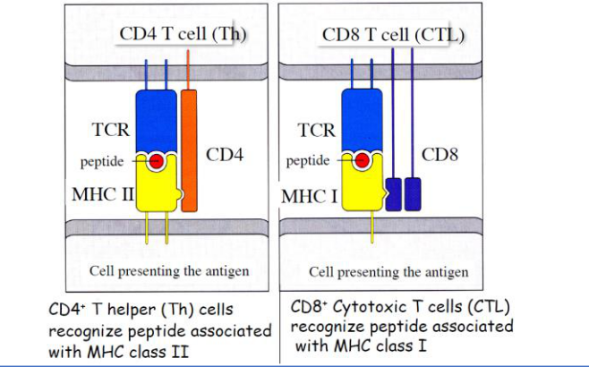
- B cells recognize epitope of tertiary structure of a protein

MHC II presents small peptides ~12-25aa
MHC I presents small peptides ~8-10aa
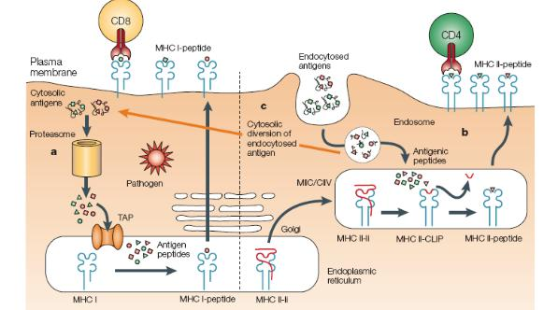

- There are separate antigen-presenting pathways for endogenous (are generated within a cell by normal metabolism or e.g. caused by a viral or intracellular bacterial infection) and exogenous (enter the body from the outside, are taken up by APCs) antigens:
- Intracellular proteins are processed in the ER and

transported to the MHC I structures via the Golgi

  - External proteins are cleaved in the lysosome and endosome, from where they are brought to the MHC II structure

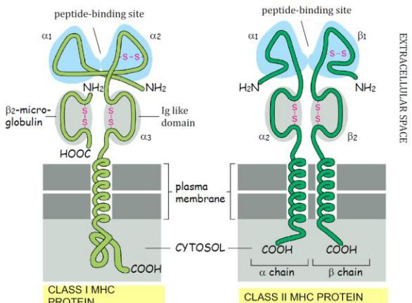
- Cross-presentation (orange arrow): Ability of certain antigen-presenting cells to take up, process and present extracellular antigens with MHC class I molecules to CD8 T cells (cytotoxic T cells)

Diversity of MHCs
- Exists at the level of the species → not within an
individual!

- The diversity is created in the population, we inherit the genes from our parents (while the T and B cell

receptors diversity is generated in the individual)

  - The chance that two people have the same combination of MHC genes is unlikely (5-10%).

- Arises from polymorphism and polygeny
- MHC molecules are highly polymorphic and have many variants
- There are 3 genes for MHC I
- There are 3 genes for MHC II for alpha and beta
chains each → total of 6
- There exist many variant alleles at class I and II loci
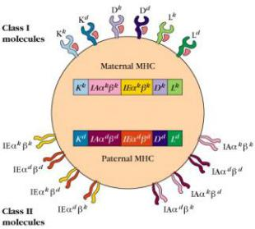

Advantages: The more different the MHC genes of the parents, the better are the children protected from infectious disease → A broad spectrum of MHC genes provides greater chance to recognize diverse pathogen structures, which results in enhanced resistance
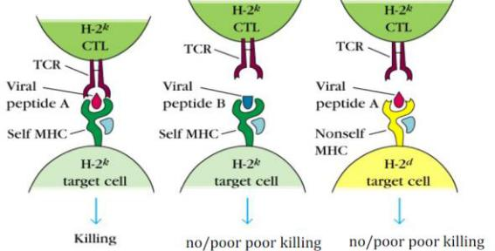

T-cells only recognise self MHC with foreign antigen. Self MHC restriction in thymus. A particular TCR is specific for both, antigenic peptide and self MHC

T CELL DEVELOPMENT IN THE THYMUS

- Immature T-cell precursors from bone marrow enter
- 96% of the cells die in the thymus because they either do not recognize self MHC (first test) or recognize self-proteins (second test, negative selection)
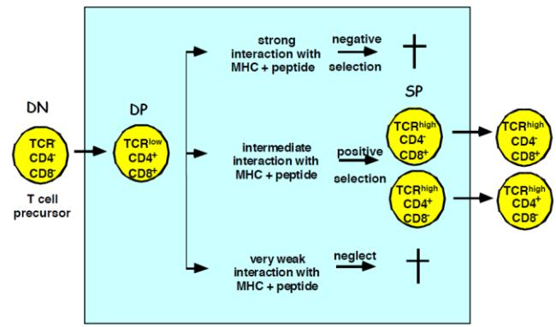
  - T cells die by apoptosis without inducing inflammation → macrophages phagocytose apoptotic thymocytes

- There exists a population of cells (medullary epithelial cells, MEC) in a specific lobe within the thymus that expresses a plethora of tissue specific antigens represented in the body

- AIRE (autoimmune regulator) Transcription Factor is a "master" regulator of ectopic (out of place) expression of peripheral tissue-restricted antigens in stromal cells of the thymic medulla which enables MEC’s to mimic other tissue.

Carmen Joder - 2019

TWO SIGNAL MODEL FOR T CELL ACTIVATION
- Two signals are required for T-cell activation
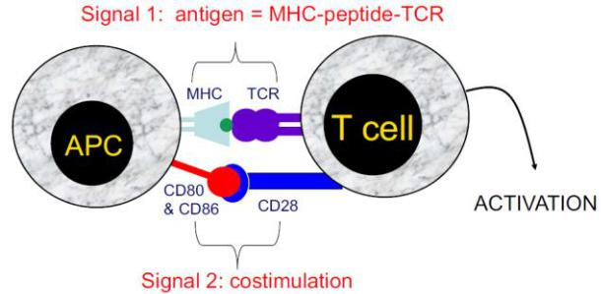

- Costimulatory molecules are expressed by most APC including dendritic cells, monocytes, macrophages, B cells etc. but not by cells that have no immunoregulatory functions such as muscle, nerves, hepatocytes, epithelial cells etc.

The T-Cell Growth Factor IL-2

- Resting T-cells express receptor IL-2R and chains but no α chain or IL-2

- Upon antigen encounter, the transcription factor NFAT binds to the promoter of IL-2R chain gene → α chain converts the low affinity IL-2R to a high affinity form
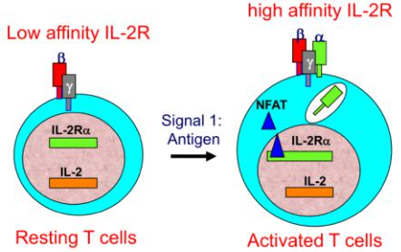

-

T-CELL ACTIVATION AND PROLIFERATION

- CD4+ and CD8+ T cells leave thymus and enter circulation. They are in a resting (G0 of cell cycle)

- Naive cells recirculate between blood and lymph system every 12-24h

- 90-95% of peripheral T cells express αβ-TCR (remaining are T cells)
- CD4:CD8 T cell ratio in lymphoid organs ≈ 2: 1

- Activation of naive T cell results in primary response: After 24 hours, initiation of repeated rounds of cell division and differentiation into:

- Effector cells: cytokine producers (CD4, helper cells),

cytotoxic killers (CD8, cytotoxic killers)

- Memory cells – long lived, respond faster and with heightened activity in a secondary response

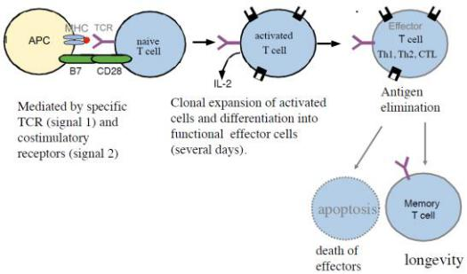
The CD28 Family

- CD28 is a family of co-stimulatory molecules for the interaction between T cells and APCs

- CD28 and ICOS provide positive signals o CTLA-4 and PD-1 provide negative signals (good for cancer cells because they can inhibit immune response)
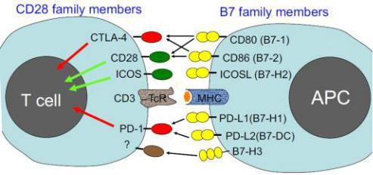

The TNF (Tumor Necrosis Family) Receptor and Ligand Superfamily (CD40)

- Members of the TNF receptor and ligand superfamily are also essential for crosstalk between APCs and T-cells

- CD40 is important in the interaction of B-cells and T helper cells (abbreviated as Th or Tfh) → Th cells express CD40L after activation and co-stimulate B cells by triggering of CD40:
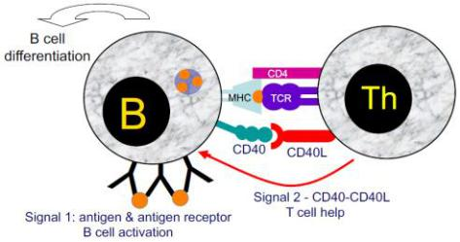

5

CD4+ TH-DEPENDENT B-CELL RESPONSES
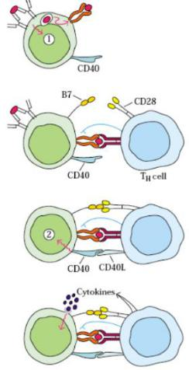

- B-cell activation by antigen mediated crosslinking of the B Cell Receptor → results in upregulation of MHC II and B7 molecules (CD80/CD86)
- Antigen presentation to T-cell

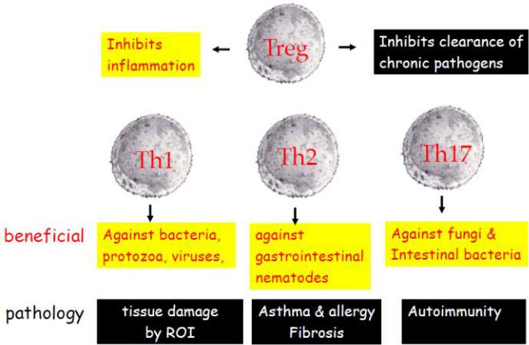
- T-cell activation, upregulation of CD40L, production of cytokines

- CD40 and cytokine-mediated activation of the B cell

- Once the B-cell has been activated, there are growth factors which allow upregulation of certain receptors on the surface - sort of positive feedback loop

- These signals (e.g. T-cell cytokines) help the cells to decide on which constant region in the Igs (e.g. IgG, IgA, IgE) should be produced → isotype switch (involves somatic hypermutation)

- The type of Igs also determines the function / role of the B-cells
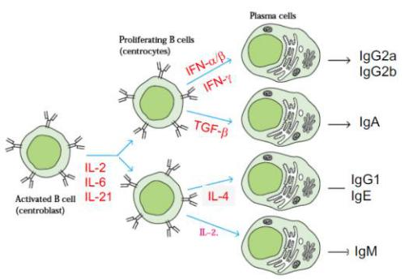

- Th cells promote survival of CD8 memory T cells
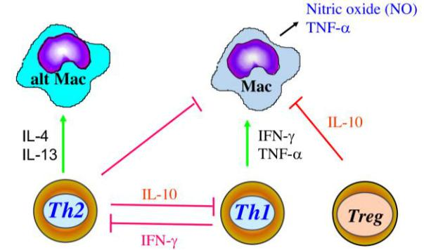
TH1 cells provide protection against intracellular microorganisms. They mainly produce IFNy to activate macrophages, which are characterised by their production of NO which damages the microorganisms.

IL-10 is an immunosuppressor.

Th2 Cells are against nematodes (worms). They mainly produce IL-4 and IL-13 (they have some overlap in their functions -> redundancy). IL-4 and IL-13 activate alternative macrophages for tissue repair and IL-13 activates Goblet cells which secrete protective mucus in the lungs and intestines.

Th17 cells are against fungal and bacterial infections. Via IL-17a, the recruit mainly neutrophils.

Th Cells also have the potential to harm the organism.

Autoimmunity
Central tolerance: Elimination of self-reactive T- and B-Cells in thymus. Not 100% exclusive because
- not all peripheral tissue antigens can be expressed in the thymus
- positive selection of Cells that show low self-reactivity but might have high pathogenic-reactivity
Therefore another level of control is added, Peripheral Tolerance, which consists of
- Regulatory T cells (Treg)

Treg
Express the TF FOXP3
Inhibit proliferation and cytokine production of other T-cells (CD8 and CD4) via
- Anti-inflammatory cytokines(TGF-β, IL-10)
- Killing of target T-cell via receptors (CTLA4, PD-1, death receptors)
- Inhibition of differentiation of DC’s into T-cells

Autoimmunity
Chronic inflammatory disease resulting from the breakdown of tolerance. Can be caused by (mostly multiple causes)
- molecular mimicry of pathogens (antigen of microorganism might have similarities to a self-antigen)
- the self-antigens might be mutated
- release of antigens from immunoprivileged sites (eye, testis, placenta, … (tissue where non-self is tolerated))
Autoimmune diseases are only due to adaptive immune system (T- and B-cells). Innate immune system doesn’t attack self.

Autoimmunity Therapy Approaches
- Anti-inflammatory and immunosuppressive reagents
- Antibodies against TNFα, IL-6, IL-1

Allergies and Asthma
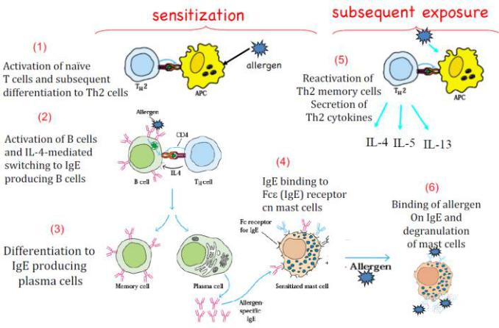
Hypersensitive reaction towards harmless antigen (allergen). Mediated via IgE (antibody attracting mast cells).
Mast cells release e.g. histamine which is responsible for oedema(highly permeable blood vessels which leads to watery swellings), itching and smooth muscle contractions. Can also lead to anaphylactic shocks (vascular collapse and cardiac failure).
Late phase allergic reactions can also be caused by the attraction of neutrophils and eosinophils.
Asthma
The lung filters around 8500 litres of air every day and gets exposed to a variety of solid and liquid particles, allergens and microbes.
Using little coordinated cilia (destroyed by tobacco consumption)on the surface of the respiratory tract, debris (mucus and pathogens) can be moved upwards and out of the lung into the bronchial tubes where it can trigger the cough reflex which is designed to expel the debris from the respiratory tract.
DC’s can reach through the epithelial layer of the respiratory system and reach for antigens.
Asthma is a term for many heterogenous phenotypes and can be triggered by various factors like allergens, exercise, hormones, air pollution, stress, etc.
Two major hallmarks of asthma are:
- Hyperactive goblet cells (also high Th2, IL-4 and IL-13 deficient mice seem to do well)
- Chronic airway inflammation (mainly eosinophils)
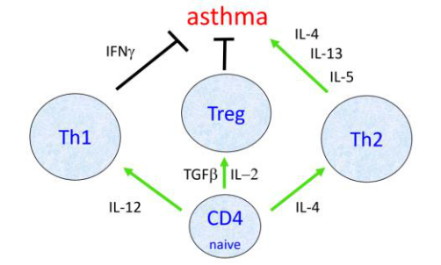
Asthma has a heritability of up to 75% and is most likely influenced by few genes with moderate effect.

Intestinal Immunology and Inflammation
MALT: Mucus-associated lymphoid tissue (are particularly vulnerable, mucus is a counter to the potential threat of many pathogens) Subcategories:
- NALT: Nasal associated “
- BALT: Bronchial “
- GALT: Gut “
THE GUT ECOSYSTEM
100 Trillion (10¹⁴) bacteria
500-1000 species

Dominated by just 2 (out of > 30) phyla of bacteria (i.e Bacteroides and Firmicutes) and one member of Archaea (i.e. Methanobrevibacter)
Most are uncultivatable
characterised by 16S RNA sequencing
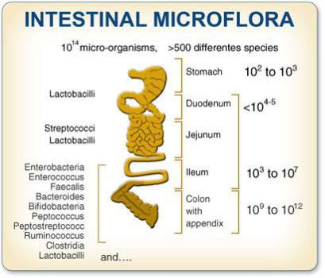
Mucus layer thickness α #bacteria (more ignorance than tolerance because ideally contact between the organism and the gut bacteria is prevented by the mucus. However, it has to allow for nutrient uptake.)
Mucus mostly glycosylated proteins that hinder microbial movement towards epithelial layer

Obesity can be majorly influenced by a gut microbe disbalance (more Firmicutes than Bacteroides).
Gut microbiota was transplanted from obese mice in germ-free mice, subsequent increase in body fat without change of diet -> Composition of microbiota affects the amount of energy extracted from the diet.
Oral tolerance: Oral admission of the antigen. Enters the bloodstream & lymphoid organs -> activates the adaptive immune system
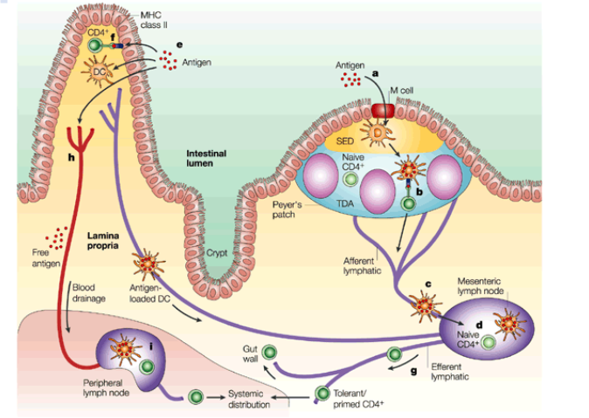
Antigen Entry into GALT
Left: systemic immune system, Right: intestinal “
a) Antigen might enter through the M cells in the follicle-associated epithelium (FAE)
b) After transfer to local DCs, the antigen might then be presented directly to T cells in the Peyer's patch
c) Alternatively, antigen or antigen-loaded DCs from the Peyer's patch might gain access to draining lymph
d) T-cell recognition in the mesenteric lymph nodes (MLN)
e) A similar process of antigen or antigen-presenting cell (APC) dissemination to MLNs might occur if antigen enters through the epithelium covering the villus lamina propria
f) In this case, there is the further possibility that MHC class II positive enterocytes might act as local APCs. In all cases, the antigen-responsive CD4+ T cells acquire expression of the 4 7 integrin and the chemokine receptor CCR9, leave the MLN in the efferent lymph.
g) After entering the bloodstream through the thoracic duct, exit into the mucosa through vessels in the lamina propria. T cells which have recognized antigen first in the MLN might also disseminate from the bloodstream throughout the peripheral immune system.
h) Antigen might also gain direct access to the bloodstream from the gut
i) Interaction of the antigen with T cells in peripheral lymphoid tissues

Peyer’s Patch
- Overlaid by follicle-associated epithelium (FAE, composed of enterocytes and M cells)
- Few goblet cells -> thin mucus -> direct contact to gut lumen
Intestinal epithelial cell types
 | Cell Type |  | Function
 | Enterocytes | → | Absorption of nutrients
 | Goblet cells | → | Mucus production
 | Paneth cells | → | Production of anti-
 |  |  | microbial compounds
 | Microfold (M) cells | → | Antigen uptake
 | Tuft cells | → | Pathogen sensing
 | Enteroendocrine cells | → | Hormone production

M cells:
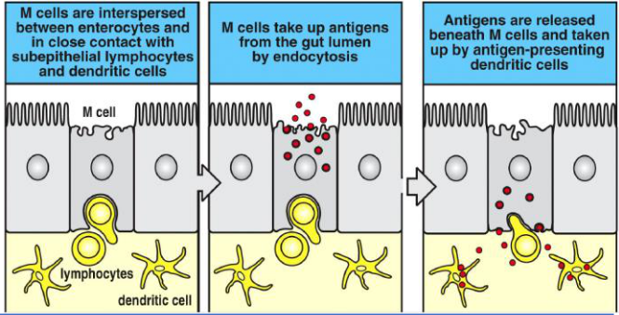
T- and B-cells without any specific target express α4β1 (extracellular, membrane bound binding protein) which binds to VCAM (Vesicular Cell Adhesion Molecule).
T- and B-cells targeting the intestines express α4β7 which binds to MAdCAM (Mucosal vascular Adressin Cell Adhesion Molecule) on mucosa endothelia cells. They also express CCR9 and CCR10 (chemokine receptors) which lead to the recruitment by CCL25 and CCL28 (chemokines) which are expressed by intestinal epithelial cells. CCR9+ cells migrate to the GALT whereas CCR9- cells migrate towards the peripheral lymph nodes.
Vitamin A deficient diet leads to impaired migration of lymphocytes to intestinal mucosa because Retinoic Acid (RA, metabolite of Vitamin A) is a driving factor of α4β7 and CCR9 expression and also induces differentiation of CD4+ cells into Treg’s which are anti-inflammatory.

Summary:
The intestine has developed specialized and separate immune responses due to the ubiquitous presence of intestinal bacteria
We cope with food antigens by inducing systemic tolerance
We cope with intestinal bacteria by systemic ignorance and the induction of protective but local non-inflammatory responses
The gut creates a special microenvironment that 'imprints' T and B cells with a non-inflammatory phenotype
Mounting an inappropriate immune response against intestinal bacteria leads to inflammatory bowel disease (IBD)

Canonical NF-κB Pathway
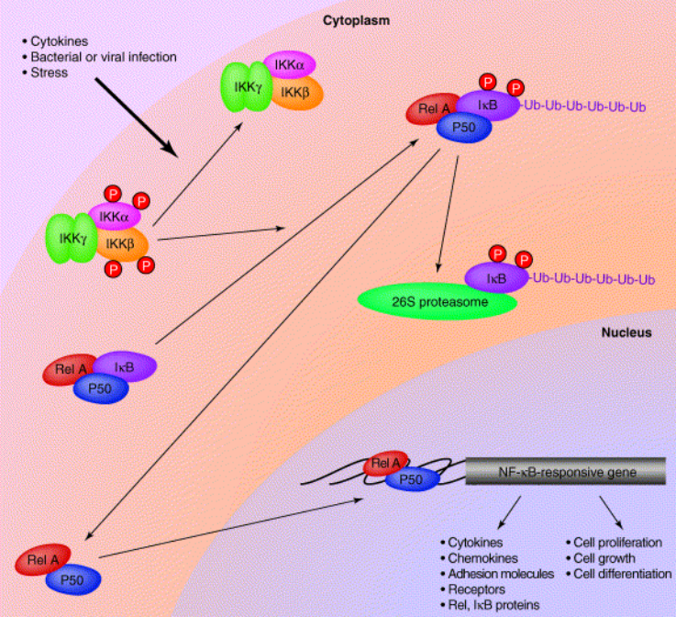
NF-kB (complex) is normally bound to inhibitory IkB. Upon activation of IKK complex, IkB gets phosphorylated and subsequently degraded by the 26S proteasome. NF-kB is released and can enter the nucleus and promote the expression of pro-inflammatory, anti-apoptotic and cytokine production genes (TNFα, Pro-IL-1β, Pro-IL-1α)

Bacterial Lipopolysaccharide (LPS) has major negative effects at low concentrations. Binds indirectly via CD14 to Toll-like receptor 4 (TLR4) which activates through a cascade IKK.

TNFα (tumor necrose factor) can bind to TNFR which also canonically activates IKK.
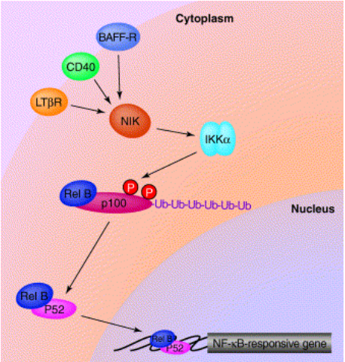
Non-canonical NF-κB Pathway
The noncanonical nuclear factor-κB (NF-κB) signaling pathway mediates activation of the p52/RelB NF-κB complex and, thereby, regulates specific immunological processes. This NF-κB pathway relies on the inducible processing of NF-κB2 precursor protein, p100, as opposed to the degradation of IκBα in the canonical NF-κB pathway. A central signaling component of the noncanonical NF-κB pathway is NF-κB-inducing kinase (NIK), which functions together with a downstream kinase, inhibitor of NF-κB kinase α (IKKα), to induce phosphorylation-dependent ubiquitination and processing of p100. Under normal conditions, NIK is targeted for continuous degradation by a tumor necrosis factor (TNF) receptor-associated factor-3 (TRAF3)-dependent E3 ubiquitin ligase. In response to signals mediated by a subset of TNF receptor superfamily members, NIK becomes stabilized as a result of TRAF3 degradation, leading to the activation of noncanonical NF-κB.
Pattern Recognition Receptors (PRR’s)
Recognise PAMP’s (Pathogen-associated molecular patterns)
Subtypes:
- Membrane bound PRR’s (also in endosome)
  - Toll-like receptors (TLR’s)
  - C-type lectin receptors
  - Scavenger receptors
- Cytoplasmic PRR’s
  - Nucleotide-binding oligomerisation domain-like receptors (NOD)
  - Leucine rich Repeat and Pyrin Receptors (NOD subfamily, NLRP’s or also called NALP’s)
- Secreted PRR’s
  - Collectins
  - Pentraxins

Toll-like receptors (TLR’s)
Can bind a variety of PAMP’s and also endogenous danger molecules.
Bacteria:
- Bacterial cell wall components
- LPS
- Flagellin
- Genome
Viruses:
- dsRNA
- ssRNA
- CpG DNA (several CG repeats which act as a PAMP)
Almost always activates the canonical NF-κB Pathway.
TLR’s are always facing to the extracellular, also in the endosome. Therefore the pathogens want to enter the cytosol to be “hidden”. Answer -> NOD-like receptors (NLR’s)

NOD-like receptors (NLR’s)
Structurally similar to TLR’s. Composed of an LRR domain (ligand recognition), self-oligomerisation domain (NOD domain, also called NACHT) and a CARD (Caspase recruitment domain) or a pyrin domain.

NOD1 and NOD2
Recognise bacterial peptidoglycans in the cytosol. NOD1 mainly gram negative peptidoglycan. NOD2 recognises almost every kind of peptidoglycan. They both activate through a cascade the NF-κB Pathway using their CARD domains.

NLRP3
Is a component of the inflammasome and has a pyrin domain.
Can lead to pyrosis of the cell (release of pro-inflammatory cytokines, swelling and bursting of the cell). Inflammasome highly active in Alzheimer’s disease.
NLRP3 can be activated by various sources:
- PAMP’s
- DAMP’s (damage associated molecular patterns, e.g. uric acid. Can lead to Gout which is a severe form of Arthritis)
- Cathepsin B (released upon lysosome rupture)
- Mitochondrial DNA indicating mitochondrial damage
- ROS (low intracellular K+ triggers ROS generation)
Single NLRs are expressed in an auto-repressed, inactive form → NACHT-mediated oligomerization is blocked and thus inhibiting NLR auto-activation
Binding of ligands → LRRs undergo conformational change that allows NACHT-mediated oligomerization and inflammasome assembly
Upon inflammasome assembly, Pro-Caspase1 is activated (now called Caspase 1) which cleaves Pro-IL-1β (inactive form of IL-1β) to IL-1β (same with Pro-IL-1α) which can then be released by the cell.
Interleukin 1
Name for IL-1α and IL-1β (pro-inflammatory cytokines) which are mainly produced by DC’s and macrophages.
Main functions:
- Defend against bacterial infection
- Upregulate adhesion molecules on endothelial cells allowing transmigration of leucocytes
- Production of more IL-1β and βα
- Bone formation and remodelling
- Fever induction (acts as a pyrogen)

Signals
 | Produced by | Effects
IFNγ | Th1 | - Activate macrophages  - Inhibits Th2
IL-1 | DC’s and macrophages | - Pro-inflammatory  - Defend against bacterial infections  - Upregulate adhesion molecules on endothelial cells allowing transmigration of leucocytes  - Production of more IL-1β and TNFα  - Bone formation and remodelling  - Fever induction (acts as a pyrogen)
IL-2 | Th1, Th2 | - Upon antigen encounter autocrine activation of Th cells  - Activates proliferation of B cells  - Promotes CD4 naive cell differentiation into Treg
IL-4 | Th2 | - Activates alternative macrophages for tissue repair  - Promotes B cell differentiation into IgE plasma cell  - Promotes CD4 naive cell differentiation intoTh2
IL-6 | macrophages | - Activates B cell proliferation  - Antagonistic to Treg’s
IL-10 | Treg, Th2 | - Immunosuppressor which inhibits macrophage activity  - Inhibits Th1 activity  - Can block the NF-κB pathway
IL-12 | DC’s, macrophages, neutrophils | - Promotes CD4 naive cell differentiation into Th1
IL-13 | Th2 | - Activates alternative macrophages for tissue repair  - Stimulates goblet cells for mucus production in lungs and intestine
IL-17 | Th17 | - Pro-inflammatory  - Recruit neutrophils
TGFβ | Treg | - Promotes CD4 naive cell differentiation Treg  - Anti-inflammatory -> inhibits macrophages  - Inhibits B cell activity
TNFα | macrophages | - Pro-inflammatory  - Can activate canonical NF-κB Pathway

Other important things
 | Functions
AIRE (autoimmune regulator) | Transcription Factor, which is a "master" regulator of ectopic (out of place) expression of peripheral tissue-restricted antigens in stromal cells of the thymic medulla which enables MEC’s (medullar epithelial cells) to mimic other tissue
CD28 and B7(CD80or CD86) | CD28 on surface of T cells, binds CD80 or CD86 from APC’s which acts as an activating co-stimulation
CD40 and CD40L | CD40 on surface of B cells, binds CD40L from Th cells which acts as an activating co-stimulation
CTLA4 and CD80/CD86 | CTLA4 on surface of T cells, binds CD80 or CD86 from APC’s which acts as an inhibiting co-stimulation
FoxP3 | Treg-specific TF
GATA3 | Is essential for development of Th2 cells
ICOS and ICOSL | ICOS on surface of T cells, binds ICOSL from APC’s which acts as an activating co-stimulation
LPS | Bacterial lipopolysaccharide
NFAT | (nuclear factor of activated T cells) activates IL-2R transcription in T cells
PD-1 and PD-L1/PD-L2 | PD-1 on surface of T cells, binds PD-L1 or PD-L2 from APC’s which acts as an inhibiting co-stimulation
RORyt | Is essential for development of Th17 cells
STAT1 | (signal transducer and activator of transcription) Is essential for development of Th1 cells
STAT3 | Is essential for development of Th17 cells
STAT4 | Is essential for development of Th1 cells
STAT6 | Is essential for development of Th2 cells
Tbet | Is essential for development of Th1 cells
TLR4 | (Toll-like receptor 4) on macrophages and all types of granulocytes, binds LPS and activates the canonical NF-κB Pathway

Cancer
Dysregulation in cell growth.
Four main cancer types dependant on their tissue of origin:
- Carcinoma (Epithelial tissue)
- Sarcoma (Connective tissue e.g. bones, muscle, fat, …)
- Leukaemia (Blood cells)
- Lymphoma (lymphatic tissue)

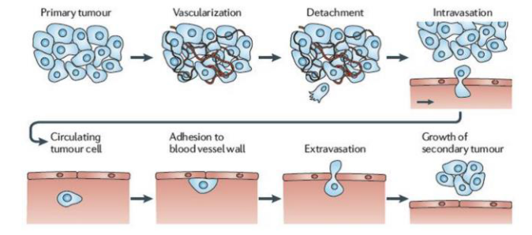
Metastasis:

Risk factors
- Hepatitis
- Papilloma virus (HPV)
- High body mass index
- Low fruit and vegetable intake
- Lack of physical activity
- Tobacco and alcohol use
- Sunlight
- Radiation

Hallmarks of cancer
- Sustaining proliferative signalling
- Evading growth suppressors
- Activating invasion and metastasis
- Enabling replicative immortality
- Inducing angiogenesis
- Resisting cell death
- Deregulating cellular energetics
- Avoiding immune destruction

1.Sustaining proliferative signalling
- Self-production of growth factors (e.g. HGF)
- Self-production of cognate receptors
- Somatic mutations that activate signalling circuits
- Defects in negative feedback loops (e.g. Ras)
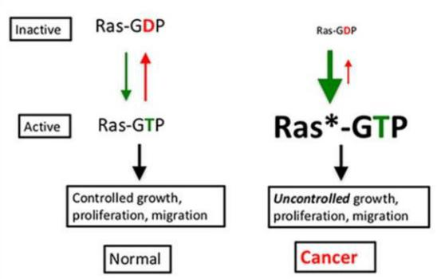

2.Evading growth suppressors
Normally there are active tumorsuppressors (e.g. RB or p53) which either regulate the cell cycle negatively or promote apoptosis or senescence.
Mutations can lead to a state where the tumor cells don’t react to tumorsuppressors.

3.Activating invasion and metastasis
- Loss of contact inhibition by e.g. loss of function in merlin or E-cadherin (scaffolding proteins).
- Expression of matrix degrading proteins
- Increased motility

4.Enabling replicative immortality
- Higher levels of telomerase

5. Inducing angiogenesis
- Expression of VEGF due to high demand in nutrients and oxygen as well as high demand for the removal of metabolic waste and CO₂.

6.Resisting cell death
- Mutations can lead to the cells being able to evade apoptosis.

7.Deregulating cellular energetics
- Warburg effect: Cancer cells reprogram their energy production by limiting metabolism largely to glycolysis and lactic acid formation. Less efficient in terms of ATP production but more molecular intermediates are generated which can be used for the production of biomass.

8.Avoiding immune destruction
- Avoid immune detection

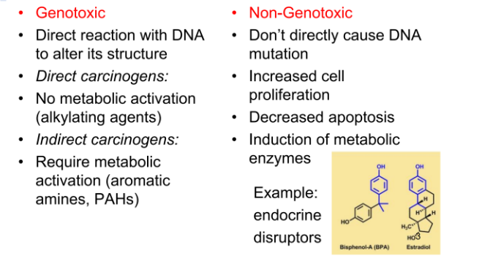
Carcinogenesis
Polymorphisms (genetic variability) in metabolic enzymes lead to different cancer susceptibilities in population. Two important proteins are:
- NAT (metabolic activation and detoxification of arylamides). People with a polymorphism that is responsible for slow acetylation have a higher risk for cancer development.
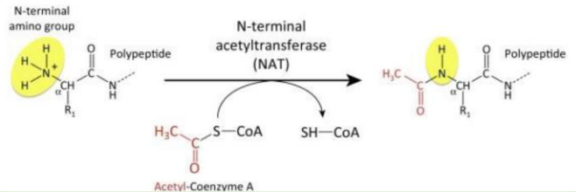

- GST (detoxification of potentially genotoxic chemicals)

DNA damage
DNA Adducts:
- Oxidative damage (every nucleobase can be oxidised, caused by oxidative stress)
- Photodimerization (caused by UV light)
- Alkylation (attached methyl group)
- Hydrolysis

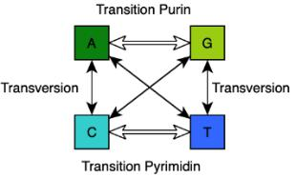
DNA Mutations:
- Transversion
- Transition
- Deletion
- Insertion

DNA Repair
Polymerases have the ability to proofread, based on DNA helix distortions.
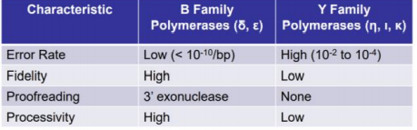

Pathways:
- Nucleotide Excision Repair (NER)
- Base excision repair (BER)
- Mismatch repair (MMR)
- Homologous recombination (HR)
- Non-homologous end-joining (NHEJ)
- Dealkylation (direct repair (DR))

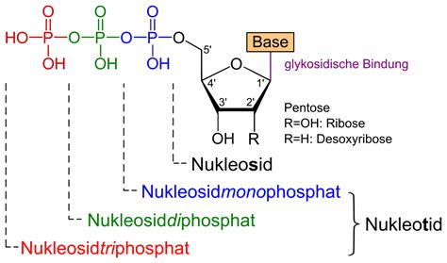

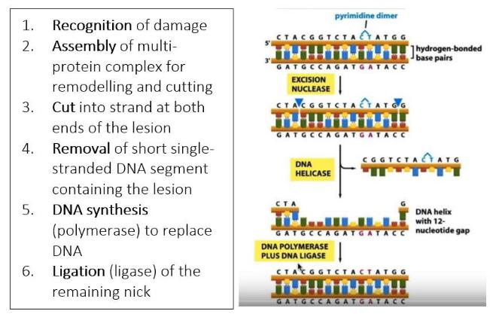
Nucleotide Excision Repair (NER)
NER occurs either as transcription coupled repair (TCR) or as global genome repair (GGR). Damage recognition step is different but the repair processes are very alike.
GGR in eukaryotes:
XPC protein recognises damage and binds to DNA, TFIIH (helicase formed by XPB and XPD) opens the double strand and forms the repair bubble and XPF cuts the sequence so that the repair polymerases δ/ε/κ can go to work.

Base Excision Repair (BER)
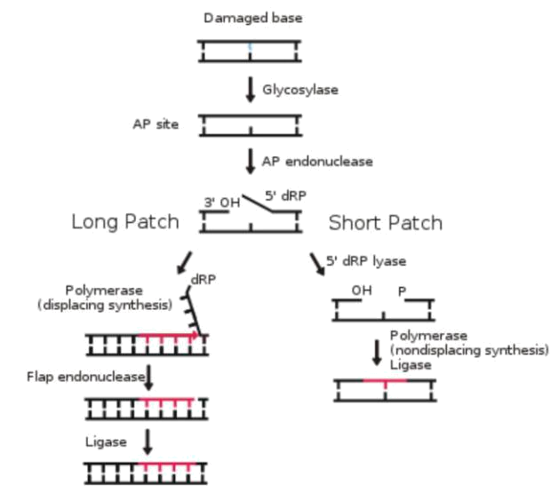

Short path: single nucleotide displacement
Long path: 2-10 nucleotides are replaced
Aag protein recognises DNA adducts and initiated BER

Mismatch Repair (MMR)
- MutS recognises and binds mismatch, helix gets distorted by MutS
- MutL makes incision at the newly synthesised strand. It gets recognised due to missing DNA methylation.
- Replication protein A (RPA) stabilises and protects ss.
- Exonuclease 1 (EXO1) removes some of the nucleotides of the daughter strand.
- Polymerase δ and DNA ligase fix the problem.

Homologous recombination (HR)
After ds-break
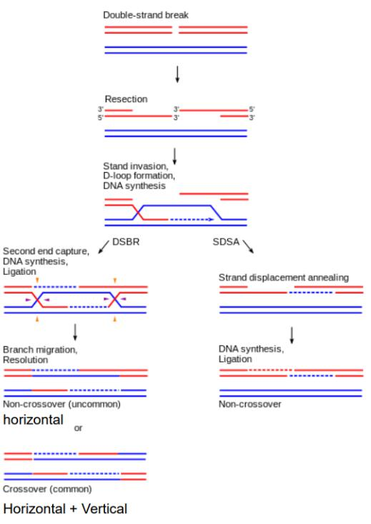

Sections of DNA around the 5' ends of the break are cut
away in a process called resection → sticky 3’-ends. Overhanging 3' end of the broken DNA molecule
"invades" a similar or identical DNA molecule that is not
broken (sister chromatid in mitosis). DSBR = double-strand break repair. SDSA = synthesis-dependant strand annealing.
Resolvase (Nuclease) can cut the Holliday junction in two possible ways leading to different outcomes.

Non-homologous end joining (NHEJ)
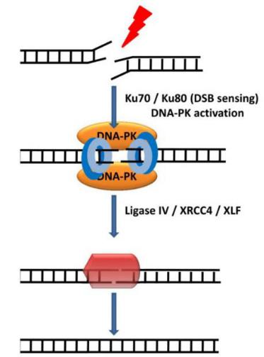
Also for ds-breaks, faster and more common than HR but also more error-prone
Recognition: Ku70/Ku80 encircles duplex DNA at DSB
Ku70/Ku80 stabilizes/structurally aligns the two DNA ends and recruits DNA-Protein Kinase (PK)
DNA-PK phosphorylates and activates the NHEJ effector complex (ligase IV/XRC44/XLF) that ligates broken DNA

Dealkylation (direct repair (DR))
Only repairs O⁶-methyl-dG (low frequency but extremely mutagenic)

O-6-methylguanine methyltransferase (MGMT) removes the methyl group in a non-enzymatic reaction whereby MGMT is used up completely and has to be degraded.
Temozolomide is a cancer drug which targets MGMT. Cancer cell can’t repair their O⁶-methyl-dG and might die as a consequence.

Overview:
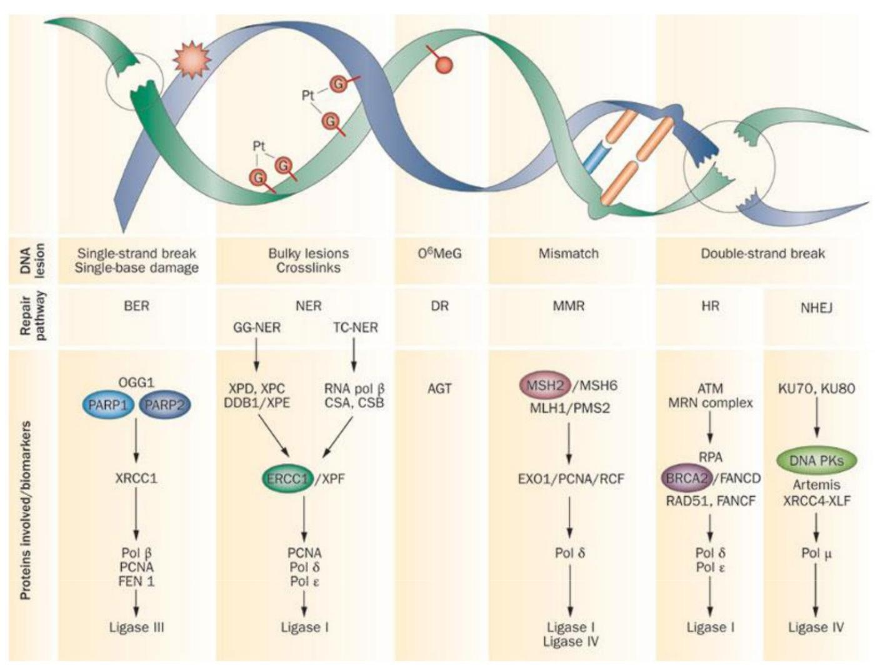
Receptor-mediated carcinogenesis
AhR protein is normally bound to heatshock proteins in the cytosol which inactivate AhR. AhR can be freed directly upon encounter with pesticides or indirectly via UVB light and can then be translocated to the nucleus where it acts as a TF. It promotes various hallmarks of cancer and many cancers have overexpression of AhR.

Hormone-mediated carcinogenesis
- Important for breast and prostate cancer.
- Prolonged exposure to high levels of estrogens (steroid) can be carcinogenic.
- Obese women have higher estrogen-levels because the adipose tissue is a major source of estrogen.
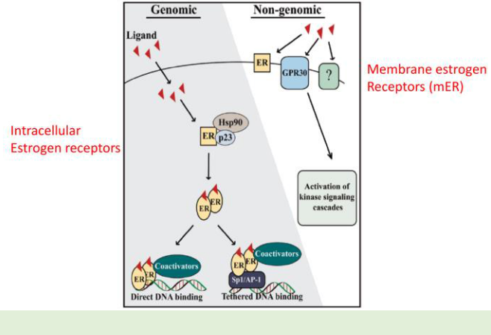
- Estrogen can bind intracellularly to an estrogen receptor (ER) or on the membrane.
- ER is a transcription factor that mostly upregulates the transcription of pro-proliferative genes and the Progesterone receptor (PG) gene which can be used as a biomarker for ER activity.
- There are various ER’s due to alternative splicing (ERα and ERβ)
- ER’s are in 70% of breast cancers overexpressed.
- ER’s are dependant on the activity of so called pioneer factors (FOXA1 and GATA3) which guide the ER’s in the nucleus to the target DNA.
- Certain mutations in GATA3 (prolonged and stable protein) has protective functions in cancer.
- Tamoxifen is a competitive inhibitor of estrogen and can therefore prevent ER activity.
- ER’s can also be activated using xenobiotics (a molecule that doesn’t belong to the organism) in this case PCB which mimics estrogen and leads to ER dimerization and activity in the nucleus.
Epigenetic mechanisms of carcinogenesis
- Epigenetic changes have an influence on gene expression
- Epigenetic information is inherited and subject to change due to various environmental factors (identical twins differ more the older they get due to epigenetic modifications)
- Euchromatin is loosely packed and more likely to be transcribed
- Heterochromatin is tightly packed and less likely to be transcribed
- H3K4 (Histone H3 lysine K4) methylation is activating
- H3K9 methylation is silencing
- The lysine residues can be mono-, di- or tri-methylated

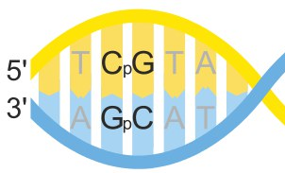
- Mostly Cytosine gets methylated and mostly in CpG sequence (5’C followed by 3’G), mostly inhibitory and in close proximity to promoters.
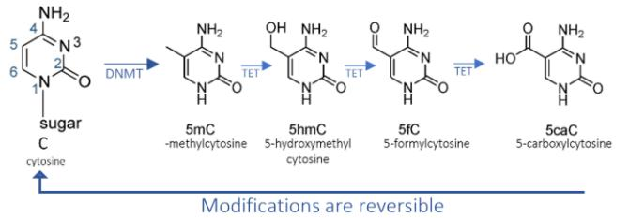
- Cytosine gets methylated by DNA Methyltransferase (DNMT).
- De novo methylation is made by DNMT3a and DNMT3b
- Maintenance methylation (during replication) is made by DNMT1 which recognises the parental strand and methylates the daughter strand accordingly.
- Demyelination can occur in the absence of DNMT1 either by continuous rounds of replication (passive demethylation) or by the activity of TET (active demethylation)
- TET2 has often a loss of function mutation in cancer which can lead to the hypermethylation of tumor suppressor genes
- Another modification is acetylation of the N-terminus of histones.
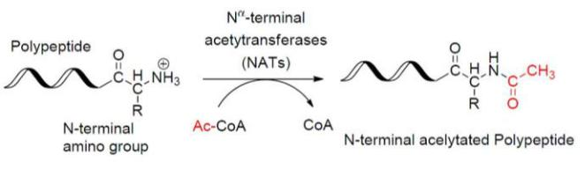
- Due to the change of charge (positive to neutral), electrostatic forces open the DNA (DNA is negatively charged) up and make it more easily accessible for transcription.

Viral carcinogenesis
RSV (Rous Sarcoma Virus) has 4 genes:
- Gag - encodes capsid protein
- Pol - reverse transcriptase
- Env - envelope gene (important for host cell invasion)
- Src – encodes a tyrosine receptor kinase that attaches phosphate groups to tyrosine in the host cell
  - Viral-src is an allele of the cellular-src which was at some point picked up by the virus. It shows abnormal functions and drives several hallmarks of cancer.

Epstein Barr Virus (EBV)
- Leads to a transformation of B cells into tumor cells.
- Constant expression of myc oncogene which drives several hallmarks of cancer.

Human Papillomavirus (HPV)
- Spreads through sexual interactions, is affecting epithelial cells and can be responsible for a lot of cancers in the intimate area.
- Leads to overexpression of E6 and E7 (oncogenes) which inhibit Rb and p53 (tumor suppressors).
- There is a vaccination against HPV

Radiation induced cancer
Can be caused by nuclear radiation or UV light. Both are so called ionizing radiations which means that they are very high-frequent and have therefore enough energy to break chemical bonds.
UV light can be grouped in 3 categories:
- UVA, around 95% of the sunlight, lowest frequency, highest depth penetration into the skin, least dangerous, can produce ROS
- UVB, intermediate frequency, intermediate depth penetration, most correlated with cutaneous cancer
- UVC, highest frequency, lowest depth penetration, most dangerous, gets mostly absorbed by the ozone layer.
- Dark skin pigment melanin as a protection against UV light produced by skin cells. Melanin is highly conjugated and can therefore absorb high frequencies.
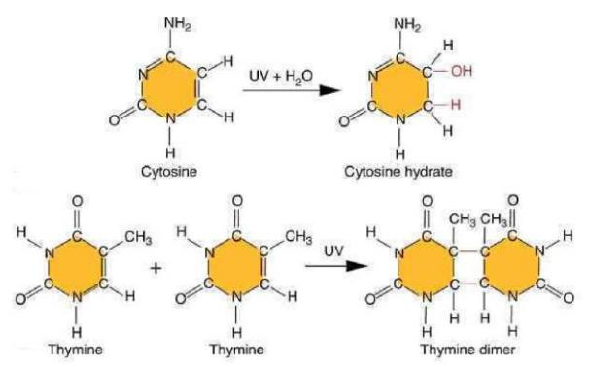
High proliferation correlates with susceptibility to ionizing radiation
- UVA can indirectly damage DNA via the activation of H₂0 (top)
- UVB can directly damage DNA by breaking and reforming bonds (bottom)
- Xerodera Pigmentosum (XP, rare genetic disorder) has a deficient TT-dimer repair system and is therefore highly susceptible to UV induced skin cancer.
- Radiation is even more energetic than UVC and can cause even more serious genetic damage which can even lead to chromosomal aberration (changes in structure and number)

Cancer and Inflammation
- Cancer can be promoted and/or exuberated by inflammation.
- The tumor can form his own microenvironment using cytokines (including TNFα and IL-6) and has similarities to a non-healing wound.
- Inflammation or oncogene activation results in the expression of vital proinflammatory transcription factors within tumour cells (e.g. NF-κB, STAT3, HIF1α)
- IL-12 often associated with suppression of cancer
- TNF-α and TGF-β (normally a tumorsuppressor but can have oncogenic functions in late stage cancer) often highly expressed in cancer
- Depending on the context, the inflammasome can promote or inhibit tumor growth
- JAK-STAT3 pathway activated in cancer
  - JAK and/or STAT inhibitors are used as cancer therapeutics
- NF-κB pathway also overactive.
  - Bortezomib is a drug which downregulates this pathway.

Cancer Immunotherapy
Treatment which uses patient’s own immune system to fight the cancer
CAR-T (Chimeric antigen receptor T-cell therapy)
- Patient’s white blood cells get extracted and reprogrammed using a viral vector which adds a new antigen receptor which should recognise cancer cells.
- The cells get multiplied and injected back into the patient who underwent chemotherapy to make space for the new lymphocytes.
- Problems are:
  - Dosing
  - Toxicity
  - Price
CAR-T 2.0
- A kill switch gets implemented as well. The CAR-T cells will undergo apoptosis if a small molecule drug called rimiducid is added to the organism. CAR-T cells can be stopped if necessary.

Cancer and mitochondria
- Warburg effect (shift to anaerobic pathways)
- ATP synthase activity downregulated by the upregulation of Inhibitor Factor 1 (IF1). Lowers ATP concentration, elevates AMP concentration and therefore AMPK activity which signals to the cell that energy is needed and overall metabolism is increased as a consequence. Can also activate the NF-κB pathway.
- Mitochondrial DNA (mtDNA) can also be subject to mutation which can promote cancer.
- mtDNA gets replicated by PolG which is encoded in the nuclear DNA and gets transported into the mitochondrial post-translationally. Mutations in PolG can also be a cause for mtDNA mutations.

Obesity
- Obesity itself is not the disease but it can lead to a variety of severe diseases
- Environmental and genetic factors
- Heritability between 60-80% (genetic and epigenetic)
- Energy expenditure is
  - ~60% Basic metabolic rate (BMR)
  - ~15% digestion
  - ~15% thermogenesis
  - ~10% physical activity
- Lipodystrophy is the inability to produce and maintain healthy fat tissue.
- an extra 200kcal a day leads to a weight gain of ~8kg per year.
- Daily kcal intake is 2000kcal for a woman and 2500 for a man

Energy intake is regulated using two systems:
- Homeostatic system (short term survival, missing energy -> hunger, wants to keep the status quo)
- Hedonic system (long term survival, pleasure-driven, aimed to create energy reservoirs)
  - Linked to dopamine which is a product of tyrosine via the tyrosine hydroxylase
  - Dopamine receptor (G-coupled receptor) doesn’t influence gene expression but via PLC (phospholipase C, Ca²⁺ concentration) and AC5 (Adenylate cyclase 5, cAMP concentration).

Leptin
Adipocyte derived hormone which increases metabolic rate and decreases food intake.
Parabiosis experiment (blood circuits of two mice connected)
ob=obese (doesn’t produce leptin)
db=diabetic (no leptin receptor, excess leptin production as counter but doesn’t work)
- ob/ob & +/+ -> ob/ob losing weight because of leptin produced by +/+
- db/db & +/+ -> +/+ starves because db/db mouse produces an excess of leptin which downregulates food intake in +/+
- db/db & ob/ob -> same thing, ob/ob loses weight rapidly and starves
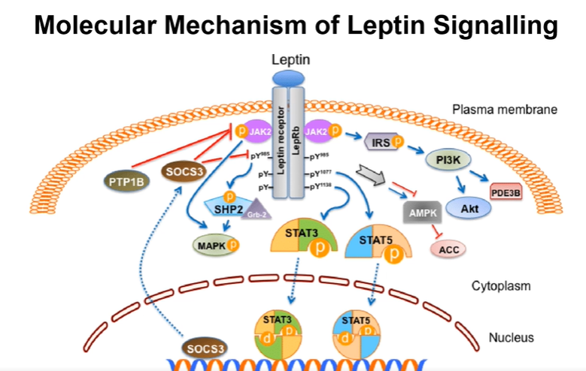
- Leptin receptor binds leptin
- Receptor phorphorylates STAT3 and STAT5 which can then dimerise, translocate into the nucleus and act as TF.
- Leptin is not a treatment for obesity because the body will react to the excess leptin by downregulating the leptin receptors.

other food hormones:
- Ghrelin and CCK (gut hormone), senses if stomach is empty and drives food intake
- GLP-1 (gut and pancreas) suppresses food intake upon nutrient absorption (top obesity/diabetes therapy is based on an GLP-1-analog which is longer-lived)
- Insulin (pancreas)

Glucose metabolism (postprandial, after a meal)
Blue has to be known and abbreviations are sufficient.
Green plus means that this process gets pushed by insulin.
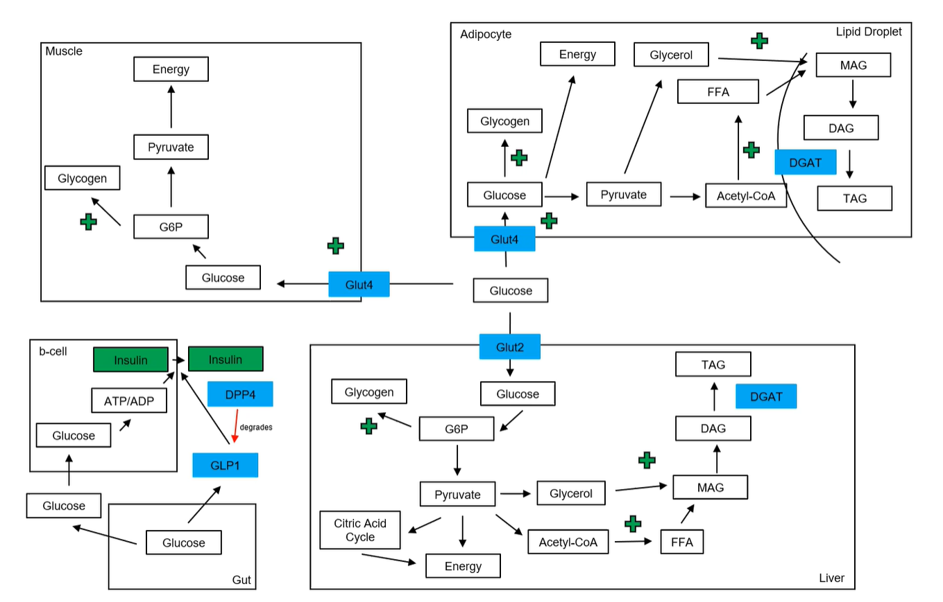
Gut and pancreas (β-cells)
- Glucose from gut gets absorbed and reaches via circulation the pancreas and enters passively
- GLP-1 gets secreted by endocrine cells of the gut upon food intake and drives insulin secretion and inhibits food intake
  - GLP-1 is very short-lived because of cleavage by DPP4 (peptidase)
- ATP/ADP ratio in β-cells increases (modulates potassium channel activity) and insulin gets produced and released
Liver
- Glucose enters the liver via the Glut2 transporter in an insulin-independent manner (follows concentration gradient -> bidirectional)
- Insulin favours glycogen production and therefore reduces intracellular glucose concentration and indirectly pushes glucose uptake
- “normal” energy metabolism (glycolysis, TCA, oxidative phosphorylation)
- Insulin pushes de novo lipogenesis
- DAG -> TAG is controlled by DGAT (Diglycerol acetyl transferase)
Muscle
- Glucose enters the muscle via Glut4 (Glut4 is normally in the cytosol but gets translocated to the membrane upon insulin increase, active transport, unidirectional)
- Insulin favours glycogen production
- “normal” energy metabolism (glycolysis, TCA, oxidative phosphorylation)
Adipocytes
- Glucose enters the muscle via Glut4 (Glut4 is normally in the cytosol but gets translocated to the membrane upon insulin increase, active transport, unidirectional)
- Low glycogen storage
- energy metabolism mostly anaerobically due to very few mitochondria
- de novo lipogenesis
- DAG -> TAG is controlled by DGAT (Diglycerol acetyl transferase)
How to counter insulin resistance (Type 2 DM)
- GLP1 analogue (increase insulin production), most commonly used
- DPP4 inhibitor
- Sulfonylurea (modulate potassium-channel activity and leads to more insulin production/secretion)
- Metformine (reduces gluconeogenesis in liver)
- Glitazone (reduce release of FFA in adipocyte)
- Insulin (direct insulin injection)
- SGLT2- inhibitors (inhibit glucose absorption in kidney)

Glucose metabolism (fasting)
During fasting, glucagon concentration is increased and insulin concentration is decreased
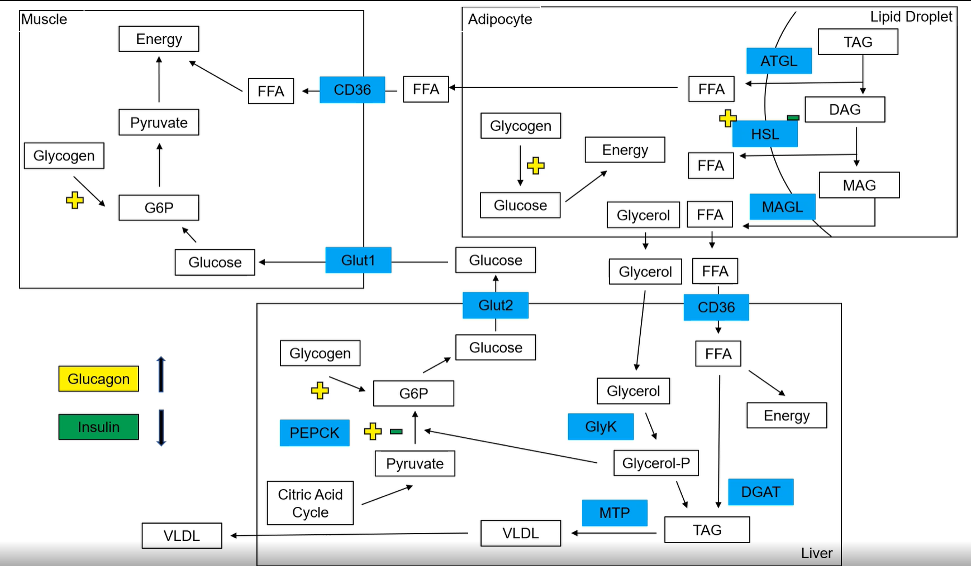

Adipocyte
- Triglyceride (TAG) is sequentially cleaved and leaves three free fatty acids (FFA) and one glycerol.
  - TAG -> DAG + FFA via ATGL (Adipose tissue triglyceride lipase), rate limiting step because everything downstream is dependant on TAG as a substrate
  - DAG -> MAG + FFA via HSL (hormone sensitive lipase) driven by glucagon, massively inhibited by insulin (no insulin is more important than glucagon)
  - MAG -> FFA + glycerol via MAGL (Monoacylglycerol lipase)
- Glycogen degradation driven by glucagon
- FFA and glycerol get released into the blood
Liver
- Uptake of glycerol
  - GlyK (Glycerol Kinase) phosphorylates glycerol
- Uptake of FFA via CD36
  - Energy metabolism
  - With glycerol-p can form new TAG (DAG -> TAG by DGAT (Diglycerol acetyl transferase))
  - TAG can be packaged by MTP (microsomal transfer proteins) in a lipoprotein called VLDL (very low density lipoprotein) which can be secreted.
- Gluconeogenesis using pyruvate from the TCA (rate limiting step is done by PEPCK (Phosphoenolpyruvate carboxykinase)). Inhibited by insulin, driven by glucagon
- Synthesised glucose from glycogen or gluconeogenesis can be passively secreted via Glut2
Muscle
- Glucose enters the muscle via Glut1 (insulin independent, passive transporter)
  - Energy metabolism
- Glycogen degradation driven by glucagon
  - Energy metabolism
- FFA via CD36 in muscle (also VLDL in muscle)
  - Energy metabolism

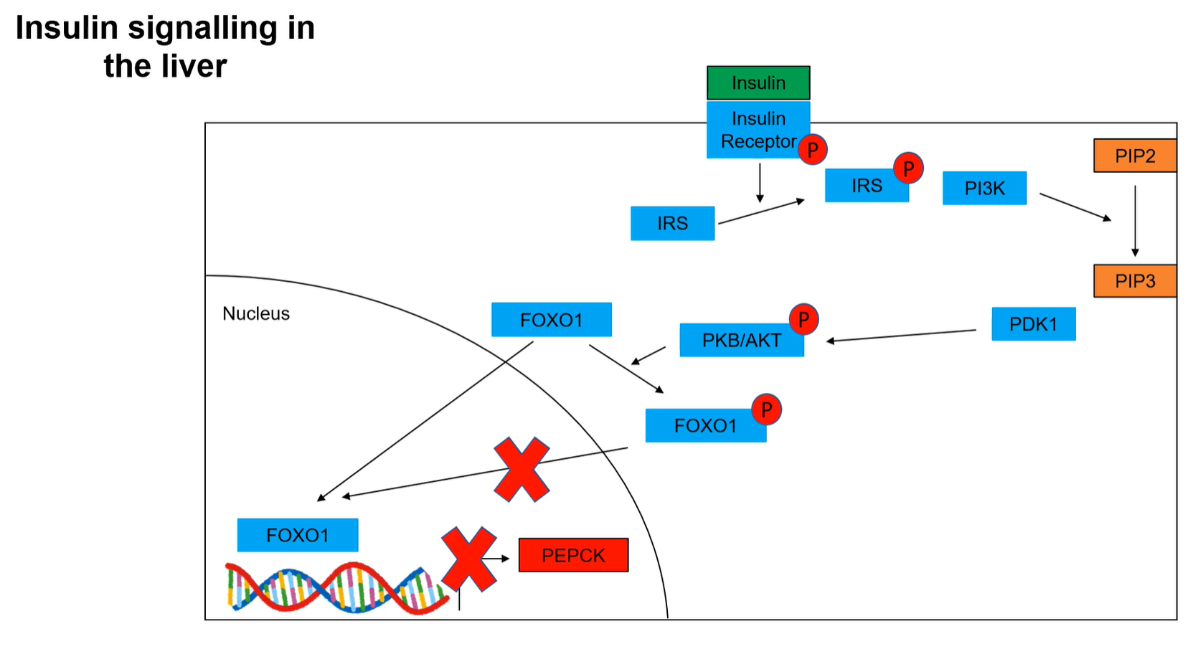
- Insulin binds to insulin receptor -> dimerization & autophosphorylation
- IRS (insulin receptor substrate protein, big variety of IRS’s -> cells can react differently to insulin stimulus) gets phosphorylated by insulin receptor
- IRS recruits PI3K (Phosphoinositide 3-kinase) to membrane
- PIP2 gets phosphorylated to PIP3 (Phosphatidylinositol-3,4,5-trisphosphate) by PI3K
- PIP3 recruits PDK1 which phosphorylates PKB/AKT (relevant in multiple signalling cascades)
- PKB/AKT phosphorylates FOXO1 (transcription factor) which can’t translocate to the nucleus if phosphorylated.
- PEPCK-transcription (important in gluconeogenesis) gets inhibited
- Insulin inhibits gluconeogenesis in liver
- insulin-resistant liver produces and releases glucose basically all the time -> hyperglycaemia (increased glucose concentration in the blood)

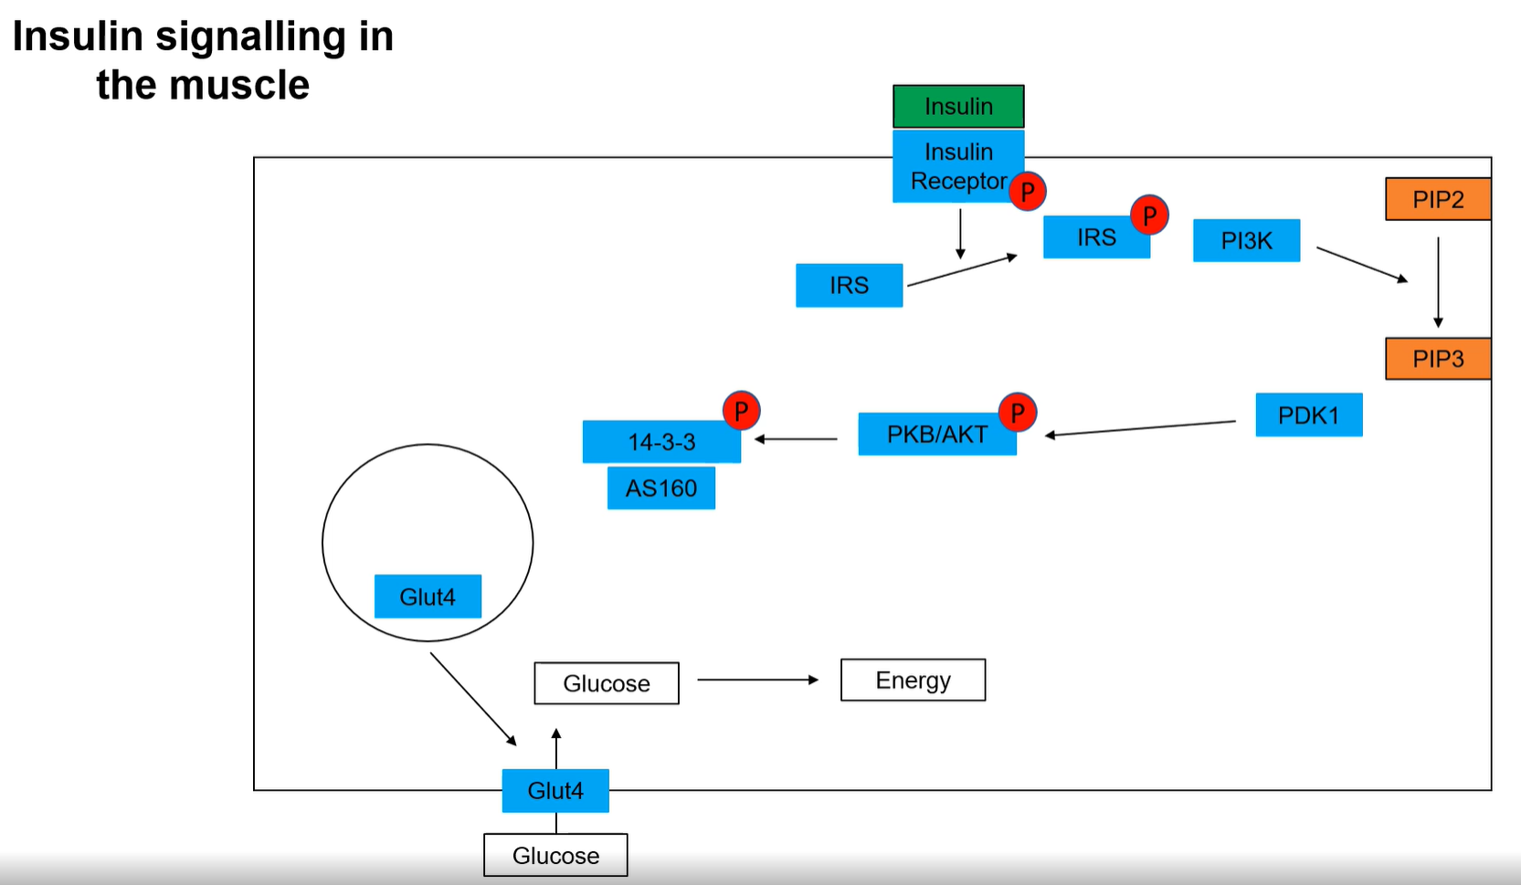
- same as in liver up to PKB/AKT-phosphorylation
- Glut4 normally in vesicles which are bound by AS160 which prevents fusion to the cellular membrane
- PKB/AKT phosphorylates 14-3-3 (scaffold protein) which then has a high affinity for AS160
- Vesicle can fuse to the membrane and glucose can be actively transported into the muscle
- Insulin promotes glucose-uptake by muscle cells
- Insulin-resistant muscle won’t take up a lot of glucose (only passively by Glut1 but not a lot -> hyperglycaemia)

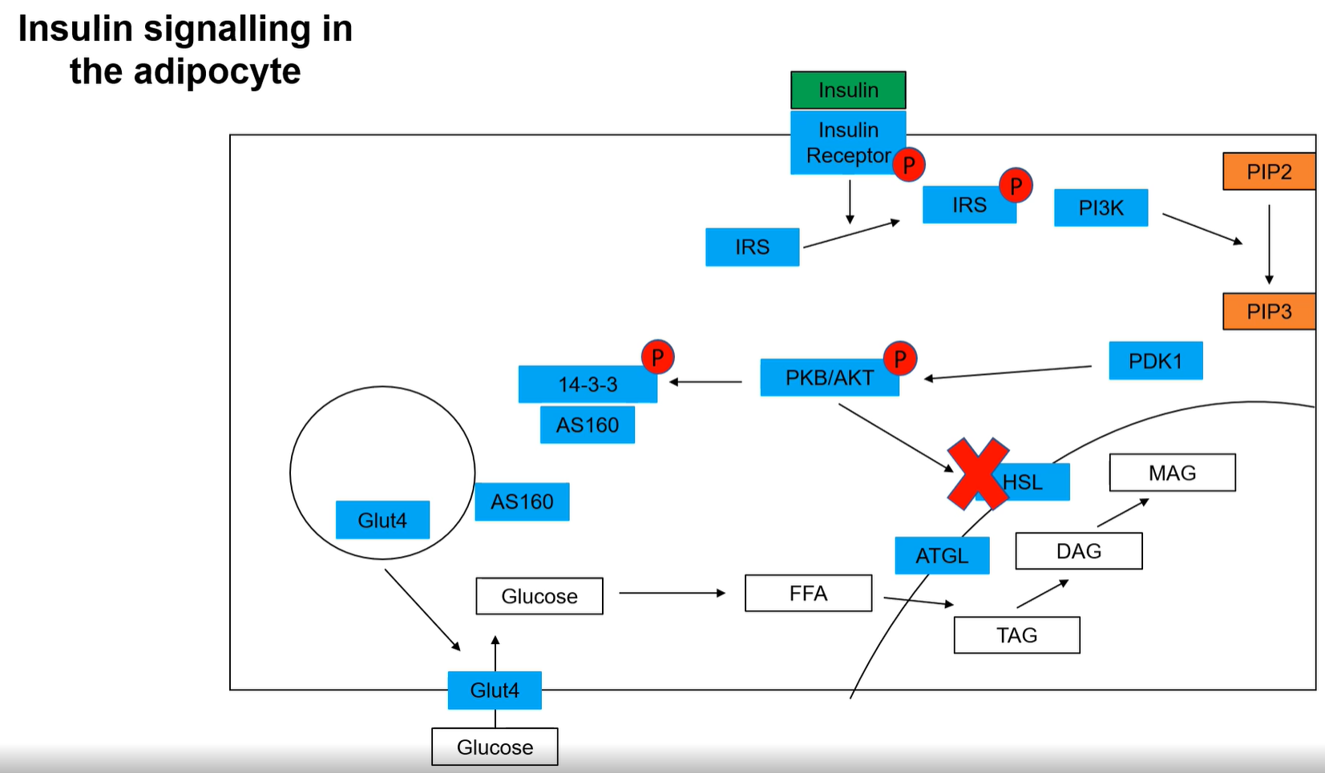
- Same as muscle up to glucose uptake by Glut4
- Glucose gets converted to FFA which are stored as TAG’s in a lipid droplet
- HSL gets inhibited by phosphorylated PKB/AKT
- Insulin inhibits the breakdown of lipids
- Insulin-resistant adipocyte constantly breaks down and releases fatty acids
- High blood lipid concentration can also cause insulin-resistance in other organs (adipocyte-malfunction is mostly one of the first cell type in the development of insulin-resistance)
Diabetes mellutis (DM)
- Absolute (type 1 ) and relative (type 2) insulin insufficiency
- Type 1 = not enough insulin present
  - Genetic disorder
  - Viral damage
  - Autoimmune damaging or toxic influences on β-cells
  - Disease of pancreatic gland
- Type2 = insulin signal not strong enough (resistance)
  - Problems in insulin release from β-cells
  - Problems in insulin transport
  - Problems in insulin pathways (receptors or further downstream)
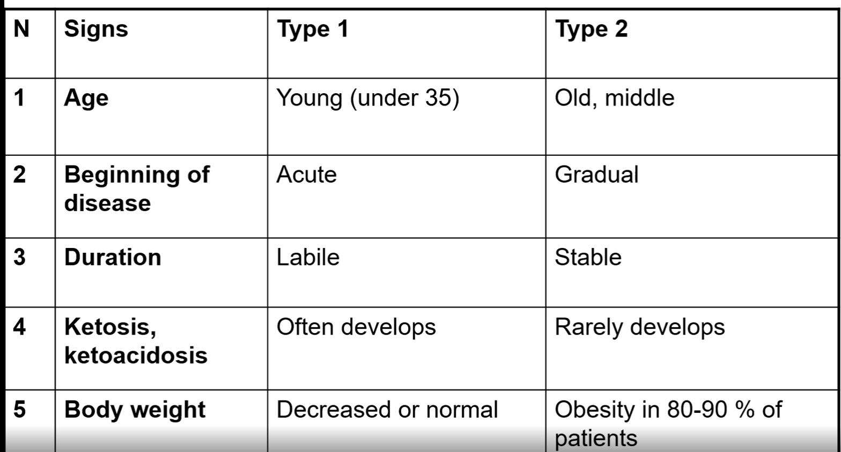
- Diabetic people produce less insulin in a longer period of time upon glucose uptake
- Overall higher insulin spike if glucose is given orally compared to intravenous because glucose in the gut triggers GLP1 secretion which drives insulin production
- Insulin-resistance under influence of genes and lifestyle/diet
- Healthy β-cells can counter developing insulin-resistance by producing more insulin (compensatory hyperinsulinemia -> normoglycemia)
  - If β-cells can’t compensate anymore (too much or damaged β-cells) -> hyperglycaemia -> type 2 diabetes
- Symptoms of diabetes
  - Polyurea (high blood sugar -> high urine sugar -> low water retention in kidney)
  - Polydipsia (more water intake)
  - Polyphagia (increased food intake, increased catabolic activity -> lack of energy)
  - Pruritus and Paresthesia (high glucose concentration damages cells, especially nerves which can lead to several complications)

- Obesity leads to bigger adipocytes which attract more macrophages which release more pro-inflammatory cytokines
- Fatty acids metabolites (DAG, Ceramide) can activate PKC which inhibits the insulin pathway
- Fatty acids can bind to adipocyte TLR (Toll-like receptor), JNK (C-Jun-N-terminal kinase) gets activated and can shut down the insulin pathway, preventing glucose uptake (makes sense because fatty acids are a more efficient energy storage than glucose)
- JNK activity can also be upregulated by IL-6 and TNF-α

Non-alcoholic fatty liver disease (NAFLD)
- Fat deposition (steatosis) in liver (mostly obese, diabetic, hyperlipidemia, high blood pressure, rarely mild jaundice (Gelbsucht) due to problems with bilirubin (product of haemoglobin-degradation) degradation -> liver malfunction)
- Silent in the initial stage (mostly diagnosed due to abnormal liver function tests during routine blood tests, elevated serum TAG’s)
- MRI, Ultrasound, CT or liver biopsy to confirm (gold standard)
- There is also an alcoholic version of this disease (alcohol can be degraded into acetyl-CoA which can be used for de novo lipogenesis)
- Hepatic steatosis (fatty liver)
  - No evidence of hepatocellular injury
- Non-alcoholic steatohepatitis (NASH)
  - Hepatocellular injury (“ballooning” -> cell death) with or without fibrosis (pathological wound healing leading to the formation of scar tissue which replaces normally functioning tissue)
  - Can lead to cirrhosis (extensive fibrosis) or even to hepatocellular carcinoma’s
Causes:
- Obesity -> increased FFA -> more/larger adipocytes (FFA uptake, de novo lipogenesis, impaired VLDL export) -> more macrophages -> more pro-inflammatory cytokine released by macrophages and adipocytes -> fibrosis as healing response
- Diet
  - High consumption of fructose, soft drinks, meat, saturated fat, cholesterol
  - Low consumption of fibres, omega-3 fatty acids, vitamins

Fat metabolism in liver
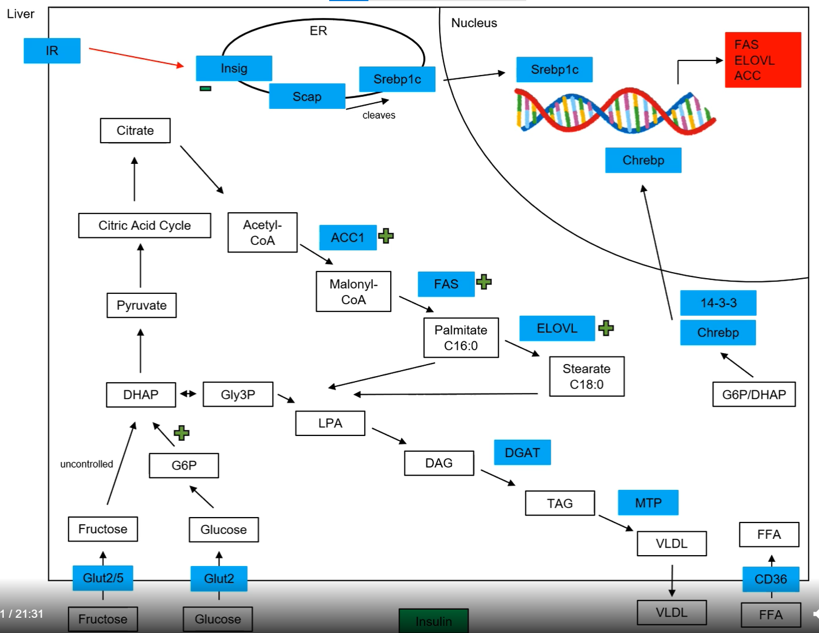
- Fructose uptake via Glut2 and Glut5 (passive)
- Glucose uptake via Glut2 (passive)
- FFA uptake via CD36
- Acetyl-CoA (C2) to Malonyl-CoA (C3) by ACC1 (Acetyl-CoA carboxylase 1)
- Malonyl-CoA in multiple steps to palmitate (C16) by FAS (Fatty acid synthase)
- Palmitate can be elongated to stearate (C18) by ELOVL (some kind of elongase)
- Glycerol for TAG’s from glycolysis
- DAG to TAG by DGAT, afterwards formation and secretion of VLDL by MTP
- Insulin somehow inhibits Insig (ER-membrane protein), Scap can cleave Srebp1c (TF) which can then translocate to the nucleus. It promotes the transcription of ACC, FAS and ELOVL (all needed for de novo lipogenesis)
- Active glycolysis (G6P and DHAP) can free Chrebp (TF) from 14-3-3 which can then translocate to the nucleus where it has similar effects as Srebp1c
  - De novo lipogenesis can be promoted in an insulin-dependent and non-insulin dependent way)
- In case of insulin resistance, gluconeogenesis will take place (and slow the passive glucose uptake via Glut2 down) but fructose is still taken up which pushes all the glycolysis/gluconeogenesis metabolites and therefore activates Chrebp which promotes de novo lipogenesis which can lead to NAFLD. This whole concept is called selective hepatic insulin resistance.
- Not a single approved therapy for NAFLD currently available

Hypertension
- Blood pressure is defined by two variables, namely cardiac output and peripheral resistance.
- Blood vessel diameter changes upon many stimuli: temperature, activity, nutritional state, …
- Blood vessel diameter shrinks upon stress, inactivity and atherosclerosis.
- Systolic pressure is when heart pumps
- Diastolic is when there is blood influx into the heart
- Overall optimal is 120/80 mmHg
- Causes: 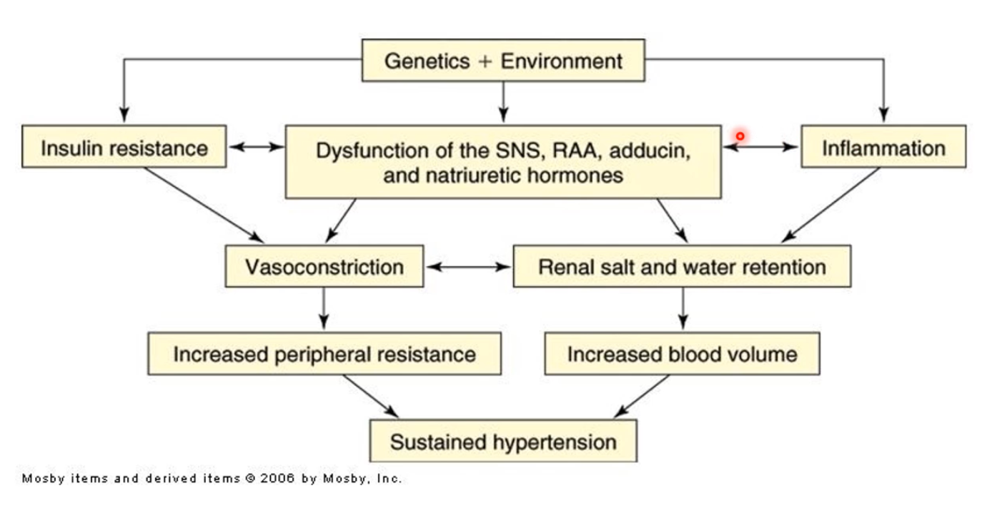
- RAA = renin-angiotensin-system
- Possible effects of hypertension:
  - Increased dilation of vessels ->Fibrosis & macrophage infiltration ->Development of atherosclerosis
  - Development of cardio-vascular diseases (CVD)

Molecular mechanisms regulating blood pressure
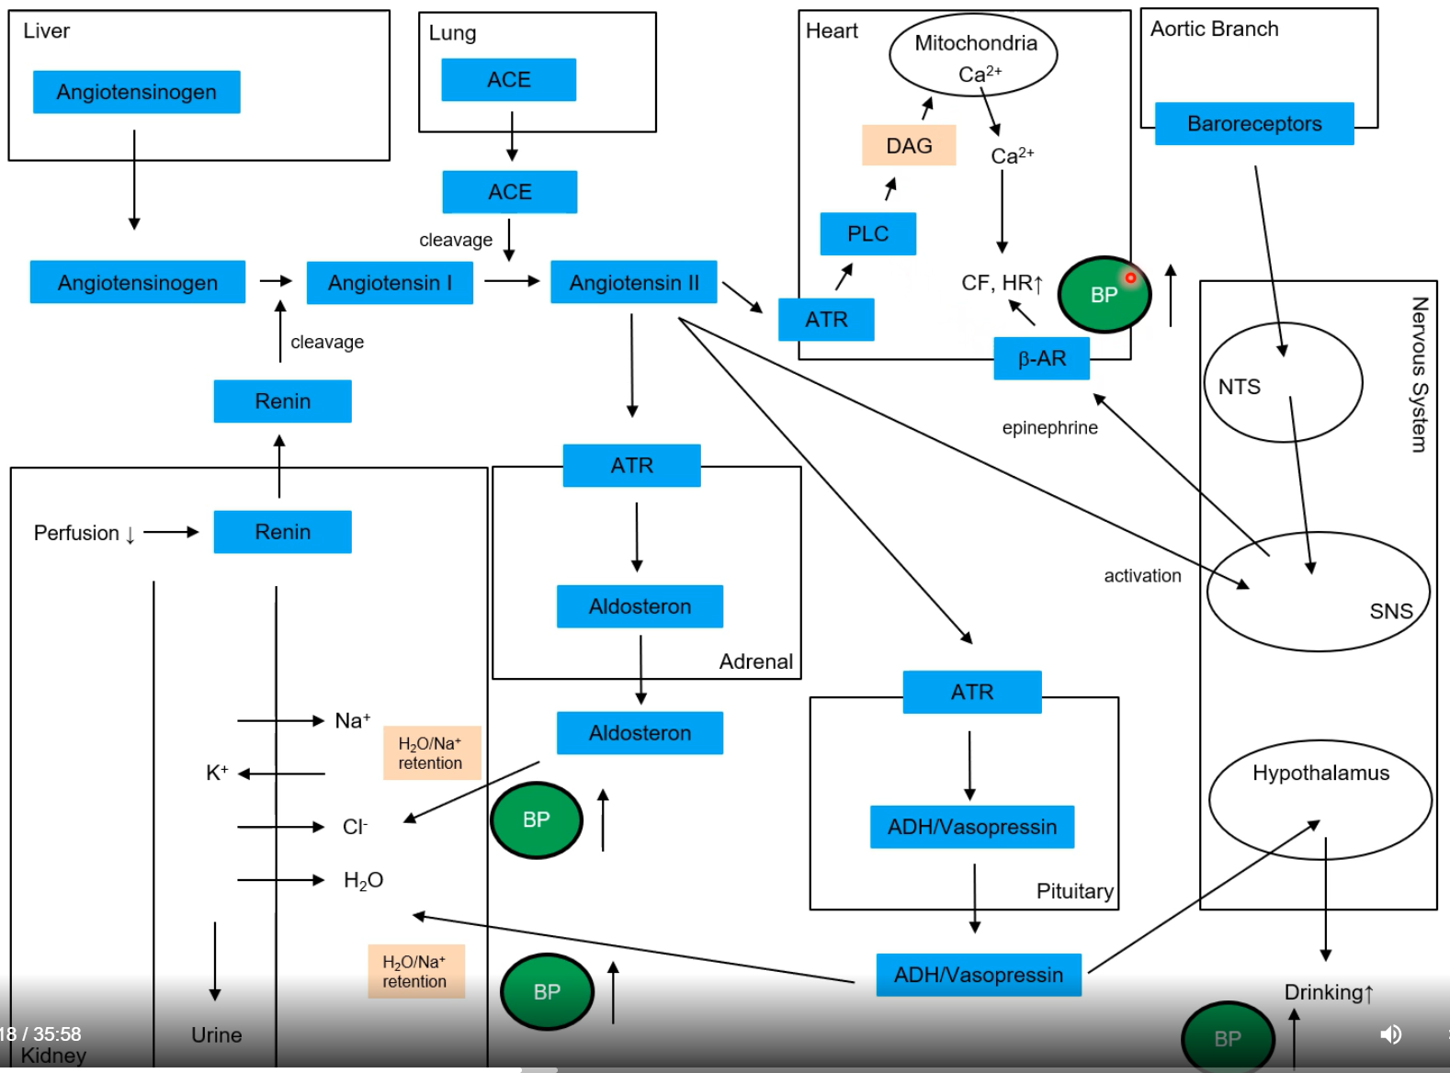
Liver
- Secretes angiotensinogen
Lung
- Secretes ACE (Angiotensin 1 converting enzyme)
Kidney
- Senses perfusion, if low -> secretion of renin (also called angiotensinogenase)
- Aldosterone increases water and sodium retention (increases blood pressure)
- ADH/Vasopressin increases water and sodium retention (increases blood pressure)
Blood
- Renin cleaves angiotensinogen to angiotensin1
- ACE cleaves angiotensin1 to angiotensin2 (bioactive molecule increasing blood pressure)
Adrenal gland (Nebenniere)
- Angiotensin2 receptor binds angiotensin2
- Production and release of aldosterone
Pituitary gland (Hypophyse)
- Angiotensin2 receptor binds angiotensin2
- Production and secretion of ADH/Vasopressin
Hypothalamus
- ADH/Vasopressin induces drinking behaviour (increases blood pressure)
Heart
- Angiotensin2 receptor binds angiotensin2
- Activates phospholipaseC (PLC, cleaves PIP2 -> DAG) which triggers calcium-release from the mitochondria
- Higher calcium levels increase muscle contractility which increases contractile force (CF) and heart rate (HR) (increases blood pressure)
- β-AR increases blood pressure upon epinephrine binding
Sympathetic nervous system
- Gets activated by angiotensin2 which leads to the secretion of epinephrine.
Aortic branch
- Baroreceptors sense blood pressure
- Deactivates SNS activity via NTS activity and leads to a decrease in blood pressure (wrongly depicted in schematics)
How to lower blood pressure?
- Diuretics (block water resorption in kidney)
- ACE-inhibitor
- ATR blocking
- β-AR blocking
- inhibit calcium release in heart

Endothelial function in controlling vasoconstriction
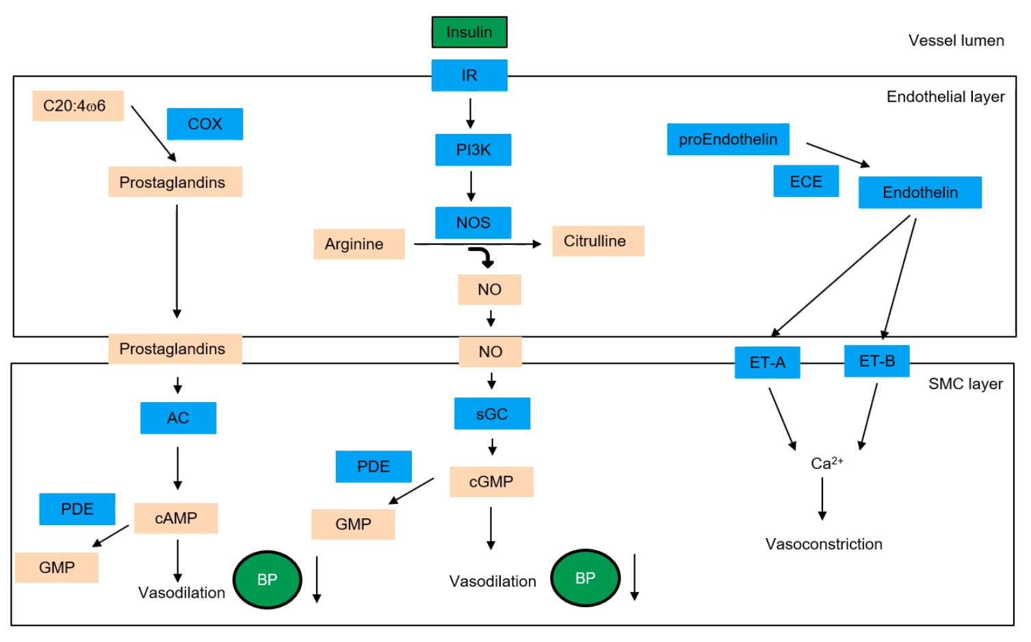
- C20:4ω6 (unsaturated fat) is the building block for prostaglandins (2nd messenger, medium stability) which are made by COX (cyclooxygenases)
- Prostaglandins act paracrine and activate AC (adenylate cyclase) which produces cAMP (2nd messenger)
- cAMP leads to vasodilation (decrease in blood pressure)
- cAMP cleaved by PDE (phosphodiesterases) to AMP (wrongly depicted in schematic) which deactivates cAMP-based vasodilation
- high saturated fat diet -> less C20:4ω6 -> increase in blood pressure
- Insulin binds to insulin receptor of endothelial layer which activates via PI3K NOS (insulin-inducible nitrogen oxide synthase)
- NOS transforms arginine to citrulline and releases NO (2nd messenger, highly instable -> narrow region of influence -> mostly paracrine signalling)
- NO activates sGC (soluble guanylyl cyclase) which produces cGMP (2nd messenger)
- cGMP decreases smooth muscular tone -> increases vessel volume -> decreases blood pressure (insulin means high blood glucose, lower blood pressure means slower blood flow which enables more efficient nutrient uptake)
- cGMP cleaved by PDE (phosphodiesterases) to GMP which deactivates cGMP-based vasodilation
- in case of insulin-resistance: increase in blood pressure
- smoking decreases NO -> increase in blood pressure
- inflammation -> IL-6 and TNFα -> phosphorylation of insulin receptor substrates -> increase in blood pressure
- PDE’s are a common drug target which decrease blood pressure
- proEndothelin produced in endothelial layer and gets cleaved by ECE into endothelin (hormone, stable -> larger area of influence)
- ET-A and ET-B receptors bind endothelin and increase intracellular calcium-concentration
- Higher calcium levels increase muscle contractility which decreases vessel diameter (increases blood pressure)

Cardiovascular Disease (CVD)
#1 cause of mortality worldwide
Refers to diseases of the heart and/or blood vessels
Atherosclerosis (progressive narrowing of the arteries typically caused by fatty deposits
- Reduction of elasticity, can lead to breakage of endothelium and blood might leak into tissue
- Reduces blood flow and can even completely block it (thrombus)
- Coronary Artery Disease (CAD)/ Coronary heart disease (CHD) (atherosclerosis of the coronary arteries which supply oxygenated blood to the heart itself)
  - Can cause a myocardial infarction (MI, heart attack), instant hypoxia of concerned area followed by necrosis (cell death)
- Hypertension
- Cerebrovascular diseases
  - Thrombotic ischemic stroke (thrombus develops in artery near brain)
  - Embolic ischemic stroke (thrombus develops somewhere else and travels to the brain)
  - Transient ischemic attack (TIA), only temporary disruption of blood flow, might be unrecognised
  - Haemorrhagic stroke, caused by uncontrolled bleeding in the brain
Risk factors:
- Smoking
  - Nicotine can cause lesions in artery wall
  - CO can cause lesions and decreases the ability of the blood to transport oxygen
  - NO concentrations decreases which prohibits relaxation of SMC surrounding vessels
- High blood VLDL and LDL-cholesterol
  - Caused by eating too much saturated fat, not dependant on cholesterol intake
- Low blood HDL-cholesterol
- High blood pressure/ high pulse
  - Damaging the vessels
- Physical inactivity
  - Exercise lowers blood pressure, increases HDL, decreases VLDL and LDL
- Obesity
  - Can lead to hypertension and/or diabetes, low HDL
- Diabetes
  - Impaired ability of the blood to store glucose which can damage the vessels
- Stress
- Low omega-3 FA
- High alcohol consumption
- Age
  - Older = higher risk
- Males are more affected than females
  - Unclear if biological or cultural difference
- Heredity
- Ethnicity

Cholesterol and lipid metabolism
- They contain TAG’s and cholesteryl esters (storage of cholesterol in ester form)
- Monolayer of phospholipids to make everything watersoluble
- Apolipoproteins are lipoprotein-specific
- Highest to lowest lipid/protein ratio (associated apolipoprotein in braces): chylomicrons (Apo B-48), VLDL (Apo B-100), IDL (Apo B-100), LDL (Apo B-100), HDL (Apo A-1)
Lesion formation
- Can be caused by hypertension or loss of vessel elasticity-> damaged endothelial layer -> macrophage infiltration into intima layer (between endothelium and smooth muscle cells)> inflammation
- High blood-LDL leads to LDL influx in intima layer through damaged endothelium -> macrophages will try to clear the LDL by endocytosis. Macrophages with high fat/cholesterol are called foam cells and are the major building block of plaques
  - Macrophages take up fatty acids and cholesterol of LDL via CD36 and SR-A (scavenger receptor A)
  - Intracellular lipids drive via PPARγ (TF) the expression of ABAC1 (formation of HDL)
- Other macrophages will start wound healing process and release collagen fibres, cytokines, additional LDL-uptake -> growth of plaque (narrowing of vessel) -> eventually rupture of plaque

Lipid metabolism (possible treatments)
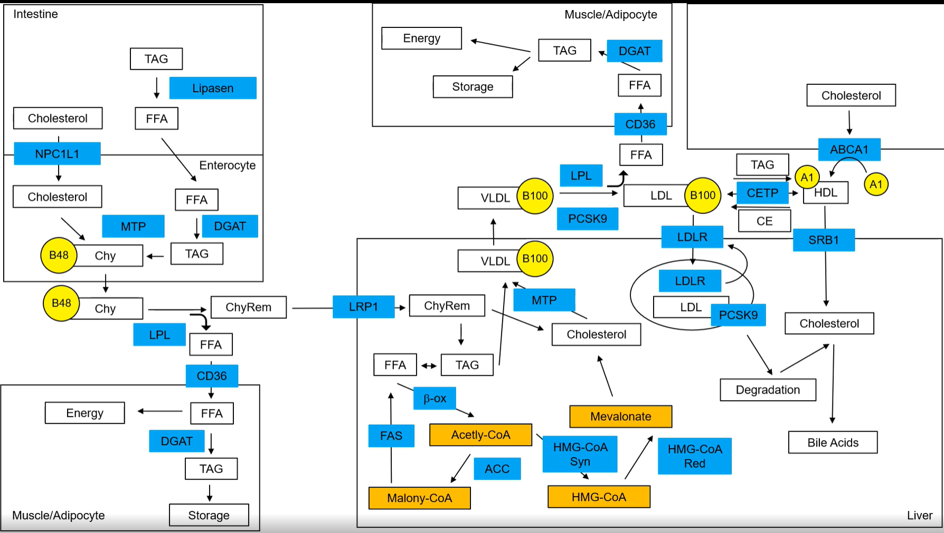
Intestine
- Cleavage of TAG’s into FFA’s by lipases for absorption, afterwards reconversion into TAG’s
  - Change of diet -> less FFA
  - Loss of weight -> less adipose tissue secreting FFA’s
- Cholesterol absorption via NPC1L1
  - even though dietary cholesterol is not very important in CAD, there is a drug blocking NPC1L1 (mostly combined with other drugs)
- Cholesterol and TAG’s get packaged into a chylomicron (tagged with Apo B-48) by MTP (microsomal transport protein) and afterwards released into the blood

Blood
- LDL is taken up by many cells due to its high cholesterol content
- Liver secretes PCSK9 which is important for cholesterol-metabolism
  - PCSK9 antibody -> less PCSK9 in the blood -> less LDLR degradation in liver -> more LDL-uptake into liver and excretion via bile acids -> lower blood LDL (weekly intake)
- CETP (cholesterol ester transfer protein) circulates and can move TAG’s from LDL to HDL and cholesterol esters from HDL to LDL (essentially making more LDL’s)
  - would make sense to inhibit CETP but there is currently no working drug on the market
Muscle
- LPL (lipoprotein lipase), which is located on the surface of target cells, can release FFA’s from the chylomicron (recognition using Apo B-28) or from VLDL’s (recognition using Apo B-100) which can be taken up by the muscle cells via CD36 and used for energy metabolism
Liver
- The chylomicron has lost a lot of its fatty acid content (but still a lot of cholesterol) and is now called chylomicron remnant and is still tagged by Apo B-28 (misses in the schematics)
- Can be taken up by the liver via LRP1 -> release of remaining TAG’s and cholesterol
- TAG’s can be used in β-oxidation (-> Acetyl-CoA) or newly synthesised
- Acetyl-CoA can also be transformed into HMG-CoA by HMG-CoA synthase which can be further modified into mevalonate by HMG-CoA reductase (rate limiting step)
  - Statins inhibit HMG-CoA reductase and thereby reduce endogenous cholesterol production and as a consequence blood-VLDL and -LDL (daily intake)
- Mevalonate is a substrate for cholesterol (raises hepatic cholesterol levels)
- Cholesterol and TAG’s get packed by MTP into VLDL which are tagged by Apo B-100 and released
- LDL can be endocytosed with and via LDLR, LDL degraded in all cases
  - if PCSK9 is present (also gets endocytosed), the whole vesicle (also the LDLR) gets degraded -> PCSK9 is a marker for sufficient cholesterol in the liver
  - without PCSK9, LDLR gets recycled
- Liver takes up HDL via SRB1
- Excess cholesterol can be transformed into bile acids and removed via faeces
How to get rid of excess cholesterol in any cell?
Reverse cholesterol transport pathway
- cholesterol exporter called ABCA1 (take lipidated Apo A1 and fill it with cholesterol -> HDL, tagged by Apo A1)

Diseases

 | Causation | Symptoms | Treatment
Leishmaniasis | Different parasites transmitted by the bite of a sandfly | Fever, weight loss, lesions | Only in mice: IL-4 or IL-4R knockout, larger Th1:Th2 ratio. (Normally Th2 against parasites but in this case, Th1 seems more effective)
Schistosomiasis | Round worm | Intestine, lung, liver damage (eggs of the worm distributed via bloodstream), dying eggs leave fibrotic plaques which leads to tissue damage, high blood pressure | IL-4 and IL-13 activate alternative macrophages (tissue repair). If deficient macrophages, the intestines get leaky -> bacterial shock
Inflammatory Bowel Disease | Inappropriate inflammatory innate and adaptive immune responses against intestinal bacteria | DC’s and macrophages secrete IL-6 and IL-23 which activate Th17 -> chronic intestine inflammation (colitis), may induce autoimmune reactions in other organs | Immunosuppressive drugs, antibiotics, surgery, antibodies against IL-6, Il-23, TNFα
Sepsis | Sepsis can be caused by many organisms including bacteria, viruses and fungi. | Common locations for the primary infection include the lungs, brain, urinary tract, skin, and abdominal organs. Low blood pressure. Can lead to life-threatening multiple organ dysfunction. | Antibiotics, intravenous fluid (and vasopressors) to elevate blood pressure
Gout | Uric acid build up (generated by breakdown of purines) | Accumulates in the body and forms crystals which can lead to painful deposits in the joints, lumps under the skin and kidney stones. | Colchicine (inhibits NLRP3 activation by uric acid) but not really understood why it helps.
Muckle-Wells Syndrome | Missense mutation in NLRP3 which leads to increased production of IL-1β | Chronic inflammation | Anakinra which is a competitive inhibitor of IL-1β
Alzheimer’s Disease | Deposits of amyloid-β plaques | amyloid-β activates NLRP3 which enhances disease progression due to chronic inflammation
Atherosclerosis | Deposition and oxidation of cholesterol-rich lipoproteins in the subendothelial space, mainly mediated via IL-1α, Oleic acid (OA, a fatty acid) triggers IL-1α production without inflammasome by mitochondrial uncoupling (leading the protons through the membrane without them passing through ATP synthase). | Pain, lesions | Exercise, healthy diet, blood thinner, bypass surgery

Exam questions me and my friends remembered:

- Explain the difference between Transition and Transversion mutations.
  - Transition: A <-> G or T <-> C
  - Transversion: A or G <-> T or C
- Co-factor of NAT?
  - Acetyl-CoA
- Inhibitory factor of ATP synthase?
  - IF1
- Ahr dimerises with which other molecule to act as a transcription factor?
  - ARNT
- What does Tamoxifen do? (Answer in 2-3 sentences)
  - Competitive inhibitor of estrogen, binds estrogen receptor (ER) -> less cell growth and proliferation
- Name one effector of Leptin signalling?
  - STAT3
- Which molecule acts on the hypothalamus?
  - Leptin
  - Insulin?
  - GLP-1
- Which molecule gets secreted by the kidney upon low perfusion?
  - Renin
- What would happen if you inhibited Angiotensin converting enzyme (ACE)?
  - Don’t remember the possible Kprim answers
- Xeroderma pigmentosum (XP) patients have difficulties with nucleotide excision repair (NER) and?
  - Translesion synthesis (TLS)
- Which is the main difference between NER as transition coupled repair (TCR) and as global genome repair (GGR)?
  - Damage recognition
- What happens in a RAG mutant?
  - ?
- What posttranslational modification of RAS happens to anchor it in the membrane?
  - Lipidation?
- You’re treating a lean patient with type 2 diabetes and hepatic steatosis. Which drug would you prescribe and why? (Answer in 2-3 sentences and only describe one drug)
  - I wrote GLP-1 analog but I’m not sure
- You’re treating a patient with a family history of cardio vascular disease (CVD) and high blood LDL. Which drug would you prescribe and why? (Answer in 2-3 sentences and only describe one drug)
  - PCSK9 inhibitor to maximise hepatic LDL uptake caused by less LDLR degradation. This leads to a decrease in blood LDL.
- Difference between CTLA-4 and PD-1?
  - They don’t bind the same ligand
  - They inhibit T cells
  - They prevent autoimmunity
- TLR’s and IL-1 activate?
  - NF-kb

- Uric acid crystals lead to?
  - Gout
  - Activation of NLRP3
  - Secretion of IL-1β
- Increased inflammasome activity leads to
  - Muckle-Wells syndrome
- Which statement is correct
  - CD36 is a FFA importer
  - SRB1 is the main hepatic importer of LDL (Wrong, it’s HDL)
  - Lipid exchange between HDL and LDL via CETP
- What happens when you give a healthy subject a superphysiological dose of insulin?
  - Don’t remember the exact Kprim answers
- Type 1 diabetes is associated with
  - Age (wrong)
  - Obesity (Wrong)
  - Destruction of β cells
  - β cell insensitivity to insulin (wrong?)
- Which domain of Src gets phosphorylated for inactivation?
  - SH1 (wrong)
  - SH2 (wrong)
  - N terminal (wrong)
  - C terminal
- What does MC4R do?
  - ?
- What is the cellular target of Bortezomib?
  - Proteasome inhibition
  - Decrease of NF-kb
- What is the function of Th17 cells?
  - Anti-fungal

