Molecular and Structural Biology Summary
HS2020 & FS2021
By JM

I tried to summarize it as densely as I could by focusing on the parts that are relevant in my view. Therefore I don’t guarantee for completeness. I recommend watching the lectures, looking at the complete study material and using my summary afterwards. I’ll provide the summary as a word document so you can easily make adjustments if you want to.

I somehow decided to start the summary by hand (Glockshuber), therefore I just scanned it and added it to the document.
I had troubles summarizing the part of Prof. Jonas since there was no lecture recording provided and I only had the slides, so I guess this is the worst part of the summary :)

Nevertheless, I hope that the summary helps you to better understand the topics.

The other document provided in the vebis website is very similar to the actual exam.

Best wishes :)
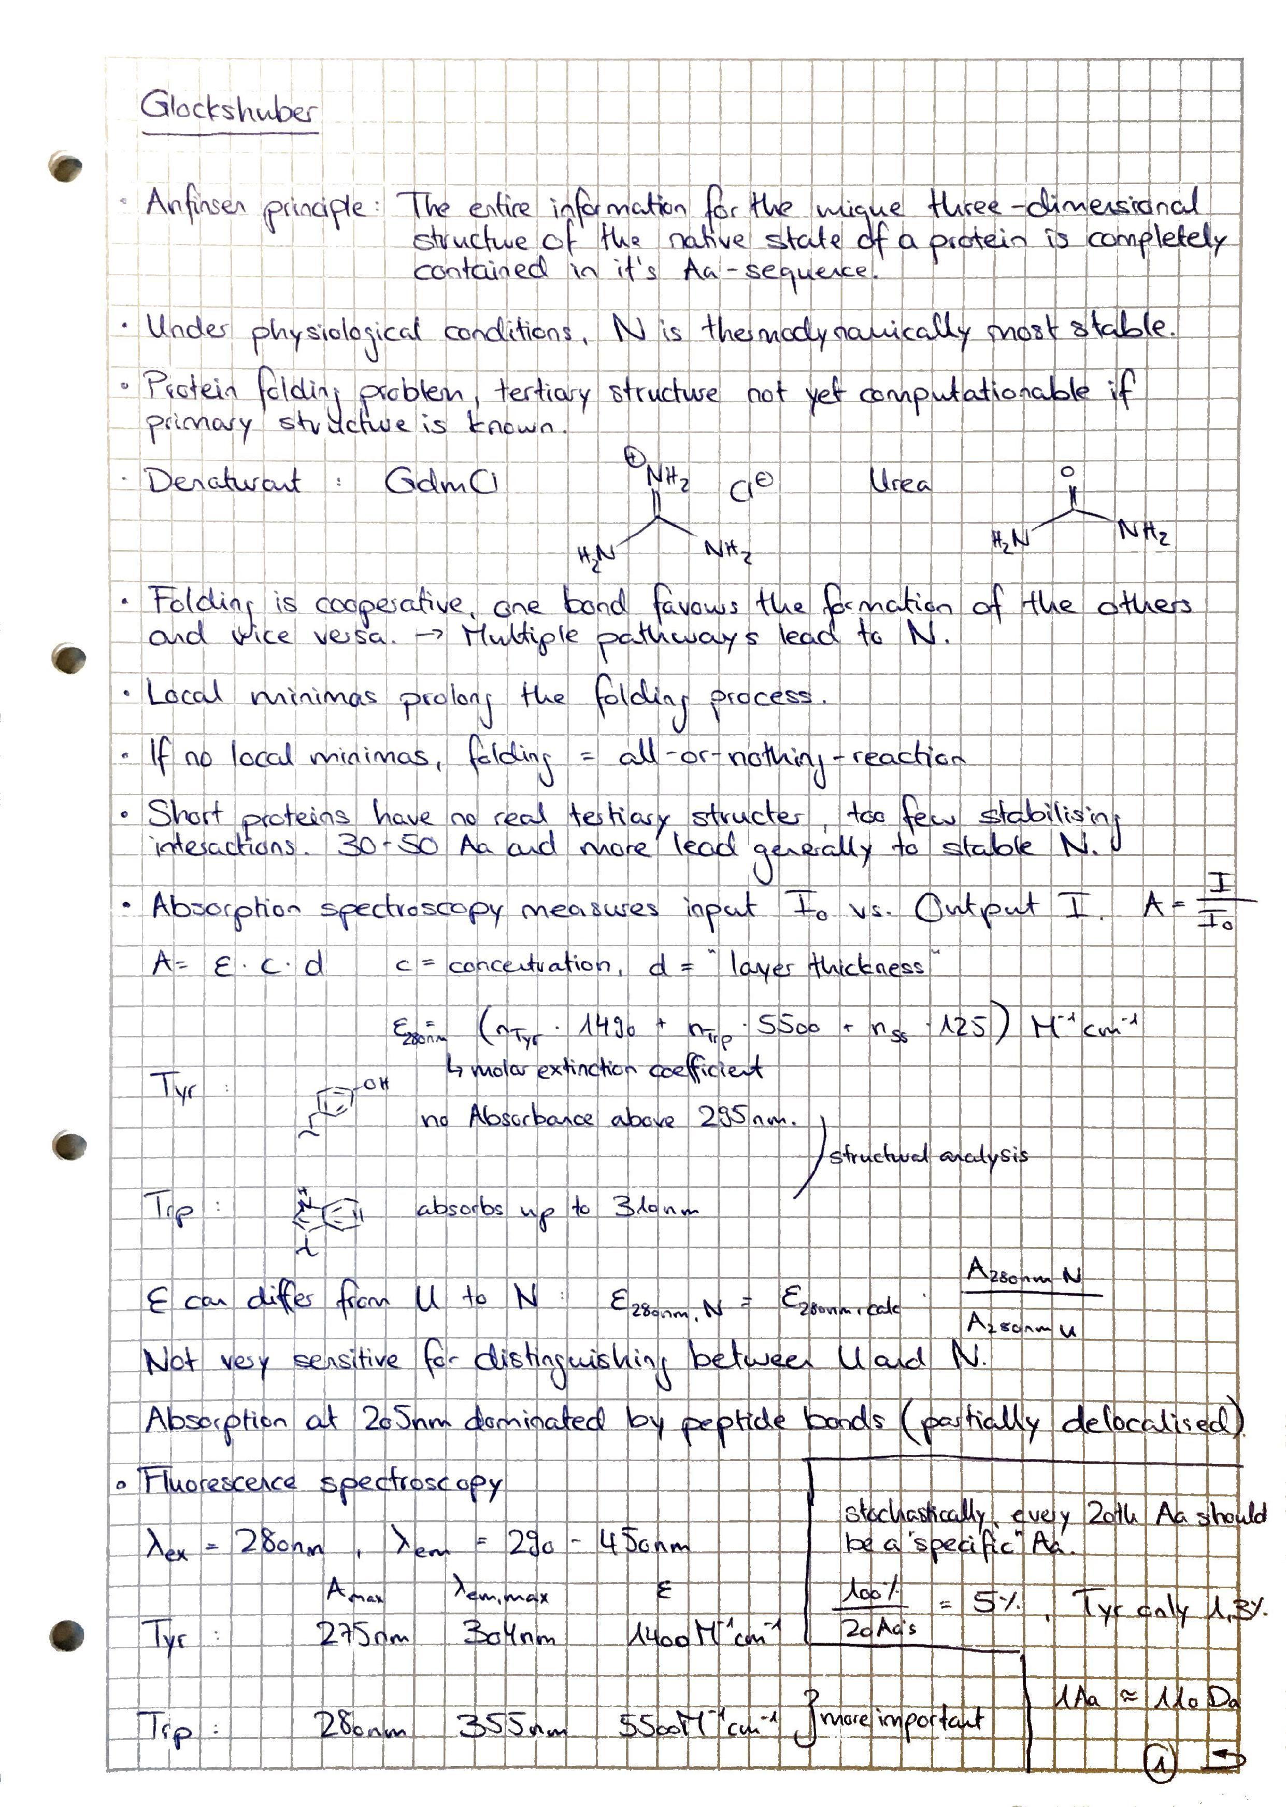
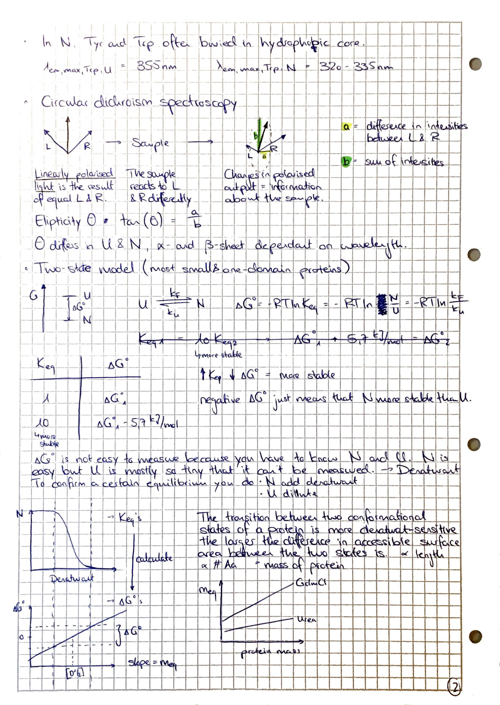
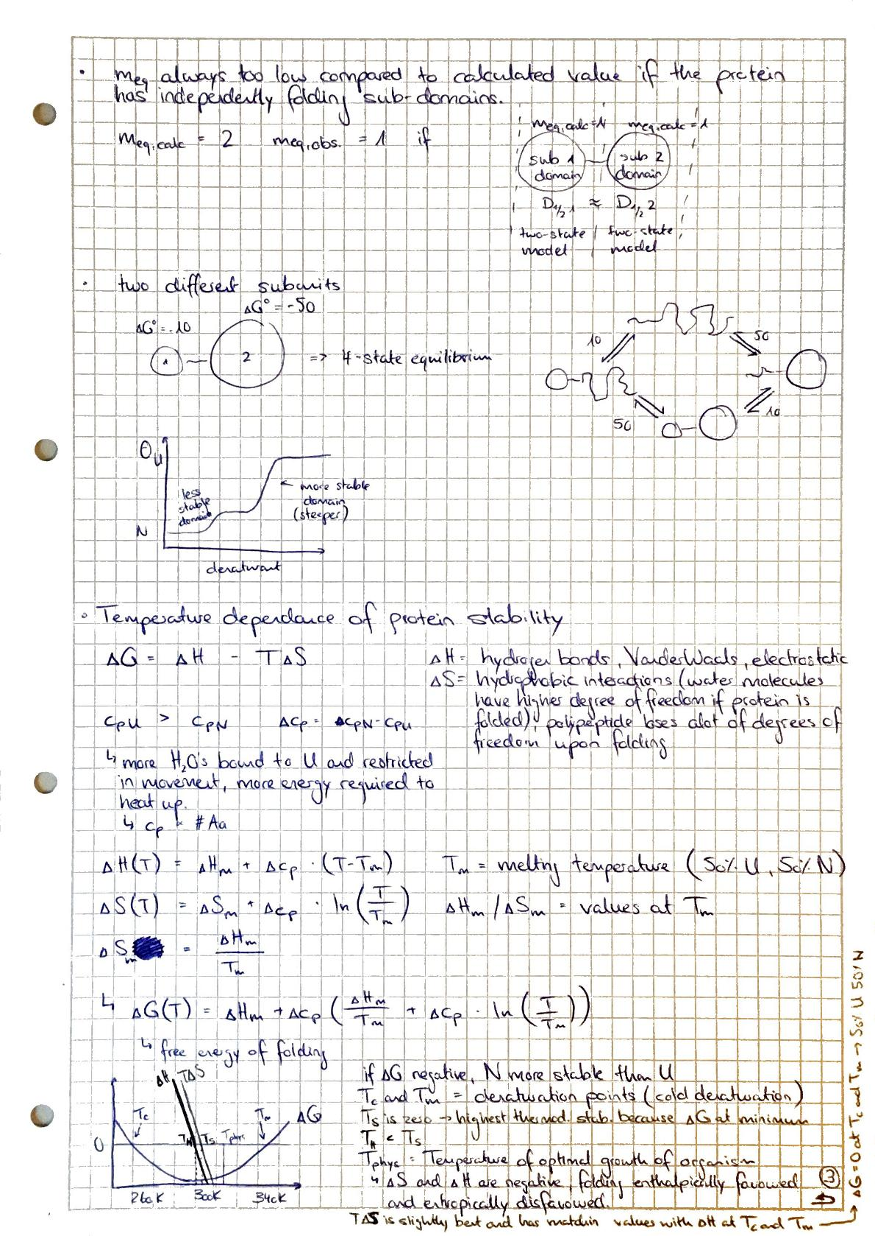
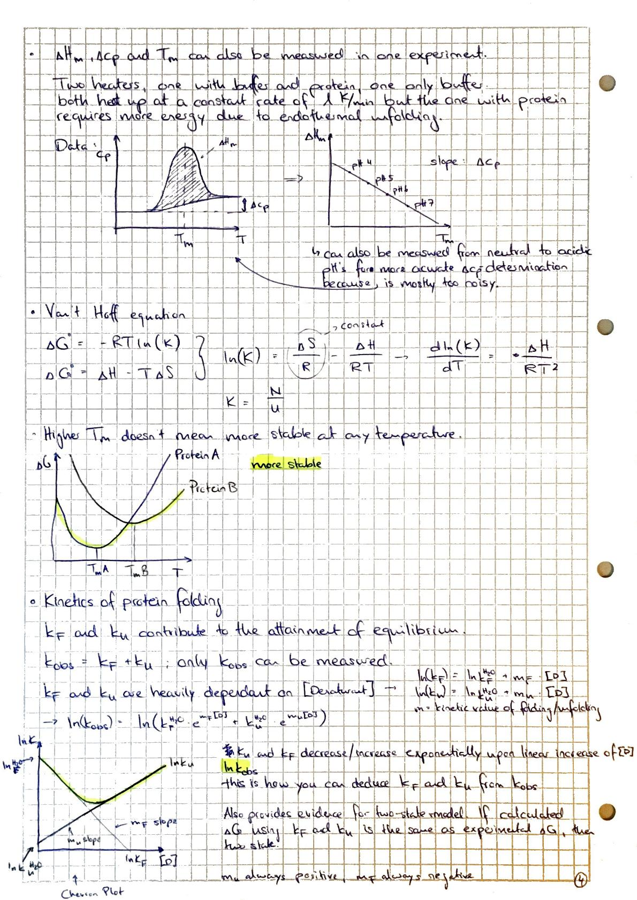
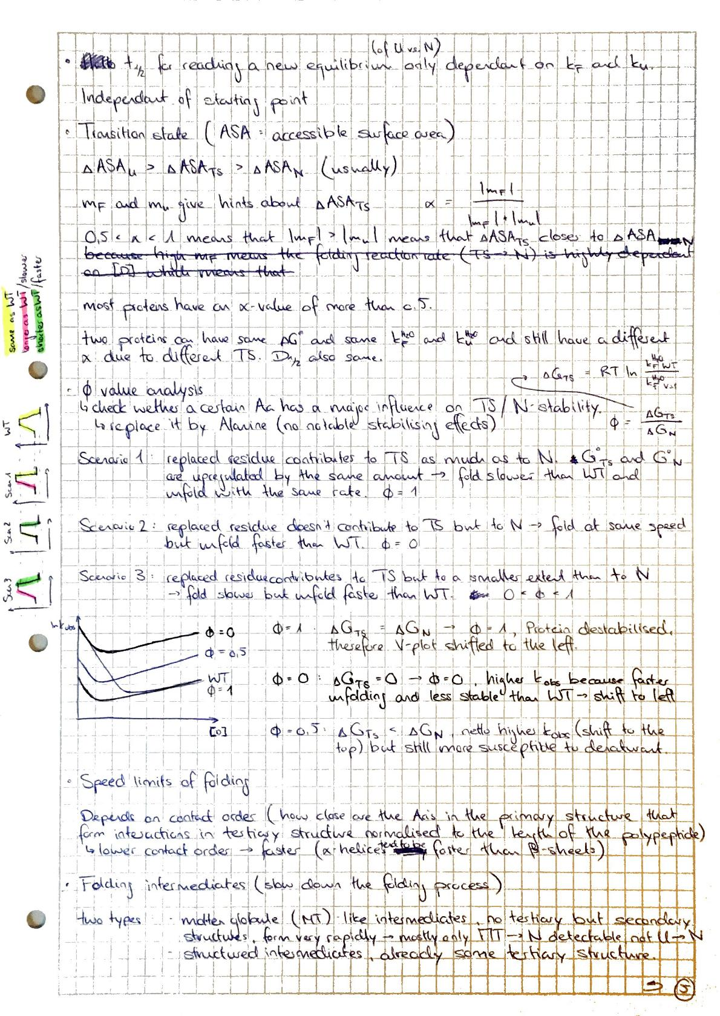
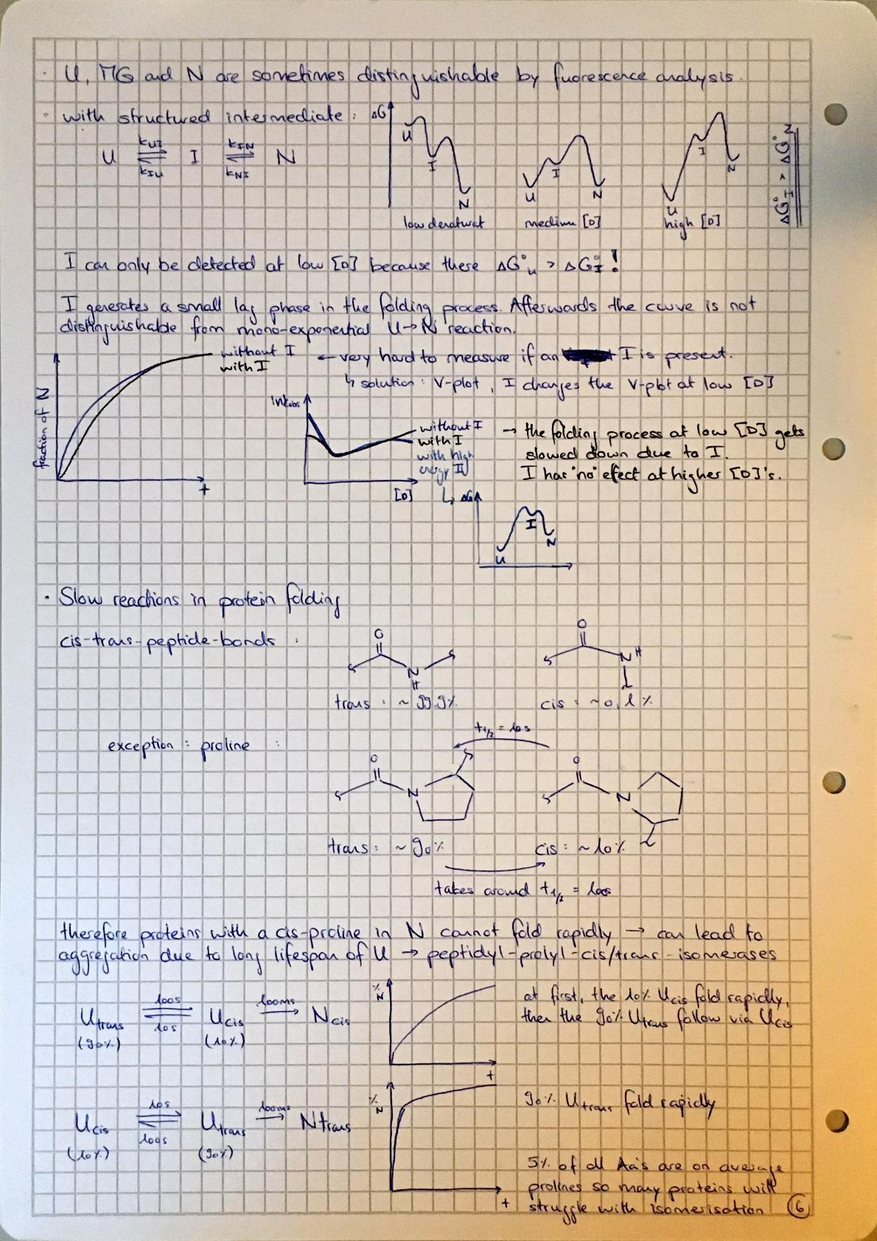
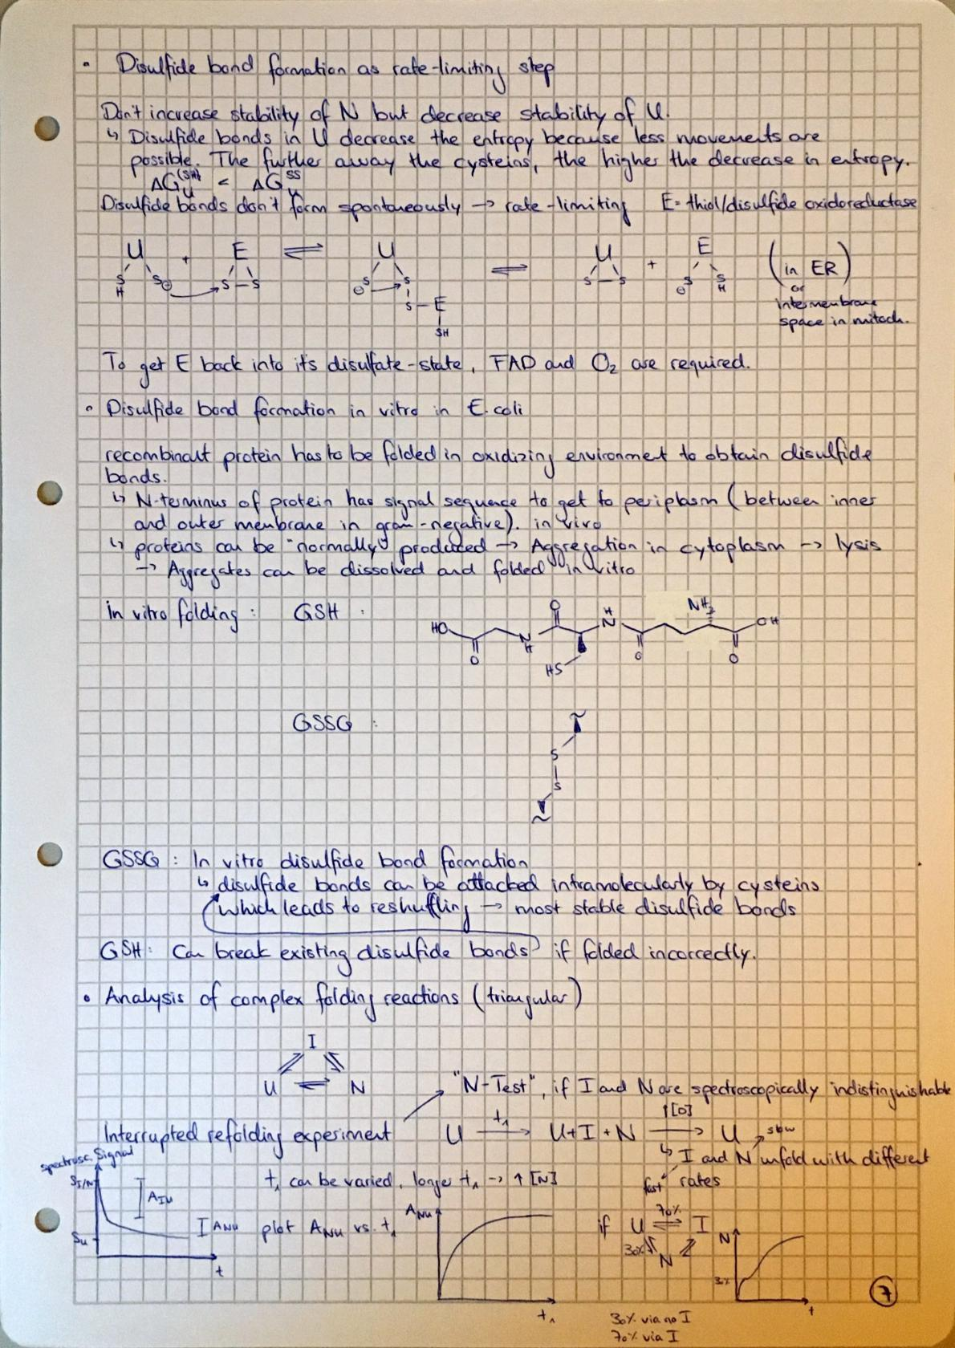

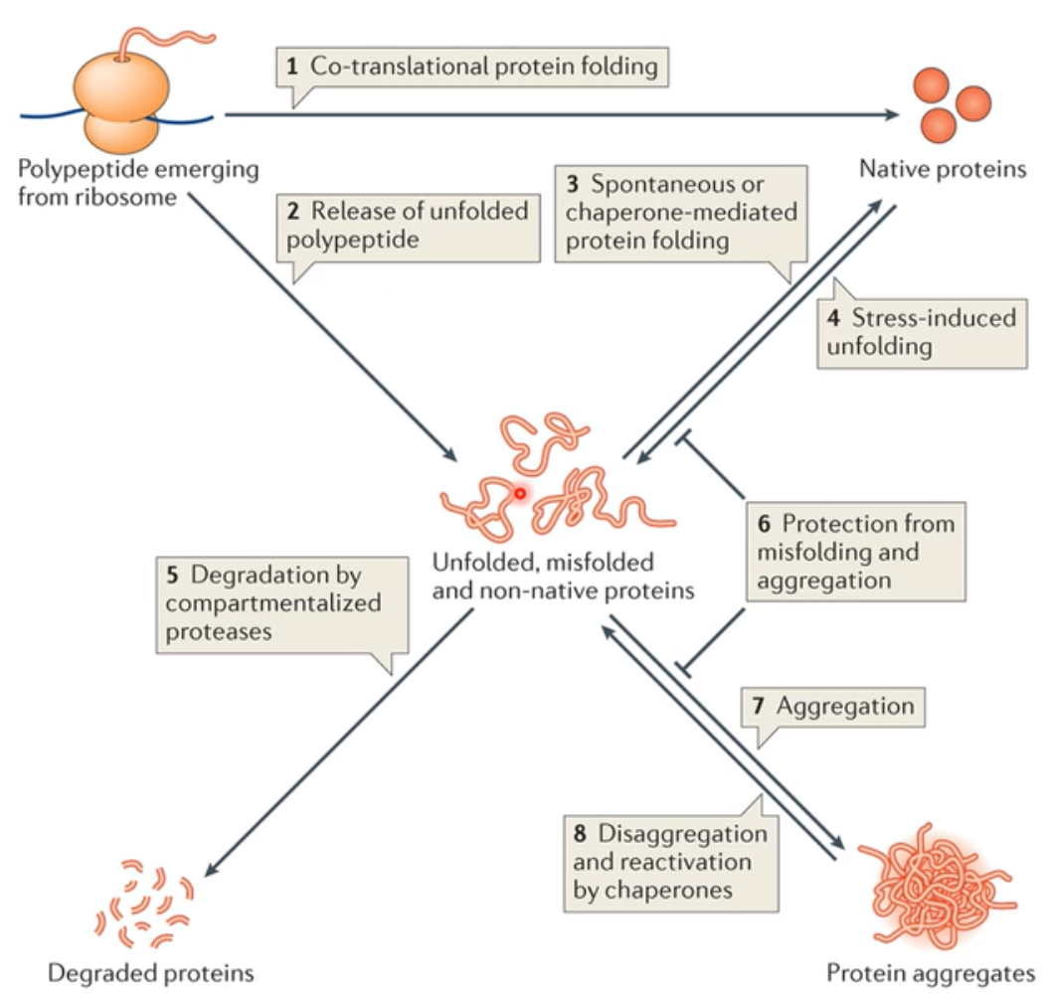
Weber-Ban
Protein quality control (mainly done by chaperones) ensures correct folding of proteins
- Chaperons aid unfolded protein to reach native state and prohibit unfolding, misfolding and aggregation (even though it would be energetically favourable for the protein)
- Chaperons (nucleoplasmin) also have a function in the nucleus where they lead to a regulated nucleosome (histones (positively charged) and DNA (negatively charged)) assembly
Chaperons
- “Molecular chaperones are proteins that assist other macromolecules in folding/unfolding and in assembly/disassembly of higher order structures without being components of these final structures”
- Cells produce a set of well-conserved HSP’s (heat shock proteins) which can protect the cell from stress-induced (heat, oxidizing conditions, toxic compounds) damage.
  - Hsp-transcription mediated via heat shock σ-factor
  - Hsp’s are mostly chaperones
  - Hsp’s are not only present during stress
- >20 chaperon-families with huge structural and mechanistic variety (found in eucaryotes (in many cellular compartments) and procaryotes)
Main function:
- Assist folding process by masking hydrophobic patches of substrate unfolded protein to inhibit aggregation based on hydrophobic interactions
  - Hydrophobic patches will be mostly buried inside the native protein
- Important during:
  - Co-translational (when nascent chain exits the ribosome)
    - Trigger factor (chaperone), attached at the exit tunnel of the ribosome
    - Hsp70/40 system, not attached to ribosome
  - Post-translationally
    - GroEL-GroES
  - translocation (mostly unfolding and refolding of protein)
  - multi-subunit assemblies
  - stress
Anfinsens’s Dogma:
- “All the information necessary to direct the 3D-structure of a protein resides in its Aa-sequence”
  - Most proteins fold correctly in vitro
  - Since in vivo is very crowded, chaperons are used to prevent any “side reactions”. They don’t contain folding information, they only increase the yield of correctly folded, functional proteins.

Hsp70/40 chaperone system
Hsp70 (DnaK) Functions:
- Protein aggregation prevention
- Protein disaggregation
- Protein refolding
- Protein degradation
- De novo protein folding
- Protein translocation
- (dis)assembly of protein complexes
- Regulation of protein activity
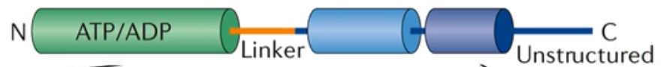
Hsp70 Structure:
- Highly conserved, N-terminal ATP binding domain
  - 3D structure of two lobes separated by a deep cleft where the ATP binding pocket is located (two phosphate binding loops and an adenosine binding pocket, common for ATP binding pockets)
- C-terminal substrate binding domain
  - light blue = conserved, 2* 4-stranded β-sheets
    - binding pocket
  - dark blue = less well conserved, α-helix which spins back over sheets
    - functions as a lid to allow entry and release of substrate (controlled by ATP binding domain)
Hsp40 Functions:
- stimulate ATPase activity of Hsp70, followed by lid-closing
- after ATP hydrolysis, the affinity of Hsp70 for Hsp40 is reduced
Nucleotide exchange factor (NEF, GrpE)
- triggers ADP release, followed by lid-opening
- after ADP release, ATP can rapidly rebind
- most of the Hsp70’s require GrpE-like chaperones
Whole cycle:
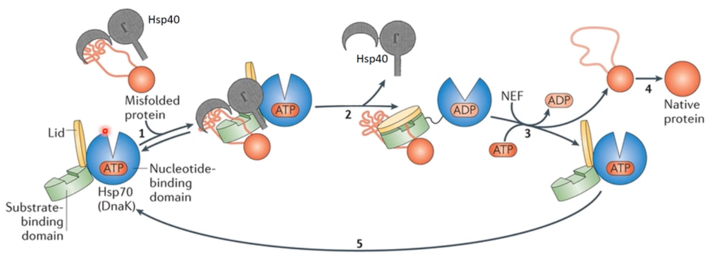

Hsp90
- all substrate are close to the native state and involved in signalling (e.g. TF’s, signalling kinases)
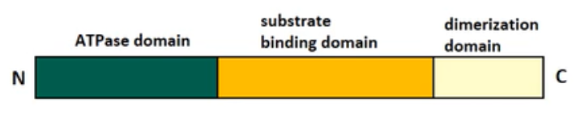
- flexible homodimer
- exists in open and closed confirmation
  - open conformation leads to ATP binding and exposes hydrophobic patch
  - closed confirmation leads to lid-closure on ATP pocket
  - co-chaperone factors lead to dimerization of N- and middle domain -> clamp down on the substrate
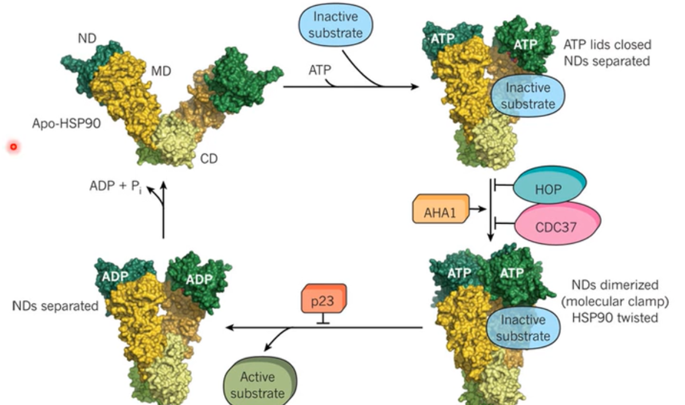
  - Many factors inhibit or promote certain conformational changes

E.coli Chaperonin GroEL/ES
Compartmenting chaperone
GroEL:
- Blue (cis-ring) and red (trans-ring), they are identical and can both work as cis- or trans-ring
- Double ring (each 7-membered) with larger cavity inside
- Each subunit is made of an apical, intermediate and equatorial domain
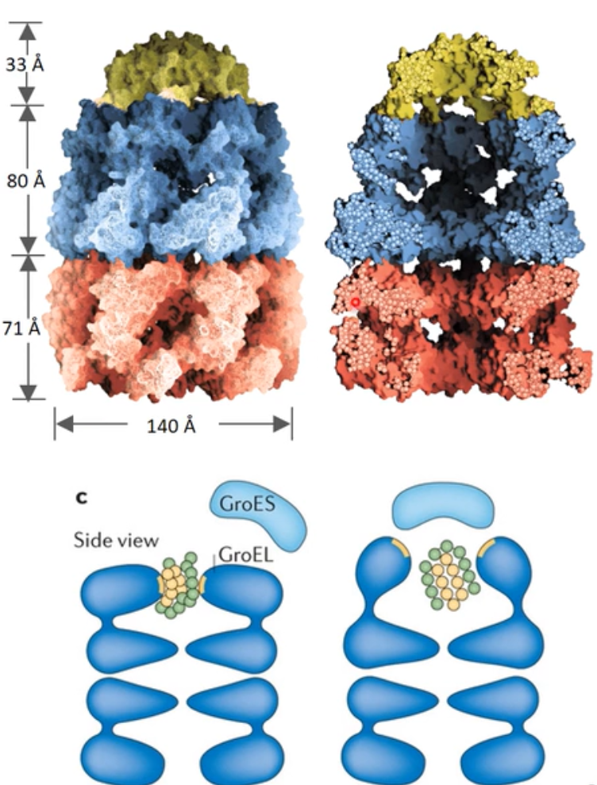
  - Apical: surrounds openings at the end of the cylinder and is locally flexible (connected by a hinge to the intermediate domain), closes upon ATP and GroES binding, at first, hydrophobic residues enable substrate binding -> twist of 90 degrees exposes hydrophilic residues to the protein which leads to a folding process
  - Intermediate: slender domain linking apical and equatorial
  - Equatorial: connects both rings and has many α-helices

GroES:
- Yellow
- Changes confirmation of blue ring and forms closed chamber between blue and yellow
- Consists of β-barrel and two hairpin loops
  - Smaller loop forms top of the dome
  - Larger loop (mobile loop binds GroEL
Mechanism:
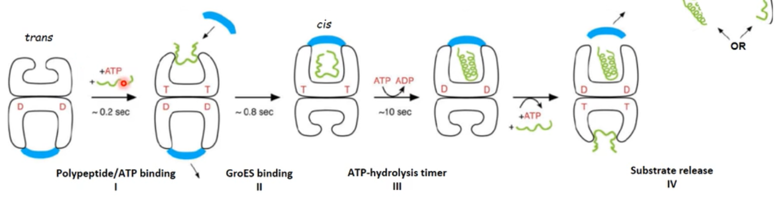
- ATP hydrolysis takes around 10s -> GroES release, release of protein (independent of confirmational state) and enabling the trans-ring to bind ATP and start a new cycle

Hsp100/Clp proteins
- Ring-shaped homohexamers
- Act as classical chaperones and helps target proteins in their folding process but some cooperate with proteases and are therefore also associated with unfolding and destruction of target proteins
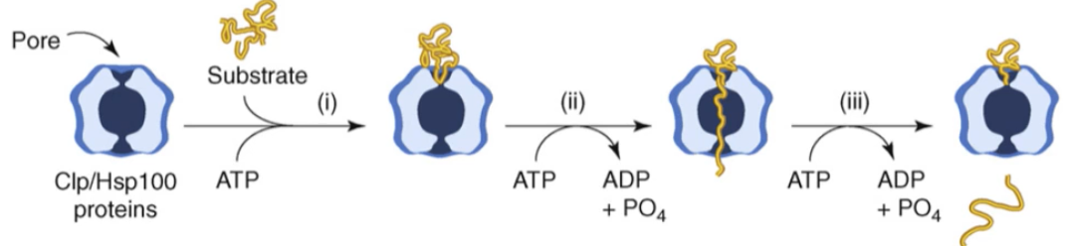
Mechanism:
ClpB/Hsp104 chaperon:
- ClpB is bacterial, Hsp104 is the eukaryotic homolog
- Disaggregate target protein without protease-association
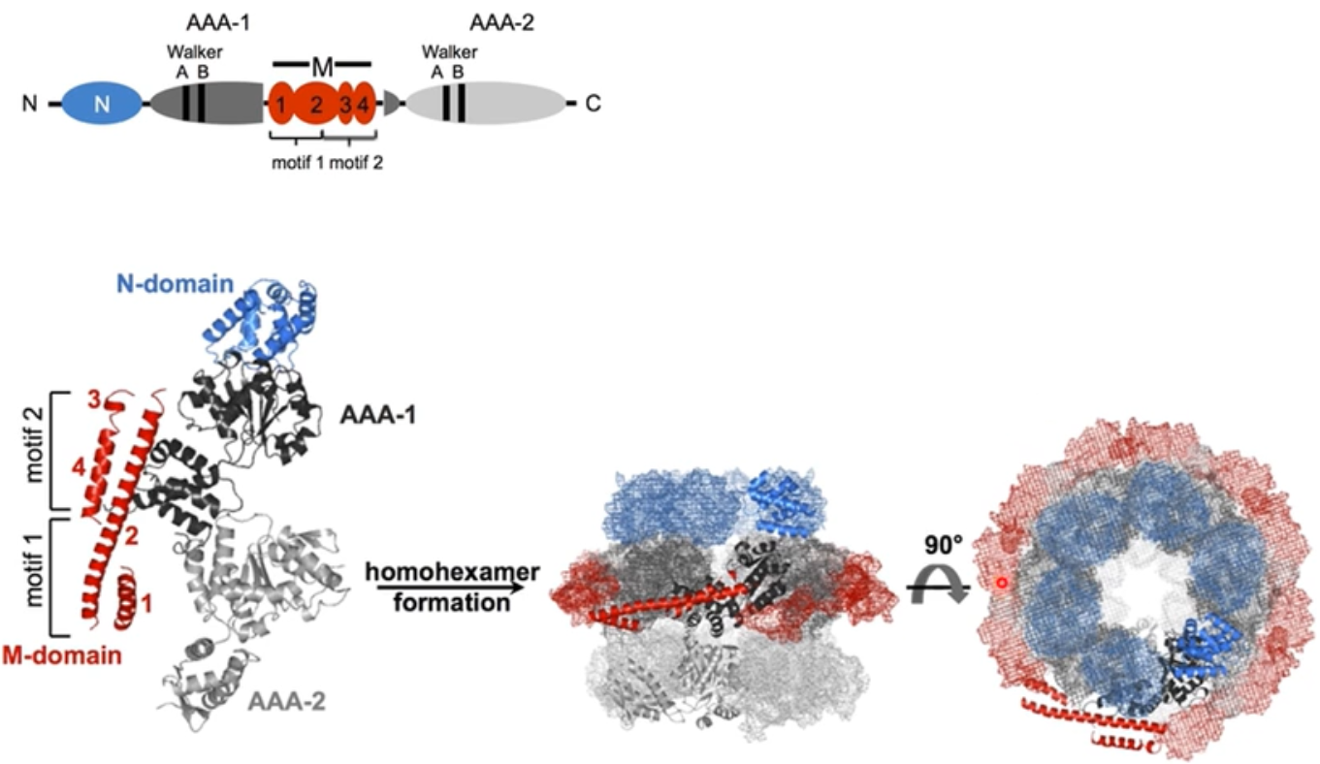
- Works like a translocation protein
Mechanism:
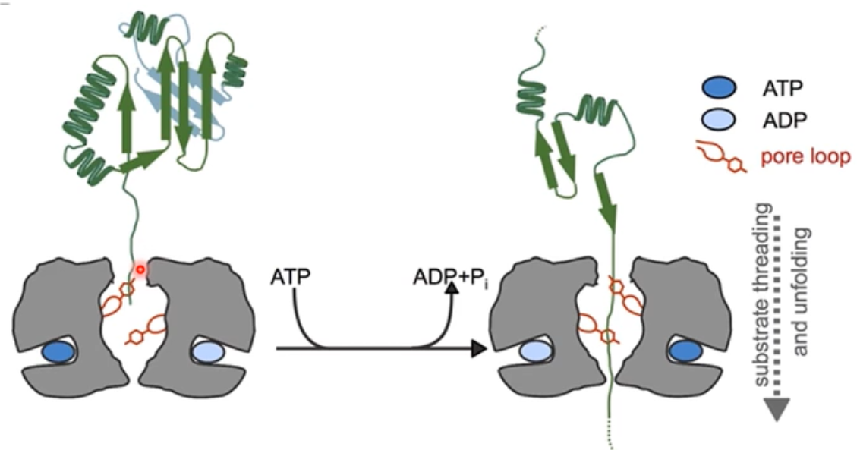
- Tyrosine residues at the end of the pore loops

Protein folding in the ER
Post-translational modifications:
- Signal sequence cleavage
- N-linked glycosylation
- Disulphide bond formation and reshuffling
Unfolded protein response (UPR)
- Under conditions of stress, chaperone-transcription is elevated to minimize damage
ER-associated degradation (ERAD)
- Misfolded proteins that are beyond repair will be retrotranslocated to the cytosol, polyubiquitinated and degraded
Main ER-chaperones:
- Hsp70/40
- Hsp90
Protein degradation
- Not just damaged, misfolded or aggregated proteins get degraded, also important for signalling and general protein homeostasis
- Always compartmentalized (to minimize collateral damage)
- Folded proteins have to be unravelled for degradation
- Proteases hydrolyse peptide bonds
  - High activation energy but overall energetically favourable (negative ΔG)
    - Peptide bond is kinetically stable due to its resonance structure which also makes the carbonyl carbon less electrophilic
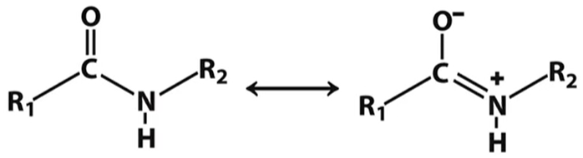

Protease Catalysis principles:
Water is too weak of a nucleophile so the reaction has to be catalysed.
Covalent catalysis:
- Stronger nucleophile: Cysteine (S⁻), Serine (O⁻) or Threonine (O⁻)
  - Have to be activated first by 3D-neighbouring residues (Triade: Asp-His-Ser)
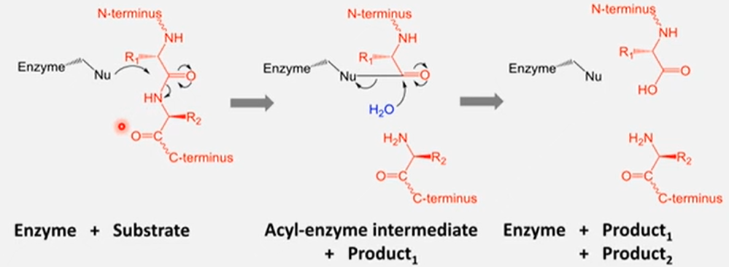
- After the nucleophilic attack, the carbonyl c is more electrophilic and water is now a strong enough nucleophile to hydrolyse
Non-covalent catalysis
- No covalent intermediate is formed
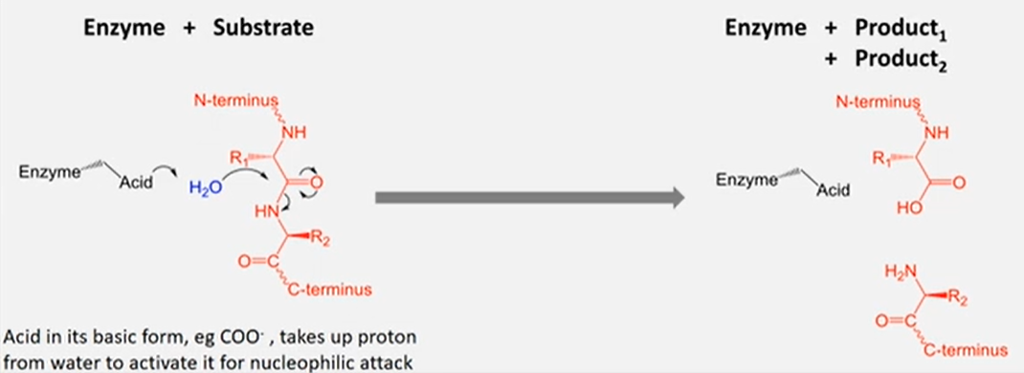
- Water is the nucleophile which gets strengthened by the enzyme via Aspartate, Glutamate or metal ions

AAA proteins (ATPases associated with various cellular activities)
- Mediators of conformation or assembly state of proteins or nucleic acids
  - Disassembly
  - Translocation
  - Unwinding of DNA duplex
- Usually in a six-membered ring confirmation
  - Subunits named RPT1, RPT2, …, RPT6
- ATP binding site in between the two domains and in between neighbouring subunits -> both subunits contribute residues for the ATP hydrolysis
- P-loop domain on the inside of the ring
Mechanism of ATP hydrolysis:
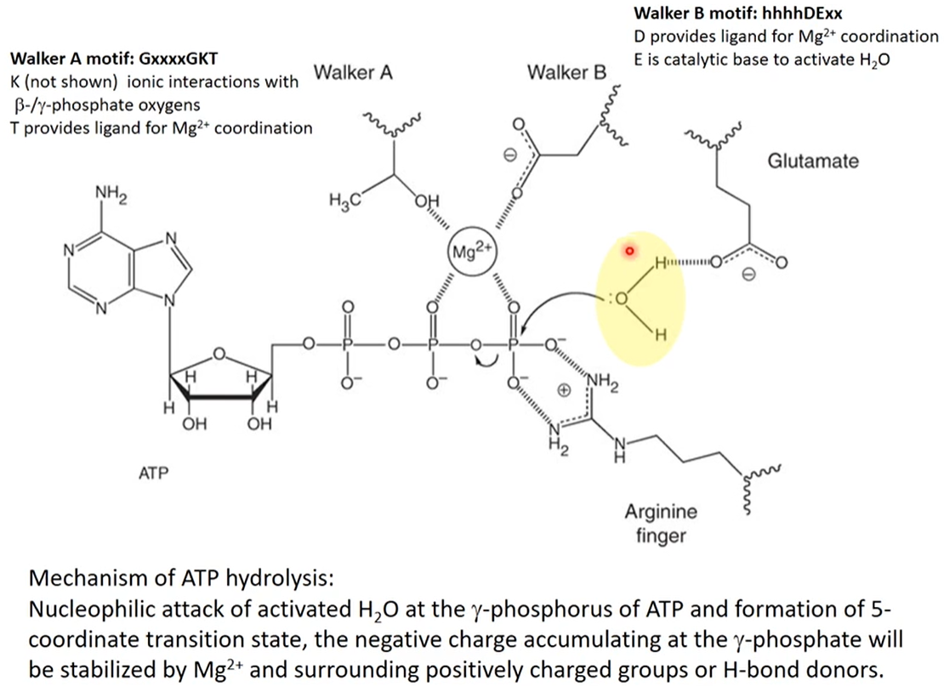
Protease architecture
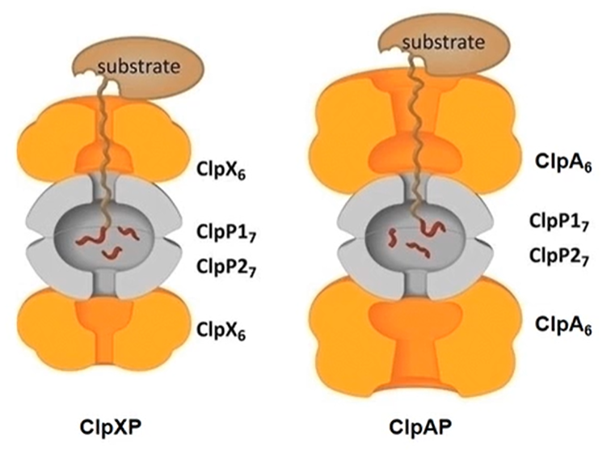
- Grey = proteolytic core (core particle), narrow entrances at either side and the active sites in the middle
- Orange = ATPase (AAA) rings with aligned pores
- Two typical bacterial proteases, same core but different chaperones/AAA
- Substrates recruited by ClpA:
  - SsrA-tagged substrates, special 11 Aa C-terminal sequence
    - If a ribosome stops translation unintendedly (e.g. missing Aa’s) the tmRNA (molecule with tRNA and mRNA components) binds the ribosome ant the 11 Aa’s sequence is added -> the protein dissociates and gets degraded and the ribosome is free for the next translation
  - N-end rule substrates
    - N-terminus destabilizing Aa’s are big and hydrophobic (F, L, W, T) which get bound by ClpS which directs them to ClpA
    - formyl Methionine first Aa at the N-terminus and usually cleaved off, except it is neighboured by a F,L,W,T. If it nevertheless gets cleaved off it indicates, that the protein is damaged, therefore it gets degraded
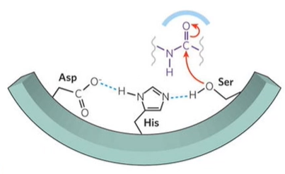
- ClpP is a serine protease
  - Triade(Asp-His-Ser)

The Ubiquitin-Proteasome System (UPS)
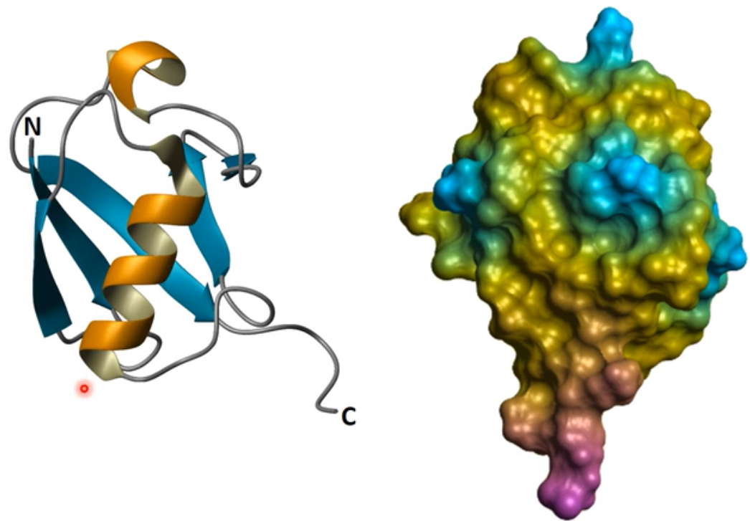
Ubiquitin:
- Only in eukaryotes (highly conserved, 76 Aa’s)
- Β-sheet “grasping” a diagonal α-helix
- C-terminal very accessible (glycine residue (no side chain -> many degrees of freedom) which gets covalently linked to target protein and/or another ubiquitin)
- Used for marking of target proteins (covalent, post-translational modification) for degradation, signalling or DNA repair
- Ubiquitin has itself 7 Lysine (K) and one Methionine (M) residues which can be ubiquitinated -> polyubiquitination
  - K48 polyubiquitination -> proteasomal degradation
- There exist many types of ubiquitinations (different conformations for different signals)
  - Monoubiquitination
  - Multi-monoubiquitination
  - Polyubiquitination (several in a row)
    - Homotypic (always the same linkage)
    - Heterotypic (linkage changes)
      - Straight or branched
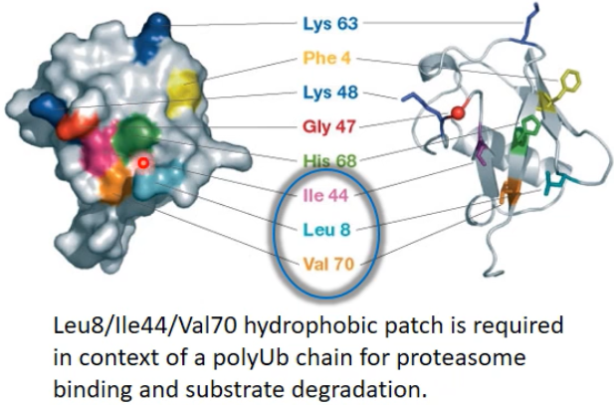
- hydrophobic patch right by the C-terminus is essential for ubiquitin-protease-interactions

Mechanism:
- Ligation is made by a cascade of enzymes (E1, E2, E3)
  - Only 1 E1, few E2’s, many (~1000) E3’s
  - E3’s determine the type of ligation and are selective for target proteins
    - All E3’s have a E2-Ub- and a target protein binding site
- E3’s recognise target proteins by:
  - Recognins (type of E3’s) recognise according to the N-end rule
    - UBR-Box recognins recognise mainly arginines and lysines
    - N-Box recognins recognise mainly hydrophobic residues (F,Y,W,L,I)
  - PEST (Pro-Glu-Ser-Thr) sequence
  - Cycline destruction boxes (CDB’s, 9 Aa-sequence)
    - Especially present in cell cycle dependant polyubiquitination

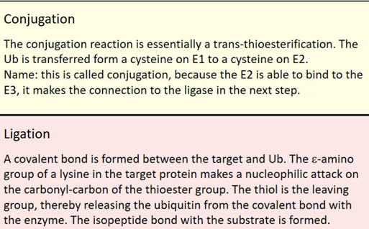
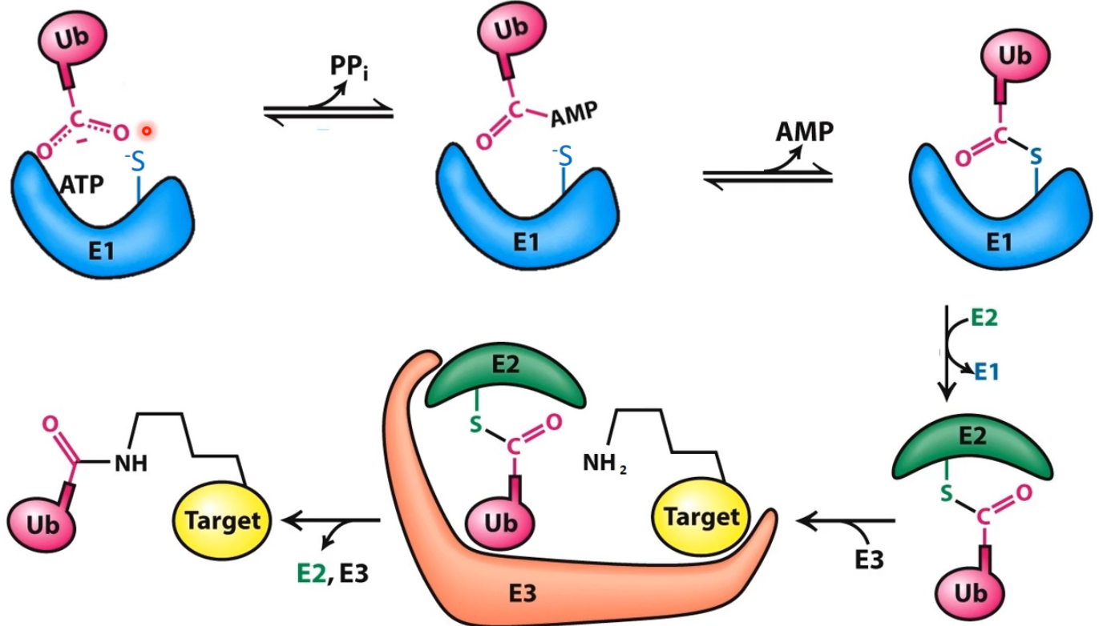

  - Two main types of E3’s
    - RING-type ubiquitinates directly
    - HECT-type ubiquitinates indirectly via cysteine
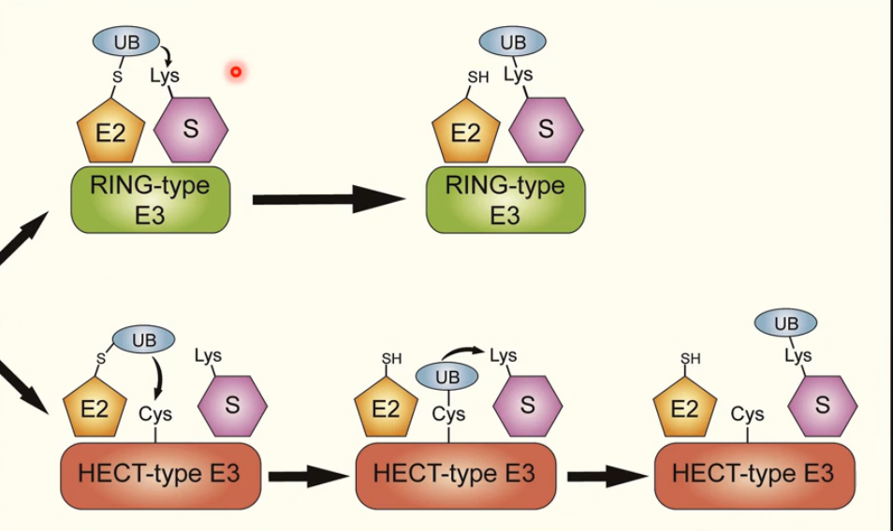
E3-RING type
Usually generate signals that leads to proteasomal degradation of target protein
- Monomeric
- Homo- or heterodimeric
- Multi-subunit complexes (substrates usually also have to be phosphorylated to be recognised which adds another layer of control)
  - SCF ubiquitin ligase
  - APC ubiquitin ligase
Anaphase-promoting complex (cyclosome or APC/C)
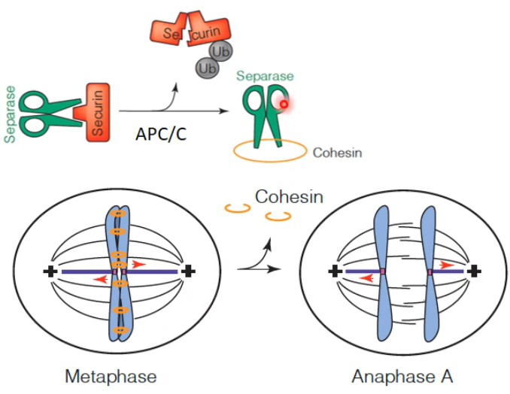
- polyubiquitination of securin
- release of separase which cuts cohesin -> enables transition from metaphase to anaphase
- uses Ubc4 (E2) for first ubiquitination followed by elongation using Ubc1 (E2) -> K48 polyubiquitination

The 26S Proteasome
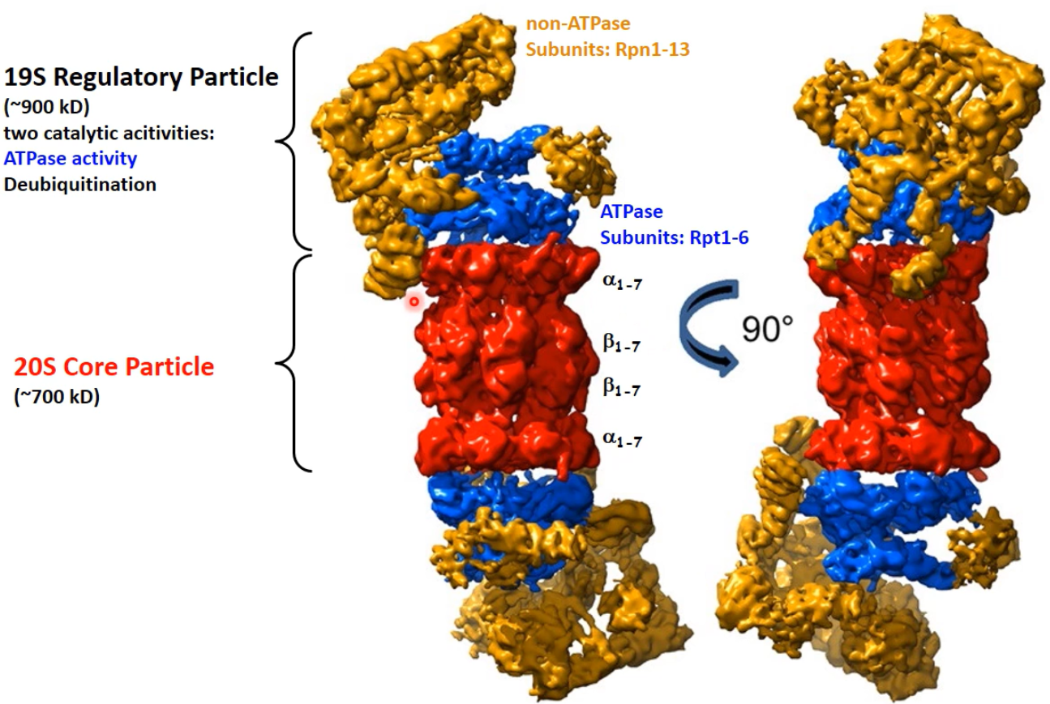
- responsible for all eukaryotic, cytosolic protein degradations
- Core particle consists of 4 rings, inner β-rings and outer α-rings
- Regulatory particle consists of:
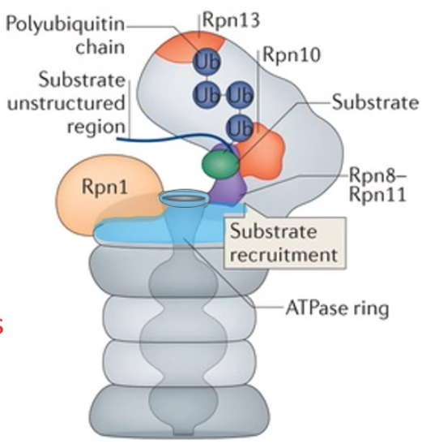
  - Non-ATPase subunits (Rpn1-13)
    - Rpn10 & Rpn13 have Ub receptors (at least 4 K48 ubiquitins to bind to Rpn10 and Rpn13)
    - Rpn11 is deubiquitinating the target protein to recycle the ubiquitins
    - Polyubiquitination is not sufficient for efficient degradation, the target protein has to have a loosely structured tail that can serve as thread to be pulled into the proteasome
  - ATPase (AAA module, called Rpt1-6, 6 different subunits)
    - Build a tyrosine (Y) ‘spiral staircase’ around the incoming polypeptide chain 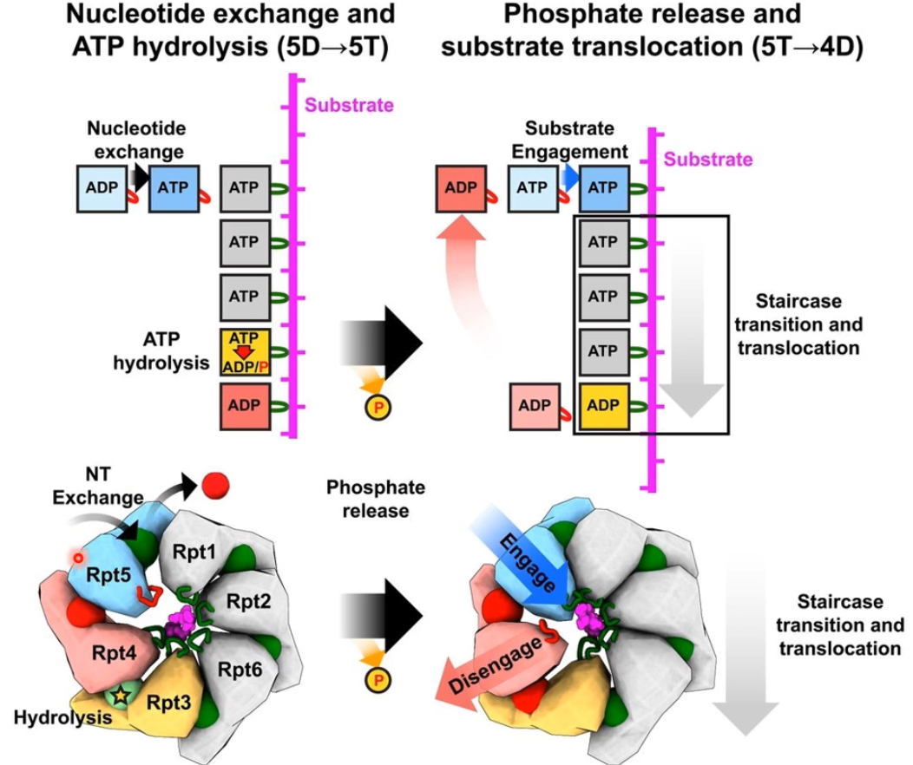
    - 5 of the 6 subunits are engaged via their tyrosine residue with the substrate
    - All engaged subunits have ATP bound and are flexible enough to have different confirmations to move the polypeptidechain
- The 26S Protease is a N-terminal threonine protease
  - Free N-terminal amino group of β-subunit acts as a base to activate the threonine sidechain
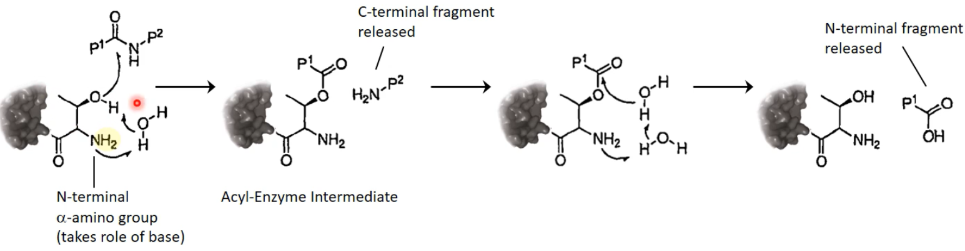

Locher
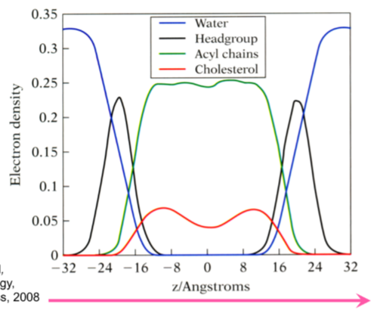
Membranes
1nm = 10Å
- Molecule distribution of a lipid bilayer
- Basically no water inside the membrane (little water exchange is possible)
- Membrane positively charged on the outside and negatively charged on the inside
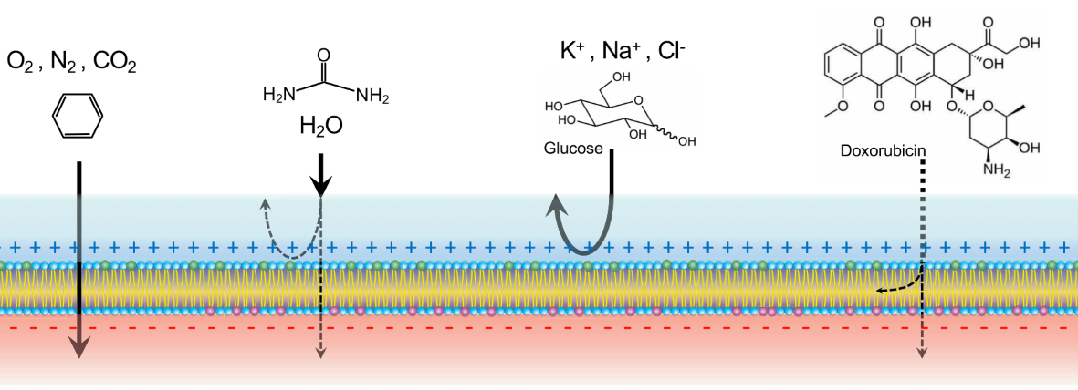
Transporters
- Passive transporters
  - Dependant on concentration gradient, electric field, etc.
  - Transport until ΔG=0
  - bidirectional
- Primary active transport
  - Against concentration gradient
  - ATP dependant
  - Unidirectional
- Secondary active transport
  - Symporter
    - Passive transport of substance 1 (energy source)
    - Active transport of substance 2 in the same direction
    - Both substances bound at the same time
    - Theoretically bidirectional
  - Antiporter
    - Same as symporter but substrate 1 and substrate 2 are transported in opposing directions
    - Only one substrate at a time can be bound
- Synthesis happens usually with the help of Sec61 which directs the ribosome to the ER membrane and the protein gets translated directly into the membrane
  - Transmembrane domains located in the membrane
  - ICL = intracytoplasmic loop
  - ECL = extracytoplasmic loop
- Every amino acid has a certain hydrophobicity value which can be used to predict transmembrane-sections of a Aa-sequence (high values = hydrophobic)
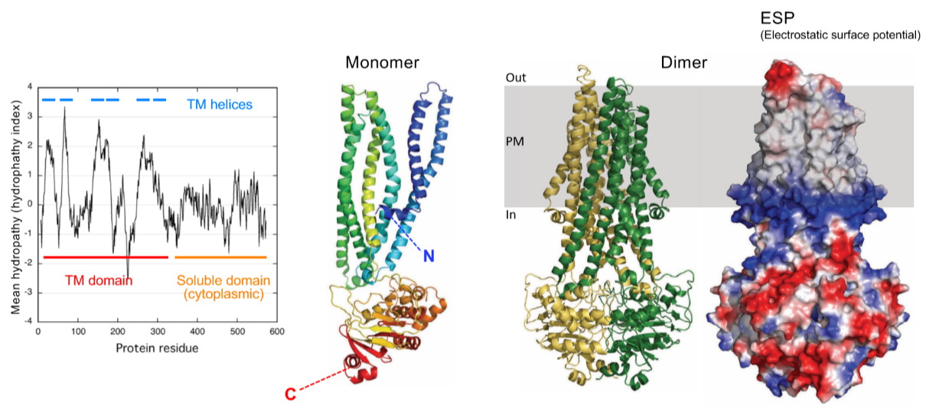
  - Hydrophobicity values of neighbouring Aa’s have to be averaged (always in odd numbers (called slider window), the higher the number, the less noise in the plot ant the easier the interpretation)

  - Grey = uncharged
  - Blue = positively charged
  - Red = negatively charged
  - Very hard to separate different transmembrane-sections -> hard to predict whether the loops are ICL or ECL
  - Variety in transmembrane-sections is big (e.g. there are sections that are in the membrane but are buried inside the rest of the protein and therefore doesn’t interact with the lipids and hasn’t to be especially hydrophobic)
    - Later analysis showed that the buried sections of either transmembrane and cytosolic proteins don’t differ in their hydrophobicity, they are both mildly hydrophobic
- Blue ring at the inside of the membrane is an example for the positive inside rule
  - Many arginines and lysins in ICL
  - Important for directionality of protein, if the positively charges Aa’s are replaced by other Aa’s, an ICL might become an ECL
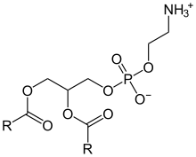
  - Positive charges determine the orientation of a transmembrane protein
  - Asymmetrical lipid bilayer (especially phosphatidylethanolamine (PE)) helps establish the positive inside rule
    - If PE is removed, the cell has troubles inserting the transmembrane proteins correctly
In vitro transmembrane protein analysis
- Full cell: plasma membrane protein
  - Closest to physiological conditions
  - Usually low signal:noise ratio (SNR)
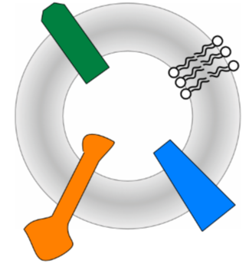
- Native membrane vesicles (liposomes)
  - Made out of cellular membrane but the cytoplasm and its organelles are removed
  - Better SNR but still difficult to distinguish the different membrane proteins from one another
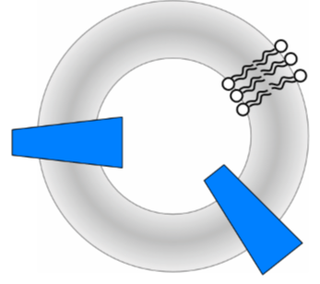
- Lipidic membrane vesicles (proteoliposomes, large unilamellar vesicles (LUV))
  - Purified protein -> better SNR
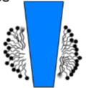
  - Hard to control the orientation of the transmembrane proteins because a uniform lipid bilayer is used
- Micelles
  - Purified proteins using detergents and studied in this form
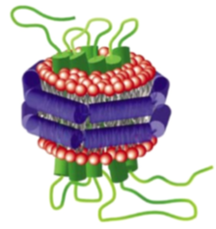
- Nanodiscs and other scaffolds
  - Derivative of Apo A-1 which encircles the membrane and target transmembrane protein

Aquaporin
Was discovered by the following experimental procedure:
- Isolate the protein from an SDS page
- Analyse first N-terminal Aa’s and translate it into mRNA
- Search in the genome for a similar sequence
- Express this gene in a frog oocyte because they have very low water permeability
- Stress them and control cells with distilled water
  - Controls stayed intact
  - Target oocytes exploded due to rapid osmotic water influx
Topology:
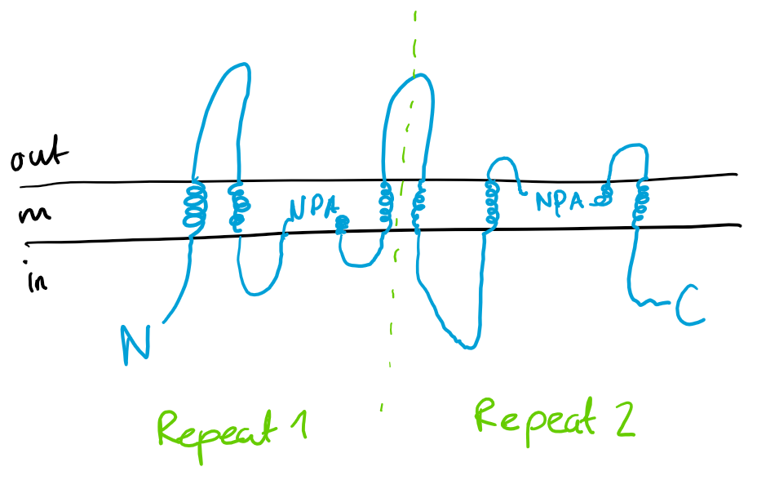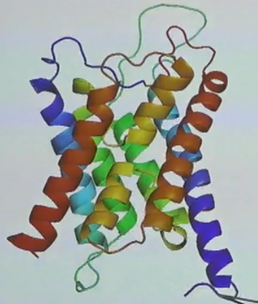
- NPA = Asp-Pro-Ala
- Pseudo-symmetric also in the 3D model (due to gene duplication)
  - Rotation axis perpendicular to screen in the middle of the two yellow half-helices
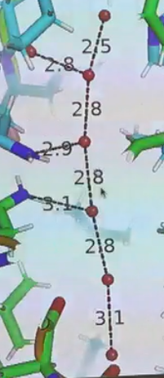
- Aquaporins are actually tetramers, but the monomers work independently, so an aquaporin complex has 4 water gateways
- Are remarkably hydrophobic
  - If there were strong hydrogen bonds the water molecules would be stuck in the aquaporin
  - Hydrophobicity also enables fast water molecule transfer since it doesn’t need a lot of energy to move the water molecules
- Red = water molecules
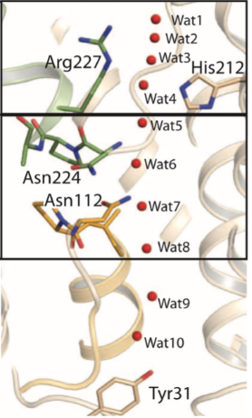
- Few hydrogen bonds, only ones with the asparagines in the two NPA’s
- Wat = possible water positions
  - Wat1, 2 and 3 are too close to each other, it’s either 1 & 3 or 2 & 4 occupied

Why no H⁺-transport?
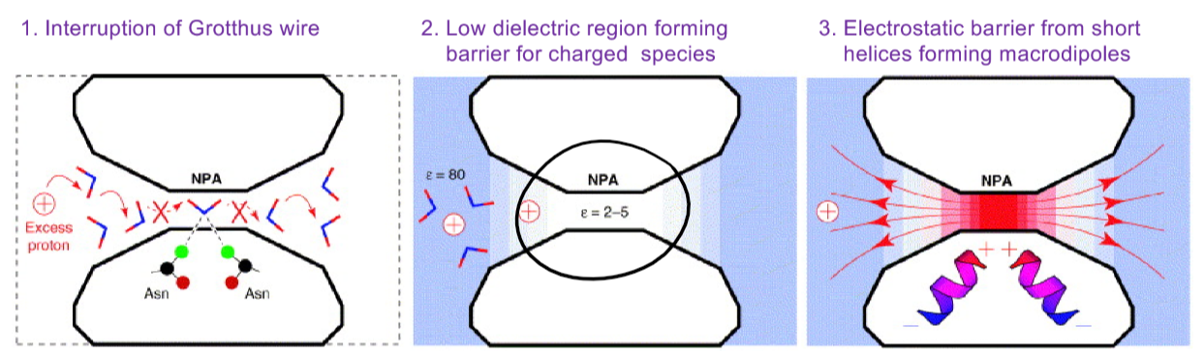
3 hypothesis:
- Grotthus wire is a way in which water molecules can transport protons fast:
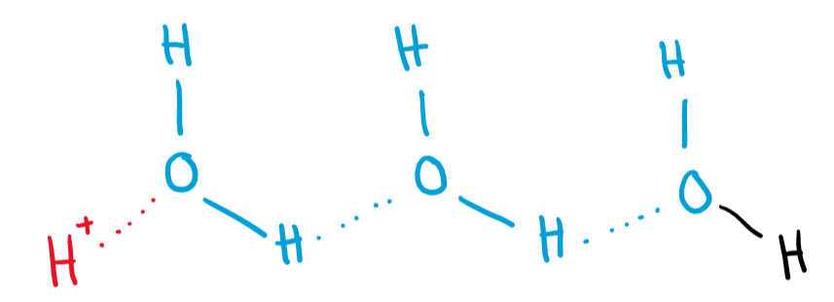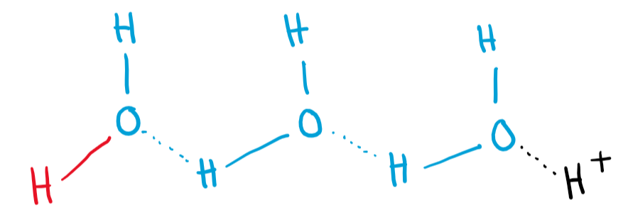
Asparagines interrupt the Grotthus wire
- Hydrophobicity makes it very hard for the charged proton to pass

- N-terminal parts of α-helices are always relatively positively charged due to all the peptide bonds being oriented in the same way. This would generate an electrostatic repulsion of positively charged ions (protons). We would not have to worry about negatively charged ions like Cl⁻ because they are anyway too big to pass through the channel

Channellology
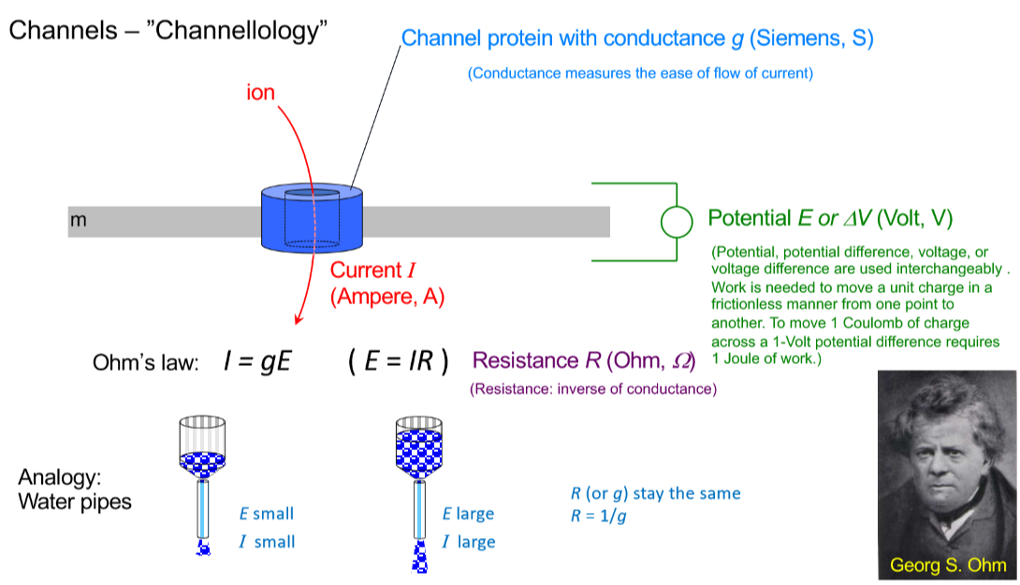
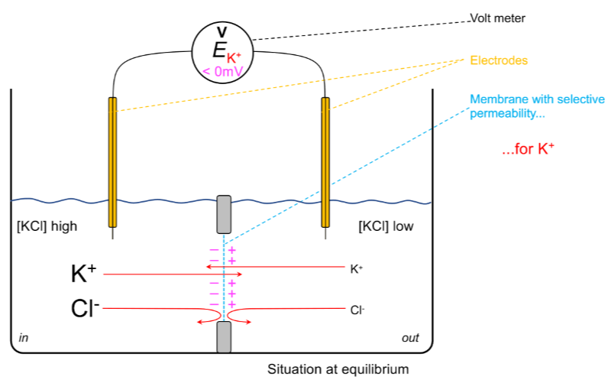
Non-permeable
- The volt meter measures 0V because there is no current
Selectively permeable for K⁺
- Net flux of K⁺ to the right
- Potential always measures inside – outside
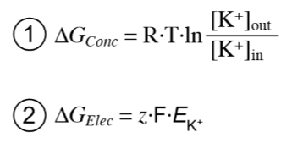
  - In this case, relatively more K⁺-ions on the outside caused by efflux which leads to a negative potential
- Two opposing forces
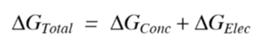
  - 1 is the driving force in terms of concentration gradients
    - Since the concentration outside is smaller than inside, the whole term will be negative and therefore energetically favourable
  - 2 is the opposing force in terms of electrical force
    - z has to be multiplied by -1 if the ions are moving from in to out

- At equilibrium, ΔG = 0
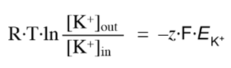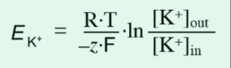
  - By convention all membrane potentials are measured inside – outside
  - Nernst potential values are
    - The exact voltage to counteract ion movement along their concentration gradient
    - theoretically calculated values for every ion separately by assuming that the membrane is not permeable for all other ions
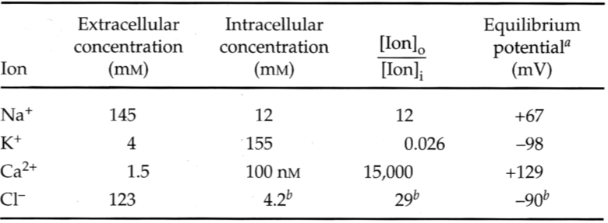
- The actually measured value (resting potential) is around -60mV.
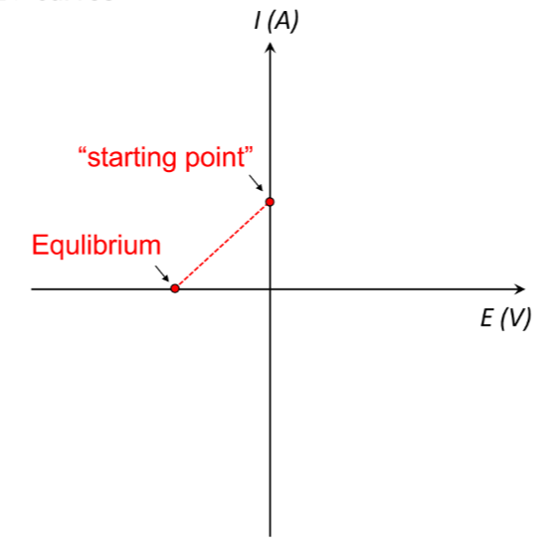
IV curves
- Positive current is defined by either positive ion efflux or negative ion influx
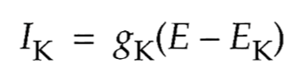
- The curve is described by an adjusted expression of Ohm’s law and shifted so that it goes through 0/0
- To explore what happens below the equilibrium potential and the hypothetical starting potential, one has to control the electrical potential
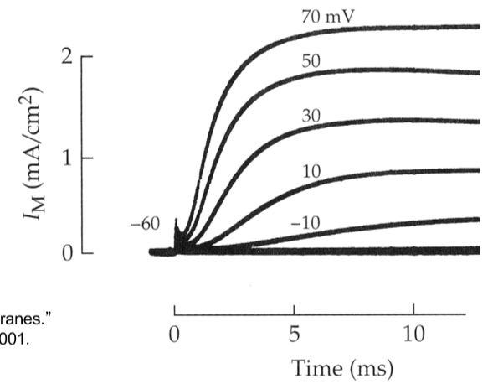
  - This is done by clamping (having an electrode which instantly counteracts every potential fluctuation to ensure a desired value)
- If a potential of 70mV (inside positive and outside less positive) is applied, the cell reacts with a net efflux of positive ions or influx of negative ions (positive current)
- When even -10mV triggers a positive current, the Nernst potential has to be even lower
- These measurements are called ensemble measurements because they measure many channels at the same time and the sum of their behaviour leads to these plot
  - Especially handy if you’re investigating channels that have a very low conductance and therefore a very low signal to noise ration

- Single channel measurements show that single channels occasionally close and open if a potential is established. The measured current when the channel is open leads to the value of charges/s (conductance), which the channel is able to transfer
  - Provides mechanistical information
- IV plot from single channel measurements:
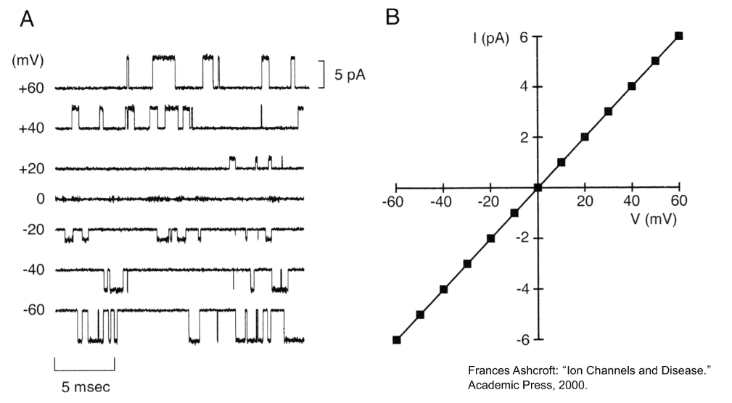
- Curve goes through 0/0 because the experiment was designed so that there was no concentration gradient meaning that at without an external potential, there was no ion exchange and therefore no observable current
- Slope of IV-plots is dependent on the conductance of the whole experimental setup which includes g (channel-conductance) and the amount of channels measured (additive conductance values)
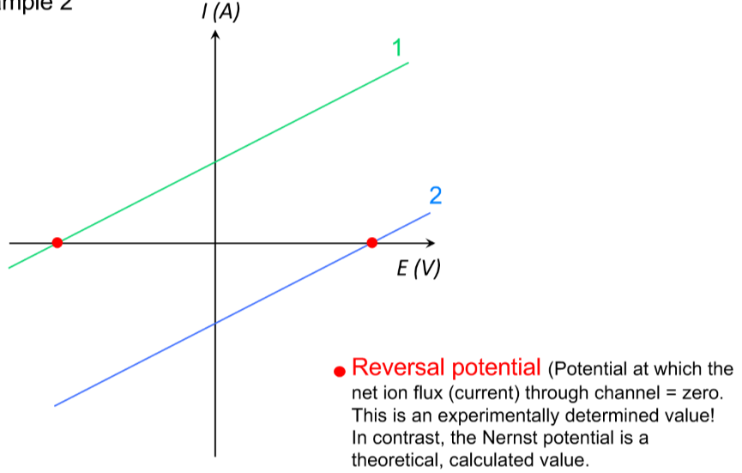
- Left and right shifted curves are caused by concentration gradients which automatically cause a current (and rapidly establish a stable situation where current is 0) even if the potential value is 0. Red dots are the reversial potentials (potential at which the net flux of target ion is 0) and they are experimental measures. Not the same as the Nernst potential.
  - 1 could be a potassium channel (high inside, low outside)
  - 2 could be obtained by switching inside and outside potassium concentrations
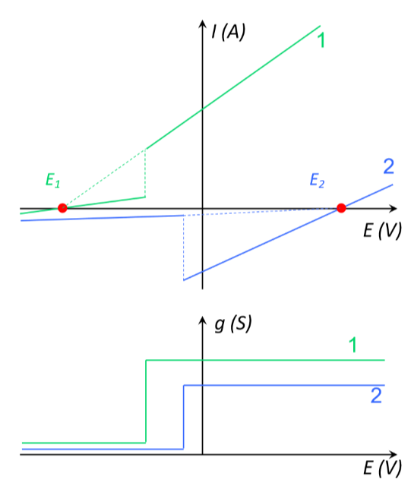
  - 2 could also be a sodium channel (low inside and high outside) with the same conductance g as 1
- Curve with two different slopes means that the channel is voltage-gated and has two confirmations with different conductance values
  - Normally closed (g=0) and open (g>0) state
  - Dotted lines still hypothetically cross at the red dot because these values are channel- and ion-specific

Homework assignment
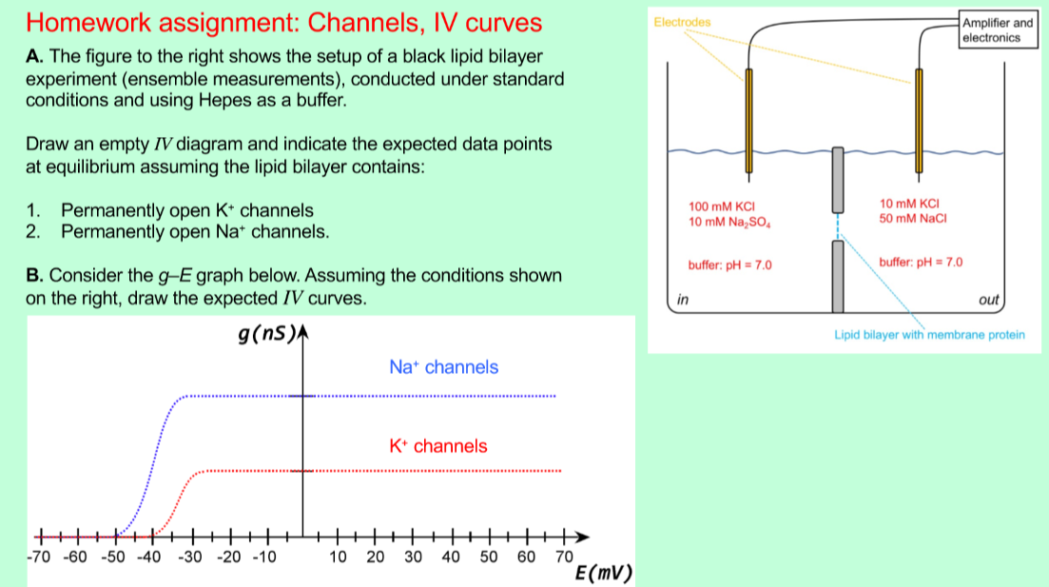
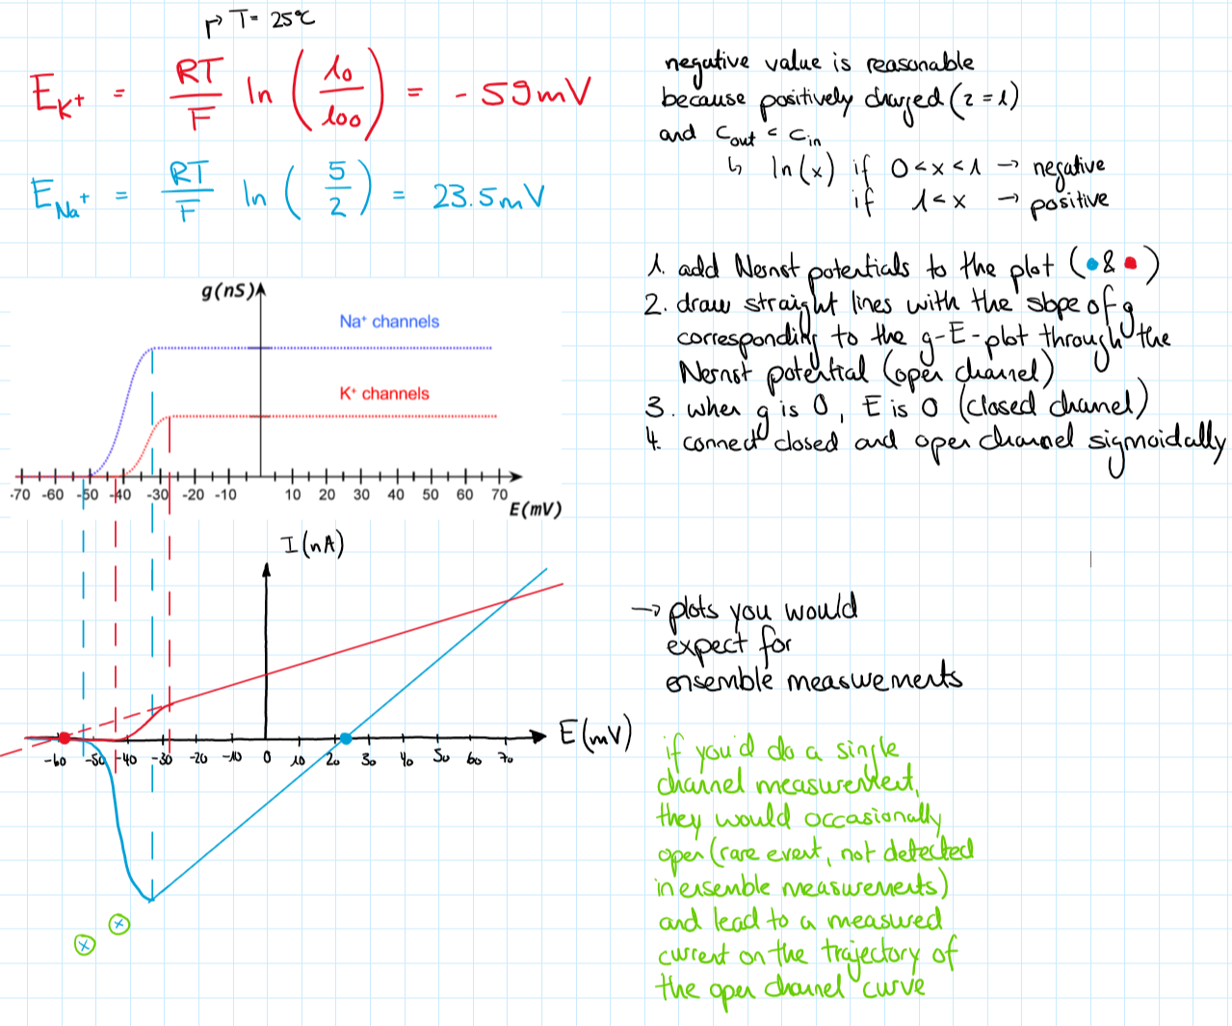
The Nernst potential (calculated) and the reversal potential (observed) are the same if the channel is 100% selective. As soon as the channel also somehow transports something else, the reversal potential shifts.

Potassium (K⁺) channels
- All potassium channels are tetramers with a single, central conductance pathway (different than aquaporin)
- Incredibly fast (~10⁷-10⁸ ions/s)
- Potassium:Sodium ~1000:1
- Very selective, measurable Rb⁺ and Cs⁺ but hardly any Li⁺ and Na⁺ conductance 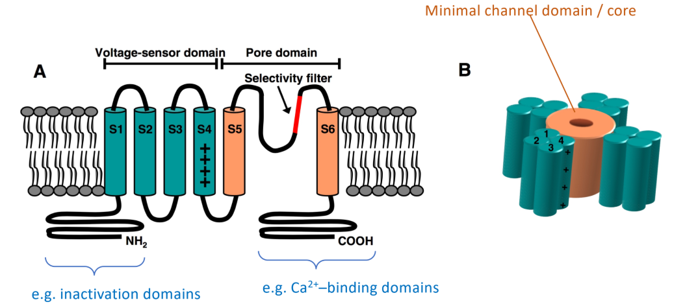
- Normally 6 transmembrane domains whereof only S5 and S6 are essential for forming the ion channel
- S1-S4 form a tight bundle
- S4 is positively charged (arginine and lysine residues) in the middle of the membrane (highly energetically unfavourable but necessary for voltage-gating)
- N-terminal domains (intracellular) have usually inhibitory functions upon ligand binding

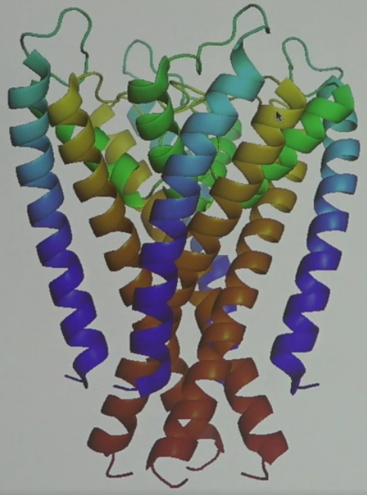
- C-terminal domains (intracellular) usually Ca²⁺-binding domains to further alter the channel behaviour
- The picture to the right shows 4* S5 and S6, the C-terminal domains (red) are in close proximity to each other
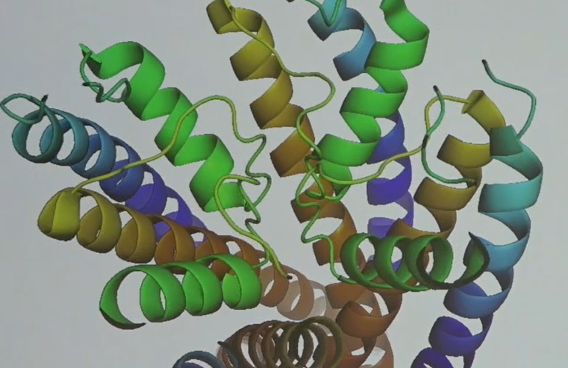
- The green half-helices (on the extracellular side) bring together these 4 peptidechains (also green, spaghetti form), which are essential for the selectivity
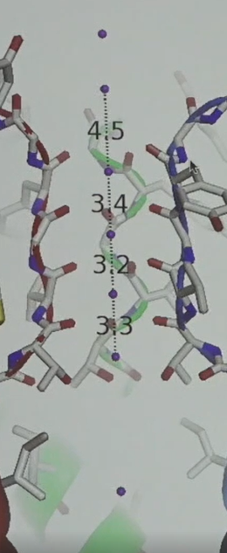
- Only the carbonyl backbone groups (not the side chains) of the “green spaghetti” interact with the transported K⁺
- 3.2-3.4Å are very short distances
  - In reality, not all of the possible places are occupied which also leads to a partial collapse of the carbonyl backbone groups which constantly change their confirmation. This picture was taken using very high ion-concentrations
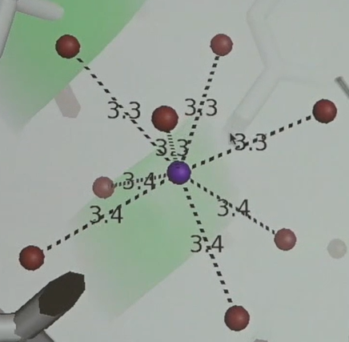
- Every potassium ion has 8 carbonyl oxygens to interact with
- Lowest K⁺ is in a cavity where it is surrounded by 8 water molecules in a square anti-prism constellation (top 4 are offset by 90° compared to the bottom ones)
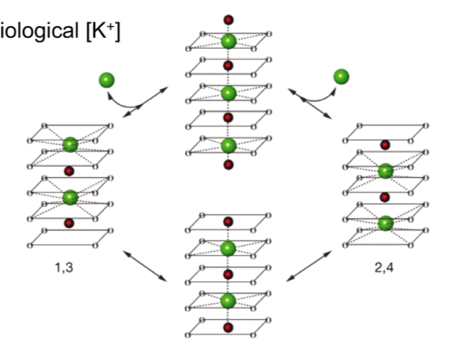
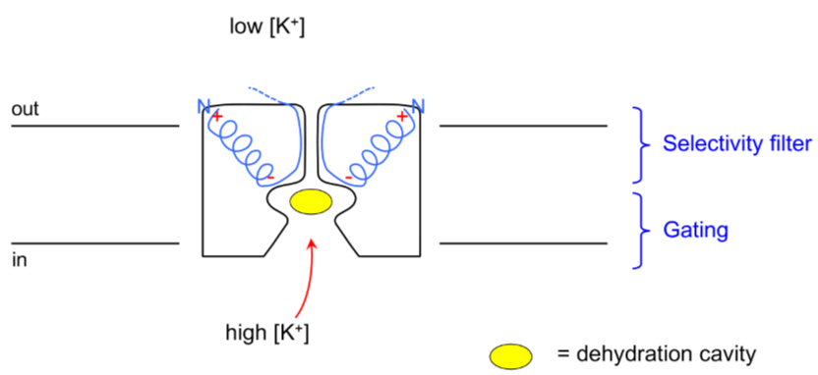
- Further analysis showed that the transported K⁺-ions alternate with water molecules. The binding with the 8 carbonyl oxygens or in the intermediate state with 4 carbonyl oxygens are not very stable which enables fast movement of the ions. It’s ability to transfer water has no real significance because the channel is only opened for brief moments.
Selectivity:
- The potassium ions are larger than the sodium ions and have therefore a larger hydration shell -> easier to dehydrate potassium than sodium which contributes most to the selectivity. The carbonyl backbone can mimic the hydration shell of potassium better than the one of sodium (“good fit”). Positive ions get attracted to the gateway by the negative charge of the 4 half-helices. If there was also a high sodium concentration inside the cell, you would observe a significant decrease in transition speed.

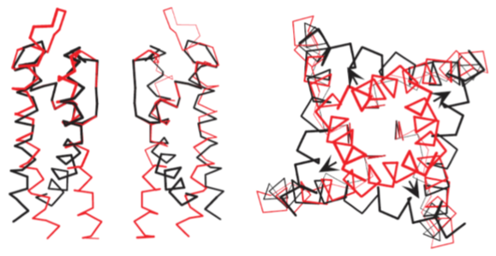
Gating:
- Red=closed
- Black=open
- The selectivity filter does not change from red to black
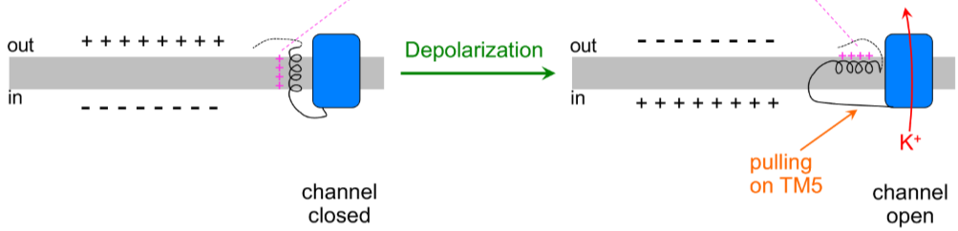
- If the cell experiences an action potential, the membranal charges switch causing TM4 to align with the newly negatively charged outer part of the membrane. Since TM4 is pulling TM5 which is connected to TM6, the gate can be opened.
- Since TM4 is positively charged and moves whilst opening and closing, a current should be observed -> gating current caused by 4* TM4 movement
  - Gating current can only be measured if the channels are unable to transfer ions since this current would be way higher > channels can be blocked by toxins
  - Measured Amperes can be converted into Coulombs which can then be divided by the number of present channels to calculate the number of positive charges present in TM4 -> 3.4 positive charges present in one TM4 -> 13.6 present in the whole channel
    - TM4’s have more than 3.4 arginines indicating that it most likely only moves partially across the membrane
    - Components of piston motion, rotation motion and swinging motion
Sodium channels
- Pseudo-tetramers, all fused together in one huge protein
  - One pseudo-monomer has also 6 transmembrane helices whereof TM5 and TM6 contribute to the channel itself and TM4 is positively charged.
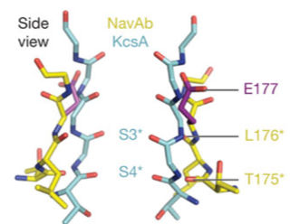
- Sodium:potassium = ~5:1
- Sodium channel selectivity filter (yellow) is shorted and wider compared to the one of the potassium channel(blue)
- Important difference: sodium channels transport from outside to inside (other way around than the potassium channels, even though they are structurally very similar) meaning that the first thing the ions encounter is directly the selectivity filter and not the dehydration cavity -> the ions are transported in a hydrated form and since sodium is smaller, selectivity can be established. The high abundance of extracellular sodium helps.
- The selectivity filter also contains 4 * a glutamate (negatively charged) which prohibit the transfer of negatively charged ions.
  - The side chains play a role in the selectivity filter of the sodium channels which was not the case for the potassium channels where only the backbone was involved.

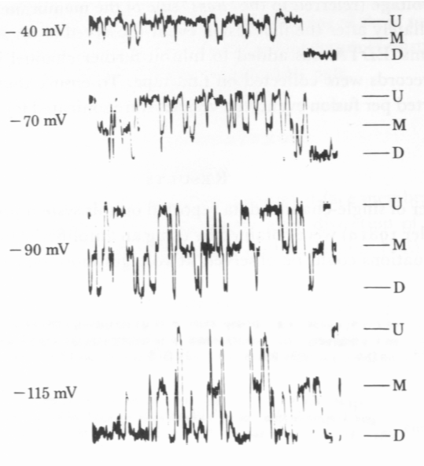
Chloride channels (E.coli ClC proteins)
- Have three possible confirmations (U, M and D) with associated conductivities g
  - U = up = open
  - M = middle = half-open
  - D = down = closed
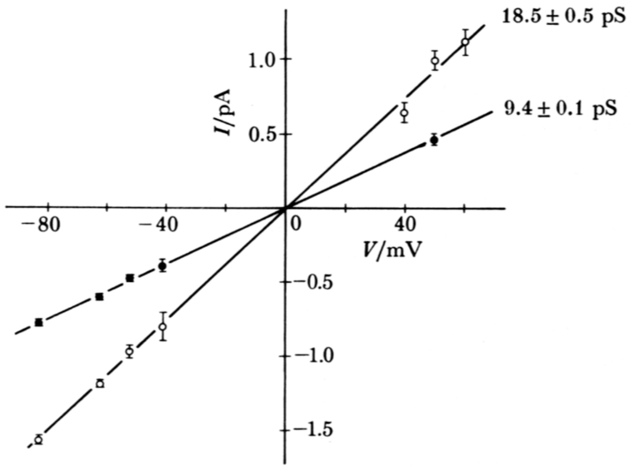
- ΔI is similar between D&M and M&U and linearly dependant on the voltage (IV-plot), approaching 0 the closer the voltage gets to the Nernst potential
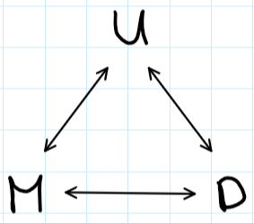
- IV-plot has two curves corresponding to U and M. U, M and D are in no particular order.
- Hypothesis: Channel has two monomers which can be independently open or closed
- Another observation was that the channel activity is pH dependant
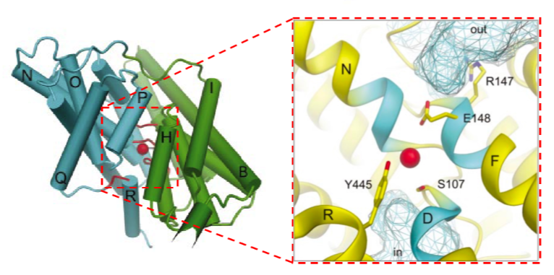
  - Lower pH -> more conductive
- Channel has a crazy architecture (here is just one monomer visible)
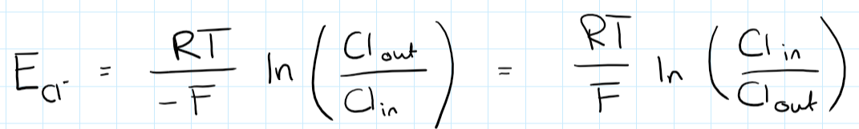
- The ClC has a pathway which is normally blocked by only one glutamate residue (E148)
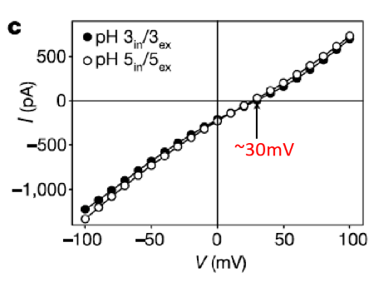
- The channel was studied and the calculated Nernst potential (48mV) was actually significantly higher than the observed reversal potential (30mV) -> conclusion: another ion has to be transported with the chloride (not a channel protein but a transport protein)
- Protons were the other substrate transported (was found out using the same KCl concentrations inside and outside and varying pH-gradients)
  - Do Cl⁻ and H⁺ move separately? No, because without a proton gradient, the reversal potential should be the same as the Nernst potential -> coupled transport
  - (Cl⁻:H⁺) 1:1 Symport? No because then you had no net charge moving and no current would ever be measured
  - (Cl⁻:H⁺) 2:1 Symport? z would be -0.5 because for every Cl⁻ there would be a transport of 0.5 H⁺. Nernst potential would be 96 mV (way too far off the reversal potential)
- (Cl⁻:H⁺) 1:1 Antiport? z would be -2 because for every Cl⁻ there would be a transport of one H⁺ in the opposite direction. Nernst potential would be 24 mV (which is also not 30mV)

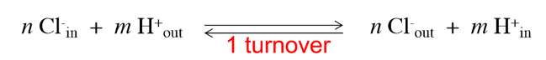
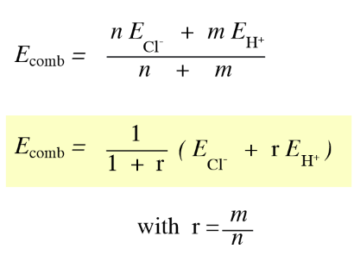
  - (Cl⁻:H⁺) 2:1 Antiport? z would be -1.5 because for every Cl⁻ there would be a transport of 0.5 H⁺ in the opposite direction. Nernst potential would be 32mV which is very close to the observed 30mV.
- Equation for combined Nernst potential
- After several experiment they showed that the E.coli ClC is an 2:1 bidirectional antiporter
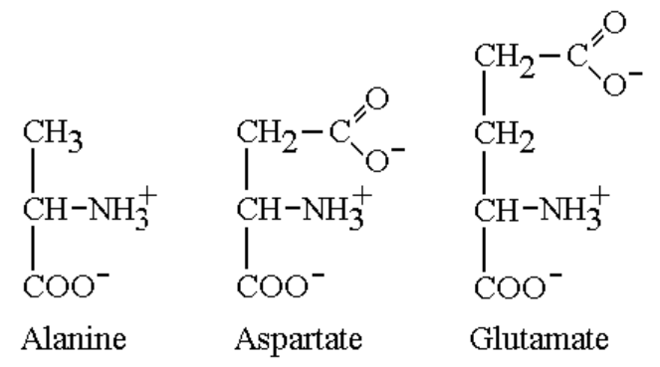
  - Some of the human ClC’s work in a similar fashion
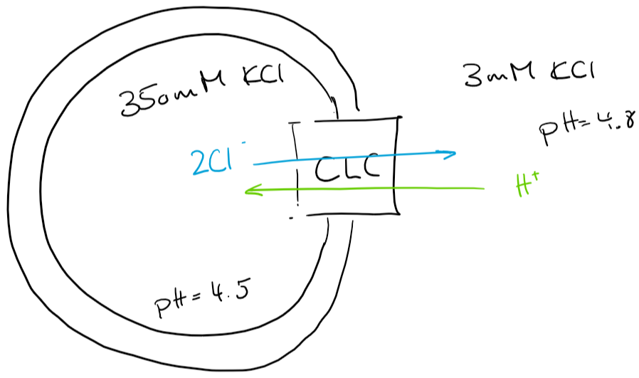
- This means that the two concentrations of chloride and protons can determine in which direction the transporter will run
  - Experiment: proteoliposome with inserted ClC, high KCl inside, low KCl outside, slightly lower pH inside. If Cl⁻ export was the driving force, the outside pH should rise.
  - Problem: You won’t see a change of pH because with every cycle, because the electrical field will get very fast very strong (with every cycle you generate an excess of 3 positive charges inside and an excess of 3 negative charges outside)
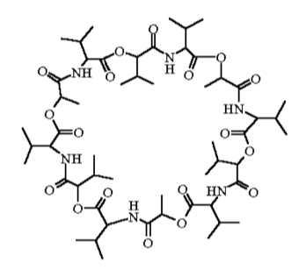
  - Solution: Valinomycin (ionophore) binds a K⁺, change its confirmation and transports it across the membrane (also concentration-driven) and counteracts the buildup of a strong potential -> measurable pH differences
    - If valinomycin is faster or more abundant than ClC, there is even a driving force built up for the ClC
  - FCCP is an uncoupling protein which can move H⁺ across the membrane and quickly restore the original pH’s.
  - ClC can also be driven by H⁺ gradient. Same KCl concentrations, different pH’s, inside proteoliposome is SPQ, a Cl⁻ -quenched fluorophore which quantifies chloride transport. Also only works with valinomycin and uncoupled by FCCP
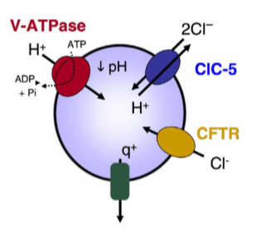
- There are human ClC’s which work as a voltage-gated channel (mainly important for stabilizing the membrane potential) and some who work as Cl⁻-H⁺-antiporter which are highly relevant in acidification of endosomes and lysosomes. Aided by ATP synthase which runs reverse. CFTR imports Cl⁻ for the ClC’s to run.

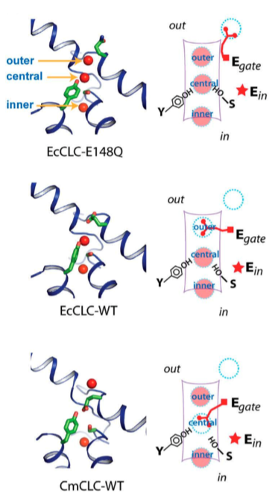
Detailed ClC mechanism
- There are 3 sites (external, central, internal) where Cl⁻ can be whereof 2 can be occupied by the Glutamate (E148)
- If E148 is mutated to aspartate (D148) or an alanine (A148), the protein behaves much more like a channel protein than an antiporter -> it is important how far the gating residue can reach

- In these experiment, a fluorescent die called ACMA was used which loses fluorescent intensity when a proton-gradient is established.
- If the only driving force is high intraproteoliposomal K⁺, there is an observable influx of H⁺ measurable in the presence of Cl⁻. If there is no Cl⁻ present in the system, no H⁺-flux is observable -> chloride is mechanistically relevant for proton transport
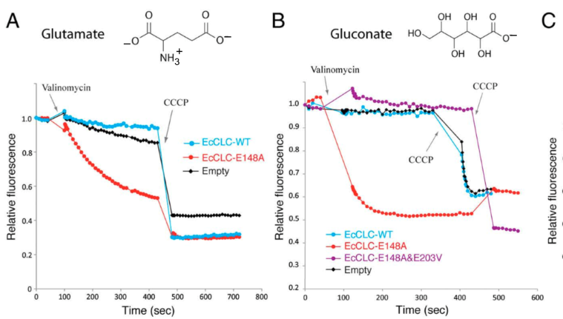
- Experiments where soluble glutamate and gluconate where added to the system, still no Cl⁻ present but driving force in form of K⁺ gradient
- Nothing happens in the WT
- If you remove the E148 and make it an A148, the soluble forms can replace its function and enable H⁺ transport (even when there is no Cl⁻ present)
- If you additionally replace E203 with V203 (loss of charge), you get a loss of conductivity
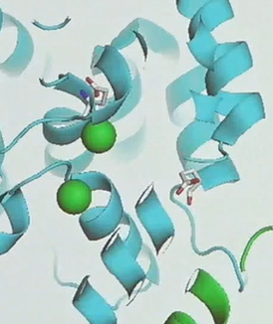
  - This leads to the conclusion that the protons take another path through the ClC than the chloride ions.
- If you add even the slightest amount of chloride, the A148 mutation acts as a chloride channel and stops transporting protons

Proposed mechanism
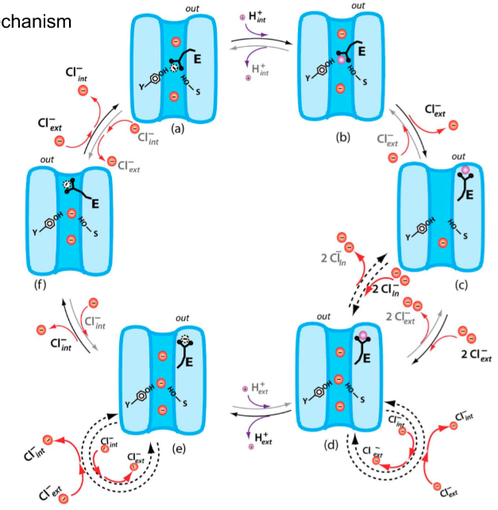
- Clockwise (2Cl⁻ inside and one H⁺ outside)
- Counter clockwise in lysosomes
- Internal position always occupied by Cl⁻
- Gating glutamate can only occupy either external or central position
- Gating glutamate can be protonated (purple ball)
  - If protonated -> loss of charge -> moves away from the pore
- If a proton wants to move from the outside to the inside, it can only transfer via the glutamate occupying the central position (reversely, a proton from the inside can only bind to the glutamate in the central position)
- a) -> f) the glutamate pushes the external Cl⁻out, the internal Cl⁻ translocates to the central position and the internal position gets reoccupied by a new Cl⁻
  - same from f) -> e)
- c), d) and e) are very unstable and therefore short-lived confirmations
  - in d) and e) there is a chance that an excess Cl⁻ slips through since the protein is then really a channel
    - I think that is also the reason why the observed reversal potential is 30mV and not as the calculated Nernst potential would suggest 32mV. z is in reality not exactly -1.5, it is just a little bigger like -1.4 (not a calculated value)
- In ClC-channel proteins, the gating glutamate moves to the inside of the protein and allows free Cl—flow
Black lipid bilayer setup
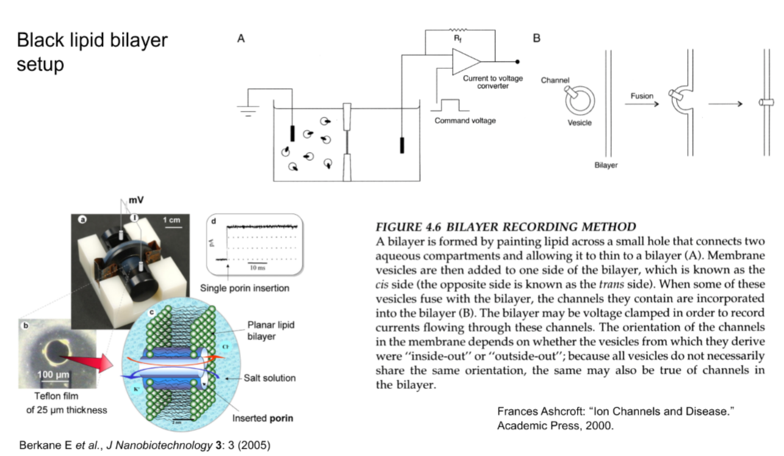
Called black lipid because if there was successfully added a single bilayer across the hole, it appears to be black.

Large cargo transport (alternating access)
- Needs gates (in passive and active transport) because if you would open a channel, everything else would just translocate
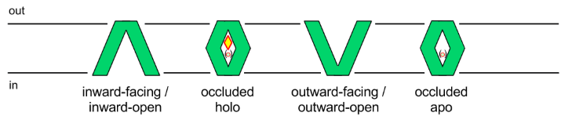
- Holo = with substrate, apo = no substrate
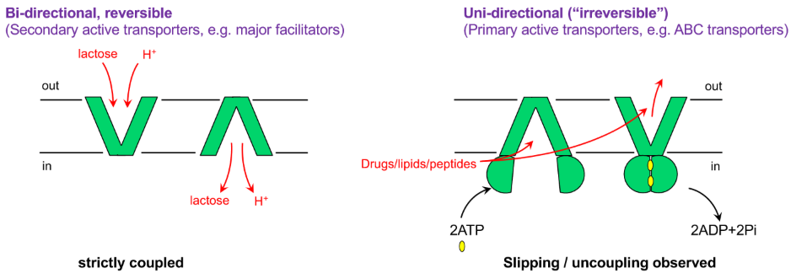
Major facilitator superfamily
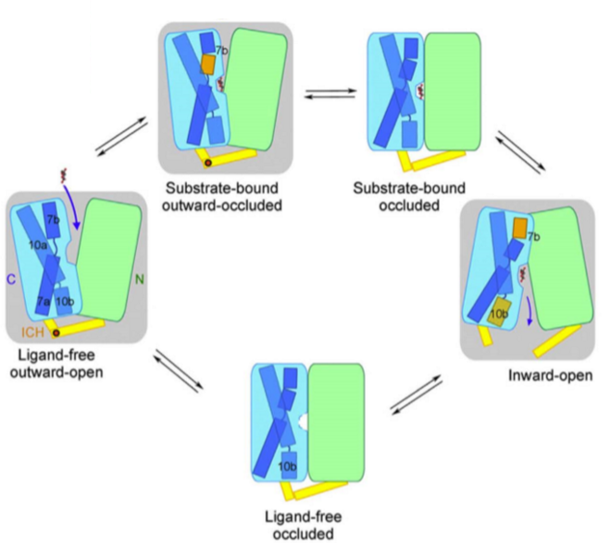
GLUT:
- Passive transport
- Other molecules will fit in the cavity but will be unable to trigger the conformational change
- Ligand-free occluded state differs active from passive transport
- Not electrogenic transport because glucose isn’t charged
Lactose permease (LacY)
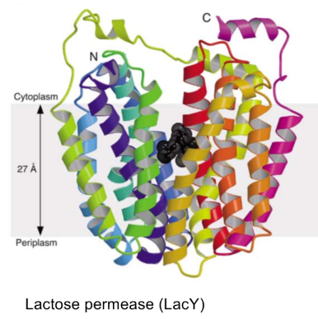
- Lactose permease is a Lactose-H⁺-symporter
  - Can be driven by either concentration gradient
- Electrogenic transport, per cycle one positive charge to the inside
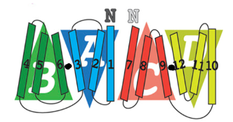
- Is a monomer but consists of 4 relatively similar subunits
- Is pseudosymmetric
- TM6 and TM7 are connected (not shown in schematics)
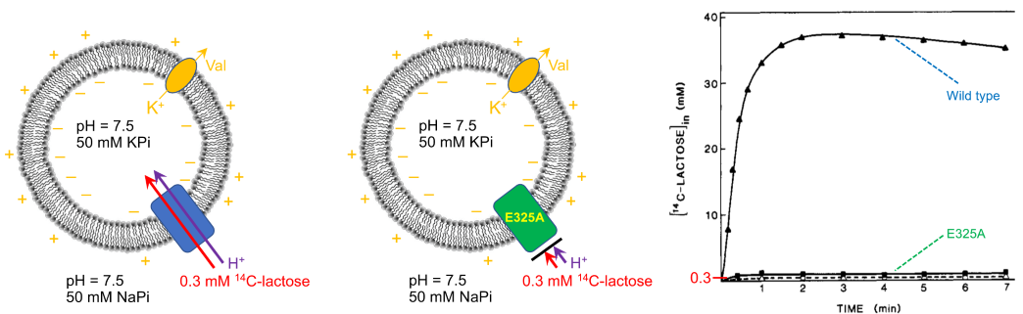
- Experiment with radioactively labelled lactose (also called “hot” lactose), valinomycin to prohibit the generation of a counterproductive electrical potential, K⁺ gradient
  - The outside volume is way larger than the inside volume and therefore such “low” external lactate concentrations can be used
- After a huge screen, E325 seems to be crucial in proton-transport
  - There is very little import detectable in E235A

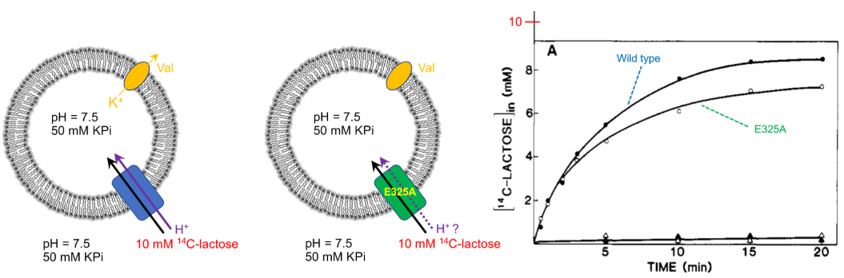
- High extracellular radioactive lactose. E325A still imports lactose but very slowly (physiologically irrelevant, timescale in minutes). Since the active transport in the previous experiment didn’t work properly, the transport observed here is most likely passive
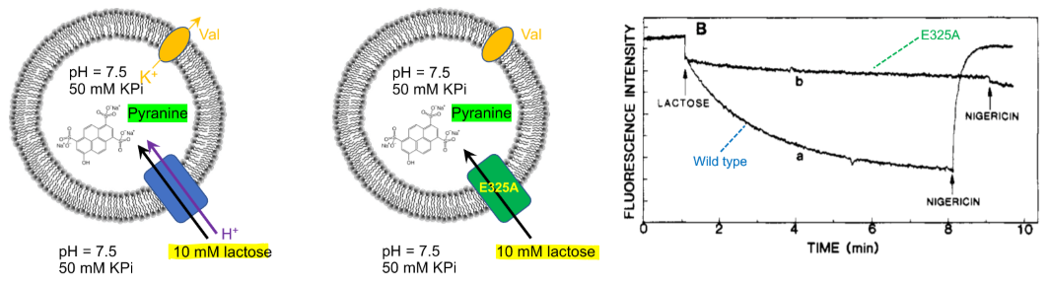
- Non-radioactive lactose (also called cold lactose) but intraproteosomal pyranine (pH detector, loses fluorescence upon pH-decrease)
  - Symport confirmed in WT protein
  - No proton-influx in E325A -> coupling is broken
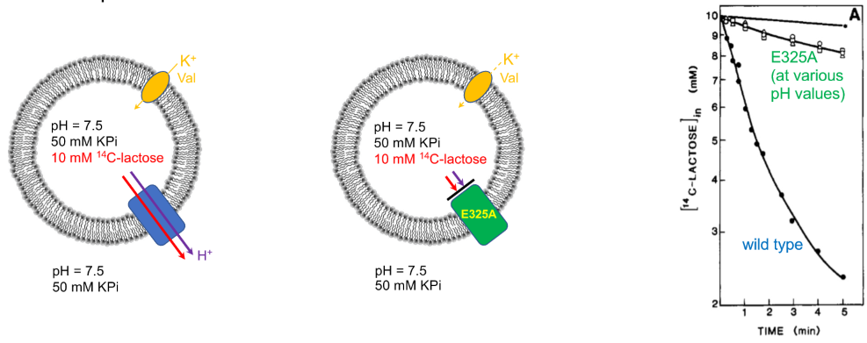
- High inside to outside radioactive lactose gradient.
  - Normal reverse reaction observed in WT
  - Very slow reaction observed in E325A (even though the lactose import was almost as fast as WT)
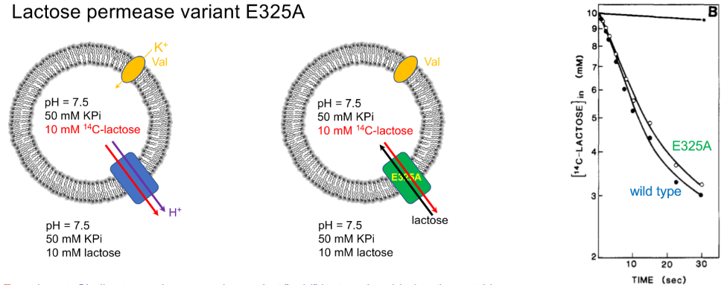
- Same as before but just add 10mM cold lactose to the outside
  - WT will equilibrate over time and lose fluorescence
  - The addition of cold lactose seems to enable transport via E325A
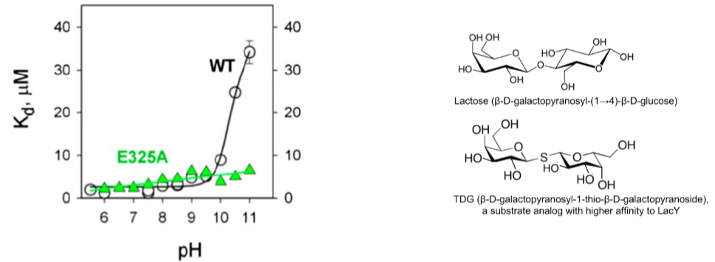
- Binding experiment using TDG (lactose analog with higher binding affinity -> easier to study)
  - WT binds TDG very good at low pH, at ~pH10 -> loss of binding affinity due to E325 (glutamate) being negatively charged
    - pK_{a} of glutamate is around 5 but it seems that the E325 is in such an environment, that its pK_{a} shifts to around 10.
  - E325A binds TDG pH-independently

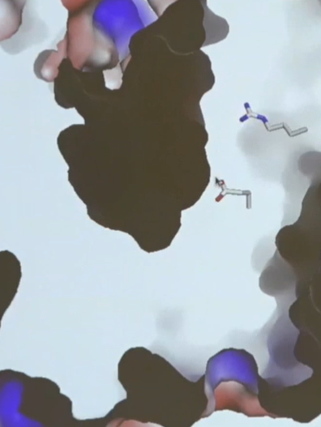
- Binding cavity (black) and tunnel leading to it is very small compared to the substrate (current state is outward-occluded
- E325 (bottom Aa) which is protonated and therefore neutral
- R302 (arginine, top Aa) helps changing the local pK_{a} of E325
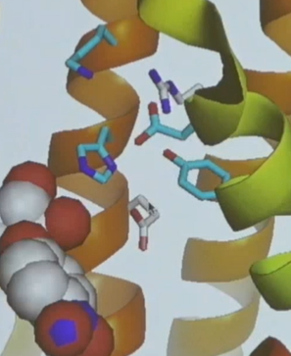
  - If E325 or R302 are replaced, there is no more proton coupling
- Several other side chains help establishing a proton relay to protonate E325

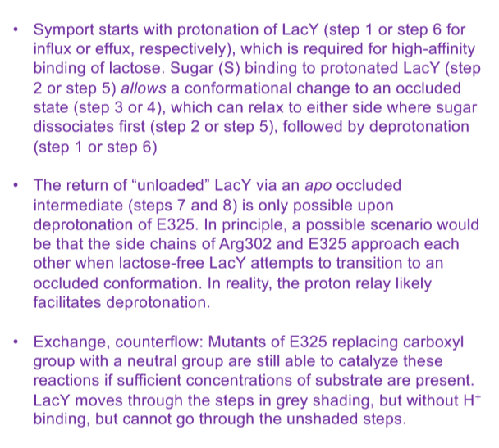
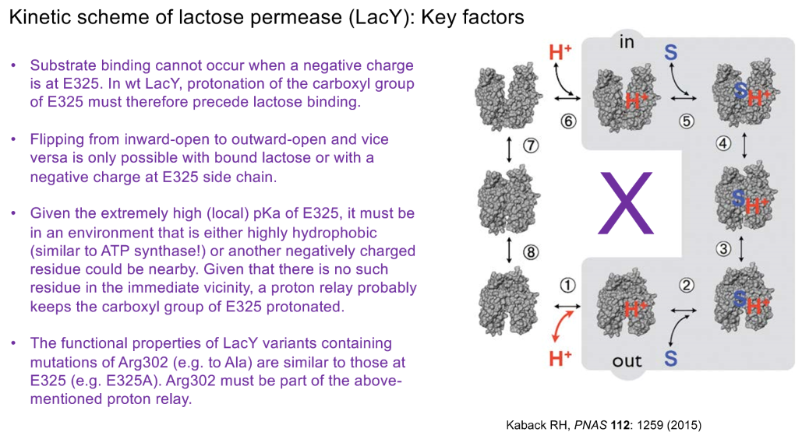
- To point 2. Either substrate and proton or neither for successful flipping. Difference to passive transport (GLUT) which only has one substrate and can flip either loaded or empty
- If 1 to 6 were directly connected, the cell would uncouple itself and loose the proton gradient
- E325A can only run through the grey confirmation meaning that it isn’t an active transporter anymore, it is an exchanger (for every sugar in, one sugar has to go out)
  - This is true for fast (in the range of seconds) activity but as it has been shown in the experiment on the top left, the transporter can passively transport lactose (in the range of minutes which can be interpreted as a side reaction since it is way too slow to physiologically matter for the cells)

LeuT (leucin transporter)
- Similar to e.g. dopamine transporter
- Transports 2 Na⁺ and one leucie
- Pseudo-2-fold symmetry axis in the membrane
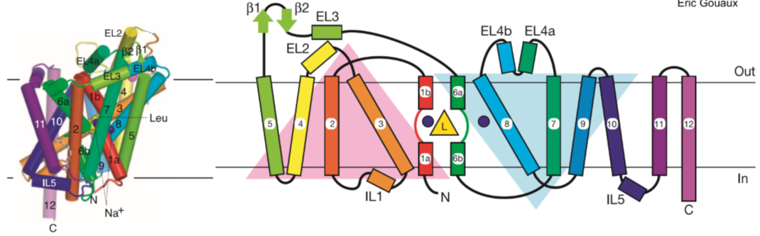
- TM11 and TM12 are extra and show no pseudo-symmetry
- Computationally predict the different confirmations because it is very hard to do high resolution analysis and trapping the protein in the different confirmations
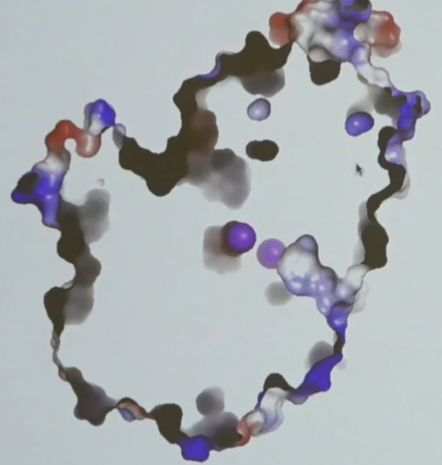
- The two violet dots are sodium ions and the leucin is behind the top one. The protein is in the outward-occluded state since the outward tunnel is in close proximity but the gate is already closed
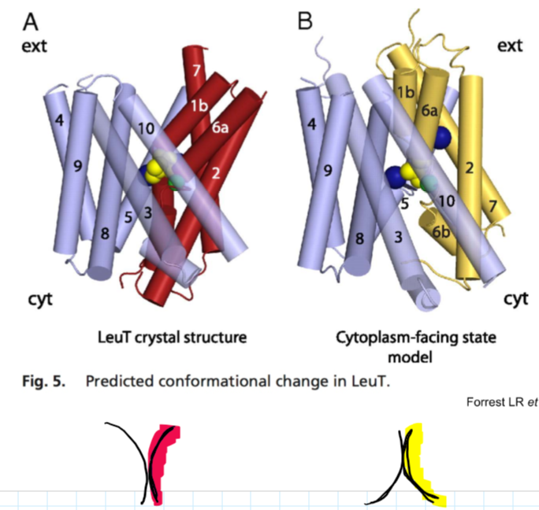
- It was found that the two repeats (here drawn without TM11 and TM12) rotate relative to each other and thereby opening and closing to either the inside or outside. Since the two repeats are pseudo-symmetric, the interactions at the inside if outward-facing and on the outside if inward-facing are similar

The topic of primary active transport was skipped due to time reasons

Ban
Viruses
Viruses are dependant on the replication machinery of the host cell
Viruses can store their genetic information in:
- dsDNA
- ssDNA
  - harder to repair -> more genetic variability
- dsRNA
- ssRNA
  - ssRNA +
    - directly translatable
  - ssRNA –
    - means the viral mRNA has to be first translated by a viral RNA-dependant RNA polymerase (RdRp)
  - RT (retrovirus)
    - ssRNA is translated into cDNA by viral RNA-dependant DNA polymerase (RdDp)
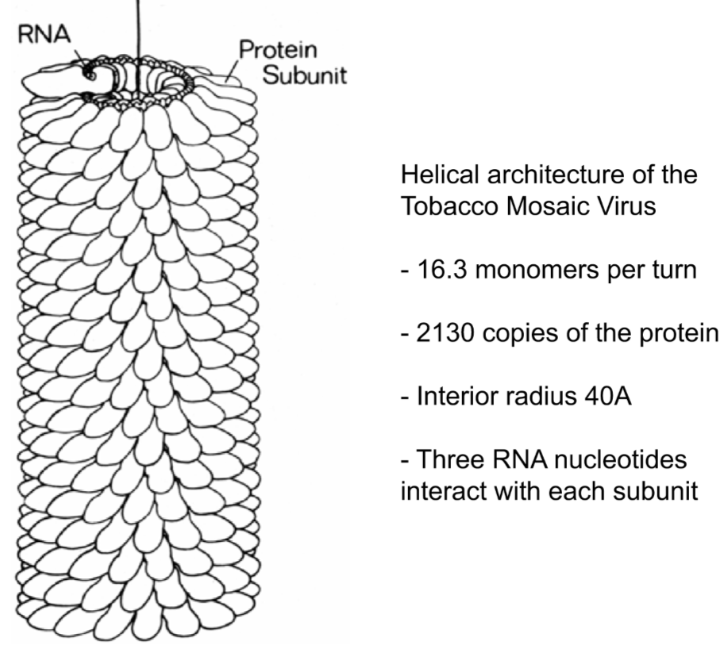
Tobacco mosaic virus
- very accurate linear architecture
- very fixed genome length (6390) and therefore fixed amount of protein (2130)

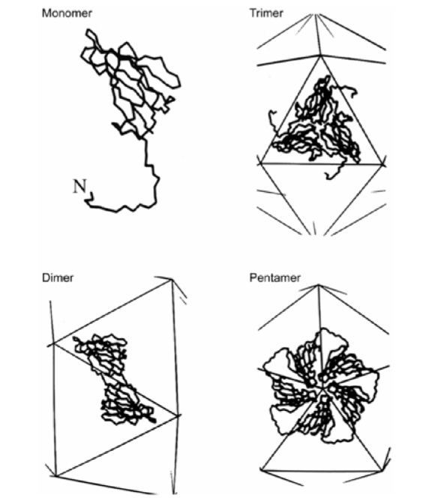
Virus architecture
often icosahedral
- 30 dimers
- 12 pentamers
- 20 triangles
  - 3 subunits (capsomers) per triangle -> 60 identical capsomers
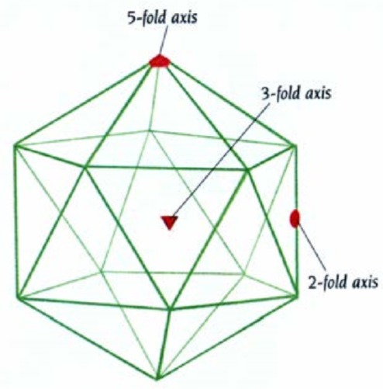
- This is the simplest possible icosahedron
- Size variation in terms of capsomer size variation
  - If the cargo is too large, other pseudo-symmetrical elements can be added (more capsomers) according to the following rules:
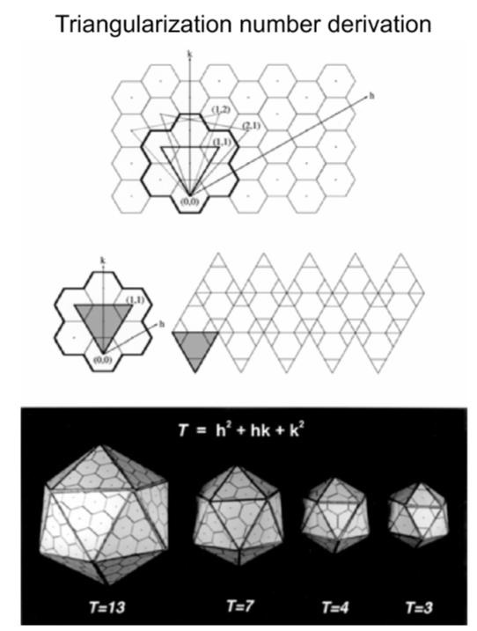
- non-perpendicular coordinate system with P(h/k) values. T (factor of 60 capsomers) can only adapt values indicated by the formula. So the next bigger capsid would be T=3 -> 3*60 capsomers

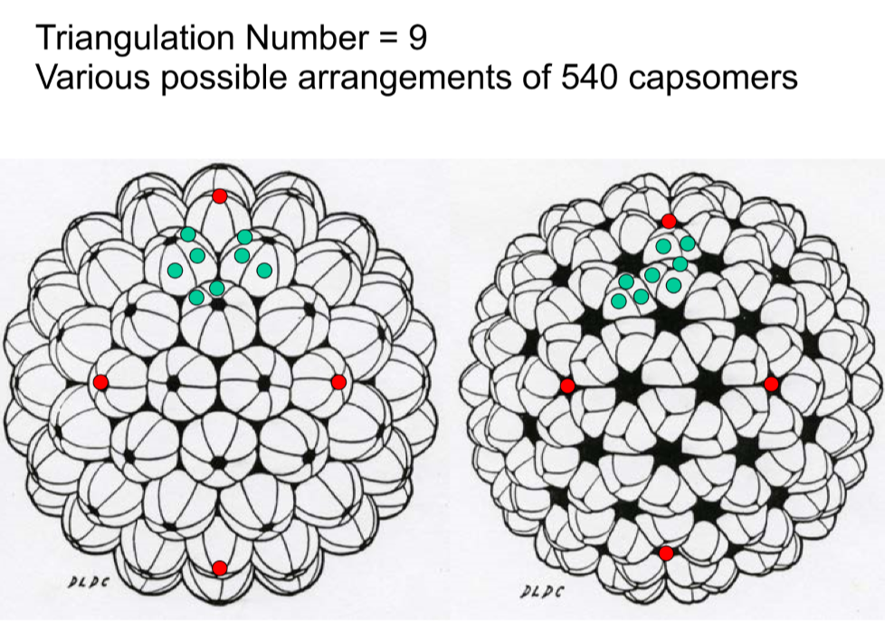
- Always 12 pentamers (pointy) and variable number of hexamers (flat or folded)
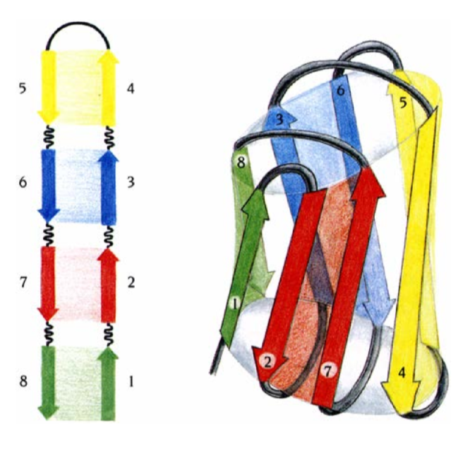
- Capsomers can be arranged in different ways but always the superior arrangement of 12 pentamers and rest hexamers
  - The capsomer cannot be deduced based on the symmetry because they are all icosahedral
- Capsomers usually have this β-jelly-roll fold
Viral RNA-capsid interactions
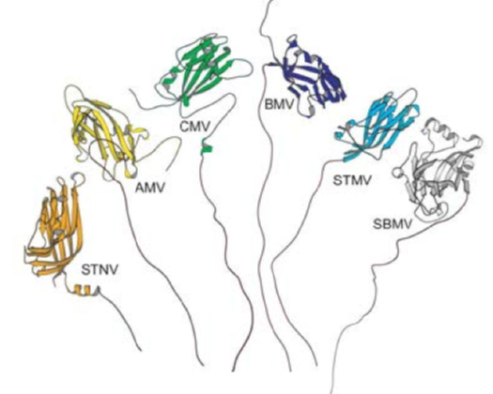
- RNA is highly structured (many RNA helices) which especially interact at the 2-fold symmetry points of the capsid
- Capsomers of different viruses also have long elongations which are rich in positively charged Aa’s (arginine (R) and lysine (K))which help arranging the negatively charged RNA
  - Forms like an inverse micelle where the RNA is the hydrophilic core -> RNA also helps to structure the capsid and the most stable confirmation is icosahedral
Polio and common cold virus
P=3 virus (meaning the virus has three different capsomers which form one subunit which then is multiplied by 60)
- Are very similar and are generated as a polyprotein which gets post-translationally cleaved into V1, V2, V3 and V4
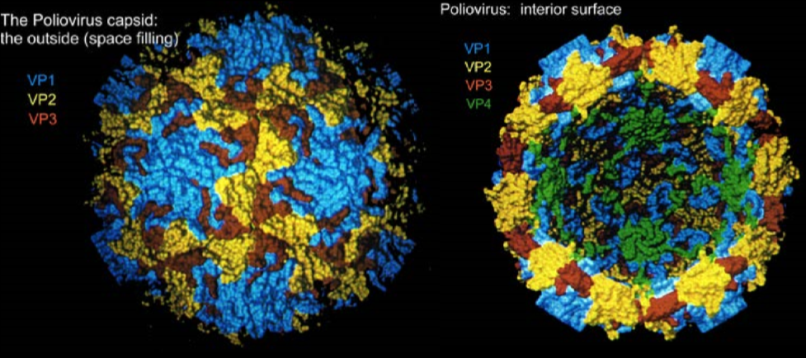
  - V4 only intracapsidally active, therefore still P=3

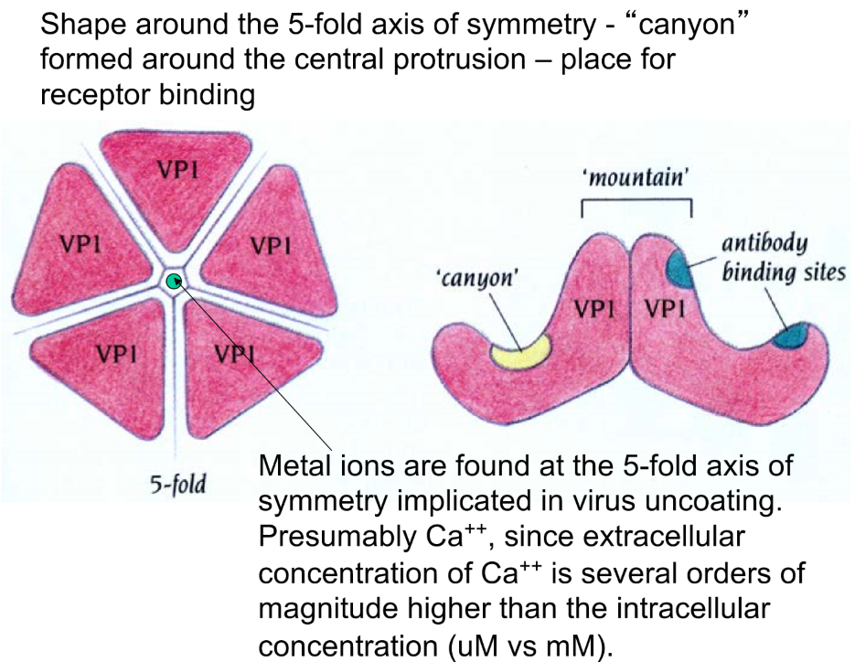
- Pentagons are stabilized by Ca²⁺ ions which have low intracellular concentrations which leads to capsid disassembly as soon as the virus enters the cell.
  - There are certain drugs that actually stabilize the virus so that the subunits cannot dissociate inside the cell
- Canyons important for receptor binding and therefore highly conserved. They are also hidden which makes it hard for antibodies to bind, therefore the immune system has to find other antigens to hopefully recognise the virus.
  - Problem: these regions are not very important for the virus and therefore it will mutate and constantly modify the non-canyon regions
- Canyons are very common. There are even viruses which can completely hide their binding site through conformational changes (e.g. HIV)
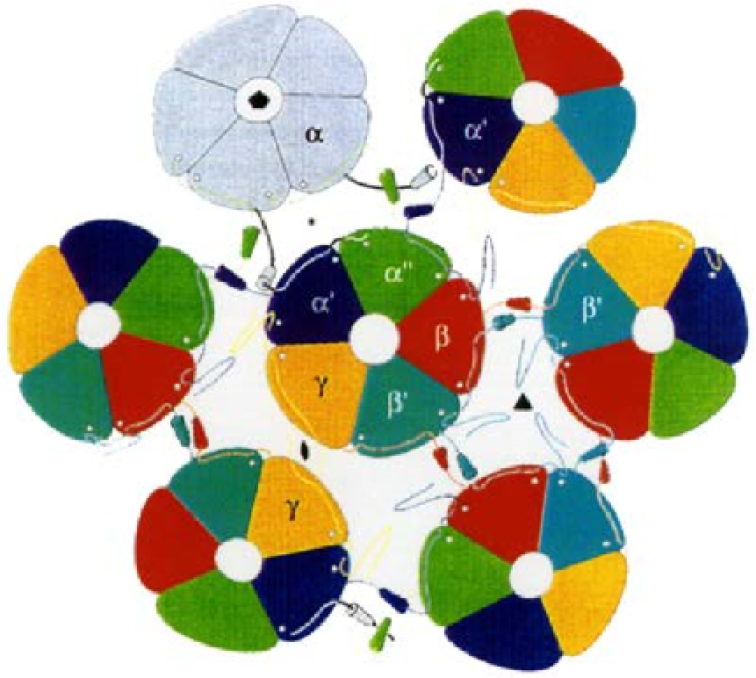
Simian Virus (e.g. HPV)
- Very special architecture, is composed entirely of pentamers (360 subunits, 72 pentamers)
- This would physically not be possible if you would form edges -> the subunits are “tied” together
Architecture of membrane enveloped viruses
- Usually consist of capsid, surrounded by membrane with additional viral, spike-forming proteins on top
- Capsid proteins serve as
  - RNA binding protein
  - Receptor for transmembrane spike protein
  - Protease to cut the polypeptide into the individual capsomers
Example (Ross-River virus (RRV))
- T4 lattice (Gitter) of the capsid and the transmembrane proteins which is offset (same architecture but different arrangement)
- Transmembrane sphere forms trimers and each monomer is of a heterodimer consisting of E1 and E2
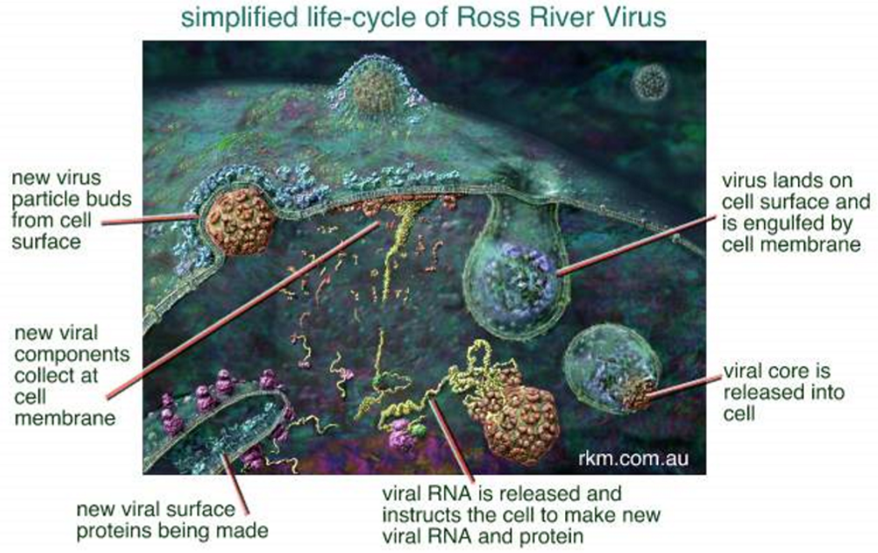

- Zika virus is a T=3 virus which also has an offset transmembrane sphere with the same architecture but different arrangement
- SARS-CoV-2 virus is a ssRNA virus which is very large and has error-correcting RbRp’s 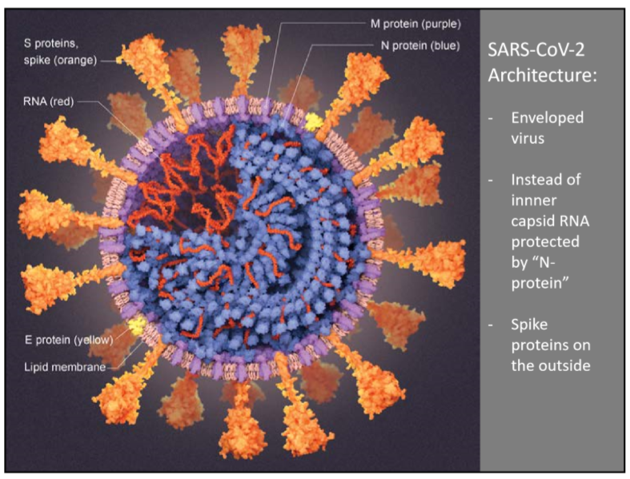
Translation
- On average, 1 in 10000 Aa’s is misincorporated. Lower fidelity than transcription and even lower than replication.
  - Errors in translation can be tolerated because there should be many more correctly translated protein and there are degrading methods
tRNA synthetases
Aa + ATP → aminoacyl-AMP +ppi
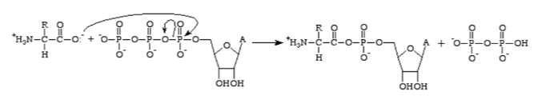
tRNA + aminoacyl-AMP → aminoacyl-tRNA + AMP 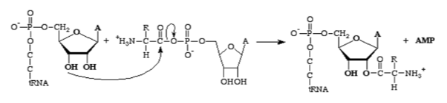
- tRNA’s have always an A at the 3’end of which one of the ribose-hydroxy groups which performs a nucleophilic attack on the carbonyl carbon of the ATP-activated peptide bond.
  - Also an error rate of around 1:10000
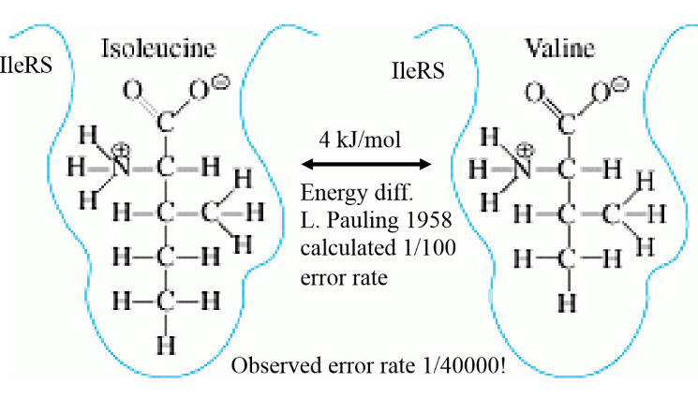
- tRNA synthetase which binds Isoleucine should based on the small energy difference compared to binding valine have an error rate of 1:100. Observed = 1:40000
  - Solution: first binding pocket (synthetic site) can bind Ile and everything smaller. Second binding pocket (editing site) can bind valine and everything smaller. Ile resides in first binding pocket and can be accurately used for tRNA loading.

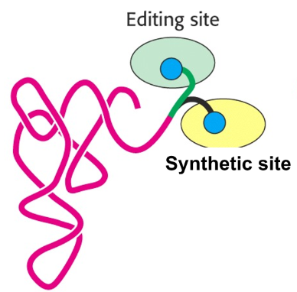
  - After the synthesis in the synthetic site with whatever Aa, the 3’end of the tRNA has a brief moment to wiggle around. If Valine or smaller was added, it can bind the editing site which cleaves the bond and the tRNA can get loaded once again in the synthetic site. If it gets loaded with Ile, it won’t be able to bind to the editing site and therefore dissociate as functional tRNA.
Ribosome
- Consist of protein and rRNA (which is architecturally dominant)
- Small ribosomal subunit binds the tRNA’s
- Large ribosomal subunit contains the peptidyl transferase center as well as the exit tunnel
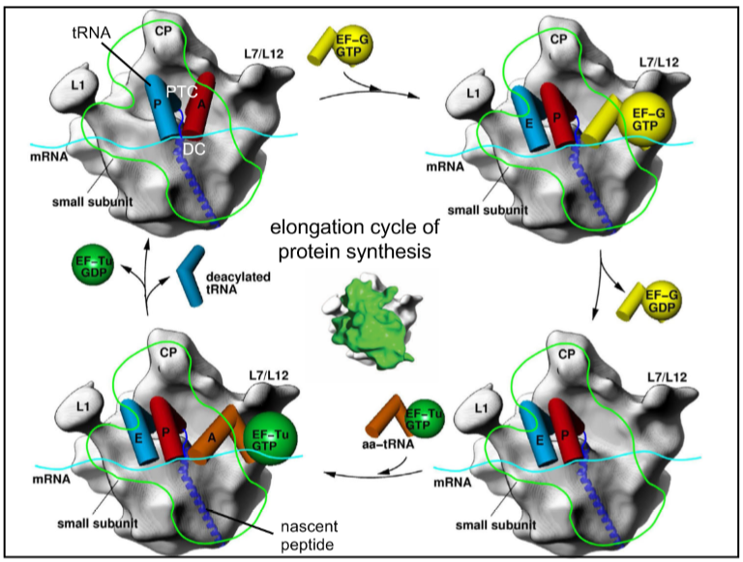
A site = aminoacylated tRNA
P site = peptidyl tRNA (which is connected to the growing polypeptide chain
E site = exit site
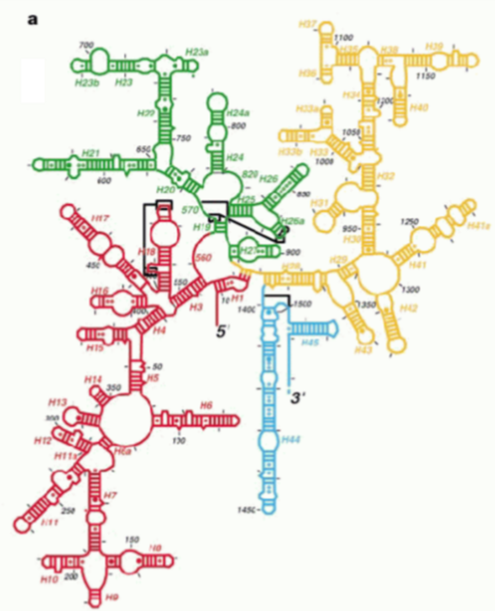
- tRNA’s interact via their anticodons with the mRNA and their 3’ end is in the peptidyl transferase center where the polypeptide chain is transferred from P to A and the tRNA’s are shifted to the left (done by EF-G GTP which gets hydrolysed) and A becomes the new P. A is now free and EF-Tu GTP brings the next aminoacylated tRNA
Small subunit (30S)
- rRNA part (16S) of small ribosomal subunit can be divided in:
  - 5’ domain
    - body
  - Central domain
    - body
  - 3’ domain
    - Head of the small subunit which can be moved relative to the body to promote tRNA movement along the A P E sites (Spectinomycin (antibiotic, works because bacterial ribosomes are slightly different than human ribosomes) prevents head-movement and therefore prevents elongation)
  - Penultimate long helix containing the ultimate helix and the unpaired 3’end
    - In direct contact with the large ribosomal subunit

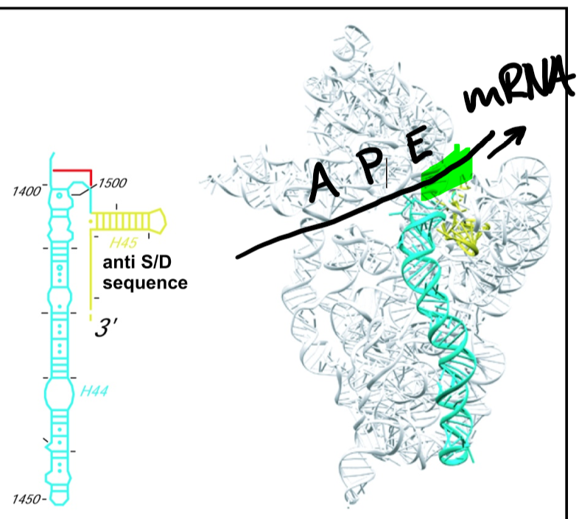
- More proteins on the outside of the small ribosomal subunit compared to the area where it interacts with the large ribosomal subunit
- unpaired 3’ end will bind the Shine-Dalgarno-sequence of mRNA
- Mediates the codon (mRNA) anticodon (tRNA) interactions
- Base pairing of 3 complementary bases is too weak to keep the tRNA in place and avoid errors
  - rRNA has some very conserved bases which are normally hidden but flip out upon correct codon-anticodon interactions at positions 1 and 2 which further stabilise the interaction. The rRNA base sits in the minor groove of the tRNA-mRNA base pairs.
  - At position 3 (wobble base), rRNA doesn’t stabilise. It allows the tRNA to wobble which can lead to non-Watson-Crick-base-pairing -> doesn’t mean that any base pair is acceptable but it has higher tolerance than position 1 and 2 which are strict
    - 64 codons for 20 Aa’s, that’s why there can be a variability in the third position
- Since the tRNA’s are rather bulky, the mRNA has to kink between the A and the P site
  - Problem: you bring two negatively charged phosphates close to each other
    - Solution: gets stabilised by a Mg²⁺ ion
- The tRNA’s cannot just slide from the P to the E site because there is a 16S rRNA loop in between which requires head movement to get out of the way

Large ribosomal subunit (50S)
- Catalyses peptidyl transferase reaction and binds initiation-, elongation- and termination factors
- Most important rRNA is called 23S rRNA (around 3000 nucleotides) and has six domains (Dom I – Dom VI) which are interconnected
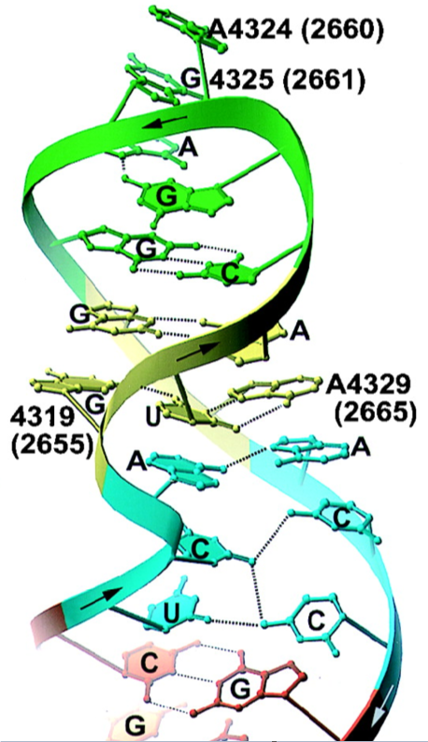
  - Dom V is important for peptidyl transferase reaction
  - Dom VI contains the Sarcin-Ricin loop which has a peculiar confirmation and is important in interactions with elongation factors
    - Sarcin is a very powerful toxin which cleaves the sarcin-ricin loop and therefore prohibits translation
- Ribosomal protein stabilise rRNA and are found on the surface and in the periphery of the side facing the small subunit -> the interacting surfaces of the two subunits are mostly rRNA
  - Ribosomal proteins have small folded areas but a lot of extensions which consist mainly of lysine and arginine (positively charged to stabilise negatively charged rRNA) and glycines (no side chain for high flexibility)

  - There are ribosomal proteins that interact with all six domains of 23S rRNA-> important role in correct confirmation
  - The long extensions reach through the whole ribosome but don’t come close enough to the peptidyl transferase active site to have a catalysing function in the reaction -> ribosome is a ribozyme (supports RNA world hypothesis)
    - But they do have a function in stabilising tRNA
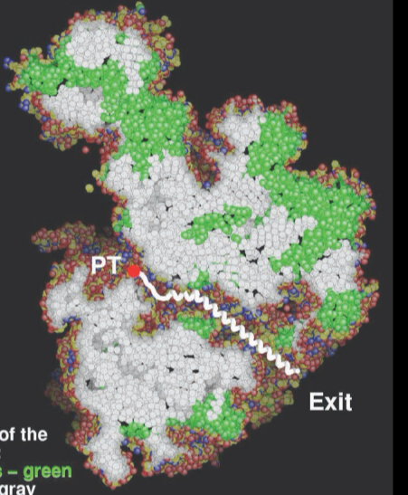
Exit tunnel:
- To prohibit the newly synthesised polypeptide chain from interfering with the translation process, it has to diffuse away from the reaction site
- The exit tunnel can store ~35 Aa’s (100Å long) or even more if there is already some secondary structure present (~66 Aa’s if as α-helix)
- The exit tunnel is aqueous (similar to protein surface) meaning that the protein can already start folding
- Macrolides (e.g. Erythromycin) can diffuse through the tunnel, bind close to the active site and block the tunnel entrance using the following structural features:
  - Relatively large ring (14+ membered)
  - Sugars attached to the ring
  - Some functional groups added (methyl group, hydroxy group, ethylaldehyde,…)
    - Some macrolides can even form covalent interactions with the rRNA
  - The macrolide-ring binds at the tunnel entrance and the linearly attached sugars project towards the active site
    - The longer the sugar, the shorter the polypeptide chain before elongation stops (there are even macrolides who don’t allow initiation)

Peptidyl transferase reaction
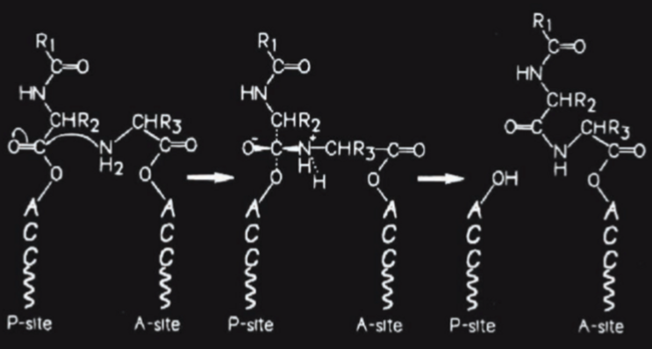
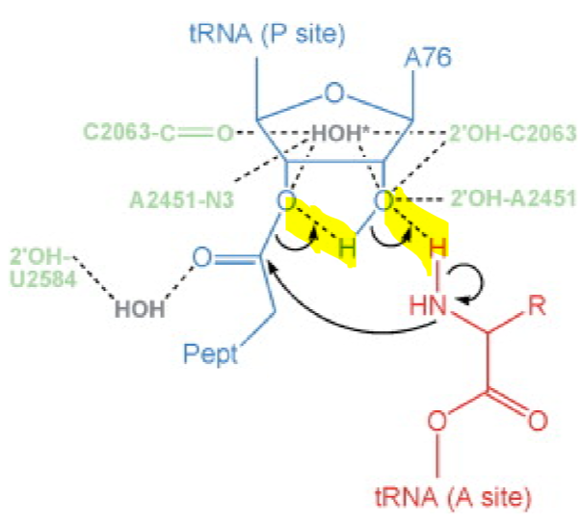
- Nucleophilic attack by the nitrogen targeting the carbonyl carbon (“C-terminus”)of the polypeptide chain
  - So called substrate-assisted, concerted proton shuttle mechanism

- Cryo-electron microscopy has a lot of noise because you use few electrons to minimise damage. You have to superimpose all the recorded proteins and as a result, the noise should be reduced and ideally you should have a 3D-model of your protein because every orientation should be present in your data
- Helped in reconstructing the different ribosomal confirmations
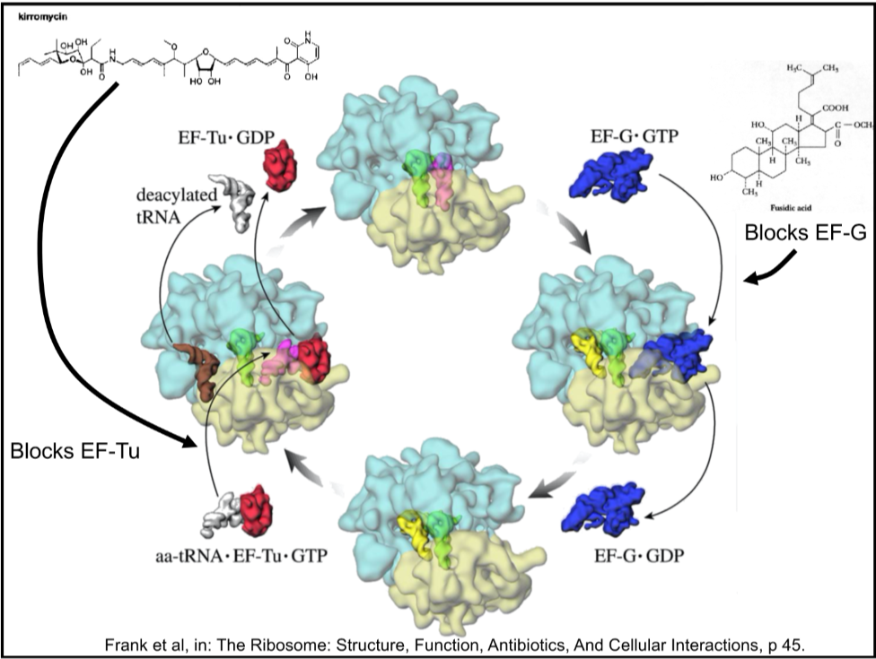
- Using the two shown antibiotics, the different states of the ribosome can be trapped and visualised
- EF-Tu binds to target tRNA and inserts it into the active site, where the tRNA has to bend to form the proper interactions with the rRNA and mRNA. This bending propagates through the whole tRNA and triggers GTP hydrolysis in EF-Tu followed by its dissociation
  - If it is the wrong tRNA, it will not successfully bind to the ribosome, GTP hydrolysis won’t be triggered and the whole tRNA-EF-Tu-complex will dissociate

Co-translational protein targeting/folding/translocation
Targeting
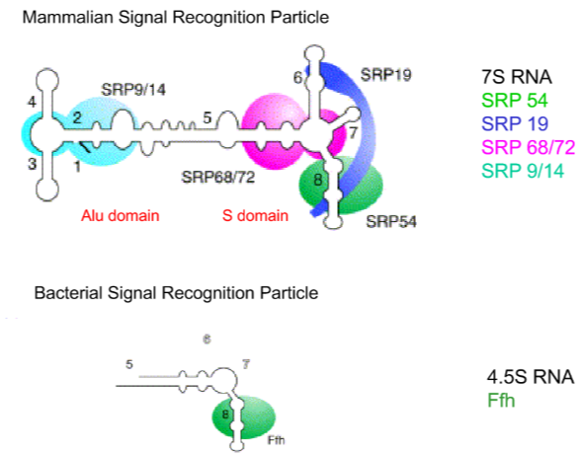
- Signal recognition particle (SRP, consists of RNA and proteins) can recognise the usually hydrophobic N-termini of newly synthesised membrane proteins which signals that the elongation has to be primarily stopped and the ribosome has to be translocated to the target membrane
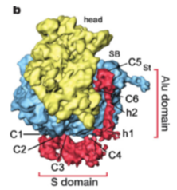
- SRP is more complex in eukaryotes but the most conserved region (SRP54) is also present in prokaryotes
  - S domain recognises target sequence
  - Alu domain plugs the site where EF-Tu normally binds and prohibits further elongation

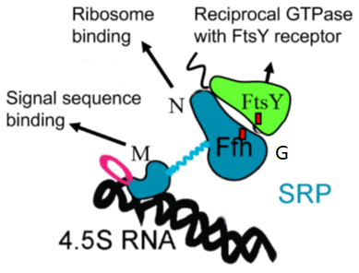
- In bacteria it’s called Ffh (fifty-four homologue)
- M domain binds SRP RNA and to the polypeptide signal
- G domain binds GTP
- N domain binds the ribosome
- N and G domain bind N and G domain of FtsY (SRP receptor) and form a NG heterodimer
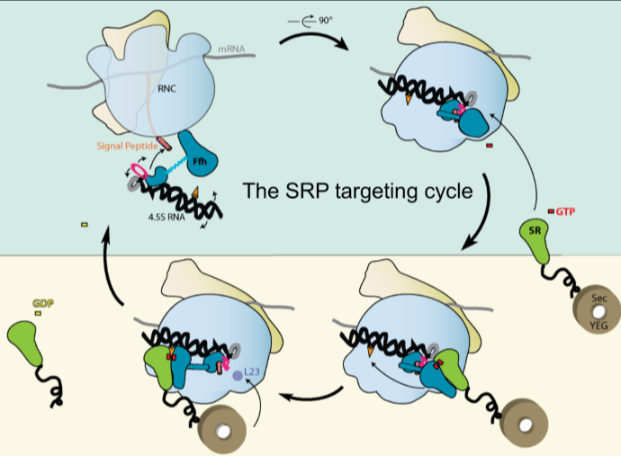
- SRP binds loosely to the ribosomal protein L23 and upon polypeptide signal, it binds to the end of the exit tunnel. SRP/FtsY migrates to the distal part of the SRP RNA (highly conserved) and exposes the signal pepitde which gets recognised by the translocon, followed by GTP hydrolysis, disassembly of the SRP/FtsY heterodimer and release of FtsY.
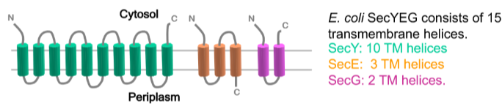
- Translocon (SecYEG in bacteria, Sec61 in eukaryotes ) is composed of three proteins (SecY, SecE and SecG).
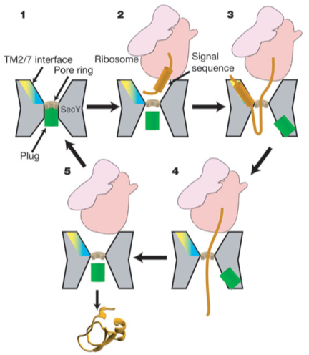
- SecY has an hourglas confirmation (thin area in the middle plugged by helix2a. Proteins can either be laterally inserted (3) or translocated (4). Translocation is done by SecA which pushes the polypeptide through the Translocon in an ATP-dependent manner.

Synthesis of soluable protein
- Co-translational folding is comparably slow because it is dependent on translation which is slower than the folding processes. Since the protein is not fully synthesized, it might be lacking some folding information and is therefore especially vulnerable for aggregation, misfolding or degradation.
  - Solution: Chaperones (e.g. trigger factor which directly binds to the ribosome)
Trigger factor
- Very abundant (1:1, trigger factor:ribosome)
- Has three domains (head, arms, tail)
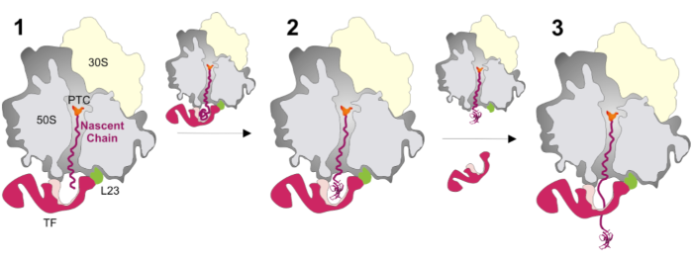
- The tail binds to the ribosomal protein L23 (in a salt sensitive way)
- hydrophobic “belly” region forms a cavity where a small folded protein domain can accommodate
- Helps folding several hydrophobic domains
- Head region has enzymatic activities (PPlase (peptidyl-prolyl cis-trans isomerase))
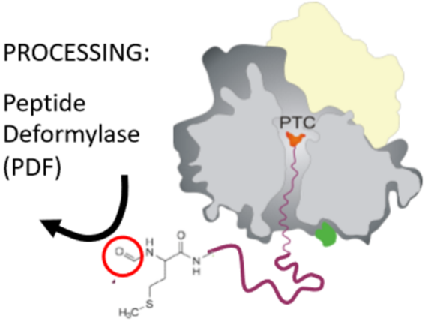
Co-translational processing
- Almost all bacterial protein will have to have their N-terminal formylmethionine cleaved off in 2 steps
  - Removal of formyl group by PDF
  - Removal of whole methionine by MAP (methionine amino peptidase)
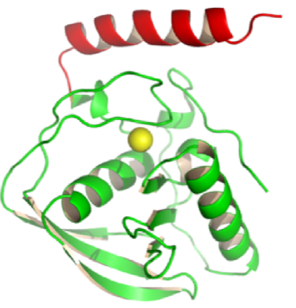
- This process has to happen co-translationally. PDF KO don’t survive
- PDF binds to the ribosome using the red C-terminal α-helix.
  - This was found out using a centrifuge. PDF and ribosomes were mixed and normally only ribosomes should spin down and form a pallet. PDF was found in the pallet.
  - No red helix -> no PDF in pallet.
  - Red helix attached to random protein -> random protein in pallet
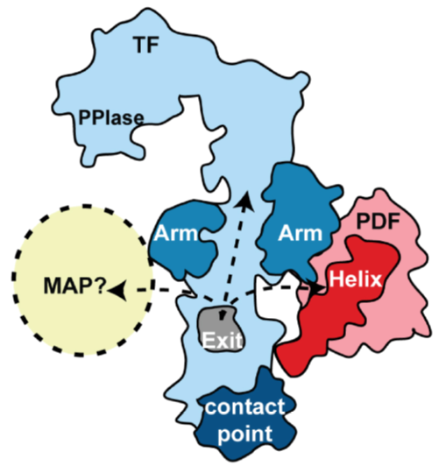
- PDF binds right next to the exit tunnel and processes most polypeptides at ~40 Aa’s of length (whereof ~35Aa’s are inside the exit tunnel)
- PDF, MAP and trigger factor can bind simultaneously to the ribosome and work in concert
  - Nascent chain can diffuse to different active sites

Prokaryotic and eukaryotic ribosomes
- Eukaryotic ribosomes are far less understood because they are larger and more complex than prokaryotic ones
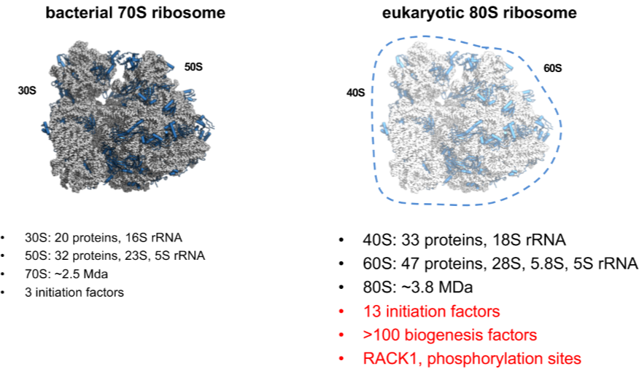
Prokaryotic | Eukaryotic
Shine-Dalgarno sequence | Use 5’ Cap to bind to mRNA and by binding of initiation factor 1 & 1a, the 40S rRNA changes in confirmation and can scan for the first start codon
Synthesized in cytosol | Synthesized in nucleus, assembled and exported to the cytosol
Some proteins on surface | Many proteins on surface
- Eukaryotic ribosomal protein is co-translated with ubiquitin which gets cleaved -> homeostasis between anabolism and catabolism
  - If it doesn’t get cleaved, the ubiquitin will sterically interfere with the tRNA binding site/EF binding site which leads to a non-functional small/large ribosomal subunit
Translation in virus-infected cells
- The viral RNA of the hepatitis C virus (HCV) has a 5’ structured region which enables binding to eukaryotic ribosome without the respective initiation factors
SARS-CoV-2
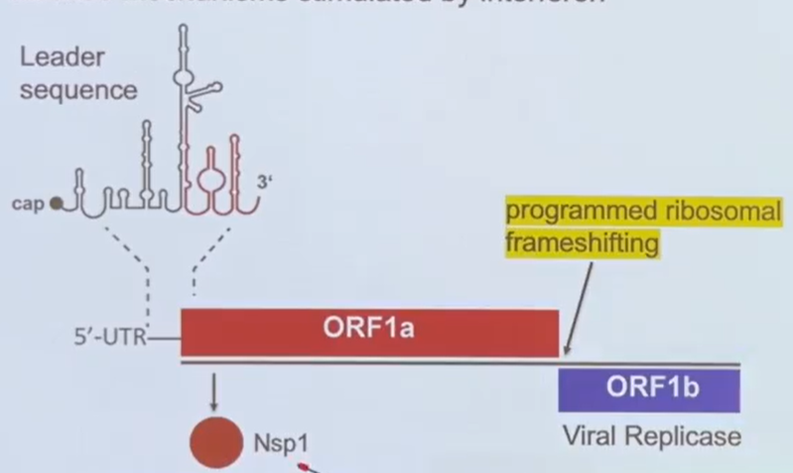
- 5’ unstructured region with initiation of translation function
- Non-structured protein (Nsp1) somehow inhibits host protein synthesis -> prevent innate immune response
  - Nsp1 binds via its C-terminal domain to the mRNA channel of the 40S subunit preventing mRNA interactions sterically
    - Follow up experiment showed that N-terminal domain has no function in ribosome-inhibition
  - Somehow vRNA can still be translated
- Viral replicase is also encoded

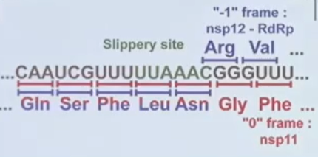
- There is a critical frameshift between these two protein
- Slippery site leads to unsynchronized tRNA and mRNA movement which leads to the mRNA lagging behind one nucleotide (-1 frameshift)
  - The mRNA contains e pseudoknot which pulls on the mRNA in the active site during unfolding which leads to this frameshift and also a significantly slower translation process in this region
  - Frameshifting is also influenced by already folding protein in the exit tunnel
  - There is a stop codon very close after the frameshifting which also plays an important role in the frameshifting itself
    - Since there are multiple ribosomes translating at the same time, the pseudoknot might not be folding again if there was no stop codon, leading to the next ribosome not encountering the pseudoknot which would prohibit successful frameshifting

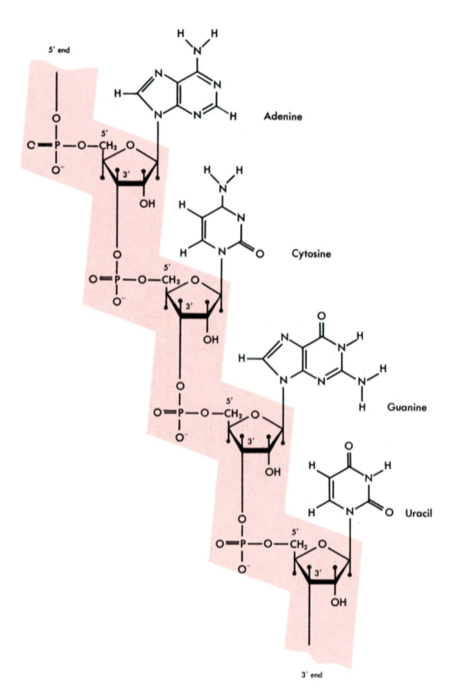
Allain
RNA-RNA interactions
- RNA is single stranded and can fold and form structures
- 2’OH in RNA makes it less stable (more reactive), more prone for degradation and allows other interactions since it is able to form hydrogen bonds
- RNA enumeration always from 5’ to 3’
- GU base pair can form almost as well as AU
- Base-modifications in RNA:
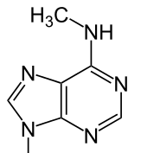
  - D isn’t planar and aromatic anymore
  - Ψ is connected to the ribose at position 5 instead of position 1, base pairs the same way as uridine
  - N⁶A is a methylation of the amino group of an adenine (most frequent mRNA modification)
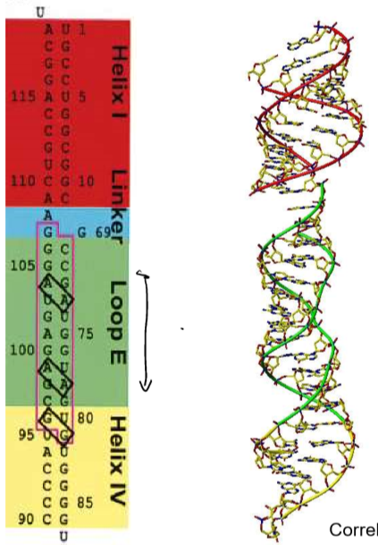
E.coli 5S rRNA
- Helix IV adopts an A-form helix (bigger minor groove, smaller major groove, common for dsRNA, dsDNA adopts B-form Helix) due to perfect Watson-Crick base pairing
- Same for Helix I
- Loop E has many non-Watson-Crick bp’s and one would normally not predict that it would have a helical structure (that’s why it’s called loop)
  - Normally, the two phosphate backbones are around 11Å apart. The narrowest point in loop E is 4Å -> very narrow major groove
  - The bases form a mixture between Watson-Crick and Hoogsteen pairing and can even form hydrogen bonds with the 2’OH
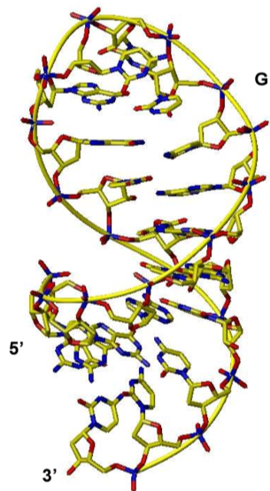
  - Not normal base stacking but cross-strand base stacking (marked in black)
Tetraloops (UUCG)
- Most frequent tetraloop
- Important for RNA folding because it changes the structure drastically
- Extremely thermally stable
- First U and G form a bp, second U bulges out, C stacks with first U and forms H bonds with its phosphate

Internal loop (also called Loop E)
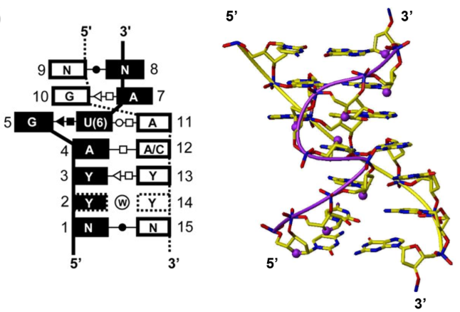
- One extra base on one strand
- G and U are not on top of each other, they are besides one another and form a base triple with the opposing A
- Flanked by a G:A and A:A/C pair
  - Y = pyrimidine base
  - N = any base
- A right below the triple is flipped by 180°
- G pairs with A, phosphate of the opposing backbone and does a cross-strand stacking with the other G
tRNA
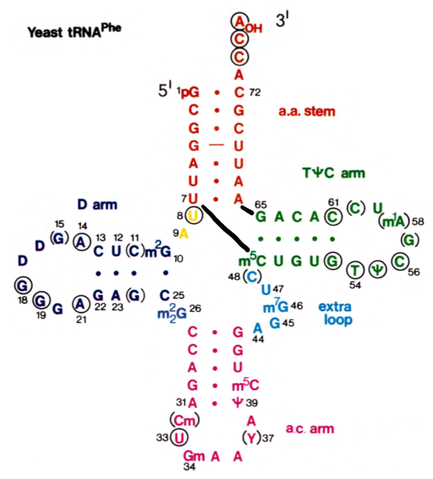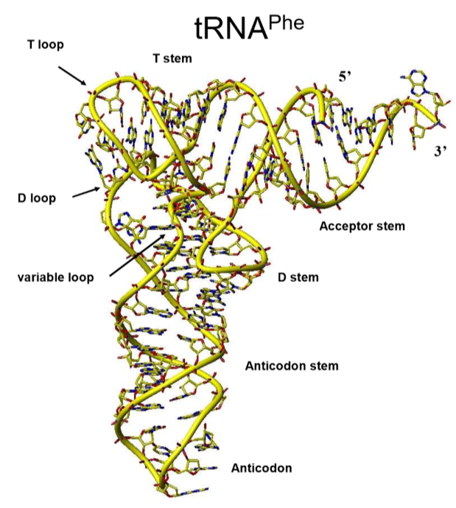
- 4 way junction
  - 4 helices coming together -> helices can stack with one another
  - Orange with green -> short arm
  - Blue with pink -> long arm
  - Green loop and blue loop will interact (base pairing and cross-loop stacking) and further stabilise the structure
- A lot of base triple
Group1 intron
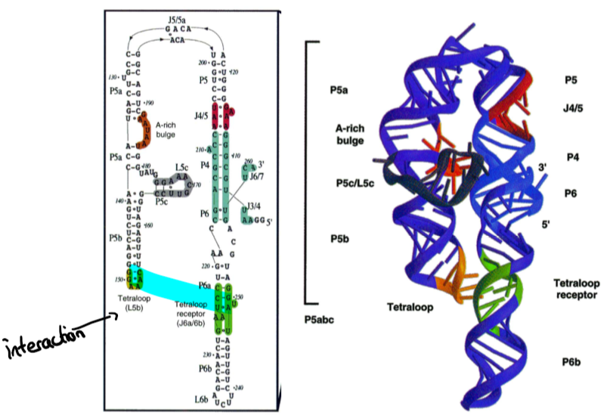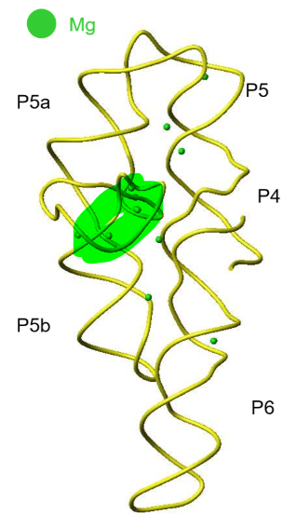
- Mg²⁺(surrounded by 6 water molecules) stabilises negatively charged RNA by preventing repulsion
- Mg²⁺(not surrounded by water) also essential for folding of the RNA and can even be covalently bound

Protein-RNA interactions
Most RNA binding proteins (RBP’s) have one or multiple (to increase affinity and specificity) RNA binding domain (RBD). Often also have a catalytic or a protein-protein domain to recruit target protein to target RNA
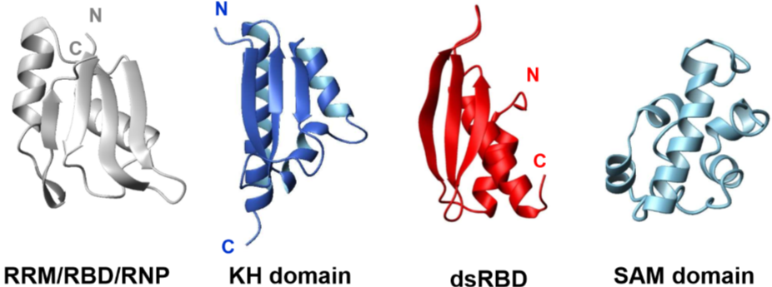
- Most frequent: RRM/RBD/RNP
  - RRM=RNA recognition motif
  - RBD=RNA binding domain
  - RNP=Ribonucleoparticle
  - Β-sheet is the primary binding surface
  - Binds ssRNA
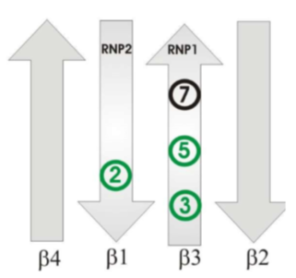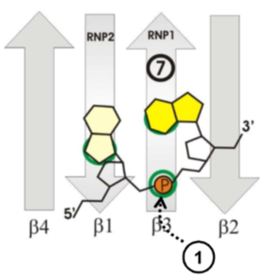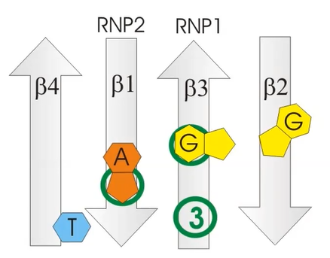
  - Green numbers are aromatic residues (tyrosine or phenylalanine) which interact with the RNA. The in between Aa’s interact with the α-helices in the back.
  - 1 is a positively charged Aa which interacts with the negative backbone of the RNA
  - The aromatic residues can stack with the ssRNA (not sequence specific, additional side chains can form specific hydrogen bonds with the bases, other additional sidechain can bind on top of the ssRNA and lock it in place)
  - One base before and one base after which are without stacking -> recognises 4 bases in a sequence specific manner
    - Mostly high affinity for Adenine
  - Two domains can be put next to each other to increase specificity (bind a longer consecutive ssRNA) or to form the RNA if the binding domains are not directly next to each other and recognise different sequences on the same ssRNA
- KH-domain
  - Binds ssRNA
- dsRBD
  - double stranded RNA binding domain
  - binds A-form dsRNA in an almost non-specific manner because it interacts mainly with the backbone
  - some Aa’s which specifically bind a bp (mostly 8-10 Aa’s apart) and lead to specific placement of the dsRBD
- SAM domain
  - Most frequent in protein-protein interactions but a subclass also binds dsRNA tetraloops which have a G on top
Arginine-rich peptides
- α-helix which is normally too big for a major groove interaction can bind to a widened (by bulges) major groove

Ribozyme
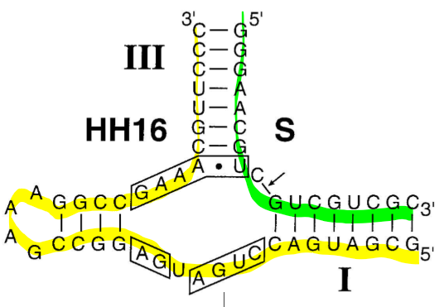
All ribozyme require Mg²⁺ or Mn²⁺
Hammerhead ribozyme
- secondary structure looks like a hammer
- cleavage between C and G (arrow) but only if the inboxed nucleotides are present
- ribozyme and substrate
- high K_{m} (high binding affinity)
- low k_{cat} (low catalysis)
  - RNAses have lower binding affinity but higher catalysis
Mechanism (S_{N}2):
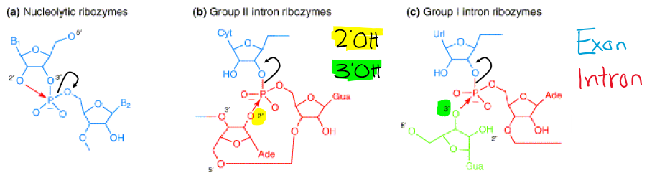
- Attack of 2’OH of the own ribose
- Attack of 2’OH of another bound ribose
- Attack of 3’OH of an external Guanine
- have to be in a straight line -> tertiary structure
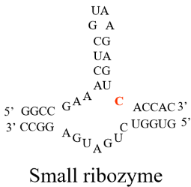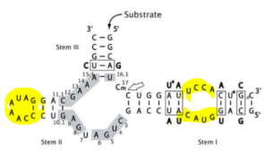
- Small ribozyme was artificially produced to investigate the catalysis but had very poor catalytic effects. The real ribozyme (right) has a tertiary structure (interaction of the two yellow loops) that aligns the three participating molecules (O, P, O) for a successful S_{N}2 reaction which was missing in the small ribozyme
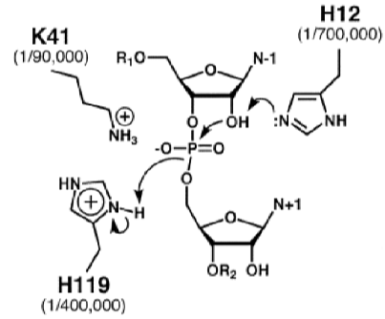
RNAse A mechanism (acid-base catalysis):
- One histidine acts as an acid and one as a base

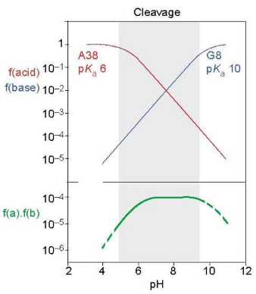
- Is the ribozyme also acid-base?
  - Yes, Adenine as an acid, guanine as a base. At physiological pH only 1 in every 1000 ribozyme has both which also explains the low k_{cat}
  - Very pH-stable at physiological values

Group I and group II introns
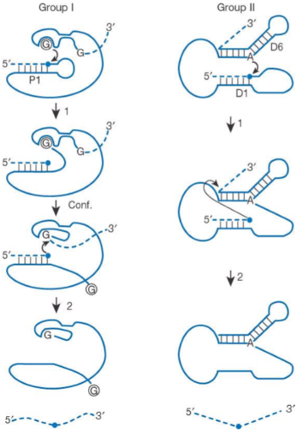
- Group I introns have no active bases doing the catalysis, there are metal ions which activate water molecules which then act in an acid-base-like fashion
Post-transcriptional mRNA-cleavage
Argonaute2 associated with siRNA or miRNA then called RISC (RNA-induced silencing complex), which guides it to target mRNA
- Perfect pairing -> cleavage
- Imperfect pairing -> translational inhibition
- siRNA/miRNA around 20 nucleotides long
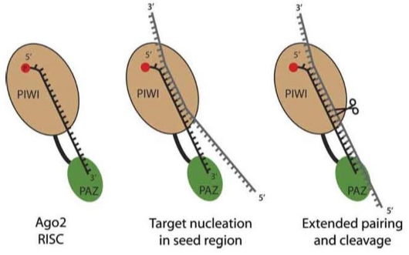
- PAZ domain binds 3’ end of siRNA/miRNA (2’OH and 3’OH, not sequence specific)
- PIWI binding domain binds 5’ end of siRNA/miRNA
  - Glutamate residues in PIWI domain which stabilise Mg²⁺ ions which activate water molecules to do the cleavage

RNA splicing
Constitutive splicing
Catalysed by the spliceosome
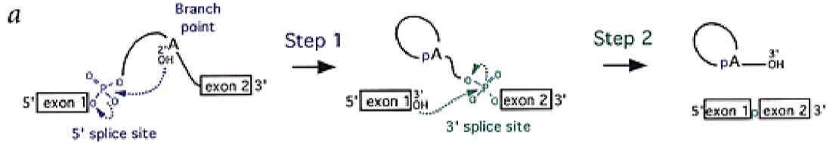
- 2’OH of Adenine will attack the 3’ phosphate of the exon and form a lariat. The newly created 3’OH attacks the 5’ phosphate of the next exon and thereby releases the intron
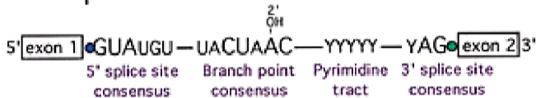
- Some structures of the intron are highly conserved (the bigger the letter, the more conserved)
  - Spliceosome also binds to the intron based on these conserved regions
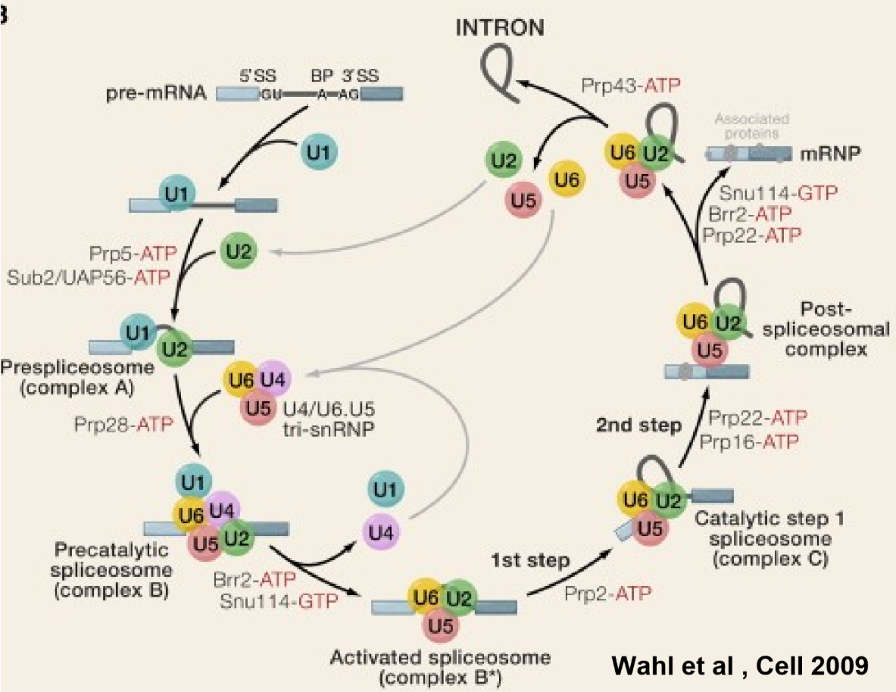
- The spliceosome has 5 subunits U1, U2, U4, U5 and U6 which all consist of snRNA and proteins (short: snRNP)
- U1 will base pair with the 5’ splice site consensus using its heavily modified tail
  - U1-C protein binds only if U1 is bound to a target pre-mRNA and then gets further stabilised by Luc7
- U2 will base pair with the branch point consensus
  - The A with the attacking 2’OH is not involved in base pairing to U”, it is bulged out
- U4, U5 and U6 form a tri-snRNP which is held together by Prp8
  - Binding of the tri-snRNP is mediated by Prp28
- U6 will bind to U2
- U1 and U4 leave and U2, U5 and U6 form a new tri-snRNP whereof U6 replaces U1 in binding to the 5’ splice site and forms a stem loop which is then the active site and binds metal ions
- Dramatic changes:
  - Complex A -> Complex B (10 proteins leave, 65 proteins join)
  - Complex B -> Complex C (35 proteins leave, 35 proteins join)
- In the complex C, the whole structure has moved and brought the 5’ and the 3’ splice site in close proximity of the U6 active site
- It is important that the attacking base is an adenine because it forms distinct H-bonds
- Spliceosome (many small RNA’s ad many protein) similar to group II intron (one comparatively large RNA)

Pilhofer
Chromatin structure and remodelling
- Chromatin = DNA & protein (huge fraction = Histones)
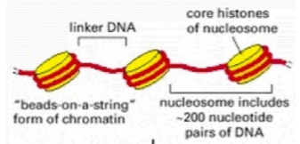
  - Mass of DNA: mass of protein ~1:1
- Nucleosome = nucleosome core particle (histones) with DNA wrapped around it and linker DNA
  - Core particle is usually an octomer (canonical nucleosome) which consists of H2A, H2B, HC and HD (2 subunits each)
- Histones differ in N- and C-terminus but have a conserved histone fold region 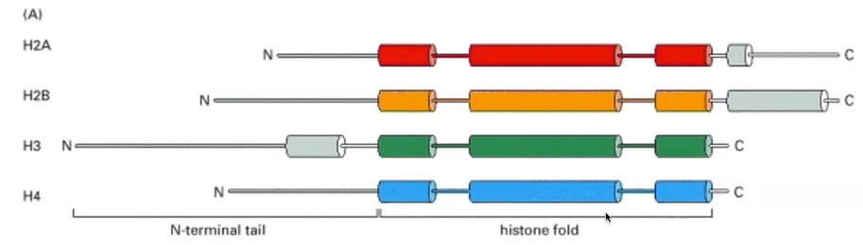
  - 3 α-helices connected via 2 loops
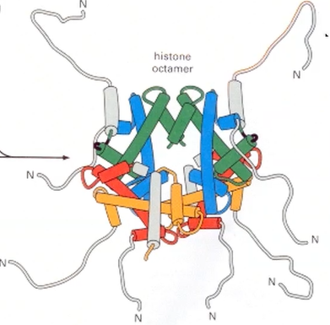
  - H2A & H2B and H3 & H4 can dimerise together (called “handshake”)
    - Two H3/H4 dimers can form a tetramer which can take up two H2A/H2B dimers and form the octamer
    - N terminal tails don’t contribute to the core
- Histone variants (mainly for H2A and H3) are present troughout a cells life whereas H2A and H3 are highly expressed during replication for cell division
- Histones are also posttranslationally modified (mainly acetylation but also phorsphorylation and methylation)
- Constant rearrangement which also enables transcription
Nucleosome positioning:
- Large macromolecular machines (mostly influenced by post translational modifications of target nucleosome) use ATP-hydrolysis to slide/disassemble/restructure nucleosomes
  - ISW1 alters the length of the linker DNA (spacing of two consecutive nucleosomes)
    - Composed of Isw1 and loc3
    - Side activity: can also bind defective mRNP and prevent their export into the cytoplasm
  - SWI/SNF have a more disruptive function and remove/slide nucleosomes mostly during replication

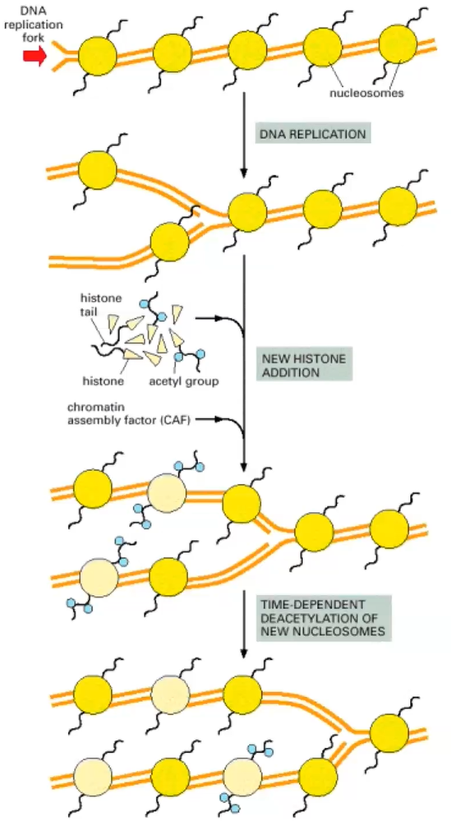
Replication
- It is known that the replication machinery can pass through nucleosomes during replication (exact mechanism not known, maybe remodelling?)
  - Challenging the notion that histones have to be removed for DNA synthesis
- Large number of new histones have to be synthesized to keep up with the speed of replication (histone genes duplicated)
Higher order structure
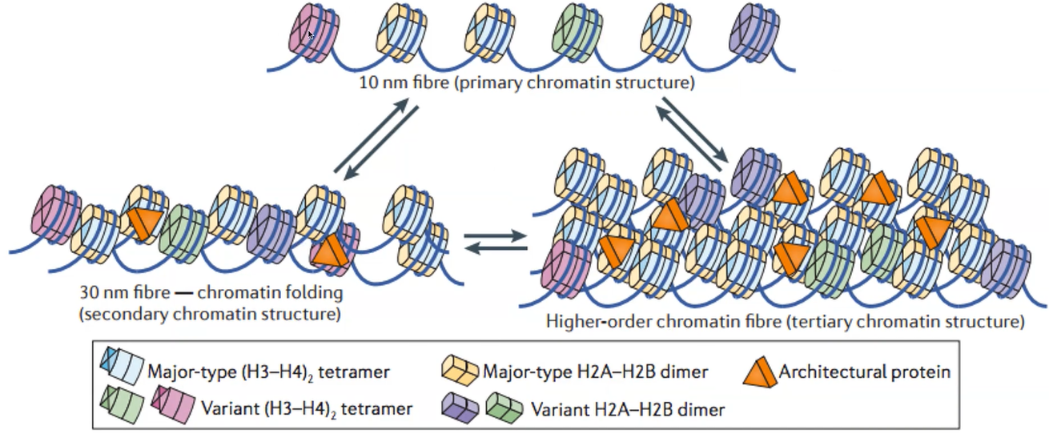
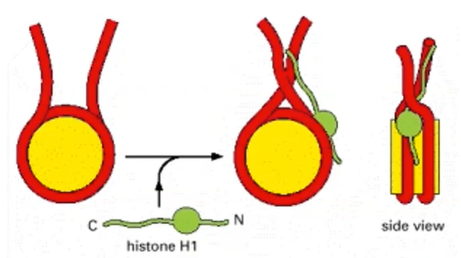
- H1 protein can change orientation of linker DNA and therefore remodel chromatin structure
- Histone tail interactions can also lead to higher order structures
  - H2A/H2B has an acidic patch which can interact with histone tails (mainly H4, other molecules evolved to also bind the acidic patch and therefore regulate chromatin condensation)
    - If you remove some of these acidic residues you can prevent the formation of 30nm fibre
30nm fibre controversy
- Regularly found in vitro and in silico (computationally) and they are so highly ordered and regular that their relevance in vivo is doubted (they exist in vivo dependent on the physiological state -> rarer than in vitro)
  - Too good to be true
  - Hypothesis: in vitro they are highly diluted and you get intra-strand nucleosome-nucleosome interactions whereas at higher concentrations (in vivo, called polymer melt model) you get inter-strand interactions and therefore less regular/structured interactions

Mitotic chromosome structure
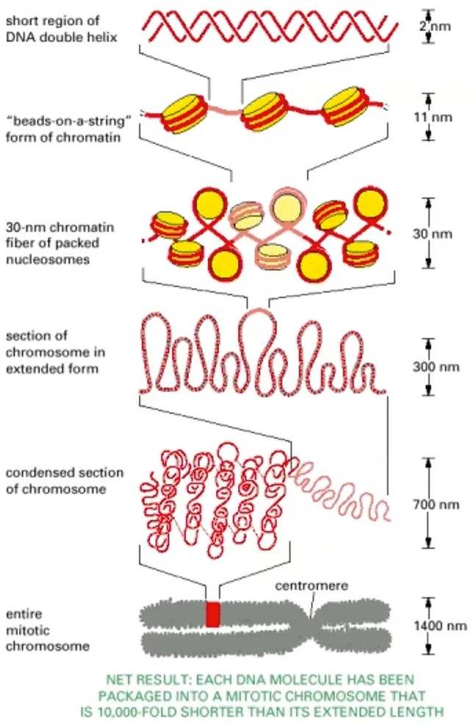
- The really condensed state silences gene expression due to sterical hindrance
- Architectural proteins involved in higher order organisation
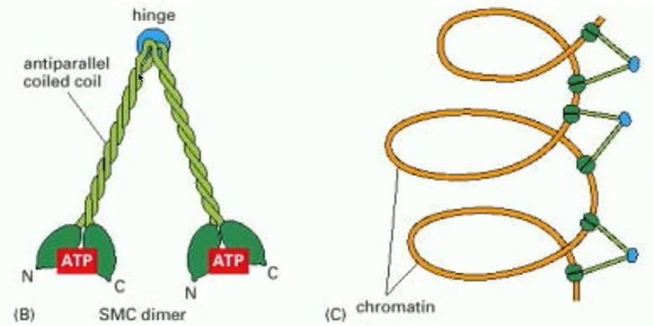
- SMC (structural maintenance of chromatin) binds chromatin loops (300nm)

Contractile Injection systems (CIS)
- Bacteria often secrete effector molecules either into the surrounding extracellular space or directly into neighbouring cells by injection
T4 phage
Important because all the other CIS’s are homologous to the one of T4 phages 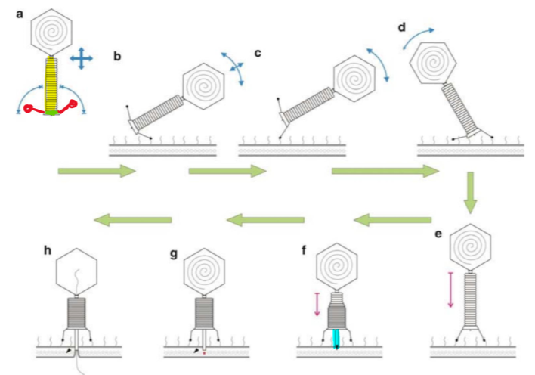
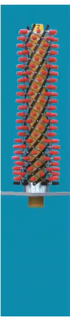
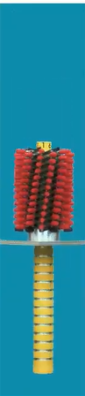
- Contractile tail, base plate, tail fibres, inner tube with spike at the end (the very end called PAAR domain) to penetrate target cell
- The contractile cascade is triggered by the base plate. The length of the contractile tail shrinks (pushes the inner tube through host cell membrane) and the diameter widens (releases the inner tube)
T6SS (Type 6 secretion system)
Bacterial secretion system
- Cell-cell contact dependant
- Very diverse and abundant
- Protein delivery (not DNA as in phage) into host cell
- Frequently observed dualing (Cell A attacks Cell B which then responds directly with a counterattack, not clear how the attack is sensed by cell B)
Functions:
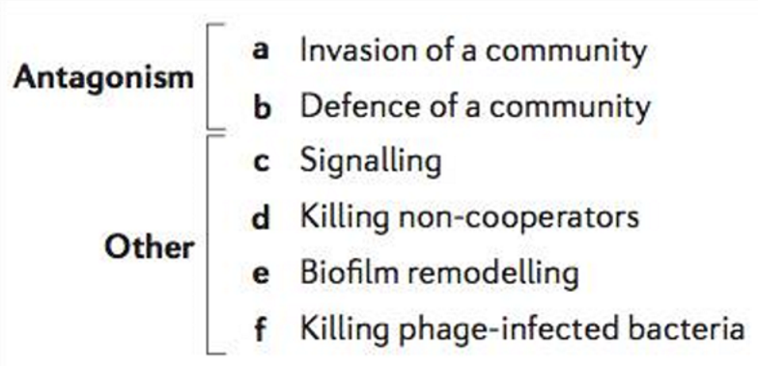
- The whole secretion system polymerises over 10’s of seconds (high energy state) and contracts very fast (low energy state). The whole building blocks can be disassembled and recycled
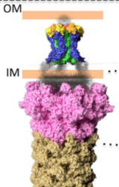
- TssJLM is a trans-envelope complex (between the inner and outer membrane inside the periplasm) which recruits the base plate and enables the inner tube of the T6SS to penetrate the own cellular envelope

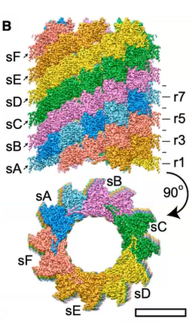
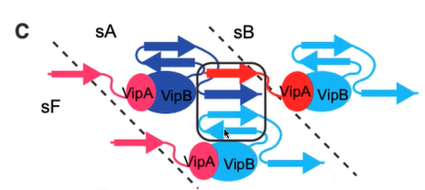
T6SS sheath
- VipA and VipB are the main proteins
- Different layers (up-down) and different filaments (left-right) interact with each other via the conserved handshake domain
- The non-contracted confirmation had to be studied by introducing a mutation which prevented contraction
3 fire modes:
- Assembly from one side, firing towards same side (canonical contraction)
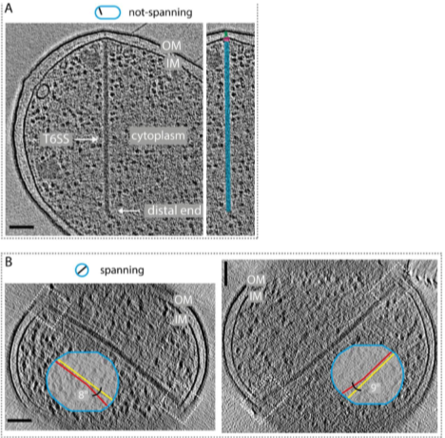
- Assembly from one side, firing towards opposite side (non-canonical contraction – opposite)
- Assembly from one side, firing towards both sides (non-canonical contraction – split)
- Secretion systems are often bent if the span the whole cell
- TssA1 protein was found to cap the distal end of the tube and prevent further growth if the opposing membrane was reached (right). TssA1 mutant didn’t stop polymerization (left)
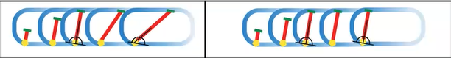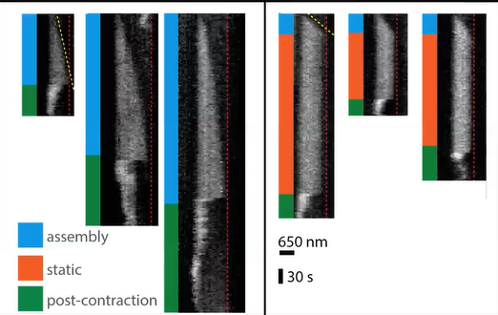
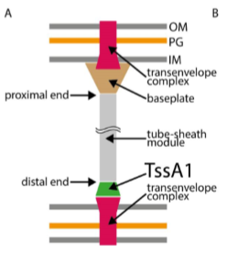
- Hypothesis which could explain non-canonical firing is that the TssA1 (distal) end attaches to another TssJLM

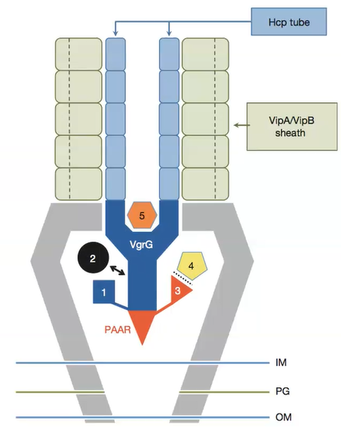
Effector molecule translocation
- Fuse to spike
- Bind to spike
- Fuse to PAAR
- Bind to PAAR
- Inside the inner tube (inner diameter of about 35Å -> very small cargo)

Homology T4 Phage and T6SS
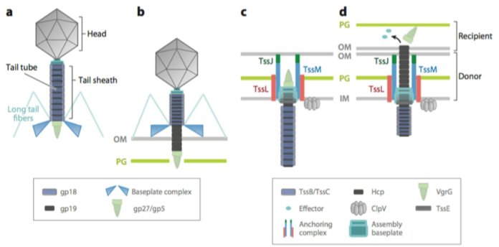
Gene transfer agents (GTA)
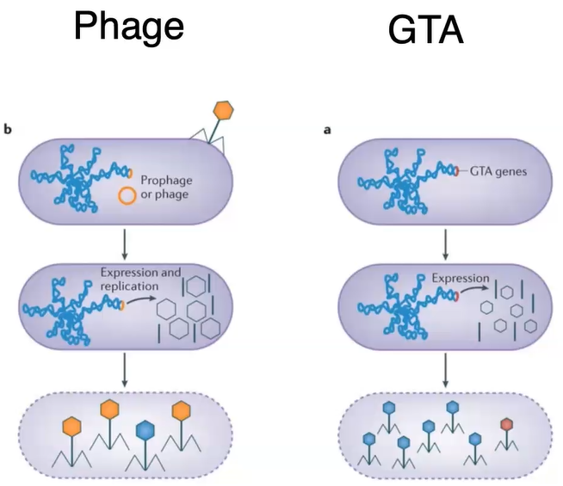
Poorly studied but there exist some phage-like structures in bacteria that pack some random DNA (non-replicative) and enable horizontal gene transfer

R-type bacteriocins (pyocins)
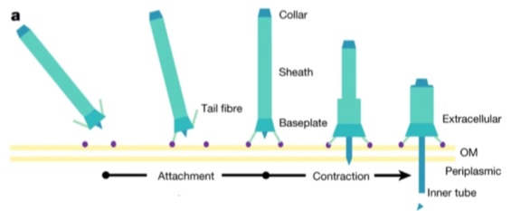
- Missing the head compared to phages
- Get released by the bacteria into the extracellular space
- Base plate dissociates after firing

Metamorphosis-associated contractile structures (MACS)
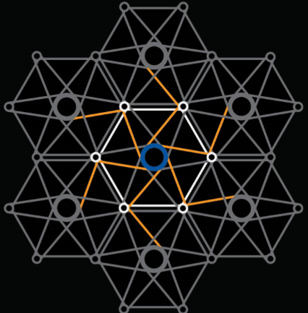
- Secreted MACS’s which induce metamorphosis in target small eucaryotic organisms. The MACS’s are secreted by only a few bacteria but they are packed with them (released by cell lysis). They are highly organised. Hypothesis as shown in the schematic.
- Possible metamorphosis-inducing factor (Mif1) is the cargo inside the inner tubes.
  - Mif1 KO showed empty tubes
  - JF50_12605 KO also empty tubes (possibly involved in loading Mif1
  - If small eucaryotic organisms were injected with Mif1 (electroporation) they underwent metamorphosis in 50% of the cases
Other CIS’s
- CIS also found in archaea and used to kill other archaea
- CIS also found in cyanobacteria but always in between the thylakoid membrane (mostly in the outer membranes)
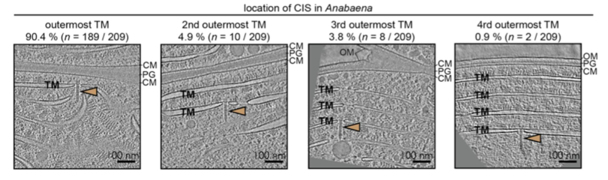
  - Baseplate binds to the thylakoid membrane using Cis12 and Cis13
  - Function unclear but hypothesis is that upon stress, the cells die and the CIS’s get exposed to potential targets

Jonas
RNA p
Polymerase II termination (eukaryotes)
- Polymerases are processive enzymes which can perform their catalysis multiple times without changing the substrate
  - Distributive enzymes are perform only a single catalytic step before dissociation
How to stop the processive RNA polymerase II (RNAPII)?
- CPSF73 (Cleavage and Polyadenylation Specific Factor) is a nuclease which associates with the polymerase II and cuts the mRNA after the poly A tail
- The polyadenylation signal (PAS) is mostly AAUAAA
  - The location of the PAS is important:
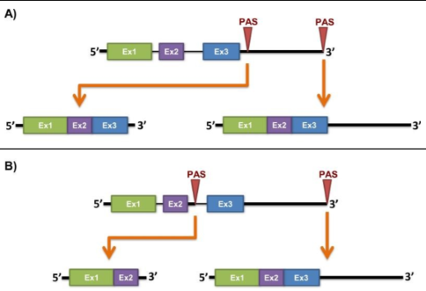
  - A can lead to different translocation or degradation
  - B can lead to different protein isoforms
Termination depends on transcription type
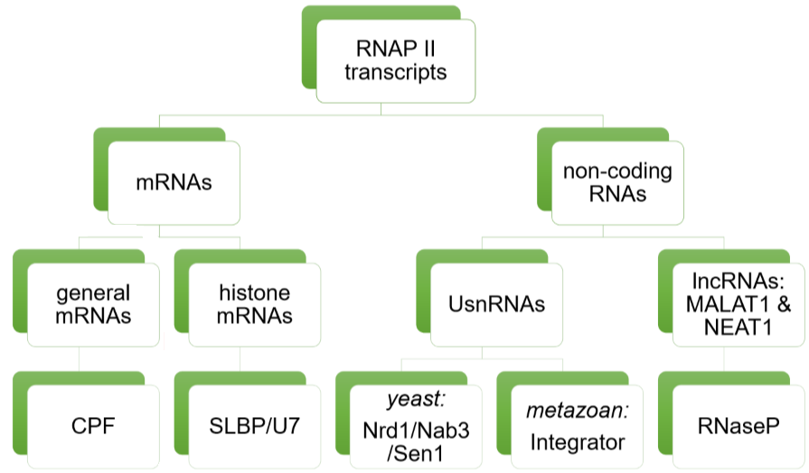

General mRNAs
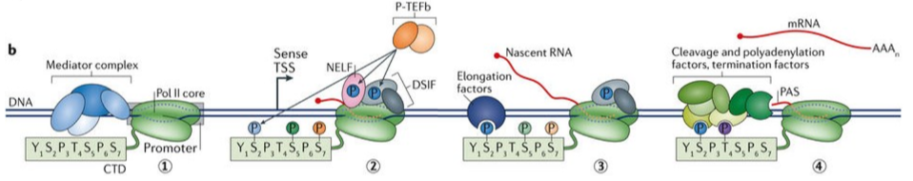
- RNAPII associates with CTD which has several phosphorylation sites.
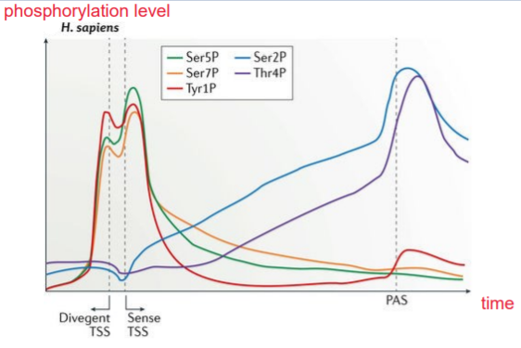
  - Y1P, S2P and T4P are responsible for termination in human cells
- Phosphorylation of CTD dependent on time
- CPSF associate with the PAS (AAUAAA)
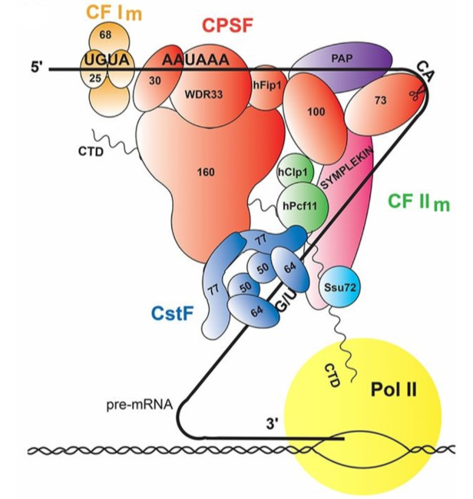
  - Combination of Watson-Crick and Hoogsteen pairing, also recognises AUUAAA (second most common PAS)
  - CPSF73 does the hydrolysis
  - CPSF100 lacks the zinc binding domain and is therefore not involved in the catalysis (pseudoenzyme)
- CF I_{m} binds two UGUA sequences which leads to mRNA looping
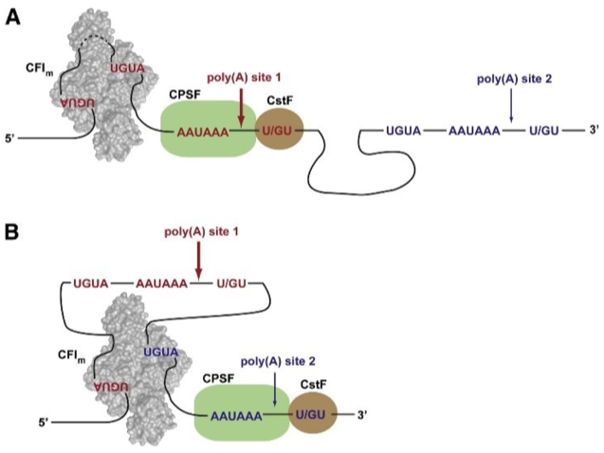
  - Depending on which UGUA sites are bound, different PAS can come into action
- CstF binds regions rich in G and U, dimerises and signals to the CPSF
- Pcf11 binds S2P
- Ssu72 removes S5P
- Symplekin activates phosphate hydrolysis allosterically

Histone mRNA
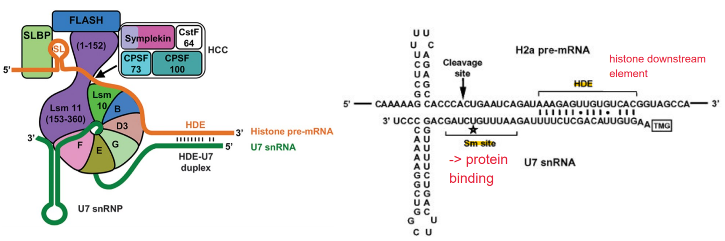
- No poly A tail, only a stem loop which is recognised by stem loop binding protein (SLBP, mainly recognises the shape and only one base is directly identified)
  - SLBP binds FLASH
  - FLASH binds symplekin
  - Symplekin binds CPSF100 and CPSF73
  - Lsm10 opens and closes CPSF73 active site
Important similarity to general mRNA:
- Recognition of short sequence motifs which are then coupled in space by protein-protein interactions
Important difference to general mRNA:
- Recognition of histone downstream element (HDE) by base pairing with snRNA, not protein-mediated

UsnRNAs (uracil-rich short non-coding RNAs) in yeast
- Recognised by Nrd1-Nab3-Sen1 complex(NNS)
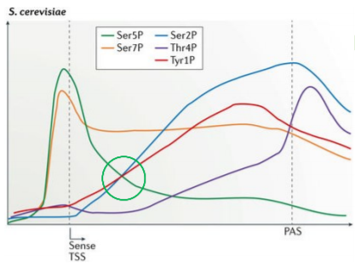
- Nrd1 binds to target GUAA with RNA recognition motif (RRM)by pseudo-base pairing (water mediated)
- Since the snRNA is way shorter then general mRNA, the phosphorylation of CTD is different
- Nrd1 also has S2 and additional S5 binding site
- Nab3 binds to UCU (pseudo-base pairing)
Important similarity to general mRNA and histone mRNA:
- Recognition of short sequence motifs which are then coupled in space by protein-protein interactions

UsnRNAs in metazoans (multicellular organisms)
- Bound by INTS11 (nuclease) and INTS9 (pseudoenzyme)
- Hijacks a general phosphatase

lncRNA’s (long non-coding RNAs) MALAT1/NEAT1
- RNAseP (normally used for tRNA maturation) 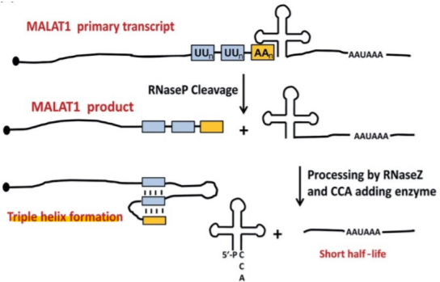
- RNAseP used to cleave -> 3’end of MALAT1 can form triple helix which makes it less susceptible for degradation

