Carina Livia Fluri, FS 2022

Crystallography and Electron microscopy
Summary MSB IV

L1: Historical highlights

"The secret of life lies in the structure of proteins and there is only one way of solving it and that is by X-ray crystallography." J.D. Bernal 1936

Milestones
1885 | Production and measurement of X-Ray | Röntgen*
1912 | Observation of X-ray diffraction in crystals, Bragg's law | Bragg*, Bragg*, Von Laue*
1913 | Crystal structure of diamond | Bragg*, Bragg*
1920 | Fiber diagrams of silk, hair, muscle, and tendons | Herzog, Astbury
1924 | Structure graphit | Bernal
1933 | First electron microscope | Ruska*
1935 | Classification of structural proteins: KMEF (keratin, myosin, epidermin, fibrinogen) + weird poem about wool (Astbury) | Astbury, others
1936 | High-resolution crystal structures of amino acids and dipeptides | Corey, Pauling*
1944 | The genetic material is DNA | Avery
1946 | Genetics of bacteria and viruses | Delbrück*, Hershey*, Lederberg*, Luria*
1951 | Regular polypeptides secondary structures; α-helix, β-sheet | Pauling*
1953 | DNA double helix | Franklin, Crick*, Watson*, Wilkins*
1954 | Collagen triple helix | Ramachandran
1955 | First amino acid sequence of a protein: insulin | Sanger*
1956 | Ramachandran plot | Ramachandran, Sasisekharan
~1957 | X-Ray Crystallography
1959 | First protein crystal structures: myoglobin and hemoglobin | Kendrew*, Perutz*
1961 | Gene regulation, lac Operon, allostery | Changeux, Jacob*, Lwoff*, Monod*, Wyman
1962 | Amino acid sequence determines 3d protein structure | Anfinsen*
1962 | Restriction enzymes | Arber* at Uni Genève, Nathans*, Smith*
1965 | First nucleotide sequence of a t-RNA (clover leaf structure) | Holley*
1965 | Genetic code | Khorana*, Nirenberg*
1968 | 3D EM model of a bacteriophage T4 | De Rosier, Klug*
1960ies | Structures and action of proteins, Review of 1960ies crystal structures: Myoglobin, Hemoglobin, Cytochrome c, Lysozyme, Ribonuclease A, Ribonuclease S, Papain, Chymotrypsin, Carboxypeptidase A
1970 | Gene technology, genetic engineering | Berg*, Boyer
1974 | First crystal structure of a t-RNA | Klug*, Rich
~1975- | Synchrotron beamline for protein crystallography
1975 | Low resolution EM structures of bacteriorhodopsin | Henderson*, Unwin
1976 - | EM image processing "SPIDER" | Frank*
1977 | Sequencing of DNA | Gilbert*, Sanger**
1978 | Splicing of m-RNA in eukaryotes | Roberts*, Sharp*
1980 | First crystal structures of A-, B- and Z-DNA | Dickerson, Rich
1981 | Scanning tunneling microscope | Binnig*, Rohrer* at IBM Zurich
1982 | RNAs with enzymatic activity (Ribozymes) | Altman*, Cech*
1983 | Crystal structure of the photosynthetic reaction center | Deisenhofer*, Huber*, Michel*
1984 | Vitrification of EM samples | Dubouchet*, Glaeser, Taylor
~1984 | NMR with proteins in solution
1985 | First NMR structure of a globular protein in solution | Havel, Williamson, Wüthrich* at ETH Zurich
~1985 | Mass spectrometry of proteins | Fenn*, Tanaka*
1986 | Polymerase chain reaction | Mullis*
1990 | High resolution EM structure of bacteriorhodopsin | Henderson*
1991 | Third generation synchrotron beamlines for protein crystallography
2000 | Protein structure initiative: structural genomics
2000 | DNA sequence of the human genome | Sakaki, Sulston*, Venter, Wada et al
~2012 | Cryo EM
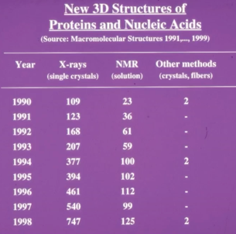
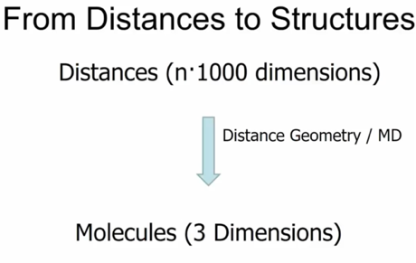
* got Nobel prizes

Structural Biology in the 21st century:
- More efficient use of the methods of the 20th century
- Emergence of new technologies (electron detectors for cryo-EM, single molecule spectroscopy (Betzig*, Hell*, Moerner*), free electron laser [FEL] & hybrid structures from integrative use of multiple experimental techniques & computational modeling (Baker, Karplus*, Levitt*, Sali, Warshel*)
- New results include structures such as: chromatin core particle, cytochrome c-oxidase, DNA polymerase, membrane channels, GPCRs, ribosomes & viruses
- At end of 2020: PDB listed more than 150 000 X-ray crystallography structures, > 6000 EM structures of proteins, nucleic acids & supramolecular assemblies

Style of exam questions (FS17 & FS19)
- Who won the Nobel prize in year xy/ for xy?
- First 5 structures solved

L2&3: Macromolecular Crystallography

PDB Files
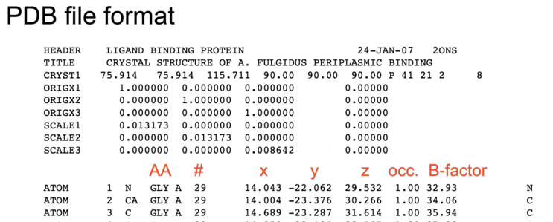
Determine a 3D atomic model (“structure”) of a macromolecule with X-ray crystallography. In a PDB file, each atom is described by 3 fractional coordinates (x,y,z), occupancy & temperature ("B") factor.

CRYST1 (defines unit cell):
- First three numbers = A, B, C,
  - Cell vectors in right-handed coordinate system describing the unit cell
- Next three numbers = α, β, γ
  - Angles defined between unit cell dimensions
- P = primitive
  - Describes space group
- 41 etc: Symmetry axis
  - Example: one four-fold symmetry, two two-fold symmetries
SCALE 1-3: scale matrix

Steps in structure determination ...
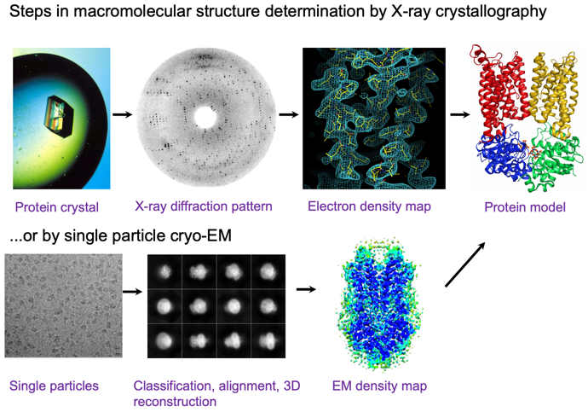
... by R-ray crystallography

Relevance
- Single particle cryo-EM: alternative for macromolecules/ complexes > 100 kDa. Method of choice if no crystals can be obtained & for macromolecular complexes > 0.5MDa.
- NMR = option for de novo structure determination (labeling can be challenging) & small molecules (< 35kDa)
- X-ray crystallography: often >2 Å resolution which is essential for studying (chemical) reaction mechanisms & describing protein-ligand interactions with great precision (>2 Å atm exception in cryo-EM). The smaller particles, the lower chance of obtaining high resolution
- AlphaFold: often predicts excellent apo structures but not of help for ligand binding/conformational changes

Why X-rays?
The use of electromagnetic radiation to visualize objects requires the radiation to have a wavelength comparable to the smallest features that you wish to resolve.
Why Crystals?
X-ray scattering from a single molecule would be unimaginably weak (not detectable above noise level including scattering from air & water). Crystal: arranges huge numbers of molecules in same orientation, so that scattered waves can add up in phase & raise signal to a measurable level => crystal acts like an amplifier

Why Diffraction?
Obtaining a direct image of an object requires focussing of the scattered light. There is currently no material that bends X-rays sufficiently to act as a lens. Diffraction is scattering followed by interference. Origin of phase problem.
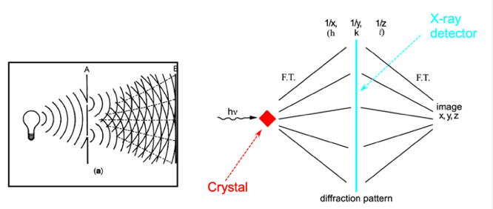
Diffraction = interference or bending of waves around the corners of an obstacle or through an aperture into the region of geometrical shadow of the obstacle/ aperture.

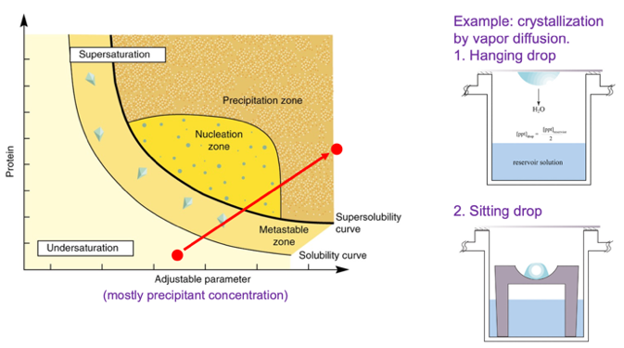
Crystallization: supersaturation of macromolecule solution at “good” conditions

Crystallization results: 3D crystals or precipitation

Workflow: Mix protein with precipitant, try to get rid of water, check under microscope if crystal or precipitation, adjust concentration to drive it out of solution if necessary.

X-ray diffraction experiment
Laboratory X-Ray source:
- Rotating, water-cooled copper anode is bombarded with electrons:
  - Some inner shell electrons are knocked out, other electrons (from outer shells) are promoted to higher levels and decay from from L or M shells to K shell, thereby emitting photons.
- Copper wavelength is 1.54 Å, not very bright light
- Mirrors focus X-ray beam, collimators & apertures control beam size
- Crystals are mounted on goniometer
- Today: almost always cryo crystallography -> nitrogen

Synchrotron
- Storage ring contains electrons in a vacuum tube at near light speed
- Bending magnets or insertion devices cause electrons to change course, thus emitting photons
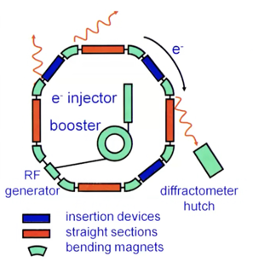
- Wavelength variable depending on setup, intensity much higher than at laboratory source
- Mirrors focus X-ray beam, collimators & apertures control beam size.
- Crystals are mounted on goniometer head.
- Fundamental ideas: electrons travel through ring & are deviated from their path using magnets. Whenever a charged particle has to change course because of a magnet, it gives off some X-rays or photons depending on magnet strength etc -> X-rays are emitted as electrons are forced to change path.
- X-Ray wave length change by changing beamline station

X-Ray diffraction form a crystal pattern
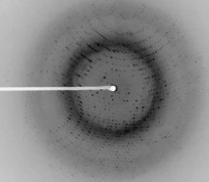
- White line and point: Beam stop shadow (beam stop: piece of lead which holds in place (point in middle) another piece of lead (line) to protect the equipment form X-ray beam, is located right behind crystal) -> get lost data from shadow through rotation of crystal
- Rings: Ice
- Distance of rings from center can be used to determine resolution

X-ray data set:
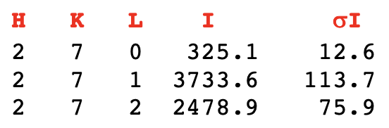
Integrated intensities of all reflections hkl (miller indices) & sta-tistics. (Crystal symmetry causes symmetry in diffraction pattern).

Basic idea: Every black spot gives rise to one line in document. Every single reflection has a miller indices and an intensity (integrated form picture "darkness of spot", 3D peak integrated from peak), and error (plus negative intensity and sigma intensity).

Electron density equation
$$ρ(xyz) = \frac{1}{V} \sum_{h}{\sum_{k}{\sum_{l}{|F(hkl)| exp[-2πi(hx + ky + lz) + iα_{hkl}]}}}$$

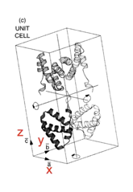
|F(hkl)| Structure factor (wave) amplitude, can be measured as I(hkl)^{1/2} (I= Intensity of reflection) -> essentially describes all waves necessary to make one "black spot" on detector

h, k, l Miller indices of reflection (coordinates in reciprocal lattice)

x, y, z Real space position (fractional coordinate in unit cell)

iα_{hkl} Phase angle of structure factor, cannot be measured, requires indirect experimental determination or computational approaches

ρ(xyz) Function for electron density with 3 dimensions (any point has a specific electron density value calculated with this equation)

$exp[-2πi(hx + ky + ly)$: correct for "orientation" of crystal
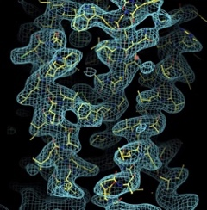
Gives way to calculate where electrons are in
the unit cell

"Wire" in electron density maps:
connecting points of similar electron density,
inside higher while outside lower electron density

Why electron density? When X-rays interact with mass, they interact with electrons (protons & neutrons "invisible" -> very little interaction). They scatter X-rays away => we are looking at repetitive 3D electron clouds of atoms: electron

Units? e⁻/Å³ (only relative values, not absolute because of iα_{hkl})

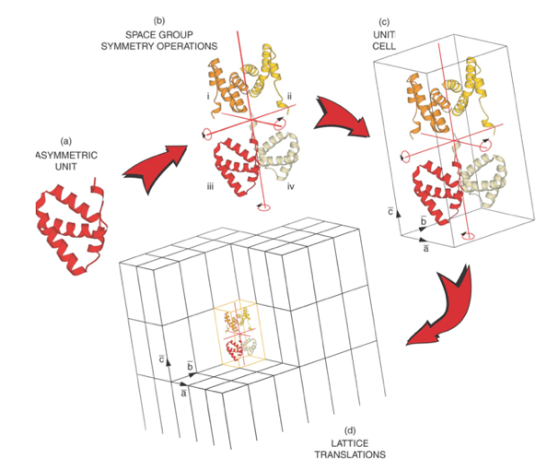
Unit cells and crystal

Electromagnetic waves
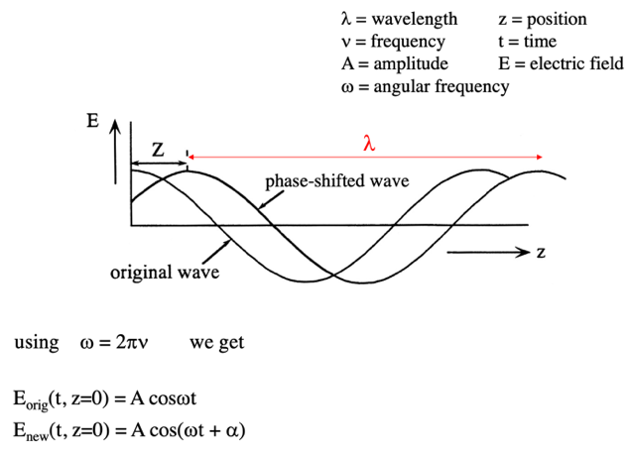
Almost always: fixed wavelength in experiments => λ does not change!

How do waves interfere?

Description of waves using the Argand diagram
The phase shifted wave:
A cos(ωt + α) = A cos(α) cos(ωt) - A sin(α) sin(ωt)
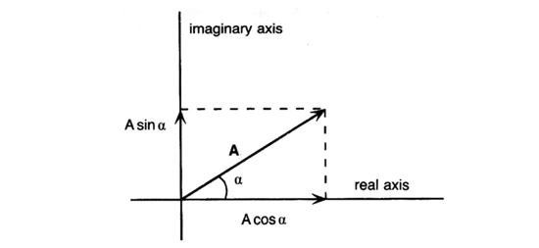
= A cos(α) cos(ωt) + A sin(α) cos(ωt + 90°)

Allows to describe waves with same amplitude but different phase angles relative to a wave that starts at the origin

Addition of Waves in the Argand Diagram
- Represent each wave as a vector in a two-dimensional axial system. The length of each vector is equal to the amplitude of the wave. The vector makes an angle with the horizontal or real axis equal to its phase with respect to a reference wave (C)
- The vector representing the total wave of a system is obtained by adding the vectors of the separate waves together

From Argand to Euler
Further simplification: each wave is written as a complex number:
A cos(α) + iAsin(α) (assuming constant wavelength)

The imaginary axis is pointing vertical, whereas the real axis is horizontal. The multiplication of the sin term with i simply describes the fact that the sin component has been rotated counterclockwise by 90°.

Euler's equation: $e^{iα}= exp(iα) = cos(α) + i sin(α)$

Using Euler’s equation, we have now a much-simplified mathematical description of the waves: Ae^{iα}

Electron density = 3D wave -> Euler structure!

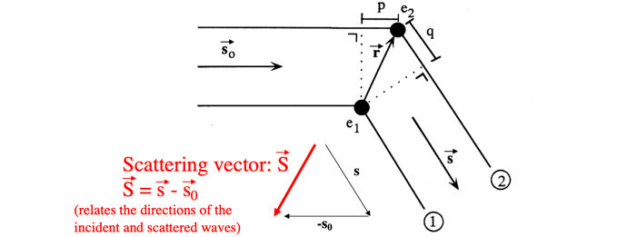
Diffraction of two points scattered

Waves 1 & 2 in the direction of $\overset{⃑}{s}$have a path difference p+q, wave 2 lags behind wave 1. p = $λ \overset{⃑}{r }{ \overset{⃑}{ s}}_{0}$ and q = -$λ \overset{⃑}{r } \overset{⃑}{s }$. Path difference is therefore $λ \overset{⃑}{r} (s-s_{0})λ$

... & phase difference is $[2π \overset{⃑}{r} (s-s_{0})λ]/λ = 2π \overset{⃑}{r } \overset{⃑}{S }$ (phase value (angle))

Scattering vector:
- Can describe every point on the detector: every point always has the same s outgoing & slightly different s incoming resulting in a different scattering vector
- Describes in reciprocal space lattice every single connection from 0 (origin of reciprocal space lattice) to the reciprocal space lattice points of all hkl combinations -> all the diffraction spots we see
If the origin is at e₁, wave 1 has a phase angle =0° (vector is on real axis) and wave 2 has a phase angle of $2π \overset{⃑}{r } \overset{⃑}{S }$
The resulting wave T:
T = wave 1 + wave 2 = 1 + 1 exp[$2πi \overset{⃑}{r } \overset{⃑}{S }$]

If the origin is at O, all phase angles change.
Wave 1 now has a phase angle = $2π \overset{⃑}{R } \overset{⃑}{S }$ & wave 2 = $2π (\overset{⃑}{R }+\overset{⃑}{r } )\overset{⃑}{S }$
The resulting wave, T = wave 1 + wave 2 = exp[$2πi \overset{⃑}{R } \overset{⃑}{S }$] + exp[$2πi (\overset{⃑}{R }+\overset{⃑}{r } )\overset{⃑}{S }$]
= exp[$2πi \overset{⃑}{R } \overset{⃑}{S }$]{1 + [$2πi \overset{⃑}{r } \overset{⃑}{S }$]}

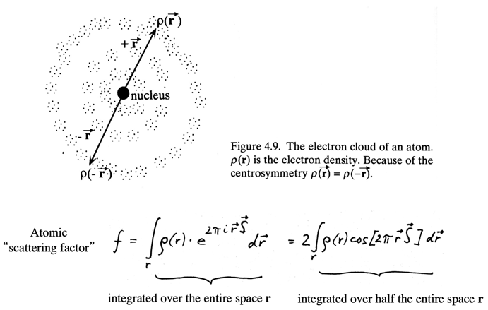
Diffraction from an atom
(Normally not spherically symmetrical! Esp. in bigger atoms. Here it is assumed spheric)

The diffraction is (as a first approximation) independent of the direction of $\overset{⃑}{S}$ but does depend on the length of $\overset{⃑}{S}$ (and hence on the diffraction angle!)
Note: Scattering is dependent on the number of electrons.

Atomic "scattering factor
-> center area of strong density, then: lesser and lesser density

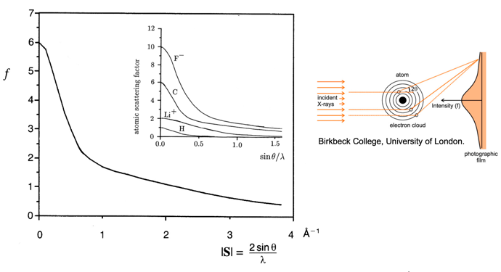

The bigger e⁻ clouds the faster the fall of intensity from the center (tighter packed = slower fall of intensity). Different for every atom!

B factor
100A² for example in membrane proteins "normal" -> quick loss of information!
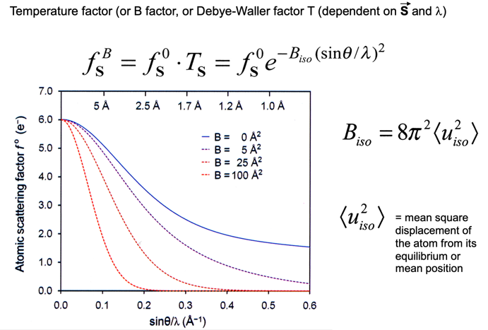

Diffraction form unit cell

Add up waves for every direction -> leads to image (molecular transform = Fourie transform of real image into diffraction space

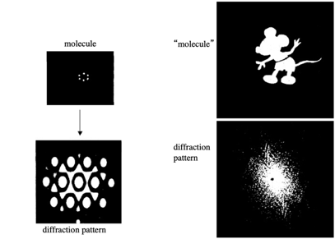
The molecular transform

Depends on side from we look at it!!

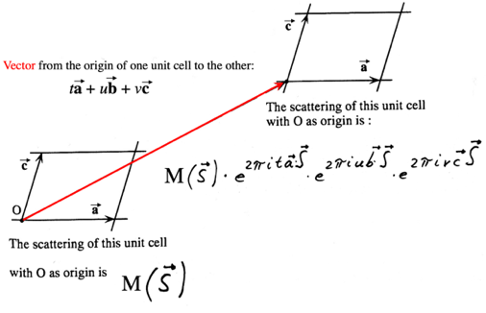
Diffraction from a crystal

Considerations
- What is the sum of an “infinite” number of waves having about the same amplitudes but random phases?
All waves will cancel themselves out -> on average we will see nothing -> only see something under special circumstances

- What is the sum of an “infinite” number of waves of similar amplitudes but each out of phase with the wave ahead and the wave behind by some constant phase increment delta phi?
Same as for 1! They will all cancle eachother out

- What happens in #2 when delta phi approaches and then equals zero?
Only now we will see diffraction!!

- Each arrow represents the scattering by one unit cell in the crystal
- Diffraction is in general zero because all these vectors point in different directions
- Only when $\overset{⃑}{a } \overset{⃑}{S }$ is an integer (and thus $2πi \overset{⃑}{a } \overset{⃑}{S }$a multiple of $2π$) is positive interference possible
- For this to happen, $\overset{⃑}{S }$ and $\overset{⃑}{a }$ have to have the right angle
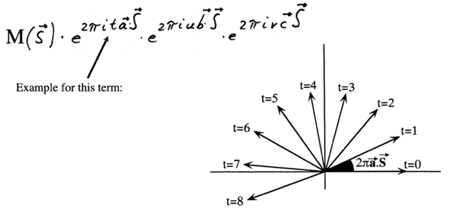
- i.e. the crystal has to be in the right orientation with respect to the X-ray beam

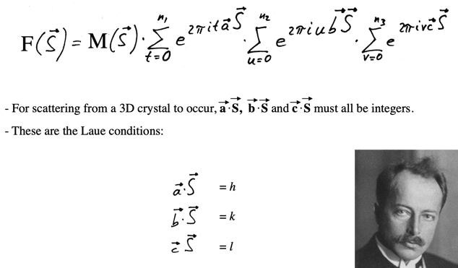
Laue conditions

Exactly same equation as for 2 point scatters just applied to entire unit cell!
- products have to be multiple of 2π so that wave is in perfect sync! Otherwise, they start cancelling each other out! -> Have to align in 2π difference
- Laue conditions introduce Miller indices

Structure factor equation
Structure factor = wave which made it out "alive"-> leaves spot on detector
Take the Fourier transform of the target objects (point scatterers, atoms, unit cells, crystals) when calculating the diffraction from them.

Structure factor equation:
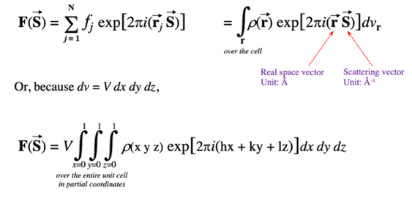

F($\overset{⃑}{S}$): Summation of all atoms based on dot product $\overset{⃑}{r}\overset{⃑}{S}$ (Structure factor)

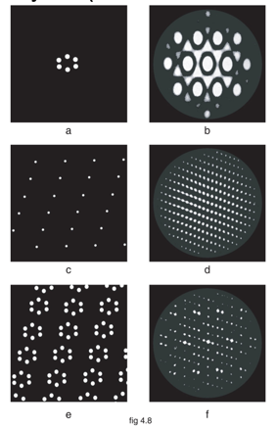
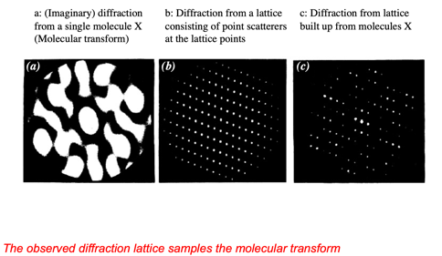
Diffraction from a crystal: a lattice of molecules

Crystal has put severe restriction as to where we can see diffraction: most waves cancel each other out so we can only see it in certain directions where we can see what is left of the transform
Firsts: molecules
Seconds: lattice
Thirds: observed patterns as combinations of lattice plus molecules

Bragg's Law
Diffraction can be thought to occur from an imaginary reflecting plane, indicating that the conditions for diffraction are fulfilled

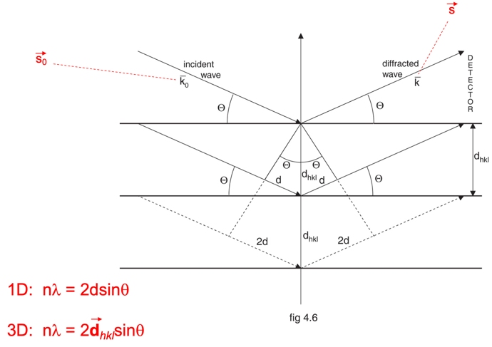
If you have an ordered array of molecules (or anything else), then where you will observe diffraction is governed by geometry of the unit cells

Bragg approach & Laue conditions: same result but Bragg approach easier to use!
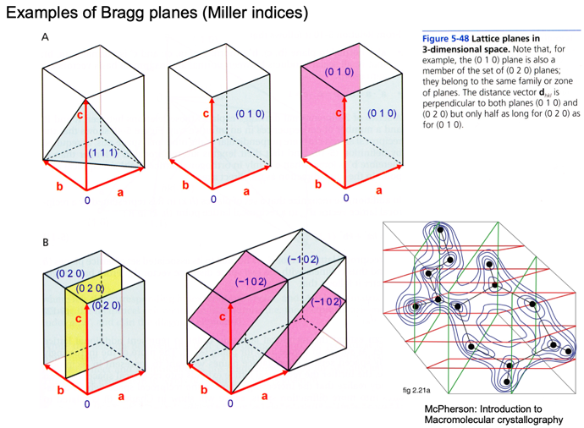

Laue, Bragg, and Miller (light)
$\overset{⃑}{a}\overset{⃑}{S}$ = h $\overset{⃑}{b}\overset{⃑}{S}$ = k $\overset{⃑}{c}\overset{⃑}{S}$ = l

If the Laue conditions are fulfilled, the 3 dot products of the unit cell axes with the scattering vector all yield integers (every wave that comes off the neighboring cells have to be multiples of 2π). Each set of integers hkl corresponds to a specific Bragg plane through the crystal. The integers hkl are called Miller indices.

Example: h=2, k=3, l=1 define Bragg planes that cut the a-axis twice, the b-axis three times, and the c-axis once per unit cell.

The Miller indices hkl are also the coordinates of the reciprocal space lattice. It will be shown (Ewald’s sphere construction) that when a reciprocal lattice point intersects with Ewald’s sphere, diffraction occurs.

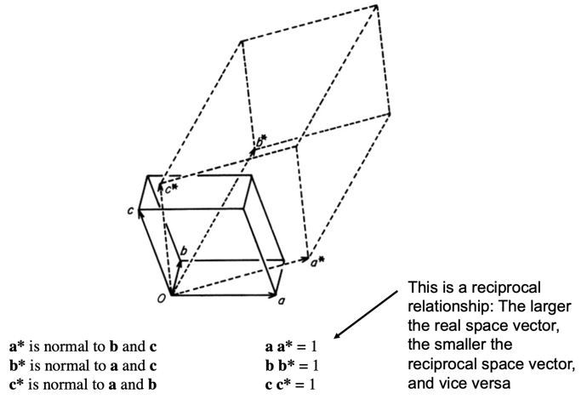
Reciprocal space lattice

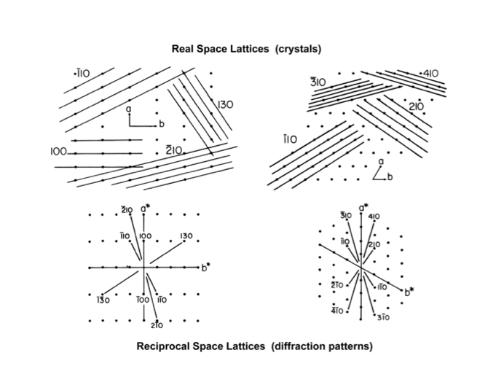
Relationship between reciprocal and real space

Numbers = how many times a or b get cut! => Specific numbers for each point!

Ewald sphere: a visualization concept
left side: X-ray source, right side: detector
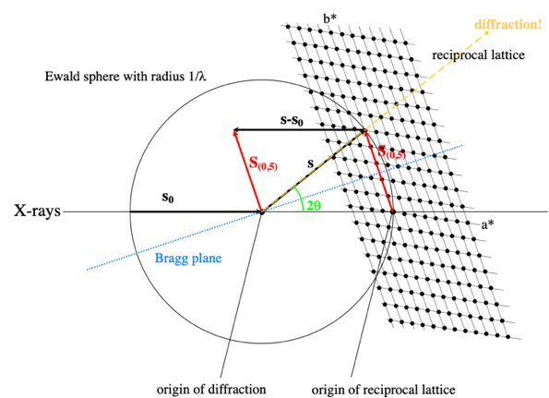
Image 1

Origin of reciprocal lattice: = 000 point

Each point on lattice has possible correct spaces of the Laue conditions and hkl = alows Laue conditions to be fullfilled: If the orientation of the crystal is correct, we can put these braggs planes into diffraction conditions! S(0,5) works (image 1), S(2,4) does not diffract with current angel (image 2)! If crystals gets rotated, then S(2,4) does diffract (image 3)!
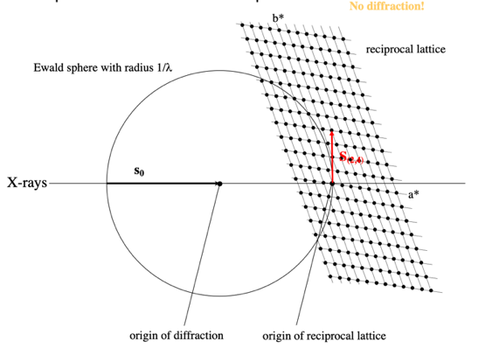
Image 2

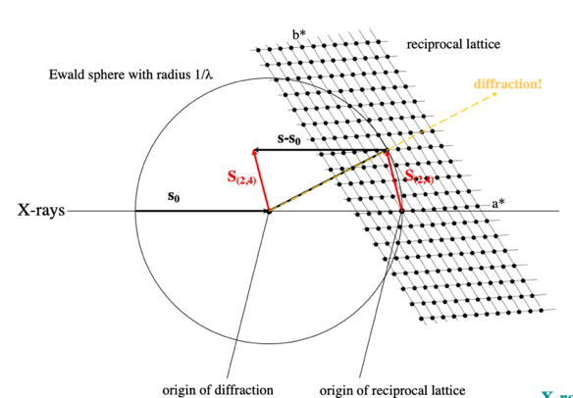
Image 3

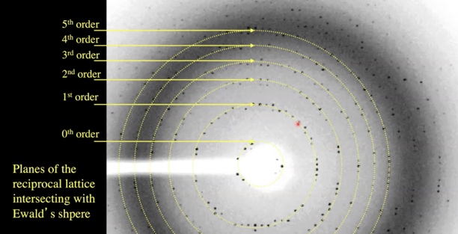

1. Figure out for each point what Miller indices hkl (= indexing of data, possible because geometry of setup/ spacing of crystal, detector, wavelength are known and we have a first image)
2. Collect second image, now angle between images is known, they can be pieced together
3. to get complete data: continue rotating crystal 360° into every possible orientation to get every possible spot
-> If there is symmetry: less needs to be collected!

Resolution
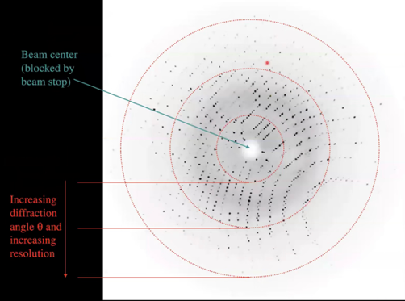

If high resolution (<1.5A) in proteins: build reliable 3D models
If low resolution (>3.6A) in proteins: α-helices but AA difficult/ impossible

Steeper angle relates to Braggs planes are closer = higher resolution therefore the closer to the center (lower angle), the lower resolution we have!
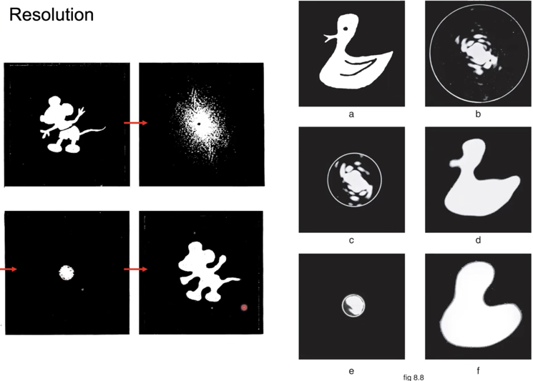

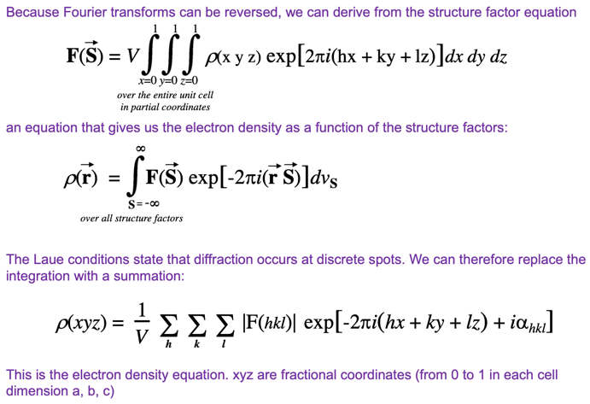
Electron density equation from the structure factor equation

F(S) (structure factor equation) can be transformed into electron density equation by taking reverse Fourie transform.

Big molecules -> big unit cells -> small angle changes for information
Small molecules -> small unit cells -> big angle changes for information

Electron dense equation: huge sum of different waves

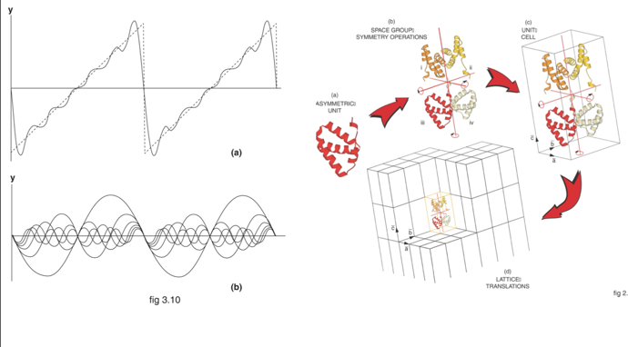
Crystals as waves of electron density in 3D space

a) addition if all waves start at same point and don't have different phase angles
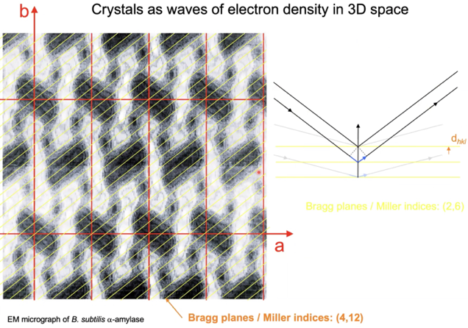
b) if waves start together

Adding all components up => reproduce 3D image
Crystals:
Large addition of waves that we add up in the summation of the electron density equation. To get the parameters of the electron density equation we need to know the geometry through indexing, have the intensity through integration and the phase.

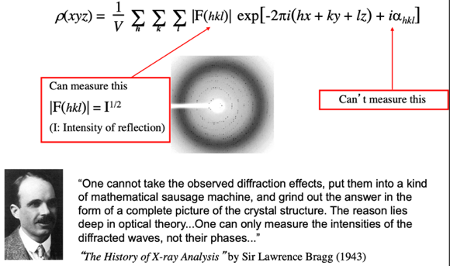
...Phase: The phase problem in crystallography

We cannot do the inverse because we cannot have a lens -> no way to measure how different waves that come out of diffraction differ in their phase angles! Parameter completely lost!
Solution: Phasing

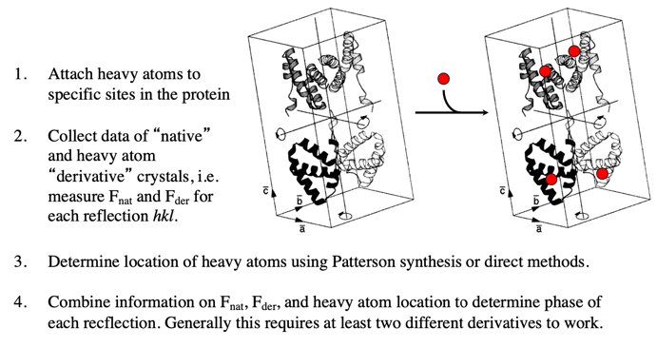
Example: Isomorphous replacement (IR)
Isomorphous: should not alter
its form (usually gold, mercury...)

IR step 1: Heavy atom derivatives
- Covalent attachment of mercury compounds to cysteine.
Examples: HgCl₂, PCMB (phenyl-chloromercuribenzoate), EMTS (thimerosal), Diethylmercury (poisonous!)
- Platinum compounds bind to many side chains. Example: PtCl₄
- Gold, lead, silver, uranium. lanthanide salts
- DNA: Iodination of bases
Biosynthetic incorporation of selenomethionine
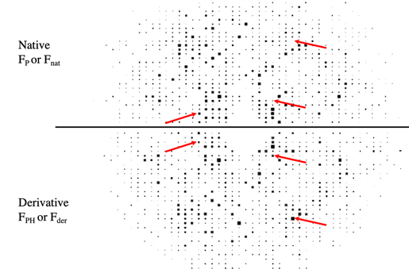
IR step 2: Collect native and derivative data

(= one with and one without heavy metal)

IR step 3: Determine locations of heavy atoms in unit cell
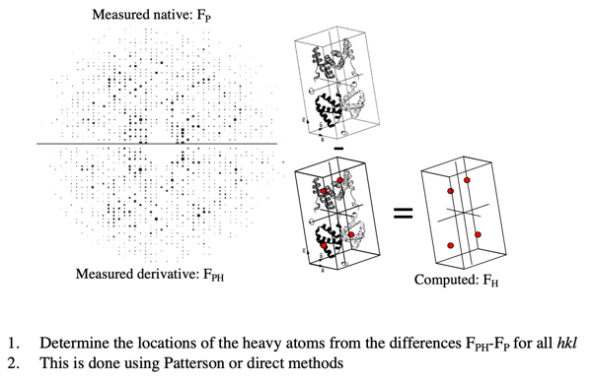
-> subtract non-metal data from heavy metal data

IR Step 4: "Phasing" by Harker construction
*Problem: We have to measured |F_{P}| and |F_{PH}|
but we only know |F_{P}| and |F_{PH}|, i.e. the length
of the vectors, not their angles
*Using Difference Patterson methods or direct
methods we have located the positions of heavy
atoms and have therefore determined F_{H} (including α_{H}!)
*How do we obtain α_{P}?

- Draw a circle with radius |F_{P}|to indicate all possible positions for F_{P}.
- Add vector F_{H} with its tip at the origin. We will need it to figure out the phase triangle
- Draw a circle with radius |F_{PH}|with its origin at the tail of vector F_{H}
- This yields two possible F_{P} with different phase angles
- To resolve the remaining ambiguity, we need a second derivative with independent phase information

Question session:
- What is a structure factor? How is it related to the intensity of a diffraction reflection?
It's the wave which makes it out "alive" which means it leaves a black spot on the detector. Its amplitude can be measured as the intensity of the diffraction reflection.

- Define the scattering vector.
Can describe every point on the detector: every point always has the same s outgoing & slightly different s incoming resulting in a different scattering vector. Describes in reciprocal space lattice every single connection from 0 (origin of reciprocal space lattice) to the reciprocal space lattice points of all hkl combinations -> all the diffraction spots we see

- In general terms: What determines the positions of the reflections on the X-ray detector? What determines the intensities?
The position of the reflection on the detector is defined by the e⁻ positions while the intensity is determined by the tightness of packing and size of the e⁻ cloud of an atom.

- What limits the resolution of a protein diffraction exper-iment?
The quality of the crystal, increasing diffraction angle, ...?

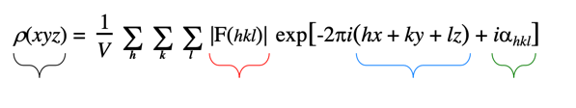
- Define the terms of the electron density equation. Explain for the three terms on the right side of the equation how they are obtained.

black: function for electron density in 3 dimensions
red: Structure factor (wave) amplitude, can be measured as I(hkl)^{1/2} (I= Intensity of reflection) -> essentially describes all waves necessary to make one "black spot" on detector
blue: frequencies along real space axes
green: Phase angle of structure factor, cannot be measured, requires indirect experimental determination or computational approaches

Style of exam questions (FS17 & FS19)
- Explain lattices, indices
- Fourie transform
- Electron density equation explain which part is what

L4.1: Crystal symmetry
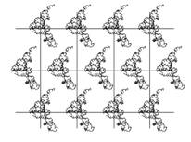
Arranging asymmetric objects on a regular grid
– simplest crystal packing in which the asym-
metric object is directly repeated in all three
directions

Crystal unit cell symmetry
Point group
The concept of the unit cell and the asymmetric unit
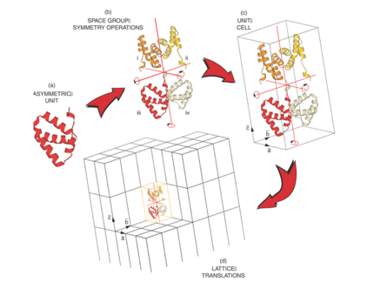

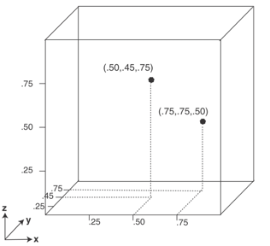

Fractional coordinates are frequently used in crystallography they are important for understanding the coordinates for equivalent positions.

Crystal space group symmetry

Rotational symmetry
What is a 2-fold axis?
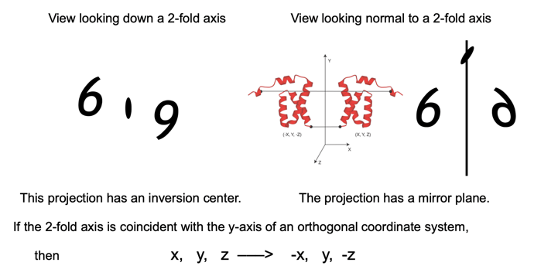
The 2-fold axis replicates a starting object by making a second copy rotated 180° around the axis. The translational position along the axis is unchanged.

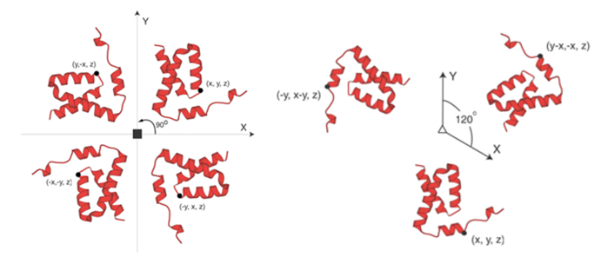
The view looking down a 4-fold and a 3-fold axis:

The presence of a second 2-fold axis orthogonal to the first 2-fold axis automatically generates a third, orthogonal 2-fold axis.
This arrangement of lattice points is classified as orthorhombic.
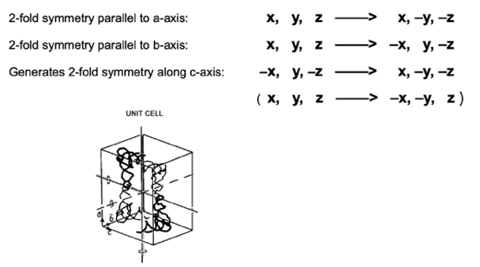

Screw axes
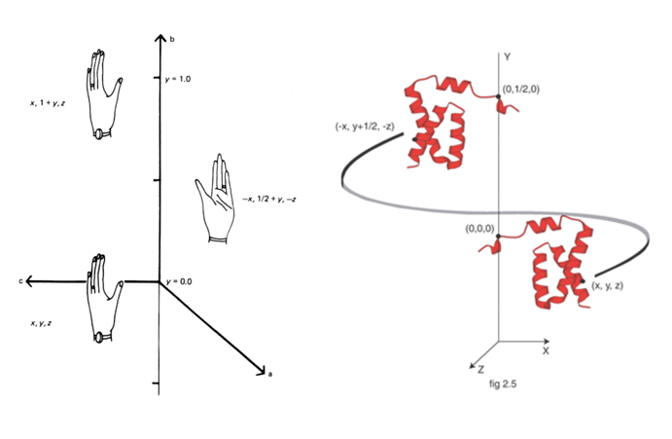
A 21 axis (2-fold screw axis) combines a 2-fold rotation with a 1/2 unit cell translation, generating a second asymmetric unit from the first for every unit repeat.

- Crystallographic point group: set of symmetry operations that leave a central point fixed -> ∞ many 3D point groups (Periodic crystal: group must also be consistent with maintenance of the 3D translational symmetry)
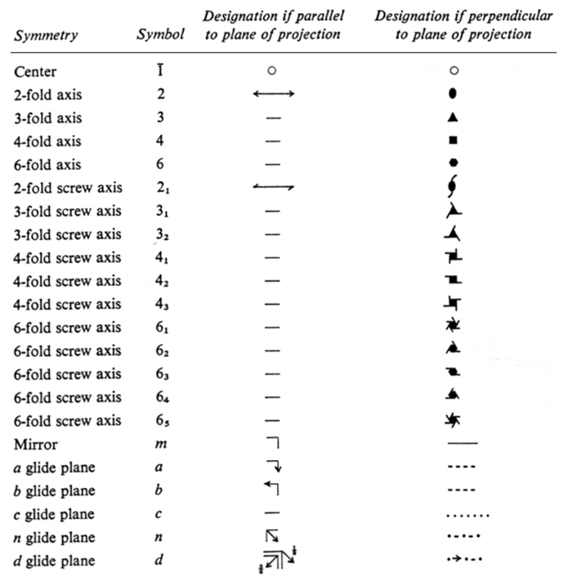
- In macromolecular crystallography mirror planes and centrosymmetric point groups are not possible since most macromolecules exist in only one stereoisomer.
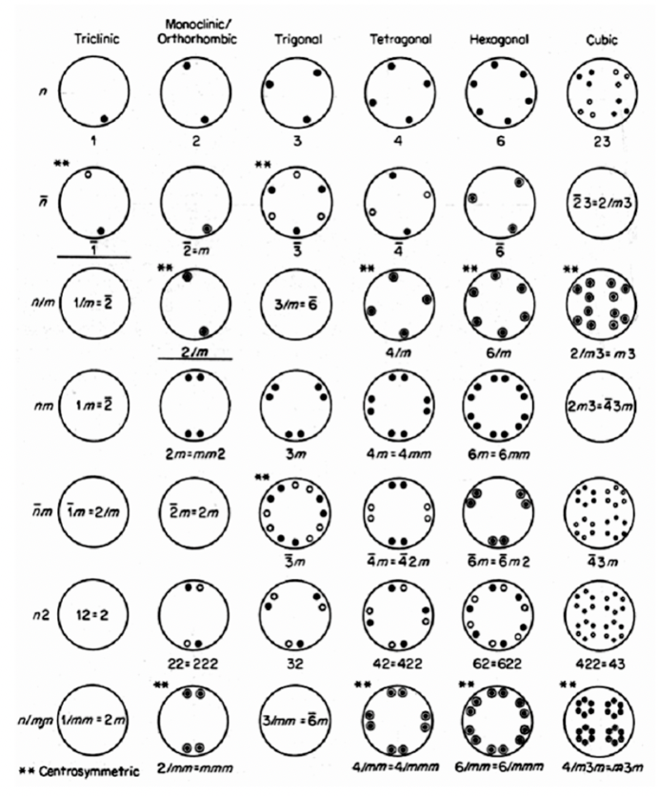

Crystal lattice translations
7 Crystal Systems (unit cells) and 14 Bravais Lattices
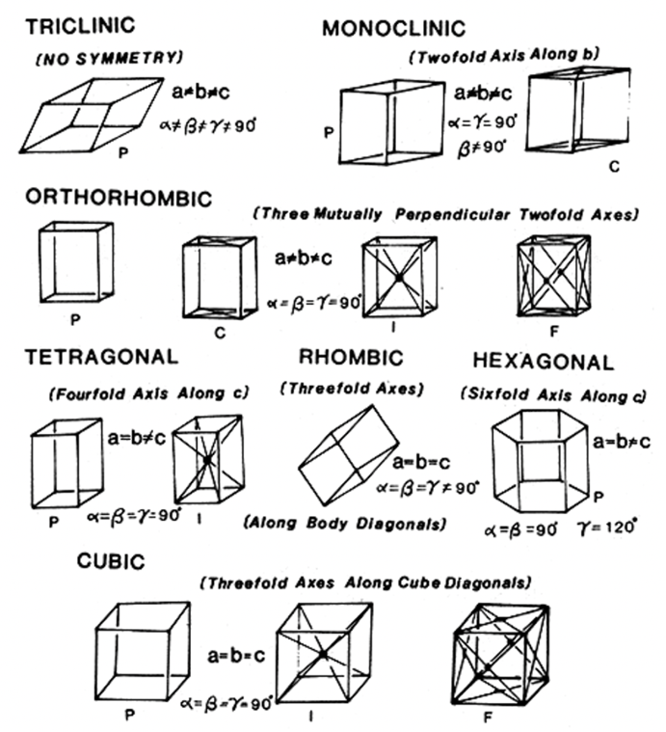

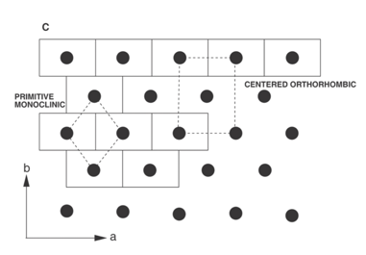
Unit cell choices include possible centered cells that increase symmetry of the space group. These space groups are characterized by a checkered diffraction pattern.
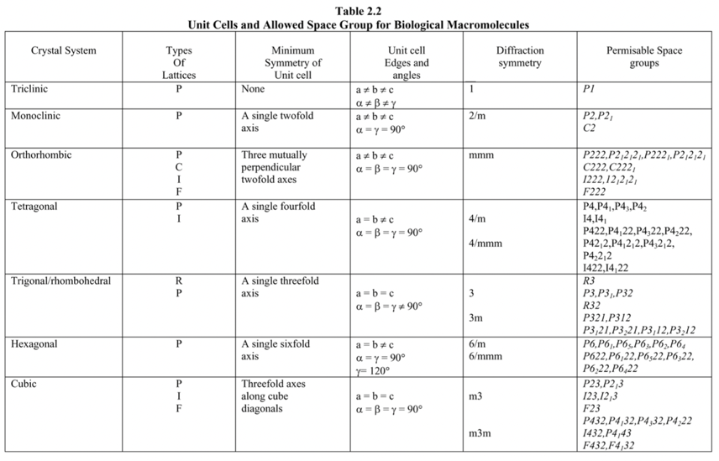
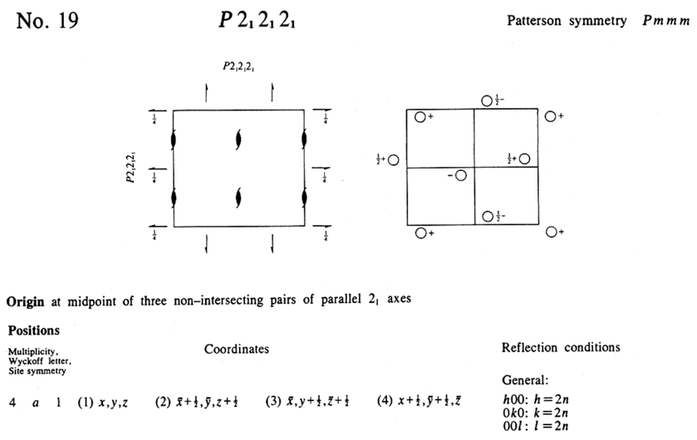
Examples of how space groups are listed in crystallographic tables

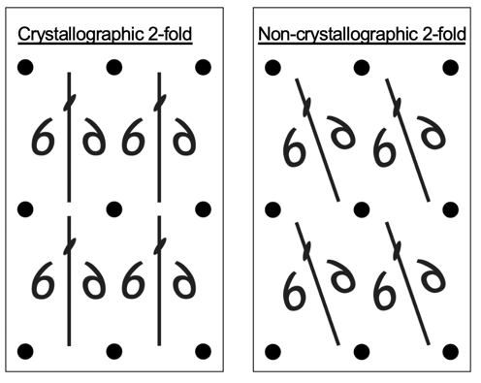
Non-crystallographic symmetry

Crystallographic symmetry
leaves the crystal unchanged
after its application.

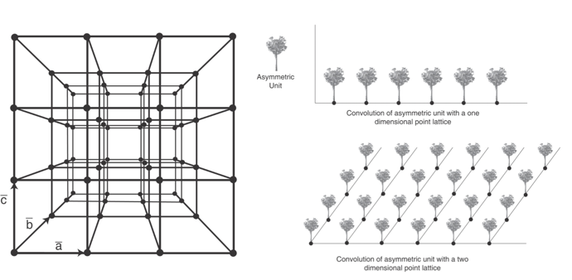
Three dimensional point lattice – mathematical simplification of a real crystal

Organization of lattice points into families of planes

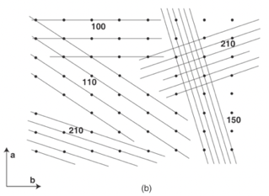
Families of planes that intercept each unit cell edge at regular intervals are known as the Miller indices & are identified with 3 integers (h k l) corresponding to the integral # of edge intercepts.
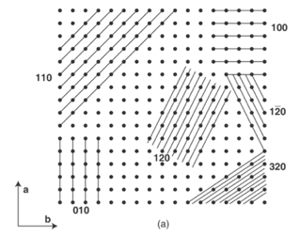

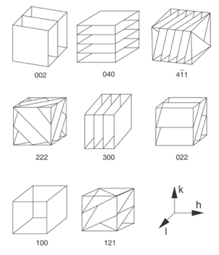

Scattering from families of planes according to the Bragg’s law will correspond to Fourier analysis of the contents of the unit cell (which is a periodic electron density wave).

A few corollaries:
- The lower the angle, the larger interplanar spacing must be to satisfy Bragg’s law.
- All atoms contribute to a particular scattered wave (one can think of it as a reflection)
- Waves of different amplitudes (function of the atom type) and phases (function of the distance to the planes) are added resulting in a single reflection with a new amplitude and phase (structure factor).
- Individual Miller planes in real space correspond to spectral components of the crystal (a complex electron density wave) with a wavelength equivalent to 1/d.
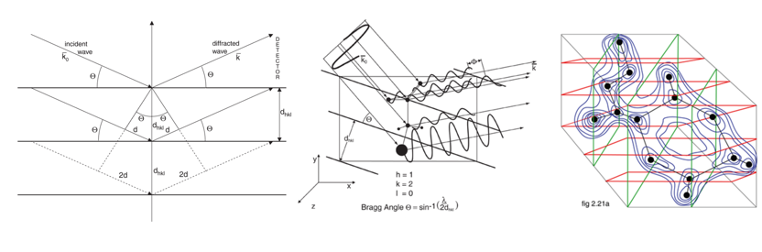

Reciprocal lattice is constructed such that for every family of planes a vector is drawn from a common origin having direction of plane normal and length reciprocal to the interplanar spacing (this is what happens in reality when X-rays are scattered from crystals).
- In reciprocal space each point has frequency (wavelength) associated with it.
- The intensity of each reciprocal lattice point is a Fourier transform (a simple sin wave) of the electron density surrounding the corresponding planes h k l.
- Phase has to be determined for each point to back calculate the electron density in the crystal.
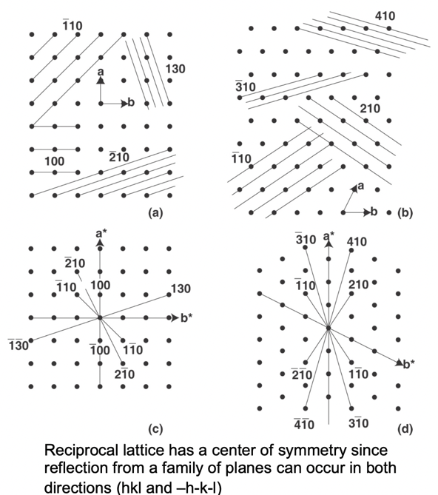

Geometric relationships between real and reciprocal unit cells - detailed relationships available in crystallographic tables but
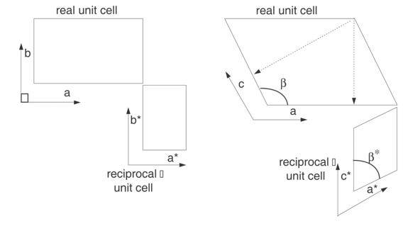
in general - alpha* = 180-alpha

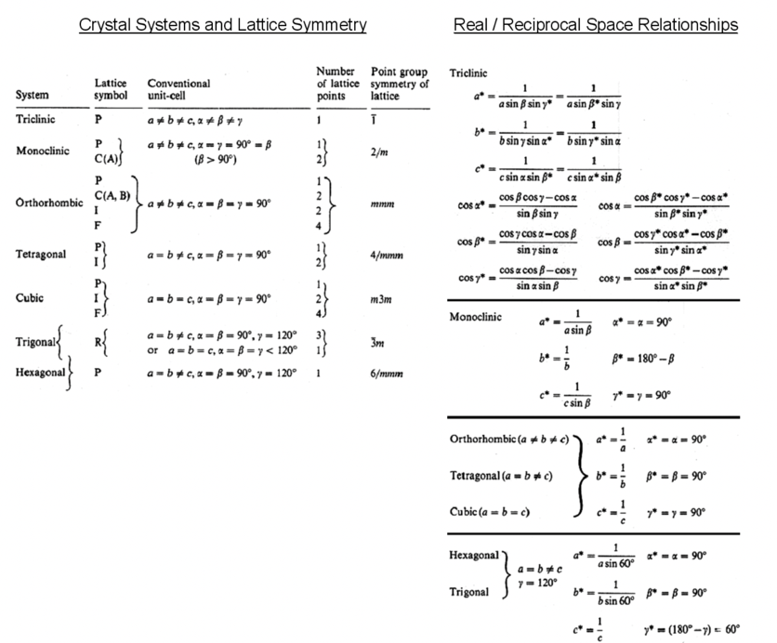

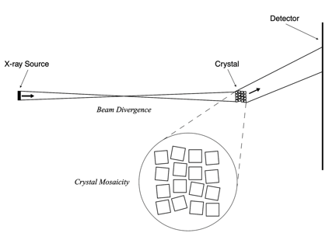

Crystallographic data collection experiment
- How to relate reciprocal lattice relative to the physical crystal?
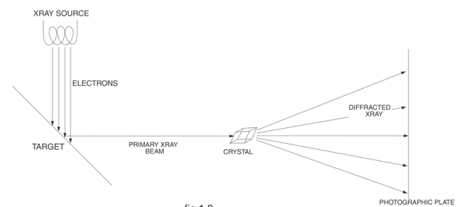
- Geometric construction can help in visualization – Ewald’s sphere

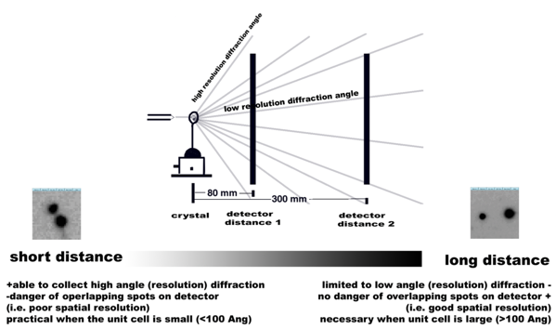
Diffraction geometry and detector distance

Circles correspond to hkl Miller indices
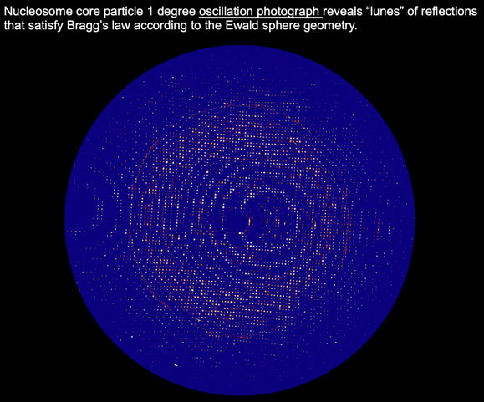

Macromolecular crystals
- Macromolecule maintained in hydrated environment with high percentage of solvent.
- Need to be grown in physiological condition
- Enzymes are active in crystalline state.
- Rapidly freeze crystals / kept cold
- Crystals per se are not of interest but rather a way to obtain measurable X-ray diffraction data.
(_____ =260nm)

Radiation damaging & protection by cryocooling
Primary – direct absorption of radiation
Secondary – damage by formed radicals

Crystal Mosaicity & Beam Divergence
Microscopic images of crystallized molecules (complexes) reveal packing arrangements and errors in the crystal lattice that lead to disorder and reduce the resolution of diffraction
- Individual blocks can diffract quite well, whole mosaic diverge the beam -> Braggs law not always satisfied, can look like crystal was rotated more than it actually was

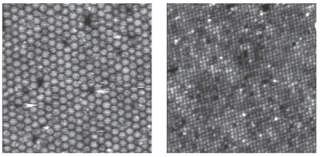

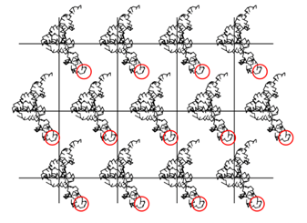
Dynamic Disorder – areas of high local flexibility

Does only affect parts of
molecules

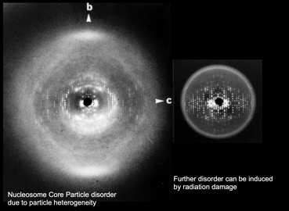
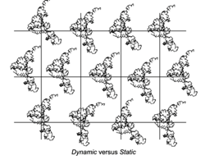
Static Disorder

Whole molecules are shifted
-> Generated diffraction spots
past a certain resolution

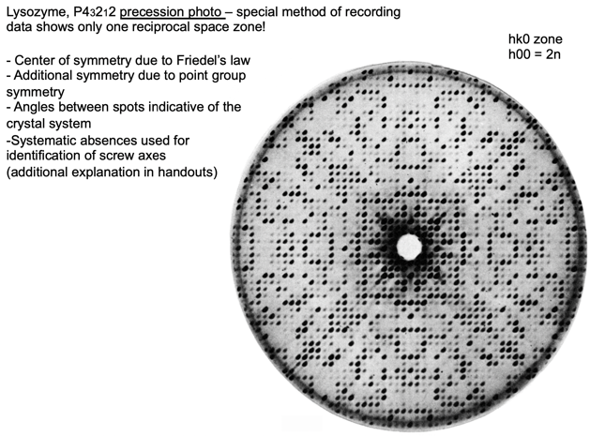
Determination of Space Group Symmetry By Crystallographic Analysis

Flowchart of data processing
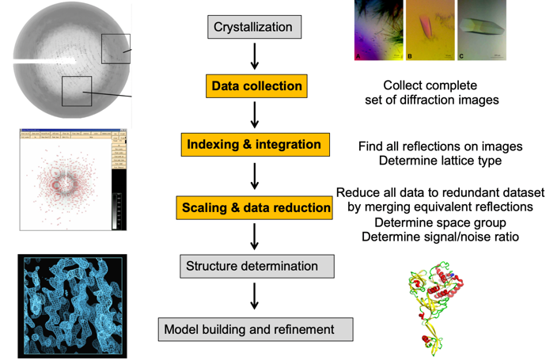

L4.2: Model Building and Validation

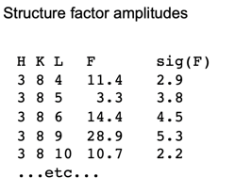
Diffraction data

Redundancy in diffraction data:
- Friedel pairs have the same amplitude but opposite
phase: Friedel pairs are (Bragg) reflections related by inversion through the origin of the reciprocal lattice (i.e. they have the same Miller indices but inverse signs) |Fhkl| = |F -h -k -l|
- Crystal symmetry results in symmetry in diffraction pattern (used to determine the space group of the crystal and increase redundancy of collected data)
- Multiple observations of identical reflections during data collection.

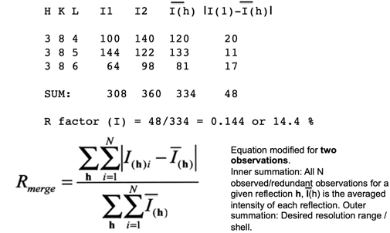
R_{merge} (or R_{meas} or R_{sym}) calculation computed on equivalent I’s (intensities or squared structure factors). In this calculation the mean discrepancy for each of the N reflections is compared to their mean intensity:

Allows to say what kind of error you have in data
50-60% = data unreliable

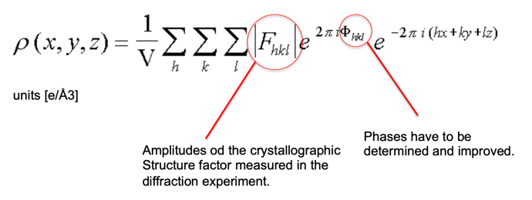
Crystallographic Electron Density: ρ(x, y, z)

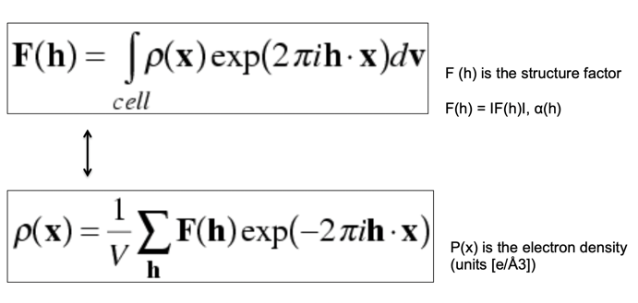
Electron density maps (Fourier Transforms)

Going back and forth in Fourie transforms between electron density maps and structure factor components allows to refine structures, compare them and understand how well they agree with experimental data.

METHODS FOR PHASING
- Heavy atom method – Small molecule crystals
- Isomorphous replacement – SIR / MIR
- Anomalous scattering – SAD / MAD
- Direct methods – Ab initio
- Molecular replacement – Model phases
- Symmetry averaging and phase extension

Molecular replacement
Idea: Similar molecules in the same crystallographic unit cell will have related amplitudes and phases. Therefore, if one calculates phases based on a know homologous molecule it may be possible to visualize parts of the structure in the unknown crystal that are not contained in the model.
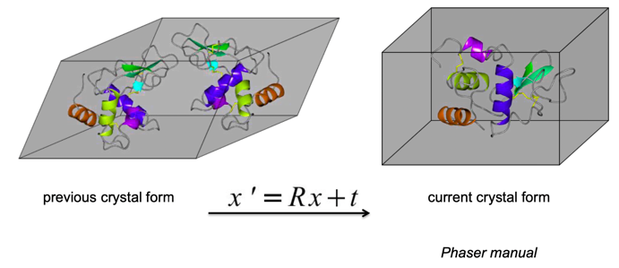
Molecular replacement method is used to determine the rotation and translation necessary to place previous coordinates (xyz) to new coordinates x’y’z’

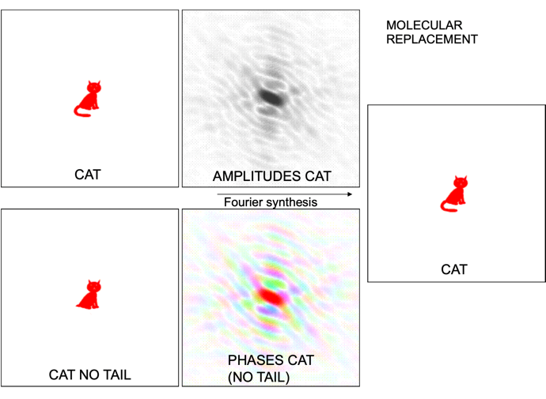
How it works: Calculate the phases from CAT, fit phases into CAT NO TAIL, get CAT

Usually not that easy, tail will mostly be shadows. Works for very small differences!

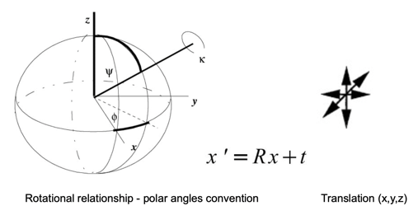
In molecular replacement the rotational search can be separated from the translation search so that the dimensionality of the problem is reduced (instead of 6D search one can perform two 3D searches – rotational search and translational search)

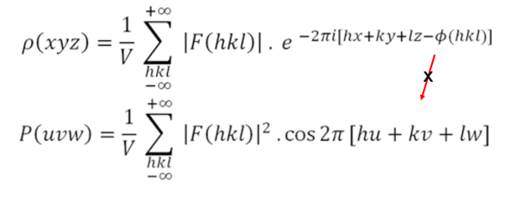
The rotation function (RFn) relies on certain properties of the Patterson function (P). The Patterson function may always be calculated from a single dataset in the absence of knowledge of phase angles (can be calculated form electron density map -> phase component get canceled out):

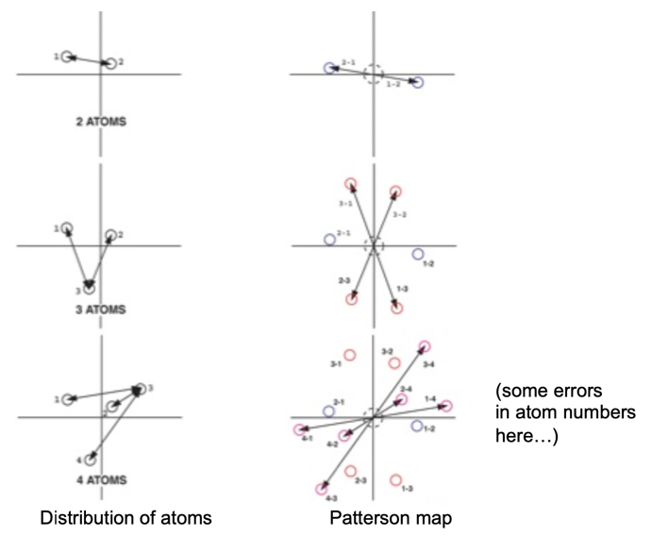
Distribution of density in a Patterson map corresponds to all interatomic vectors placed at the origin of the Patterson map (used in molecular replacement and for finding heavy atom derivatized for

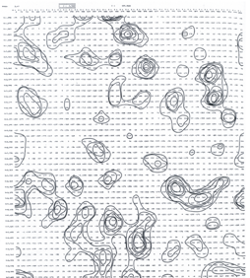
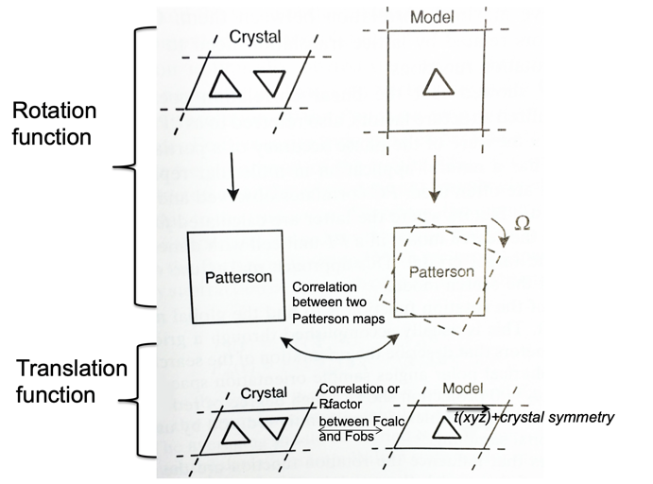
Very noisy maps as all go through origin, super difficult to interpret but useful:
Electron density maps ρ(x, y, z) are calculated from observed structure factor amplitudes (Fs) and determined (calculated) phases (frequently the determined phases have a lot of errors and the maps can not be readily interpreted) MIR or SAD or MAD structure determination)

How to improve phases
Experimental phasing frequently leads to large phase errors resulting in uninterpretable electron density maps. Therefore it is useful to use “density modification” techniques to modify the phases based on certain prior knowledge about the molecule that forms the crystal.
- Solvent flattening
- Averaging
- Histogram matching
- Structure refinement

Solvent flattening
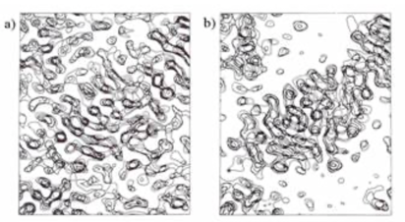
In typical protein crystal: ~half of the volume is occupied by disordered solvent -> these parts of the map should not have features & if they do => result of phase errors
=> if we flatten the solvent region & calculate phases from this modified map the phases will be more accurate

Histogram matching
Since proteins are made up of the same atom types: expect certain electron density values
If map in the protein region doesn't have the distribution of low & high densities that one expects -> probably because of phase errors
=> By altering the distribution of density values to match what we expect the phases are improved

Averaging
Frequently proteins crystallize with more than one copy in the unique part (asymmetric unit) of the unit cell of the crystal.
-> expect when same protein appears in different places in an electron density map (or in maps from different crystals): density similar, if not: because of phase errors => By averaging the density: cancel out some of the random errors & improve phases.
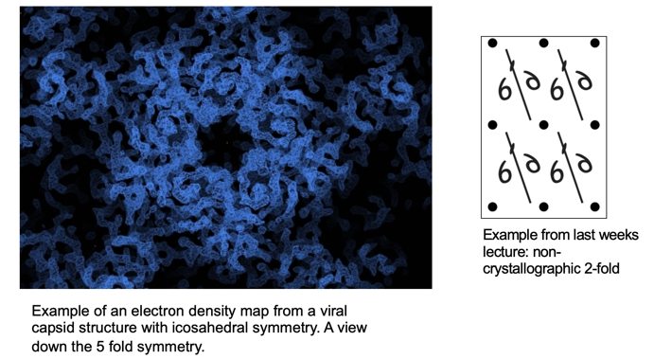

Structure refinement
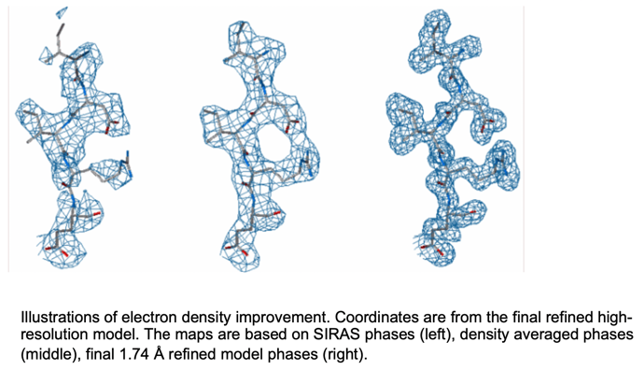
If the density can be interpreted in terms of an atomic model and since we know how atoms are arranged relative to each other (bond lengths, bond angles, the chemical connectivity defined by the amino acid sequence), we can refine the model to gain better agreement with the observed diffraction data. Combining experi-mental phases with model phases we can improve the maps.

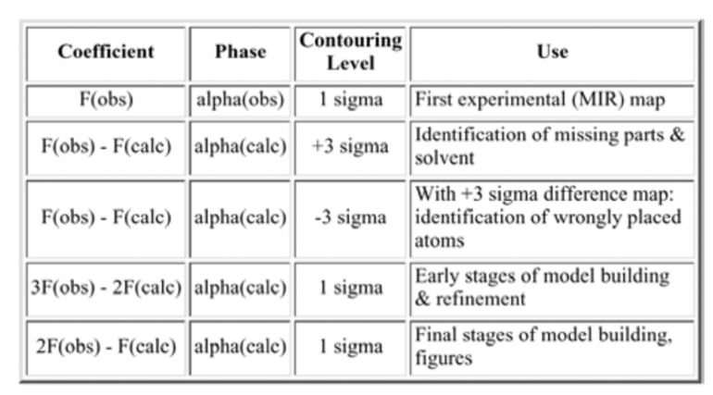
Types of electron density maps that can be calculated

Interpretation of electron density provides us with an accurate atomic structure that can be used to understand its chemical properties and the chemistry of reactions that it is involved in (catalysis, binding etc...)
Interpretation is carried out in two stages:
- Tracing of the protein fold
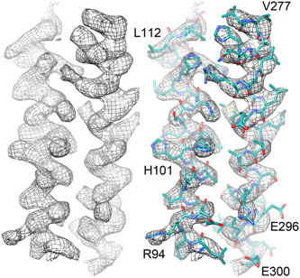
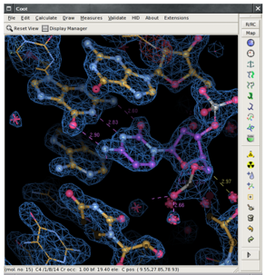
- Sequence register has to be assigned

Coot: model-building tools for molecular graphics is used to display and manipulate atomic models of macromolecules, typically of proteins or nucleic acids, using 3D computer graphics. It is primary focused on the building and validation of atomic models into 3-dimensional electron density maps obtained by X-ray crystallography or high resolution electron microscopy.

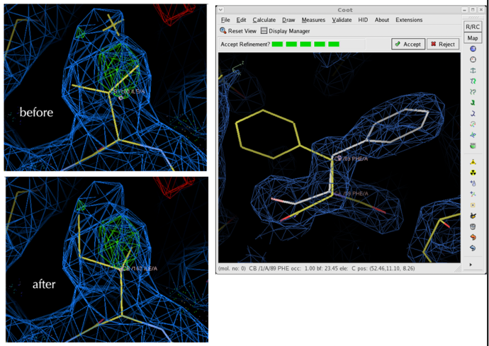
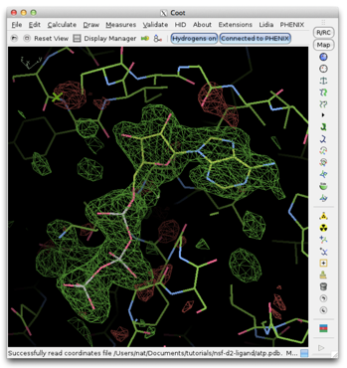
Coot mutate residue option and real space refinement...
Example of a difference map (F_{o}(with ligand) – F_{c}(protein only)) displayed in Coot with ligand fitted to the difference map. Although the phases were obtained from the model which does not contain the ligand they are sufficiently accurate to reveal the density for the ligand in the difference maps.

Crystallographic refinement is the modification of an atomic model to improve the agreement between observed and calculated structure factor amplitudes (or intensities) while maintaining reasonable chemical structure.
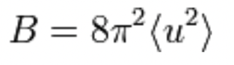
Parameters for each atom:
• x, y, z (Cartesian coordinates)
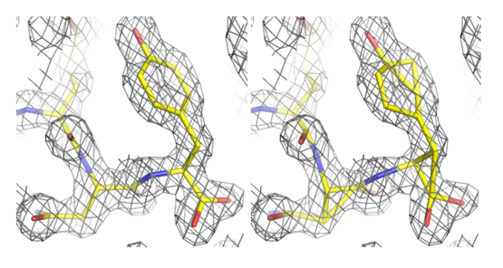
• B factor (in Å²):

Where u² is the mean squared displacement.
The B-factors can be taken as indicating the relative vibrational motion of a particular atom.
Four degrees of freedom per atom, or 4N per molecule of N atoms. So a typical 300 amino acid protein with 2,500 atoms has 10,000 refinement parameters!

Crystallographic refinement issues
A major problem of refinement stems from the complexity of the task: moving thousands of atoms to improve the agreement between the Fourier transform of these atoms (F_{calc}) and the observed structure factors (F_{obs}) to achieve the best global fit.
In principle, this type of non-linear optimization can be carried out by least-squares or conjugate-gradient minimization approaches which minimize a target function: Residual = Σ [F_{obs} - F_{calc}]²

R-factor calculations and their significance
The traditional crystallographic R-factor (or R-value) is defined as
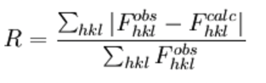

This R-factor is a measure of the level of (dis)agreement between the:
- observed structure factors (F_{obs}), properly scaled
- calculated structure factors (F_{calc})

It is usually reported in %, i.e. an R-factor of 0.18 is reported as 18%.

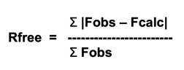
R-free: R-factor calculated from a small subset of reflections not used in refinement, typically 5-10% of the data or 1000-2000 reflections (in statistical terminology this is called "cross-validation"). If the refinement was parameterized appropriately, the R-free should be reduced along with the R-factor for the "working" set (R-work), although it will always be a higher value. A large spread between R-work and R-free is a primary symptom of over-fitting.

R factor calculation to obtain a measure of (dis)agreement between the observed structure factors and structure factors calculated from a model:
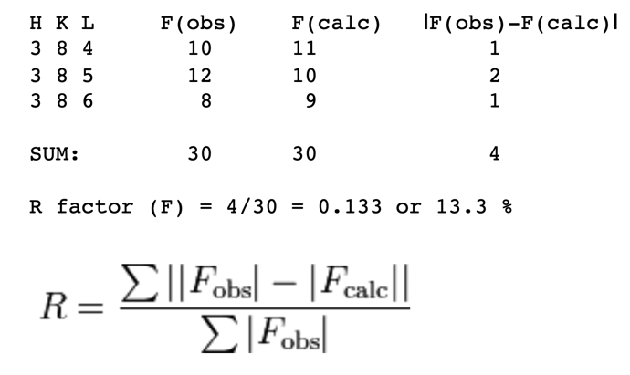

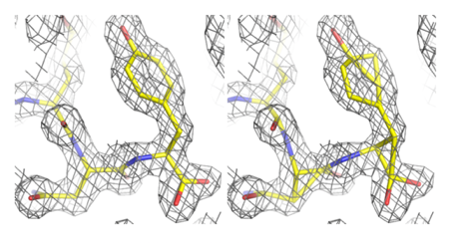
In refinement, restraints keep specific independent parameters from diverging too far. Because of the limited resolution of the data basic geometry restraints (bonds, bond angles, dihedral angles, chiral centers, planar groups, and VDW interactions) are used. Restraints do not reduce the number of refined parameters, but are essential to maintain proper geometry and prevent overfitting. Below is an example of medium resolution refinement (2Å) with (left) & without restrains (right). In the right image the molecule has been distorted away from its ideal geometry.

Ramachandran plot angles
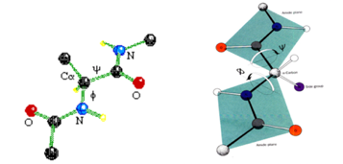
A plot showing the main-chain conformational angles in a polypeptide. This diagram is used to find problems in models during structure refinement. The conformational angles plotted are phi, the torsional angle of the N-CA bond, defined by the atoms C-N-CA-C (C is the carbonyl carbon); and psi, the torsional angle of the CA-C bond, defined by the atoms N-CA-C-N. In this figure, phi = psi = 180°.
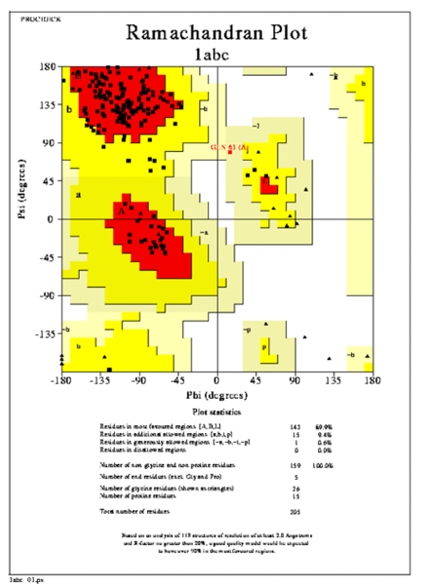
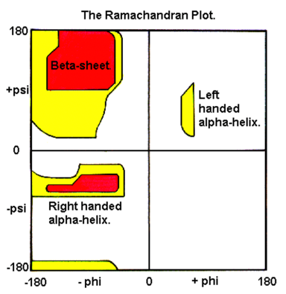
Distribution of Ramachandran plot values for proteins. Regions with values where frequently observed secondary structure elements cluster are indicated.

Data collection & refinement statistics
Resolution:
- 4+ Å: very low
- 3-4 Å: low
- 2.5-3 Å: medium
- 1.0-2.5 Å: high
- < 1.0 Å: very high
Approximate cutoffs for data stats:
- Rmerge/sym < 10%
- Completeness > 90%
- I/σ(I) in highest resolution shell >= 2.0
- Redundancy > 2
- R / Rfree < 25% / <30%
- RMSD from ideal bond lengths < 0.02 Å
- RMSD from ideal bond angles < 2°
- Ramachandran outliers < 1%

Example crystal structure determination table – what are the reported values telling us?
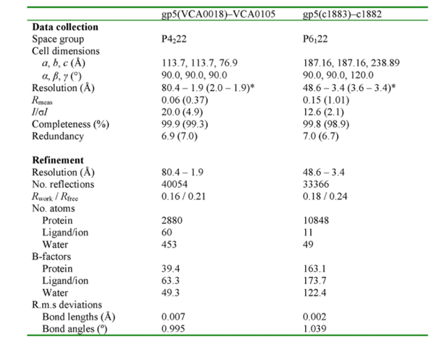

Style of exam questions (FS17 & FS19)
- Symmetry pictograms
- Diffraction pattern of lysozyme & its symmetry (/what is special)

Theory from practical sessions
Workflow
After growing large and good-looking single crystals in sitting drop plates, which involves extensive screening for optimal conditions, the crystals are stabilized with a cryo-protectant (glycerol, sucrose etc.) to prevent formation of crystalline ice in the solvent channels within the macromolecular crystal lattice (this would destroy the crystal internally & abolish diffraction). The crystals are then moun-ted on a tiny nylon loop and quickly plunge-frozen in liquid nitro-gen, such that the solvent is vitrified. The cooling of crystals at -160°C during data collection is needed to prevent the crystals from premature decay due to radiation damage.
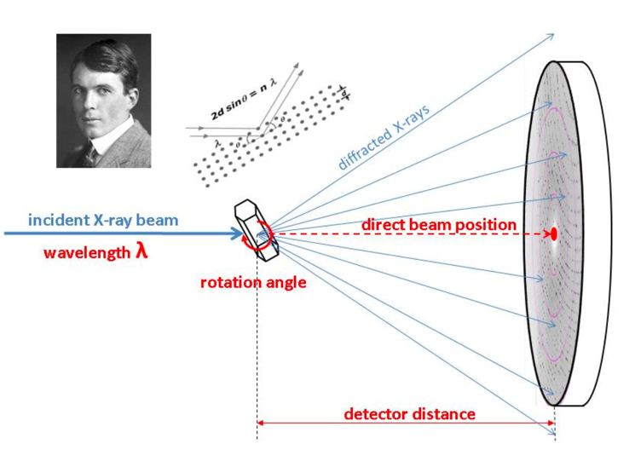
For data collection the crystals are mount on a goniometer in a synchrotron.

Fundamental parameters of the diffraction geometry which need to be known:
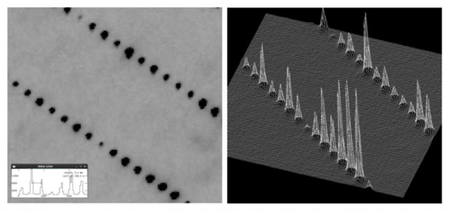
Wavelength:
According to Bragg’s equation, changing the wavelength changes the diffraction angle. (Here: cone of diffracted X-rays gets wider or narrower)

Detector distance:
Changing the distance between crystal & detector plate alters the area that is visualized on the detector plate at a given wavelength.

Oscillation width:
Crystals are typically mounted in random orientation. In order to obtain a full dataset comprising all unique reflections in the lowest symmetry space group P1, we need to collect at least 180°. We can cut these 180° for example into 180 x 1° slices, i.e. we collect 180 diffraction images, and for each of them the crystal was further rotated by a 1° oscillation.
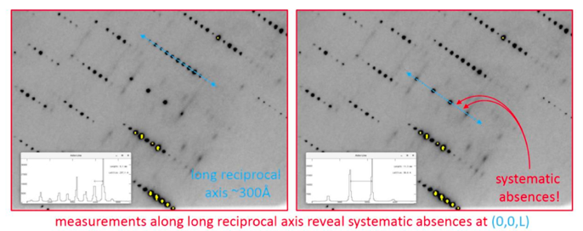
Direct beam position:
The direct beam position defines the origin of the reciprocal lattice (0,0,0) and is indicated as an (x,y) pixel position on the detector. It is needed for correct indexing. The direct beam position is hidden behind the metallic “beam stop”, which protects the detector plate from the high energy X-ray beam. It is recorded by attenuating the beam and moving away the beam stop

During and after data collection: Inspection of a diffraction images
Already during data collection, the diffraction images are inspected: Is the detector at a suitable distance? Are the reflections well separated along the axes? Are the lattice planes separated? With modern setups the data is processed on-the-fly, so you can get immediate feedback on your setting during data collection.
Individual diffraction image
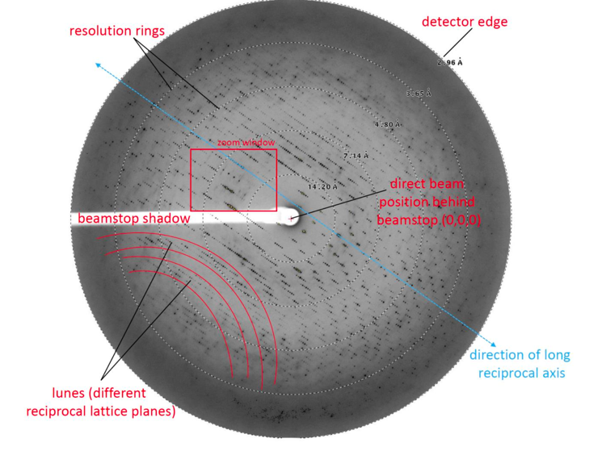

On this typical diffraction image (collected at 230mm distance, wavelength 1Å, 1° oscillation):
- detector edge limits the data to ~3Å resolution
- direct beam is prevented from hitting the detector by the metal plate of the beamstop, which is mounted on a plastic rod (“beamstop shadow”).
- direction of the long reciprocal axis, which is characte-rized by a narrow spacing between the reflections
- lunes, which represent separated reciprocal lattice planes of the shorter axes.

The direct beam position can be experimentally determined when the beam stop is removed. We can also display the reflections as 3D profiles. This shows that the separation between the spots is baseline, which is important for correct determination of the intensity values (I) and the background (sigma) around each of the intensity peaks. Thus we can precisely determine the signal-to- noise ratio (I/sigma) for each measured reflection.

2D and 3D representations of the reflections to visualize differences in intensities

Further there are systematic absences along (0,0,L), which are indicative of a screw axis. Depending on the space group systema-tic absences may be found along (H,0,0), (0,K,0) or (0,0,L) axes, which pass the (0,0,0) origin of the reciprocal lattice. (Due to the reciprocal nature of the lattice, we now measure a shorter unit cell dimension as the reflections are further apart (~100Å rather than ~300Å), which indicates that always two reflections are missing, as it is the case for a 3-fold screw axis)

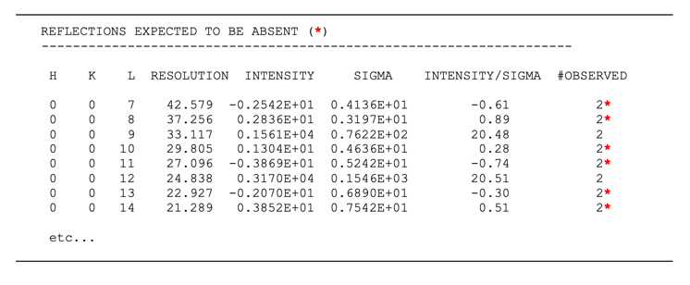
This can also be seen by inspection of the intensity table (determined by the indexing and scaling program):

Indexing, integration, data reduction/merging and scaling of a crystallographic dataset include the following steps:
indexing
Strong reflections (corresponding to pixel positions on the detector plate) on one or a few collected images are localized. From this the indexing program tries to determine the correct lattice type, crystal orientation & unit cell dimensions such that the positions of the predicted reflections fit optimally to the measured ones.

Integration
All reflections on all consecutive diffraction images are localized and their intensities & errors are determined, the crystal mosaicity, orientation & cell parameters are refined. Reflections may occur on only one image (then termed “fully recorded reflection”) or appear and disappear over several consecutive images (then called “partially recorded reflections)

Scaling
The program establishes a full spot profile for each reflection that was only partially recorded. Reflections may be recorded multiple times if the crystal is rotated far enough. They have to be brought to the same scale (intensity value) because the diffraction properties of the crystal usually decrease over time due to radiation damage or because a crystal might diffract in an orientation-dependent manner (e.g. if the crystal is a thin plate and the x-ray path-length through the crystal changes during rotation).

Furthermore, Friedel pairs can be merged & additional crystallo-graphic symmetry may apply depending on the space group. As these symmetry-related reflections have the same intensities, they can be merged into one, resulting in a reduced dataset containing unique reflections only. As result each reflection occurs only once in the HKL table. Due to the multiple recordings the signal-to-noise ratio improves with higher redundancy (i.e. the error of the measurement decreases).

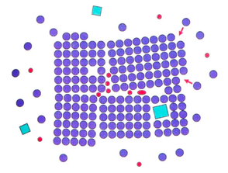
Crystal mosaic
An important quality measure of a crystal that affects its diffraction properties is its mosaicity. Crystal mosaicity is an imperfection in a macromolecular crystal as a result of slight misalignment of molecules or crystal blocks or even misincorporation of truncated or wrong molecules. As a result, the reflections are spread out on the detector plate, which decreases their signal-to noise-ratio and for long unit cells leads to problems with spot separation.

During data collection in oscillation mode, the mosaicity is also defined as the angle through which a crystal must be rotated to record the intensity of a given reflection, and the mosaicity value is therefore indicated in degrees.
A high mosaicity can also be problematic for data collection because the lunes will become wider with increasing mosaicity (reflections are visible over a larger oscillation range) and eventually spots from neighboring lunes (lattice planes) will overlap, rendering the data useless. Such overlaps can be avoided to a certain extent by reducing the experimental oscillation angle during data collection experiment, as a larger angle also leads to broader lunes.

Data visualization
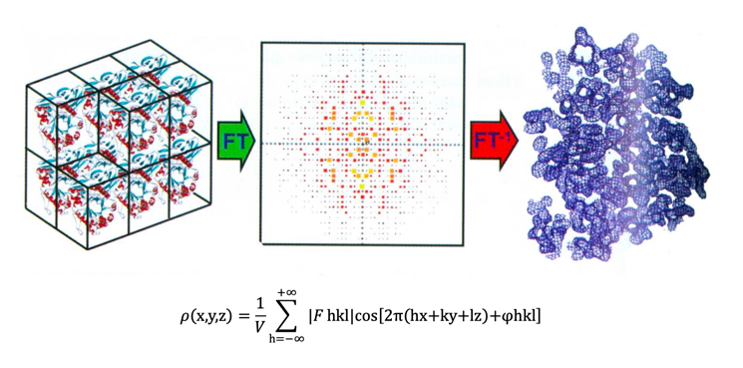
To visualize data in the form of a three-dimensional electron density map: perform a Fourier synthesis using the measured frequency (corresponding to the HKL index position), amplitude (the square root of the measured intensities) and phase angle of each reflection.

The electron density equation represents a Fourier series & gives the electron density ρ(x,y,z) as a function of the reciprocal space amplitudes ∣F hkl∣, the phase angles φhkl and the frequencies h, k and l along the real space x, y and z axes

Because the phase information is lost during our diffraction measurement, we have to retrieve the phases by a different approach, i.e. we first have to solve the phase problem. There are different ways to obtain phases: The most common are molecular replacement (MR or “molrep”), which depends on a known homologous structure that can serve as a search model to simulate the crystal packing and obtain theoretical phases, or experimental approaches such as selenomethionine single-wavelength anomalous dispersion (SeMet-SAD) or multiple isomorphous replacement (MIR), where datasets of crystals derivatized with heavy atoms are collected to get initial phase information from the heavy atom sub-structure.

Iterative model building and refinement
Model building & refinement is the essential process of inter-preting X-ray electron density map (or EM density map) in terms of a chemical structure, for which the basic parameters such as bond lengths and angles are known. For well-defined regions of density and data of ~3Å resolution or better. For typical data of large macromolecular complexes, most of the model building is carried out. Refinement can be performed in reciprocal space (for reciprocal space X-ray data) or in real space (typical for real space EM maps) & is carried out in iterative cycles with building until convergence to a satisfactory model, which meets good model geometry & agreement with map.

Reciprocal space refinement
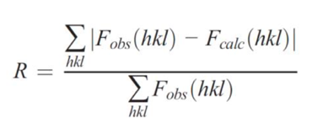
In reciprocal space, the refinement program attempts to modify the atomic model to maximize the likelihood of the experimentally observed data being derived from the model. For an X-ray crystallography structure, the overall fit of the model to the measured data during refinement is quantified using the crystallographic R-value, or “residual”:

F_{obs}(hkl) and F_{calc}(hkl) are the observed (experimentally determined) & calculated (from the model) structure factor amplitudes, respectively, indicating that the smaller the difference between the model and observed amplitudes, the lower the R value will be. The working R value (Rwork) is used as a minimization target by the refinement software, while the reliability of the refinement is validated by the Rfree value, which is calculated based on randomly selected reflections (usually 5- 10% of all reflections) that have not been included in model refinement.

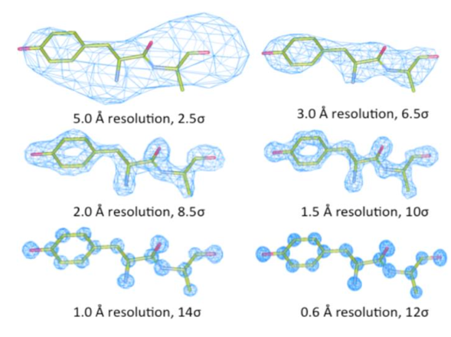
The number of observed reflections depends on the resolution obtained. At higher resolutions (1.4Å or better) the observation to parameter ratio is sufficient to refine unrestrained atomic positions (3 parameters per atom) and anisotropic atomic displacement parameters (6 parameters per atom). At intermediate resolution (1.5Å – 3.5Å), only isotropic atomic displacement parameters are refined (one parameter per atom) and prior knowledge about the stereochemistry of the model (e.g. bond lengths, angles, Van-der-Waals distances, connectivity) is used to improve the observation to parameter ratio. At resolutions > 4 Å, it may not be possible to refine individual atomic coordinates and displacement parameters (B-factors) any more. Rather, refinement is performed in group-wise B-factor mode, choosing one or two groups per residue (e.g. main and side chain). For the positional refinement, secondary structure restraints may be applied, such as secondary structure α-helix and β-sheet or Ramachandran restraints for the proteins and base pair or stacking restraints for nucleic acids. Of course, imposing these restraints depends on structural a priori knowledge (structural homologs determined to high resolution available, critical evaluation of the manually built and refined model, personal experience in map interpretation and model building) and may not always reflect the true atomic details of the determined structure any more. At very low resolution (>4.5Å), the refinement of individual atomic positions becomes impossible, and only rigid-body fitting of homology models based on high- resolution structures is an acceptable strategy for density interpretation.

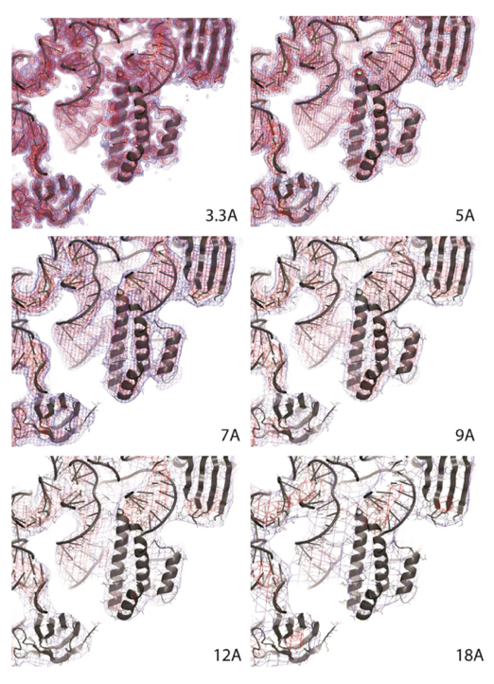

EM density of the E. coli small ribosomal subunit filtered to different resolutions. The original map is resolved to 3.3Å. Information about protein side chain conformations is lost from ~3.5-4Å. As the spacing between RNA bases is ~4Å, they can’t be separated any more at this resolution. Likewise β- sheets occur as flat surfaces without strand separation from around ~4.5-5Å. Protein α-helices and nucleic acid helices can be resolved up to ~8Å and ~12Å, respectively (corresponding to their approximate diameter).

Definition of R-factor:
The crystallographic R-factor (aka residual factor, reliability factor, R-value, RWork) is a measure of the agreement between the crystallographic model & the experimental X-ray diffraction data
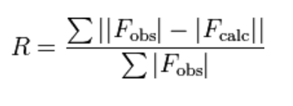
-> is a measure of how well the refined structure predicts the observed data. The value is also sometimes called the discrepancy index, as it mathematically describes the difference between the experimental observations and the ideal calculated values. It is defined by the following equation:
where F is the so-called structure factor & the sum extends over all the measured reflections (Fobs) and their calculated counterparts (Fcalc), respectively. In practice, during a successful (converging) refinement run, both the Rwork and Rfree values should drop, with the Rfree being higher than Rwork. If the Rwork drops but the Rfree raises, this is an indication for over-refinement, typically observed if the ratio between measured and refined parameters is low.

Definition of B-factor (atomic displacement parameter):
Measure related to the atomic displacement vector of an atom from its mean position due to thermal vibration, static disorder of its position in different unit cells or dynamic movement of an entire group of atoms (e.g. a flexibly attached protein domain). It can be accounted for by a single value per atom (isotropic, spherical) or six values per atom (anisotropic, ellipsoidal).
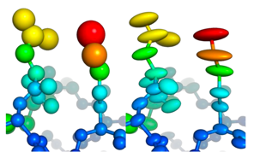
Visualization of isotropic (left panel) and anisotropic (right panel) B-factors using spheres or ellipsoids of different sizes and colors. B-factors are shown from low (blue) to high (red).

Validation of the resulting model
R-factors (especially Rfree), which should converge & have values <30%, B-factor distribution that shouldn't be random but smoothly increase & decrease between neighboring atoms/ residues.
Model validation is a further critical step in structure determi-nation. The atomic model can be validated in different ways: Reasonable model geometry values should be obtained compared to representative PDB coordinate entries at similar resolution: For a structure of > 3Å, the root mean square deviation (r.m.s.d.) bonds should be < 0.01 Å & the r.m.s.d. angles < 1.2 degrees. The Ramachandran plot (protein backbone) should be inspected & errors corrected wherever possible. There should be no clashes in the structure (contacts closer than Van-der-Waals radii are certainly due to building errors). Model building and refinement is an iterative process. Because the phases for electron density map calculation are from the model, the better and more complete the model the better the resulting Fourier maps, making it easier to detect discrepancies between the model and the map and correct the corresponding errors.

Model building
After refinement, the resulting model & its fit to the map (the Fourier transformed measured data) has to be inspected, errors need to be eliminated and the model needs to be completed. For this, apart from geometry validation statistics, the refinement program calculates 2Fobs-Fcalc and Fobs-Fcalc Fourier difference maps (written as map coefficients in the resulting MTZ file). While the 2Fobs-Fcalc map displays the entire positive density (parts into which the model is already built as well as additional features), the Fobs-Fcalc map directly visualizes the difference between the observed (measured) and calculated (model) amplitudes. Missing parts will occur as positive density while wrongly built parts will generate negative density. Both maps are used in concert for rebuilding. The “standard” color scheme and map sigma (σ) contour levels are blue and 1σ for the 2Fobs-Fcalc map and green/red with +/- 3σ for the Fobs-Fcalc map.
After rebuilding, the corrected model is again refined and the resulting R values should now be lower. These rebuilding-refinement cycles are repeated until the R value changes become subtle and no obvious corrections can be made any more.

L7: Principle of cryo-electron microscopy for biological macromolecules

Introduction
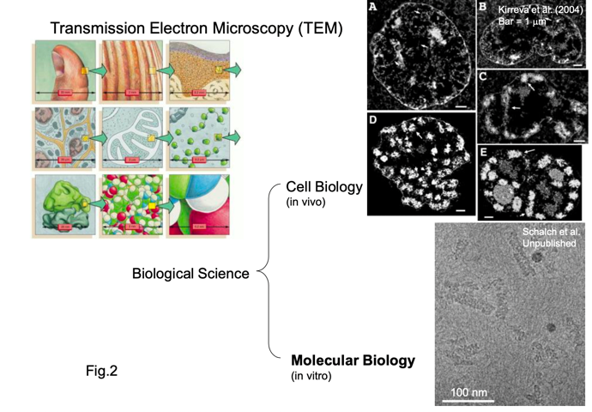
EM: method to visualize molecular structure. By electron microscopy, we acquire images (not diffraction, not spectrum), which will give us structural information at a scale between ~3Å and 1µm.

Experimental procedure of cryo-EM for biological Molecules/ cells:
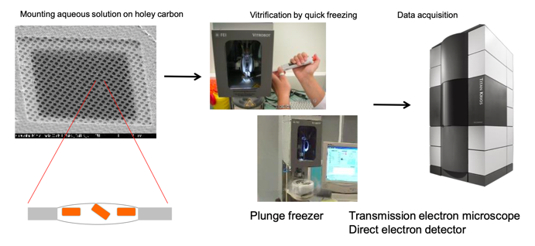

Cryo-grid preparation (blotting by filter paper -> plunge freezing) is still 80's technology: Nanotechnology, microfluidics to handle ~nl liquid could trigger breakthrough

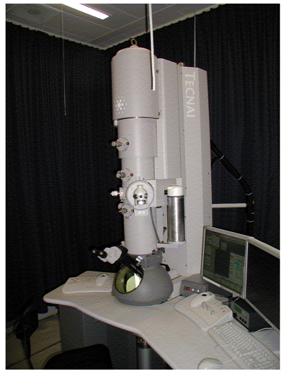
Hardware of transmission electron microscopy
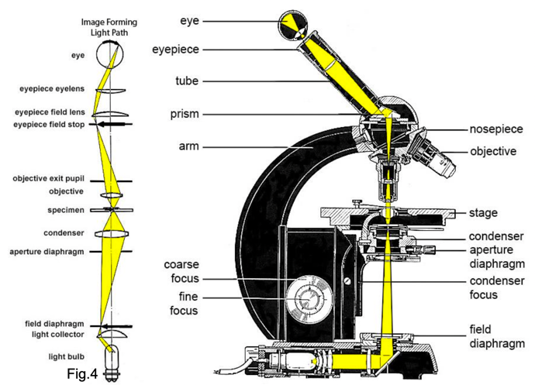
Transmission electron microscopy (TEM) has a similar optics as conventional light microscopy (LM). Both have a light source, condenser(s), a specimen stage, an object lens and a detector. The beam is converged on the specimen by the condenser lens and goes through the specimen. Images are focused by the object lens and formed on the detector. The fundamental difference is that TEM uses electrons, while LM uses photons as a probe. Since the electron has stronger interaction with material, the inside of the electron microscope must be vacuum.
LM:

TEM and light microscopy share the similar optical system
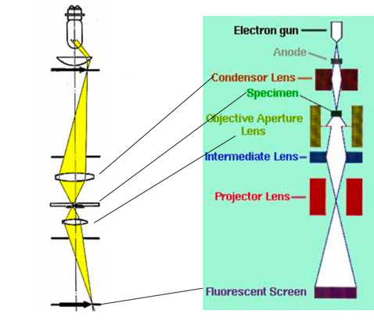

Differences:
- LM uses a photon as a probe, whereas EM uses an electron
- LM uses glass lenses, whereas EM uses electromagnetic lenses

Inside of the electron microscope
must be a vacuum. The level of the
vacuum varies depending on the
components (gun, column,
camera etc.) and different pumps
are used

Basic optics

Phase contrast and defocus
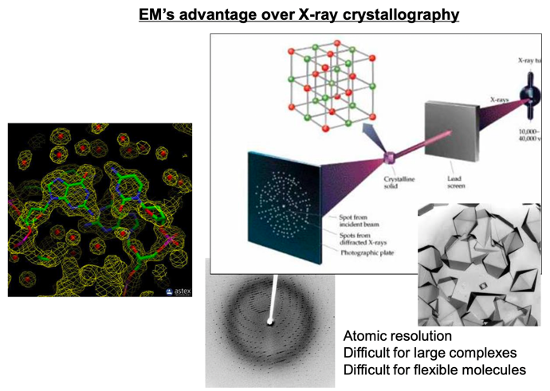
Since biological specimens has poorer contrast and are more sensitive against electron beam, different principle of image formation is required: phase contrast. To understand the image formation mechanism of biological electron microscopy, understanding of Fourier transform and wave optics is indispensable. Since water and biological molecules are almost transparent against the electron beam, intensity of the beam after the interaction with the specimen cannot make difference (amplitude contrast, which is the conventional contrast formation of light microscopy). Instead, the optics must be arranged, intentionally, with slight shift from exact focusing (defocus), to make interference between the electron beam with and without the interaction with the specimen (phase contrast).

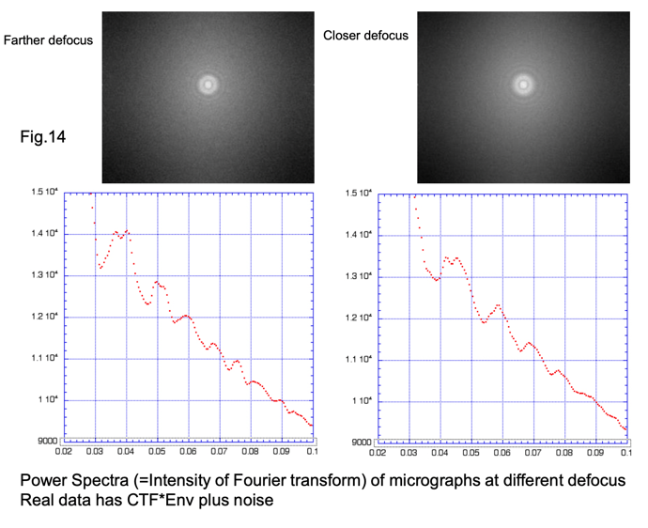
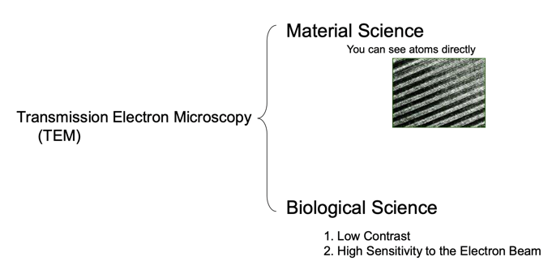

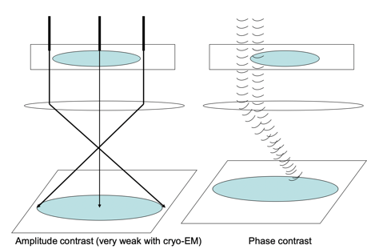
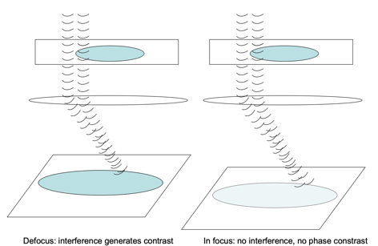

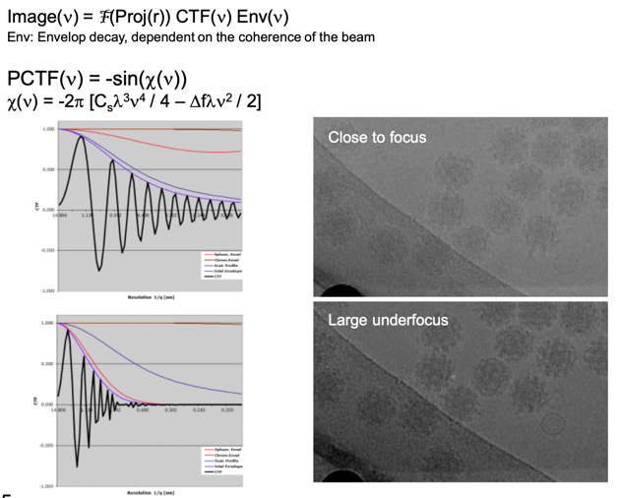

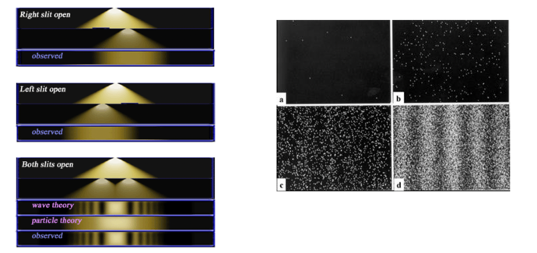
Wave-particle duality of electrons:

Contrast transfer function
However, the image is biased (contrast transfer function, CTF), because of electron optics. CTF is a function of spatial frequency, defocus and the spherical aberration. They are described easily in the Fourier space. Spherical aberration is the distortion of images when the surface of the lens is a simple sphere and affect the envelop function to reduce the high-resolution information. The more the defocus is, the higher contrast can be obtained, but the more high-resolution information is lost. This bias is described as a contrast transfer function. By evaluating CTF, part of the original image can be recovered (CTF correction).
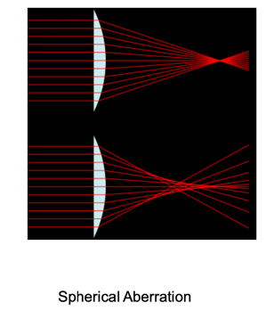
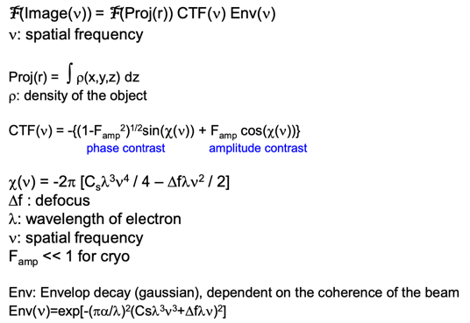
Image formation for cryo EM

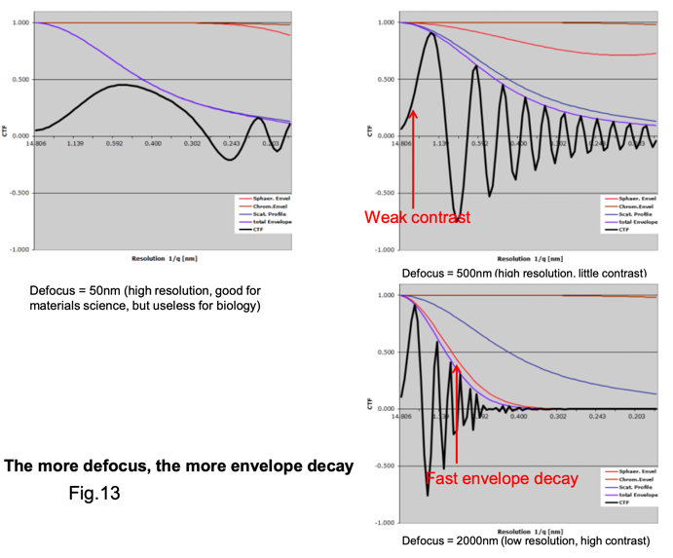

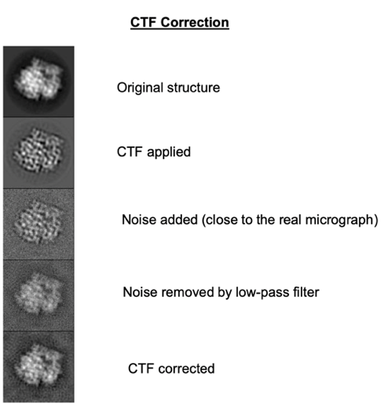

Principles of 3D reconstruction

Micrographs are 2D projections of 3D objects
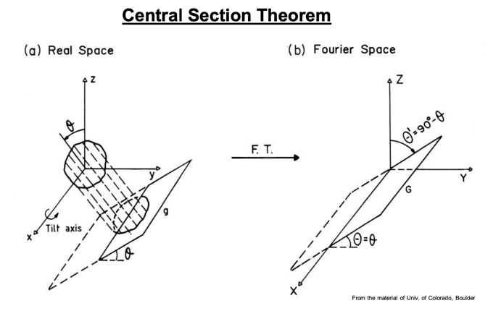
If bias from CTF is ignored, micrographs can be described as 2D projections of 3D objects.

Central section theorem
This relationship corresponds to the section in the 3D Fourier space.

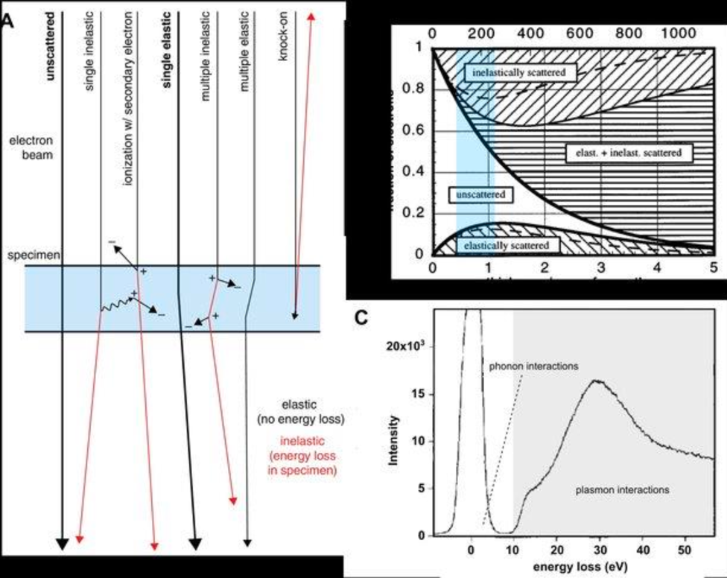
To reconstruct the 3D structure in real space is equivalent to filling all the 3D Fourier space with data
Each micrograph will fill only one section in 3D Fourier space. It is essential to obtain a number of sections with various different angles and fill the space. You need not only to collect sections, but also to know the view angle of each projection.

3D reconstruction is equivalent to filling 3D Fourier space with many sections, determining the angles
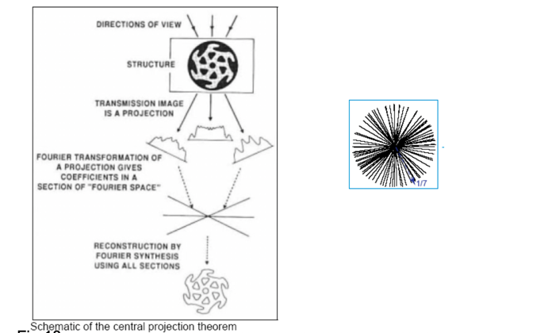

Specimen preparation
There are a few methodologies to prepare biological molecules for electron microscopy. However, recently cryo electron-microscopy is the most popular approach as the way to observe “intact” structure. In this method, molecules are quickly frozen, embedded in amorphous ice, brought into the column of the microscope, and observed at a liquid nitrogen temperature.

Various specimen preparations for biological macromolecules
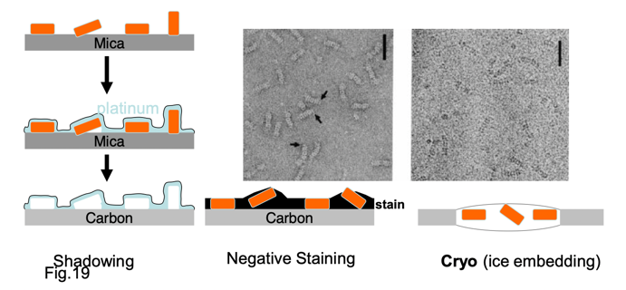
We would like to observe macromolecules as close to physiological conditions as possible

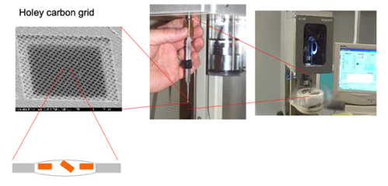
Cryo-EM: Ice-Embedding

Difficulty of thick specimen
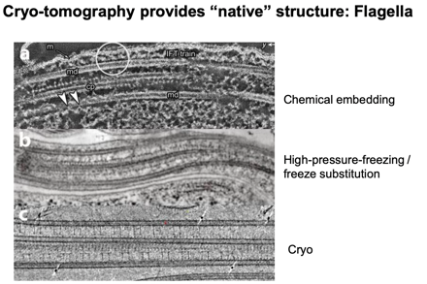
Why is thick ice
harmful?

Interaction between electrons and the object
- Inelastic scattering
- Multiple scattering
- Defocus range

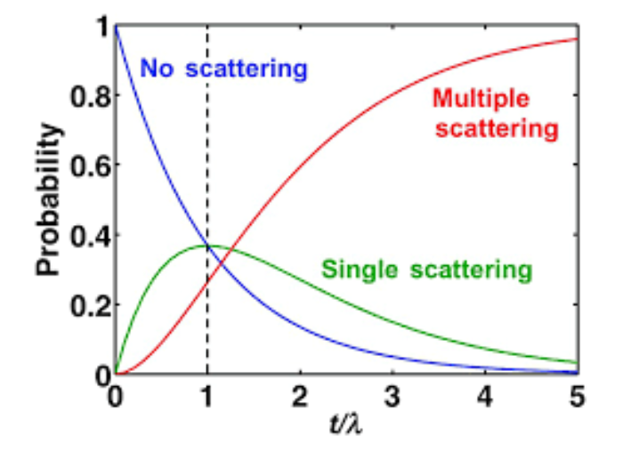

Resolution and radiation damage
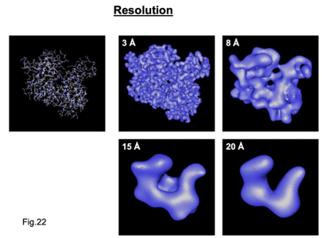
Available discussion on the molecular structure depends on the level of resolution. Electron beams damage the specimen and limit the resolution. However, if the illumination is too dark, enough amount of contrast for image analysis cannot be obtained. The most essential and serious problem of 3D EM of biological molecules is this dilemma. The low dose method is used to minimize radiation damage

Resolution limitation factors
- Wavelength of the electron beam (dependent on the acceleration voltage)
- Optics of the microscope (Spherical aberration)
- Radiation damage of the specimen
- Image analysis

Biological specimen (especially ice-embedded) are very sensitive to radiation damage)
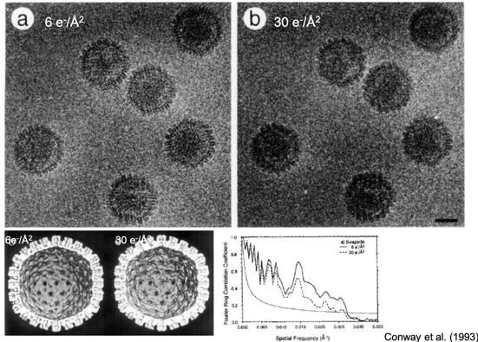

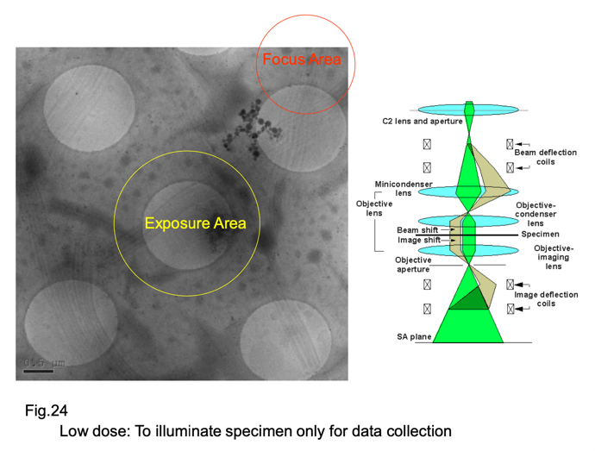

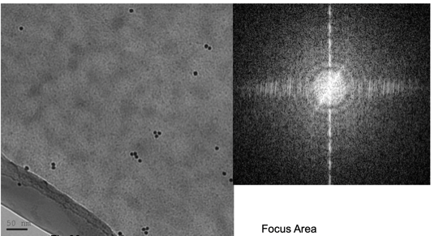
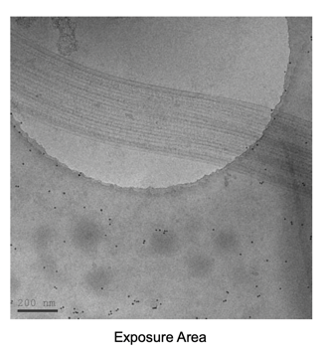

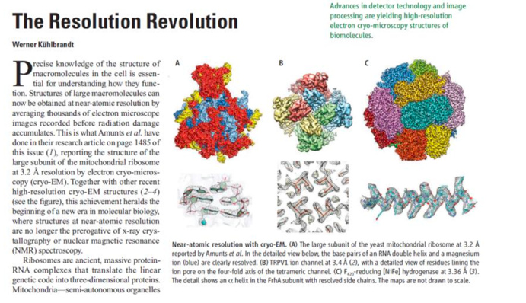

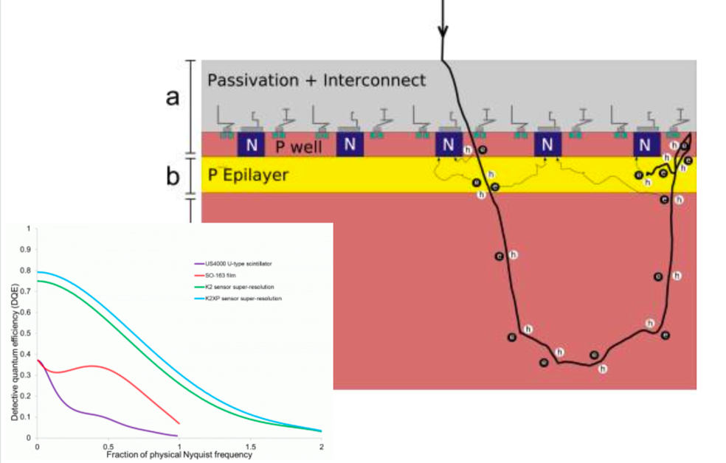

Resolution revolution: improvement of spatial resolution in cryo-EM up to near atomic resolution, enabled by direct electron detector, image analysis algorithm, phase plate. It took place at tomography of thin (<100nm) objects

Detectors
There are a few detectors to acquire electron micrographs. The important parameters to evaluate and choose detectors are resolution and the size. These two parameters are linked together. Secondary electrons generated inside the detector degrade resolution. Photographic films, though they are considered as old-fashioned, have largest view area and high resolution. Conventional digital cameras, which convert electrons to photons in scintillator and detect photons by CCD or CMOS mechanism, suffered from low resolution, until new direct detectors were developed.
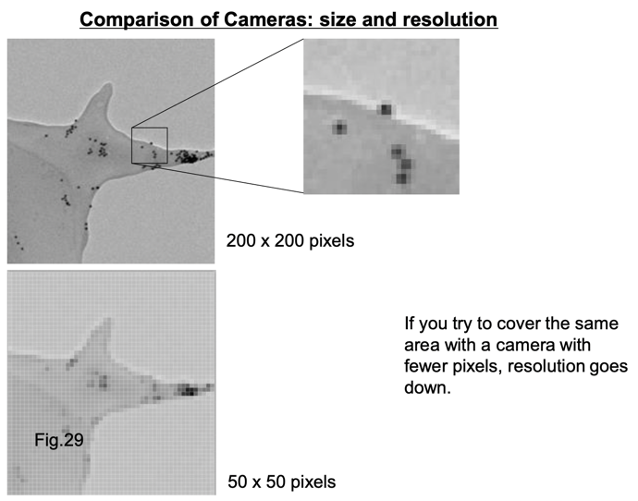
Direct electron detectors brought revolutionary improvement of spatial resolution in cryo- EM. They are CMOS detectors without scintillator.

Point spread function determines resolution of the detector:

More secondary electron
-> wide spread
Less secondary electron
-> less sensitive

Digital (CCD) camera
Advantages:
High sensitivity, high
linearity, convenience

Disadvantages:
Narrow area (4kx4k),
poor point spread
function (because of scintillator)

Direct electron detector: revolution of EM camera
Direct electron detectors are CMOS detectors without scintillators
DQE (combination of point spread function and S/N) describes image quality at low dose

Advantages of Direct Electron Detectors
- High resolution (described by MTF).
- High signal-to-noise level (DQE describes 1 and 2 together)
- Fast frame for drift correction
1 & 2 are general advantage for good detectors.

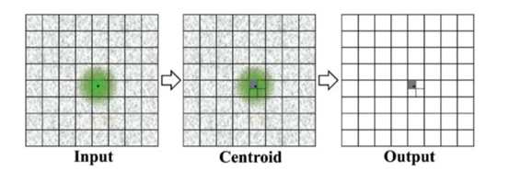
Super resolution

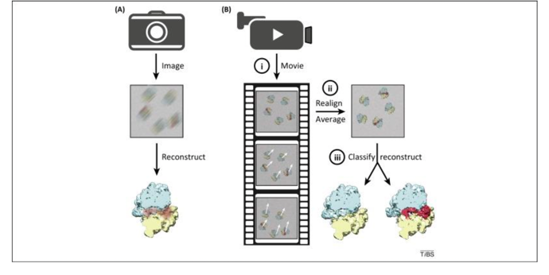
Drift correction

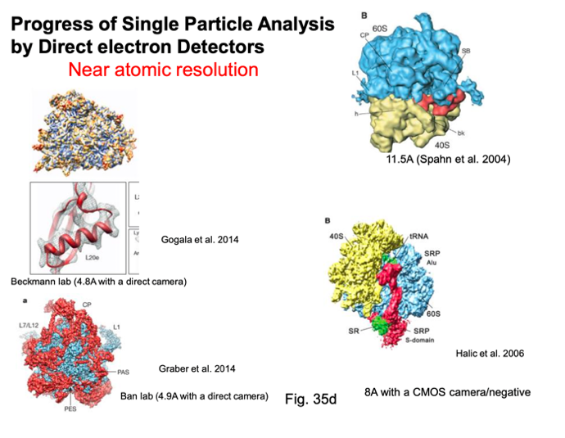

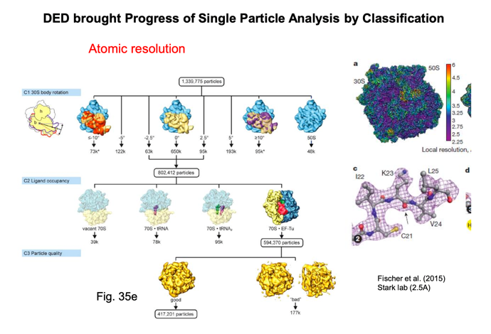

What is the cause of noise in EM?
- Noise in the electric circuit of the detector – to be reduced by better detectors.
- Electron scattered by other materials (ice etc.) – to be dealt by specimen preparation in thin ice.
- Inelestically scattered electron and multi-scattering.

"Energy filter to remove noise form inelastic scattering
An ever-increasing number of industrial and academic institutions require the analysis of highly structured materials at the nanometer level using the latest in TEM technology:
The GIF adds energy loss spectroscopy and image capabilities to a TEM that will dramatically change the was researchers look at their samples"

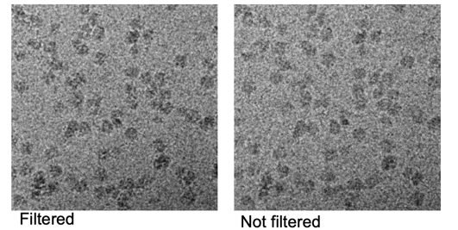
Energy Filtering: to recover contrast

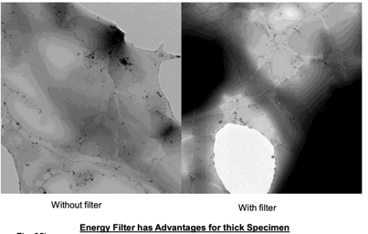
Energy filter has advantages for thick specimen

Points
- TEM is imaging methodology.
- How to build images from low-contrast and radiation sensitive biological specimen?
- How to reconstitute 3D structural information from 2D micrographs?

Fundamental Dilemma
The more the electron dose is, the higher signal-to-noise ratio can be expected, but also the more radiation-damage you will have.

Various ways of three-dimensional reconstruction technique
Two different approaches to reconstruct 3D structure of biological macromolecules from cryo-electron micrographs

Essential points of 3D reconstruction from cryo-EM
- How to minimize radiation damage and extract structural information (contrast, resolution) efficiently?
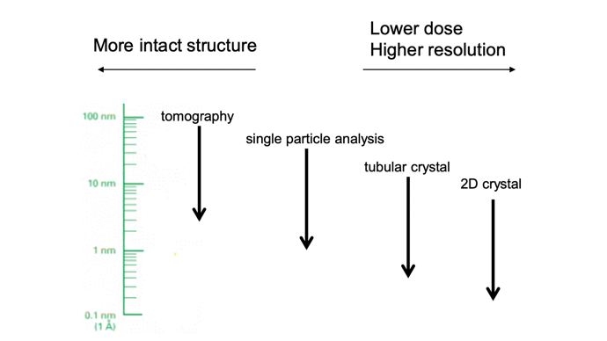
- How to obtain images (=projections) from various view angles to fill the 3D Fourier space and evaluate view angles?

2D crystal
In the 2D crystal molecules array two-dimensionally. The Fourier transform of the image is a lattice. Thus, in the Fourier space, you can earn higher signal-to-noise ratio. Which enable the high-quality data from lower illumination (i.e. lower radiation damage), resulting higher resolution (more than ten structures have been solved at the atomic resolution). However, this methodology demands, as X-ray crystallography, crystallization. The view angles of each micrograph can be determined by lattice parameters. Advantage, comparing to X-ray crystallography, is that we do not need heavy atoms, because direct images are recorded. For 3D information, tilted 2D crystals are inserted into the microscope with special holder. Dissimilar to the 3D crystal, information in the Fourier space is recorded along lines (lattice line). Since you cannot tilt 2D crystal at 90 degrees in the microscope, you will miss some information in the 3D Fourier space (missing cone).
Example: bacteriorhodopsin, water channel.
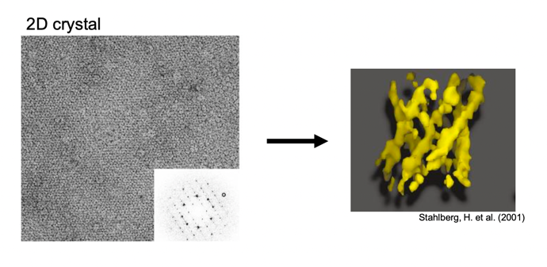

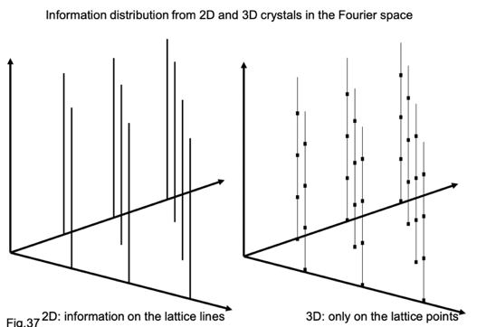
Information distribution from 2D and 3D crystals in the Fourie space

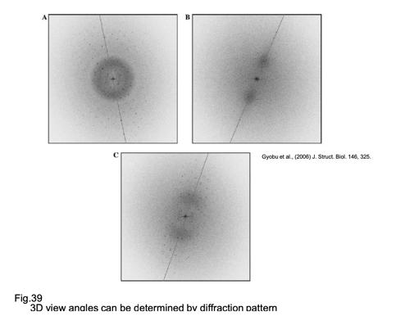
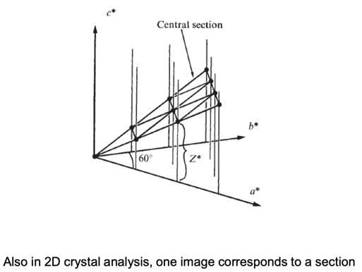

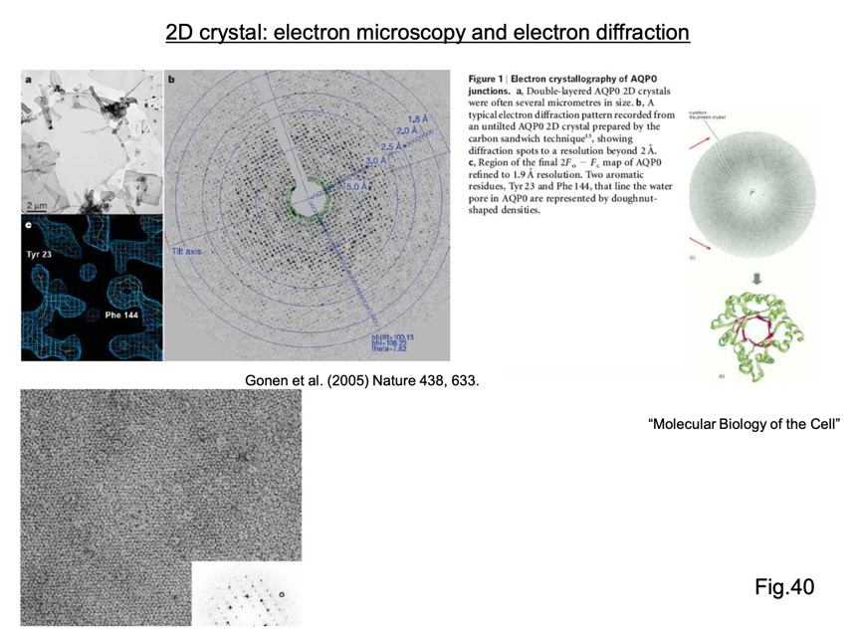
2D crystals: electron microscope and electron diffraction

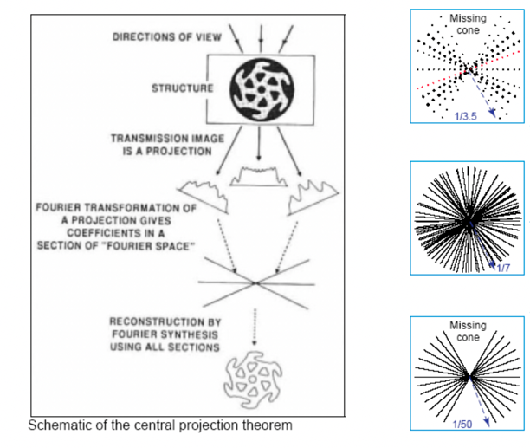
Missing wedge, missing pyramid and missing cone

Advantage of 2D crystal
Analysis can be done under the extreme low dose (=poor signal-to-noise ratio) condition, by filtering in the Fourier space.

Tubular crystal
Molecules are arrayed as spirals. Since the signal will be spread along one dimensional lines, the resolution is not so high as 2D crystals. All the necessary view angles for 3D reconstruction can be obtained from tubular crystal. Therefore, there is no missing information and tilt is not needed.
Example: acetylcholine receptor.
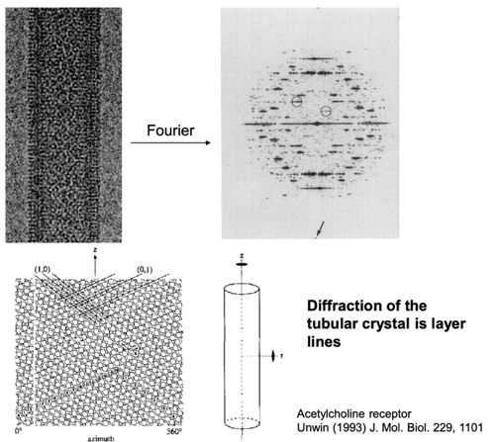

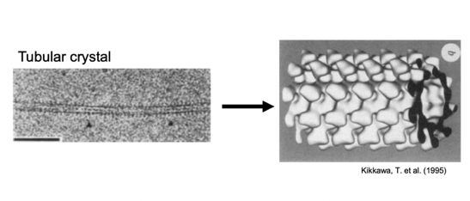

Advantage of tubular Crystal
- Image acquisition can be done under low dose condition (but not so much as 2D crystal).
- No missing information, because all the view of the molecule can be obtained from one micrograph.
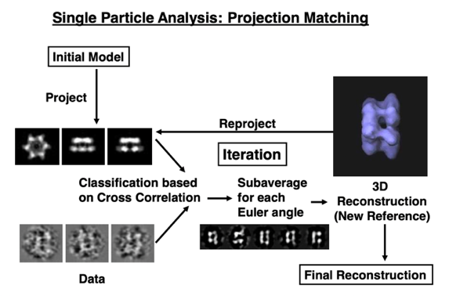

L8: Single particle EM part 1

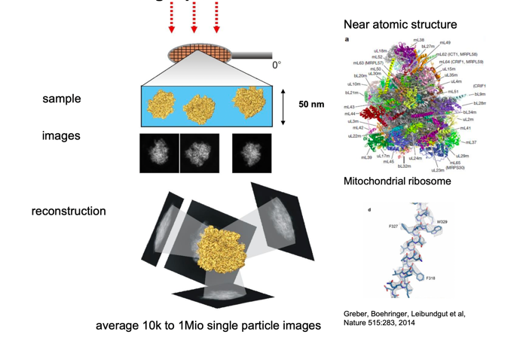
Single particle reconstruction

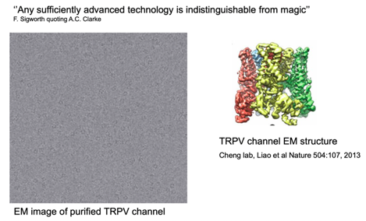
... from noisy EM micrographs

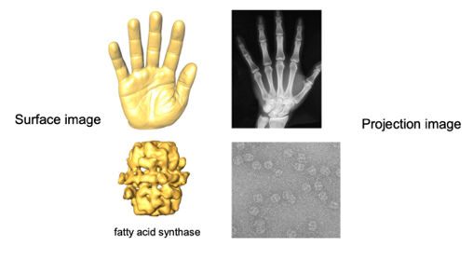
EM images are projection images

Weak phase object approximation:
For thin, low Z samples the contrast in the image is linearly proportional to the coulomb potential of the sample.

How to obtain high contrast views ?
Finding images with similar orientation/view – classification Superimposing images – alignment
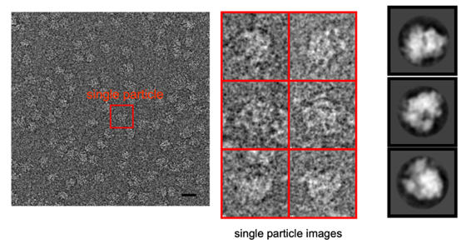
Statistical image processing - averaging noisy images which show the macromolecule from similar orientations.

Similarity of images
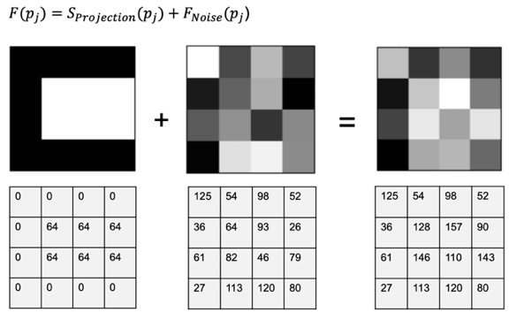
Image model:

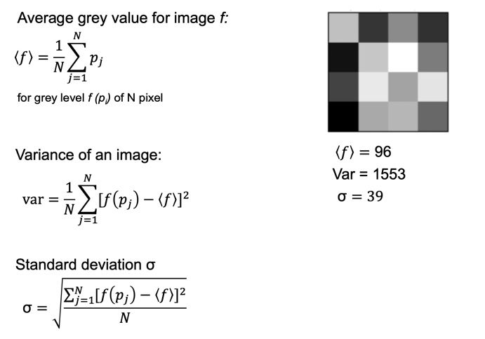
Statistical characterization of an image

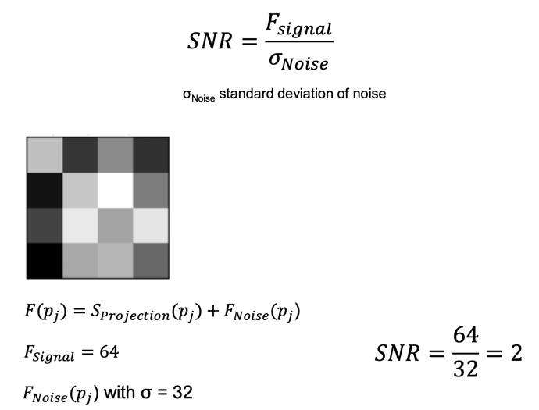
Signal-to-noise ratio SNR

Increasing the signal to noise ratio by averaging
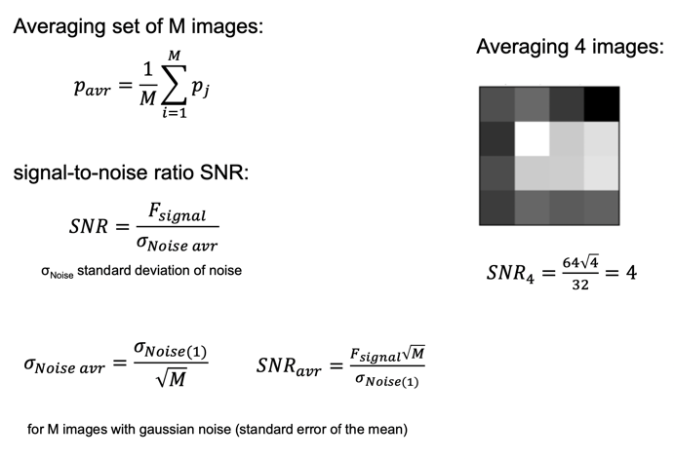
-> by averaging images

Similarity of images
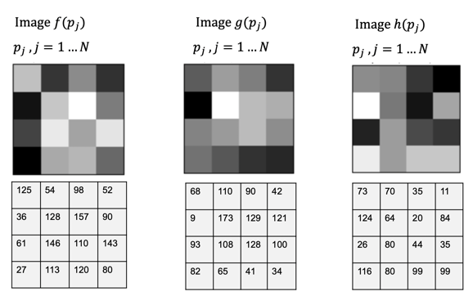

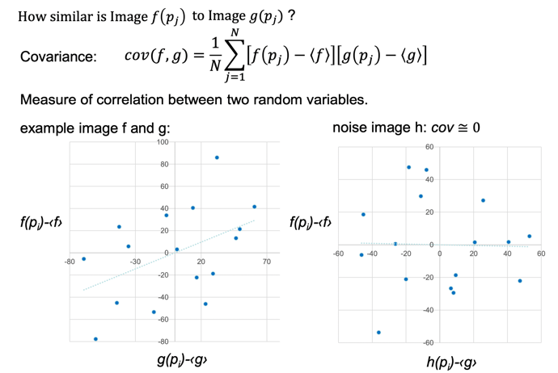
Similarity measures between images

Images should be more similar to each other than to noise!
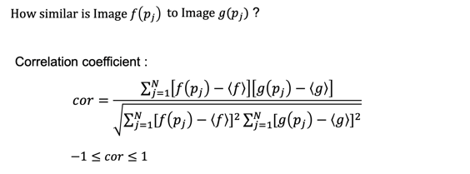

Covariance normalized with the variance of image f and g.
In our example the correlation is 0.46.
The correlation coefficient is used to determine images, the similarity of images and their optimal alignment.

Image Alignment
How to shift one image relative to another so that they are most similar?

To find the maximum correlation for a coordinate transformation f(p_{i})

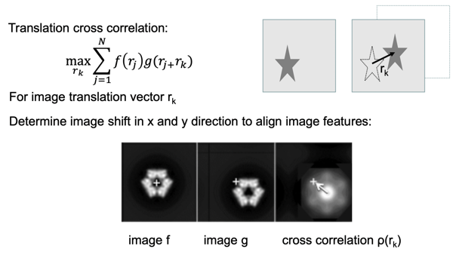

In real space the cross-correlation function would have to evaluate for all r_{k}

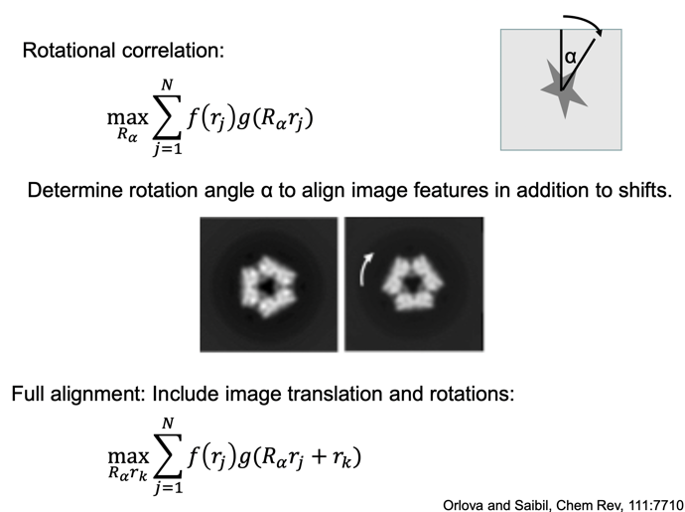
In plane rotation

Computational aspects
Real space correlation calculation requires many computation steps, slow.
Faster calculation by applying the convolution theorem:
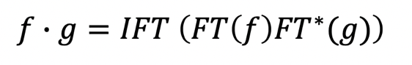
The convolution product of two functions (i.e. as found in the cross correlation function) is equal to the inverse Fourier transform (IFT) of the product of the Fourier transforms (FT) the two functions (i.e. the images).

Image alignment is the computationally most intensive step in 2D/3D refinements.

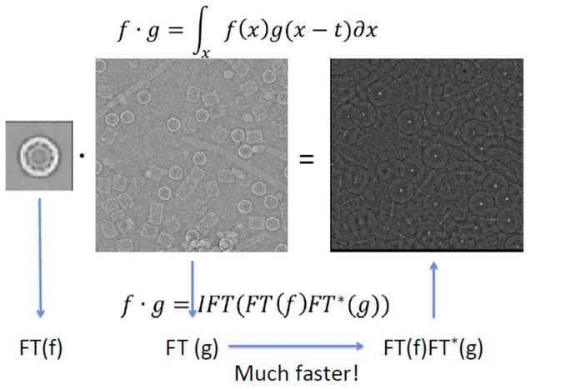
Automated Particle Picking

High correlation -> likely the particle

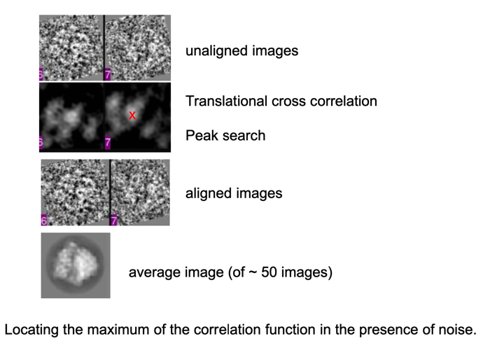
Using the cross-correlation function for EM images

Limited signal to noise ratio at high frequencies
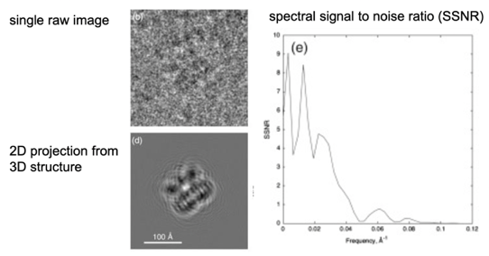
The high-resolution
content of an individual particle
cannot be measured
Single particle data are
characterized by statistics
on sets of images.

Low pass filtering of single particle images
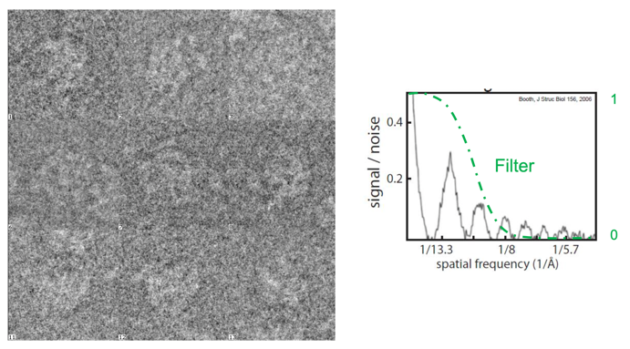
Low pass filter suppresses high frequency noise.

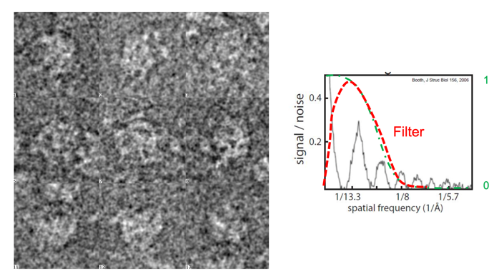

Filter used in single particle reconstruction software

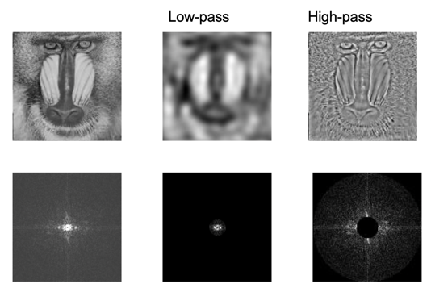
Filters – Fourier space

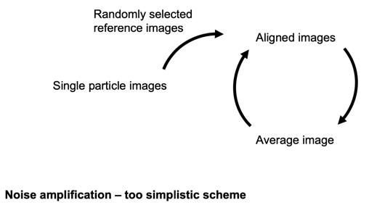
A simple iterative 2D refinement scheme

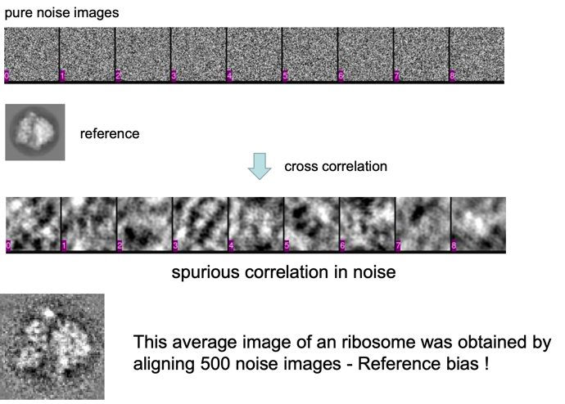
Reference bias!

Reference bias: Particle picking
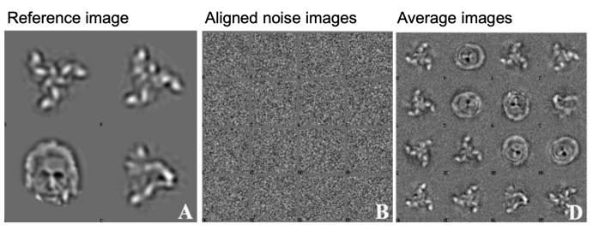

Image classification
How do we obtain initial reference images that are ‘typical’ for the data set ?

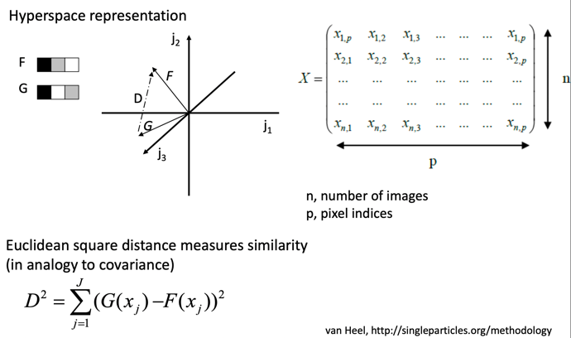
Hyperspace representation of image sets

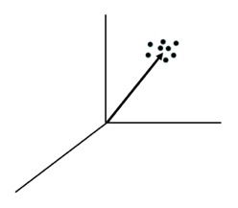
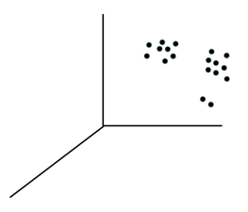
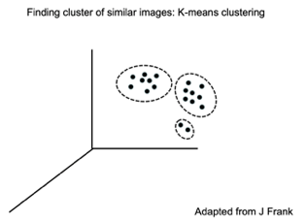

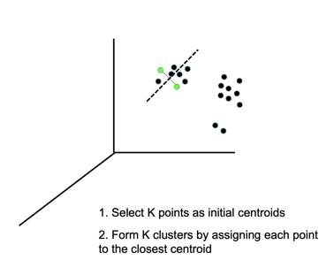
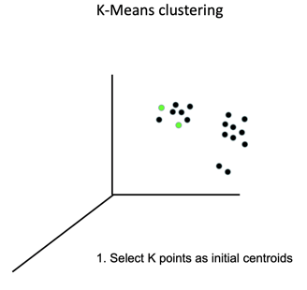
k-means clustering

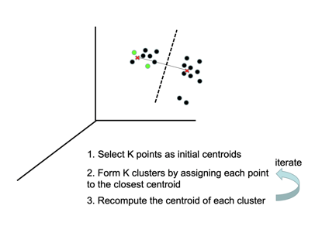
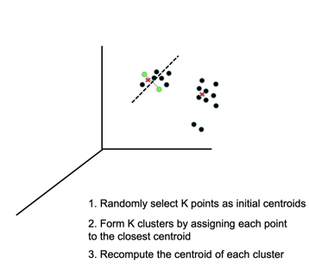

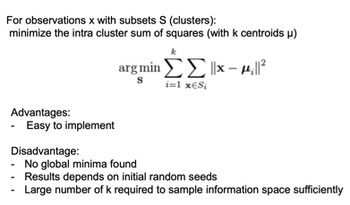
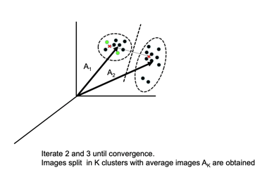

How do we obtain initial reference images that are ‘typical’ for the data set ?

Multivariate statistical analysis (MSA)

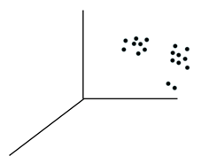
Data compression
Optimize the orthogonal coordinate system of the hyperspace to best fit the shape of the data cloud (i.e. “finding new axis u₁, u₂ ...”)

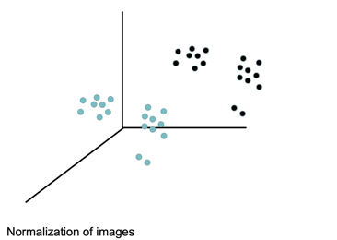
Principal component analysis (PCA)
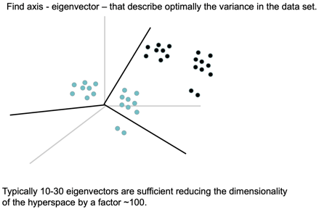

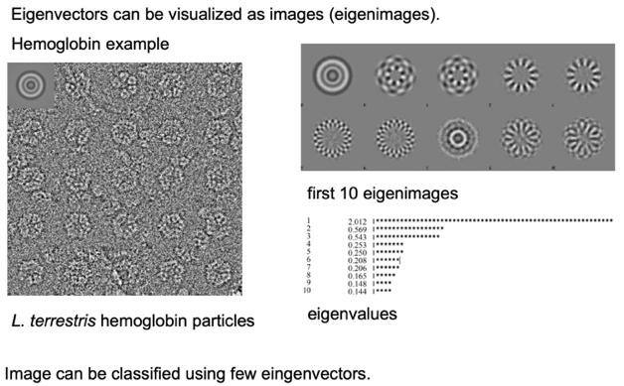
Iterative calculation of eigenvectors

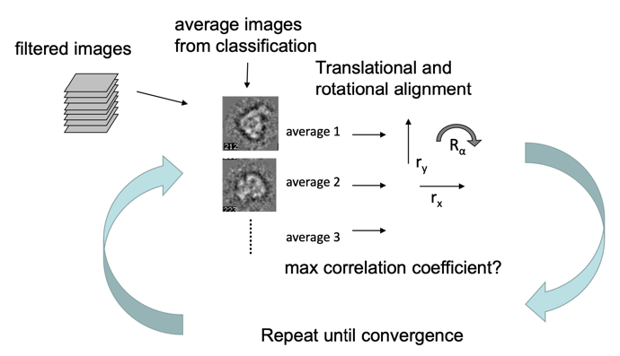
A simple multi reference alignment and classification scheme

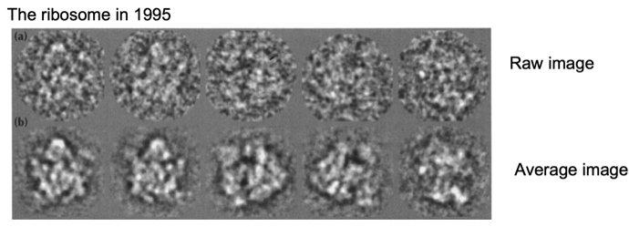
MAS - 2D classification example

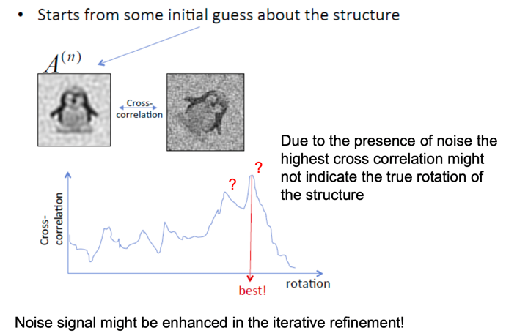
Noise bias – image alignment

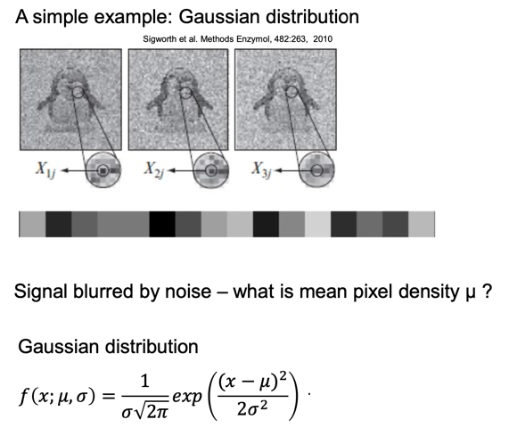
Maximum likelihood estimation

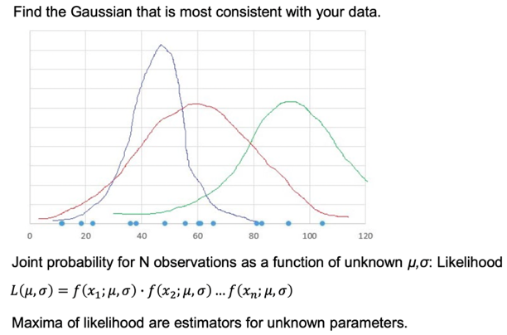

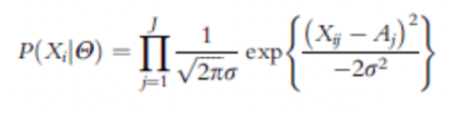
Probability of observing the image is a multiplication over the probability density function of all individual pixels.

The maximum likelihood estimation is used in expectation maximization maximum likelihood (EM-ML) algorithm to obtain the estimates for model parameters Θ

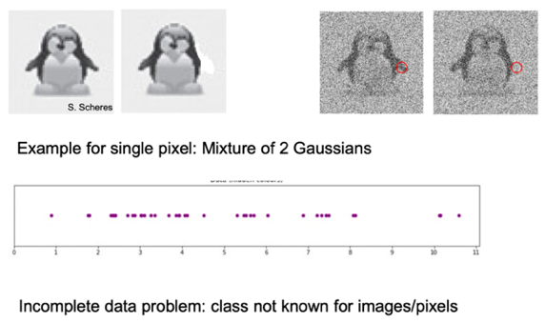
Expectation – Maximization algorithm

- Initial estimate of 2 Gaussians μ σ
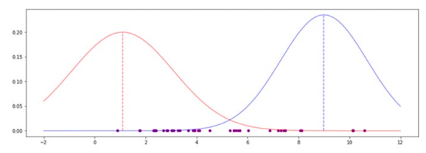
- Compute the probability for each pixel/image given current μ σ. (Expectation step)

- Determine likelihood (mixing parameter γ) for each class to have contributed – assign weights to data points.
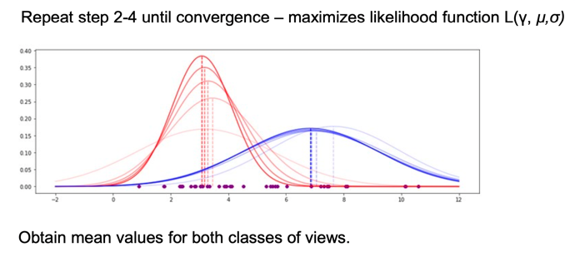
- Compute new estimates of μ σ for each class putting weights into account (Maximization step)

Maximum Likelihood methods in image alignment
Incomplete data problem – image shift and in plane angle (projection angle) Example: missing rotation angle φ
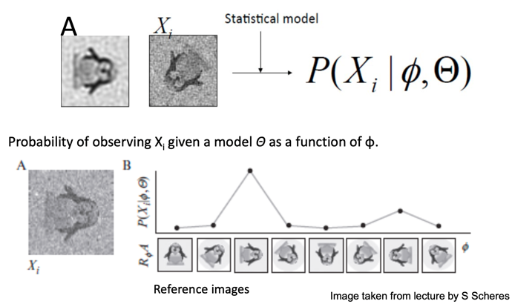

Alignment

Filling missing information in ML
Probability weighted averages over all orientations:
ML reflects the fact that any particle property can only be known with a certain probability (due to the presence of noise).
ML allows to estimate optimal filter parameters to maximize signal to noise.
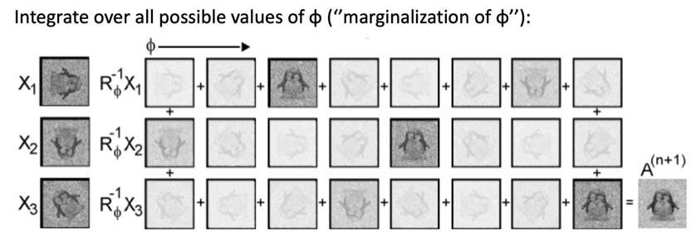

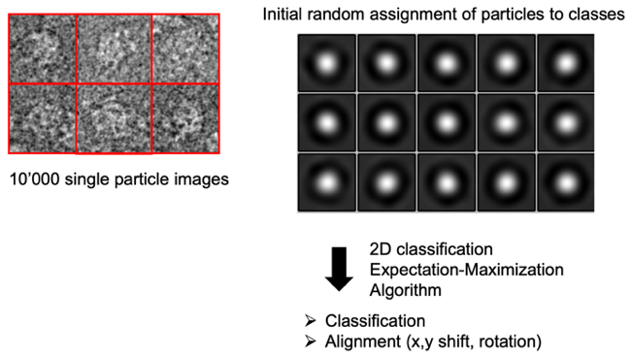
ML-2D classification - Ribosome

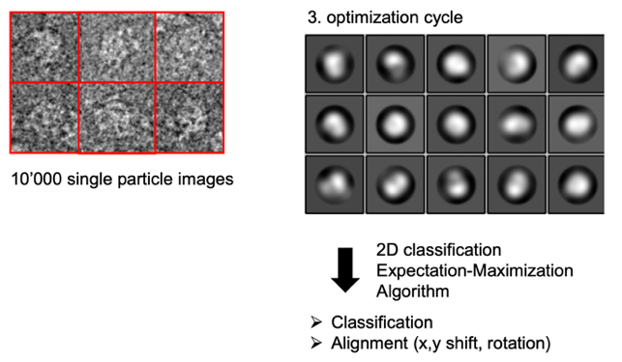

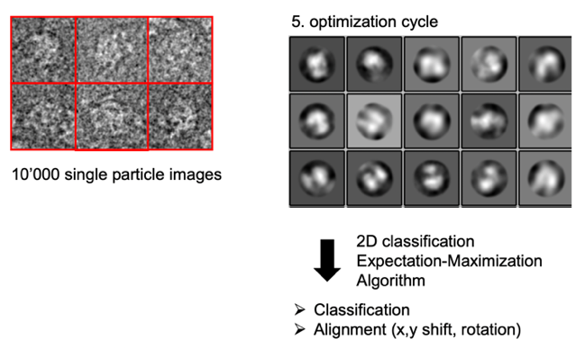

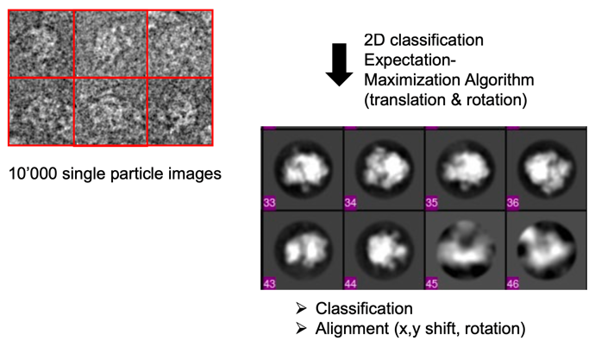

~20/25 cycles

3D Reconstruction from projections

3D Reconstruction Algorithms
- Filtered back projection - real space
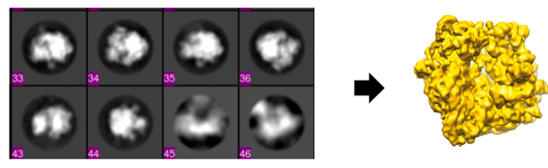
- Direct Fourier inversion

Back projection - real space 3D reconstruction
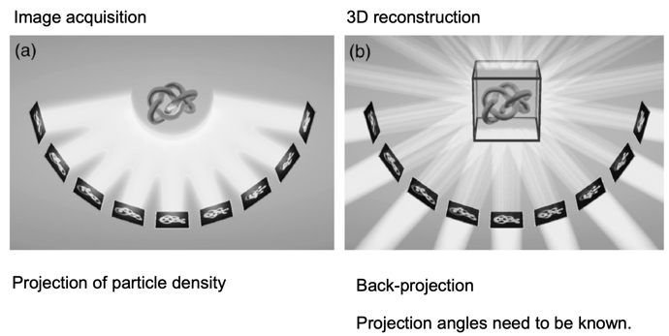

Back projection principle
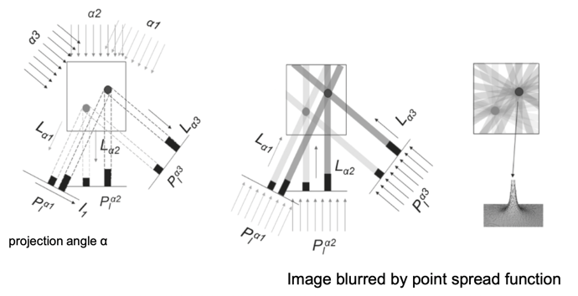
2D Example: Reconstructing a 2D image from line projections

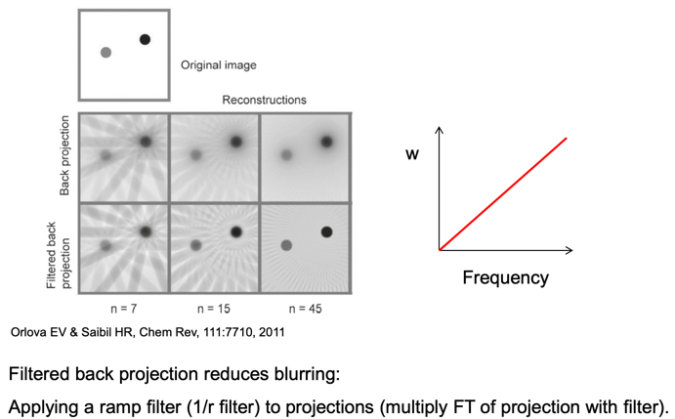
Filtered back projection

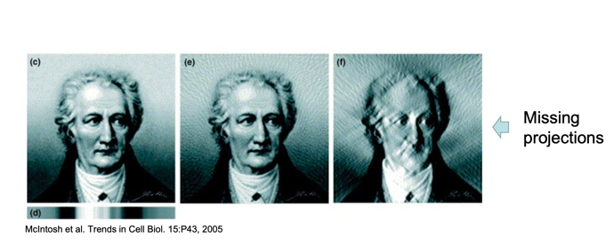
Back projection – missing projections

Artifact: Structure smears out in the perpendicular direction

3D reconstruction – Fourier space
Fourier transforms of 2D projections are central section of the 3D Fourier transform.
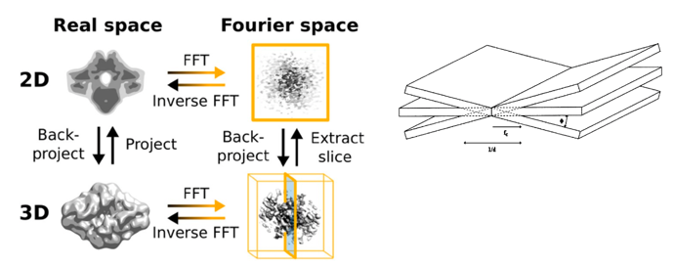

At least one tomographic 180° series of projection required for reconstruction!

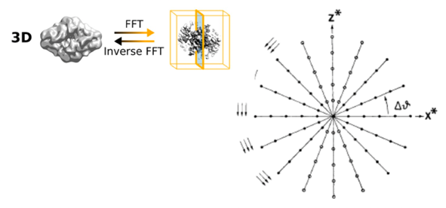
Direct Fourier methods for 3D reconstruction

weighting / interpolation of
points in Fourier space required:
gridding based direct Fourier
inversion algorithms

Obtaining projection angles for 3D reconstruction
- Structure of homologues complexes known: Determine projection angles with reference structure
- De novo structure determination: Determine projection angles for initial model

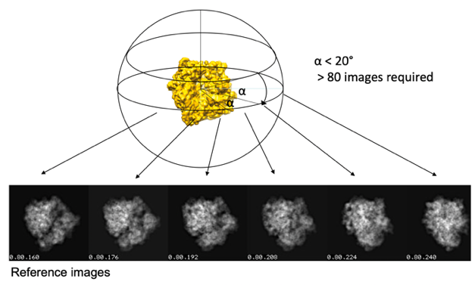
Comparison with projection of reference structure

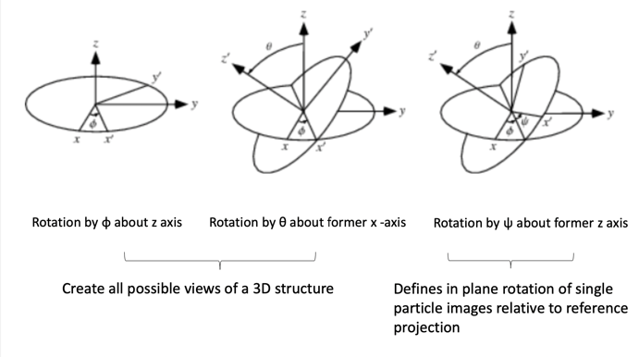
Projection of 3D structures – Euler angles

Comparison with projection of reference structure
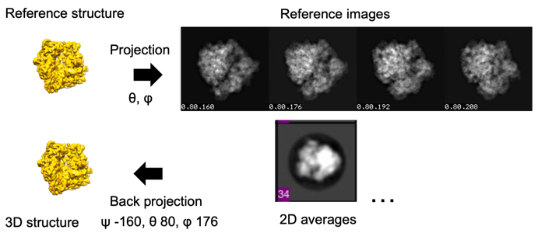

Generating an initial model

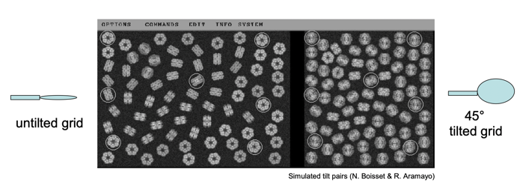
Random conical tilt (RCT) reconstruction

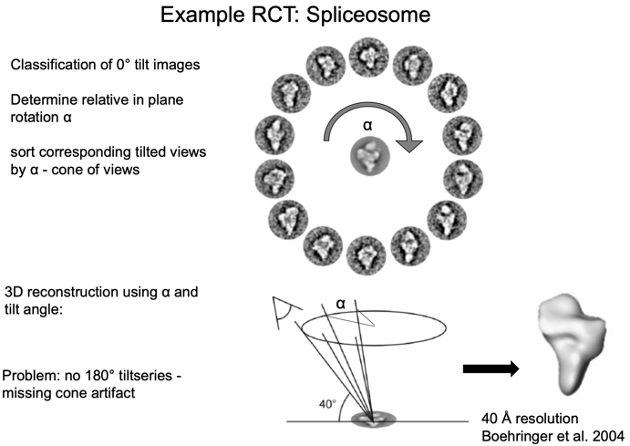
Obtain an image of the same area with 0° and 45° tilted holder. Identify the position of the same particles in each image

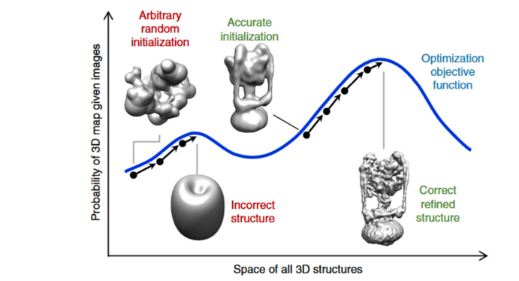
Stochastic gradient descent
CRYOSPARC

Optimization-score: how well the model fits to the data:
3D extensions - marginalize over all projection angles
Problem: Optimization could get trapped in local minima
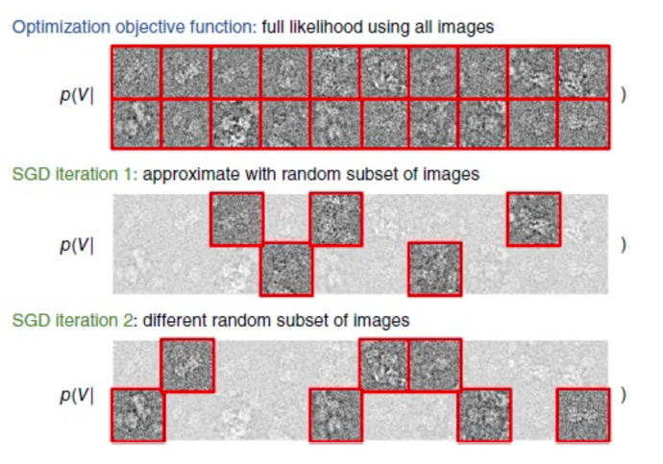

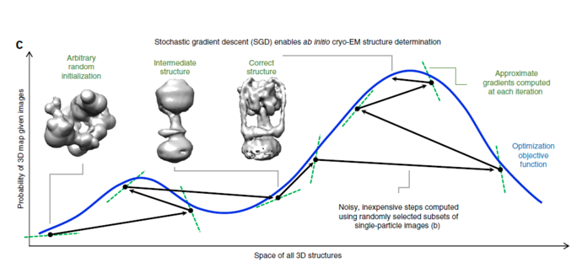

Using many small random subsets:
- Avoids optimization getting trapped in local minima
- Speeds up calculation

Refinement cycle -

Projection matching
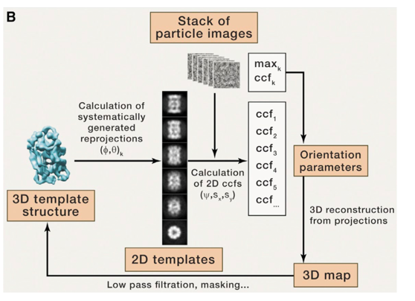
Repeated cycles of projection matching – self consistency

Maximum likelihood
Repeated cycles of projection matching – self consistency
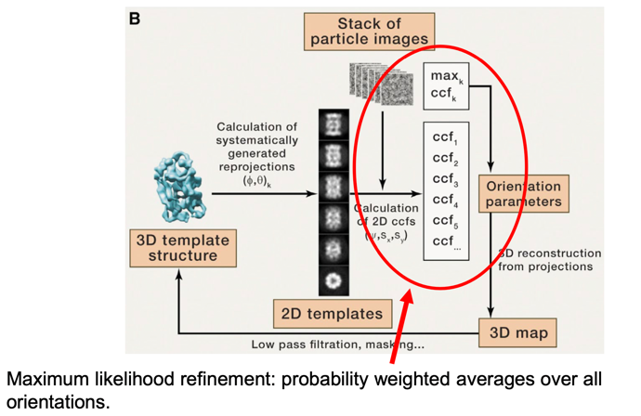

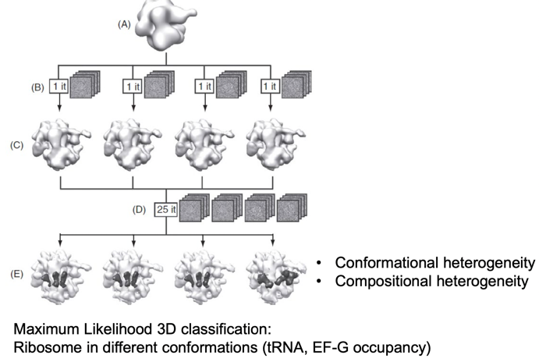
Heterogeneous data sets: 3D classification

3D classification

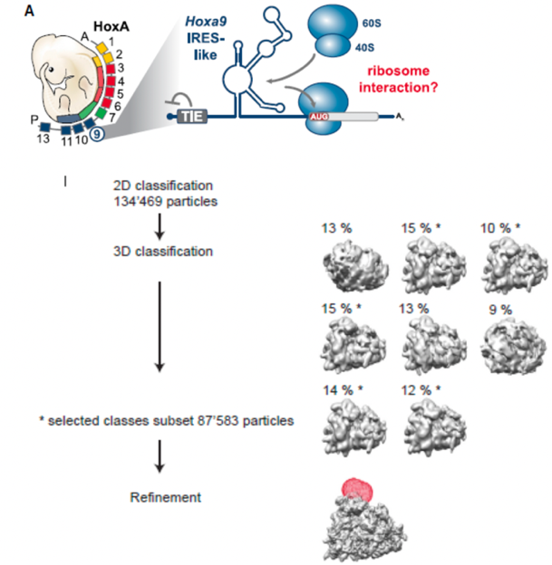
Example

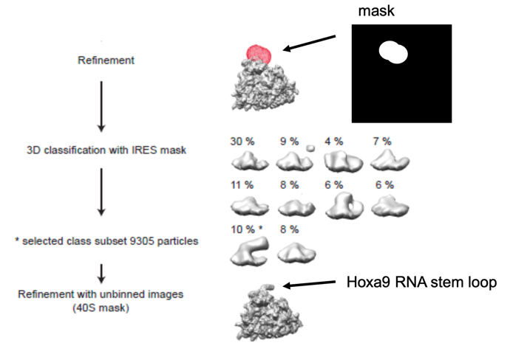
Local classification

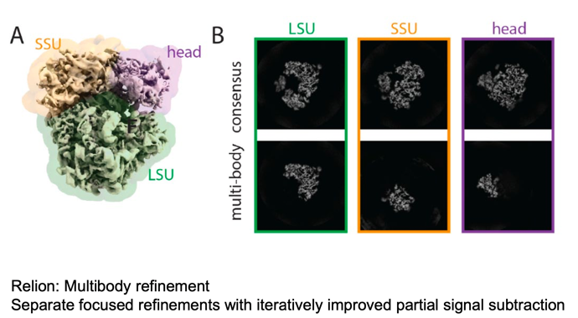
Local refinement - Signal subtraction

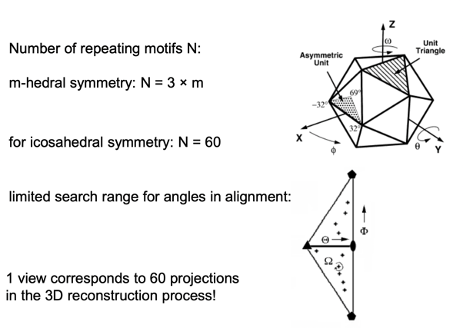
Advantages of particle symmetry

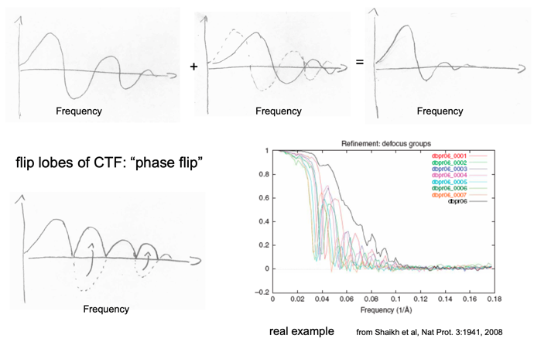
Merging of images with different defocus

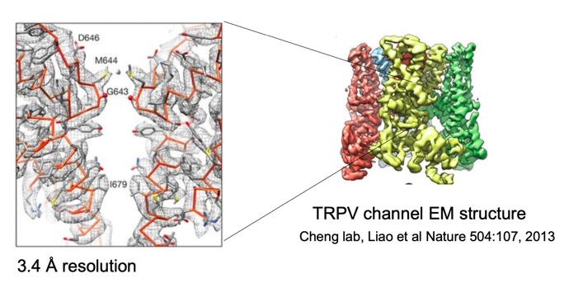
Result of a 3D refinement: (near) atomic resolution structures

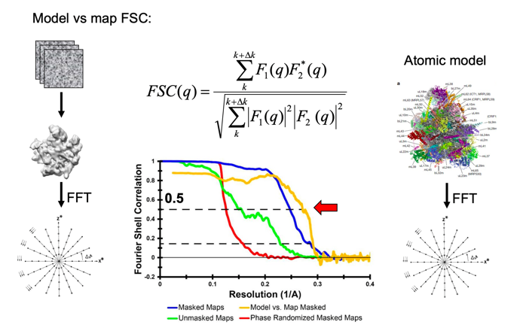

Which factors that might limit the resolution in a 3D refinement ?

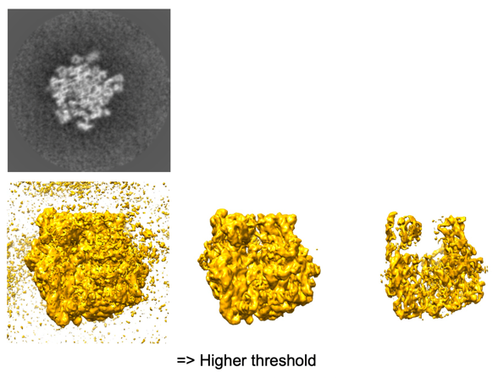
Threshold for visualization

Particle with noise

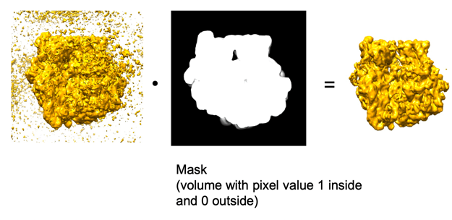
Masking

Visualization of details - Map sharpening
Guinier plot of the spherical averaged map amplitude F vs square of the spatial frequency.
Amplitudes of the map
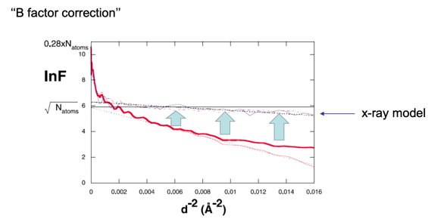

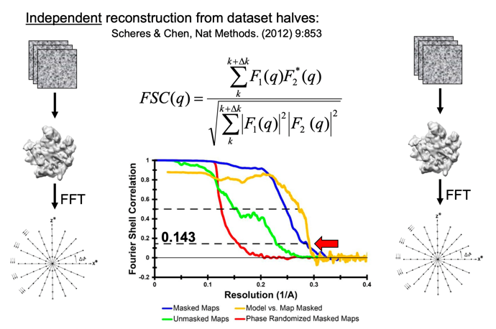
Resolution estimation – Fourier Shell Correlation

Calculate 3D refinement: split dataset in half, calculate 3D reconstructions, calculate Fourie transform for each reconstruction, calculate Fourie shell calculation -> obtain curves above

Local resolution
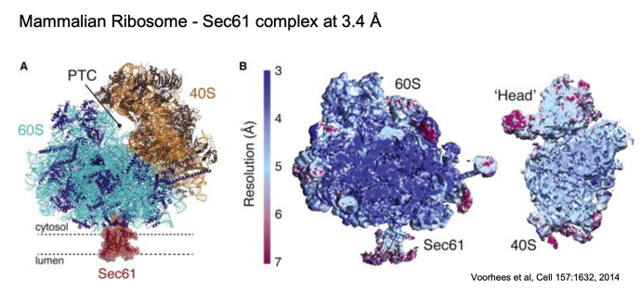
FSC for a map indicates over all resolution. Some parts of the map e.g. peripheral attached factors might be resolved to the same level of detail.

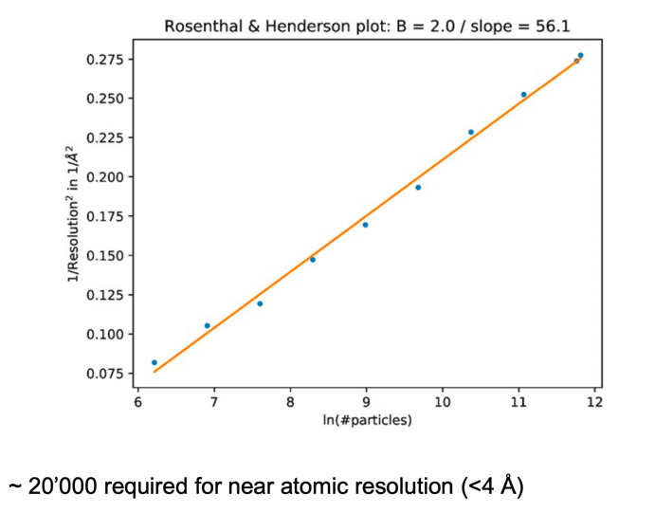
Resolution limit – number of particles

Resolution limit

Pixel size and detector properties
Pixel size - Nyquist frequency
Detector pixel size sets sampling frequency f_{S} = 1/pix.
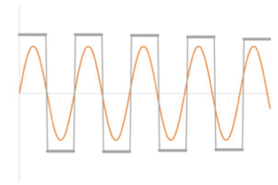
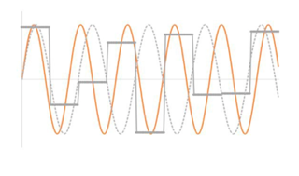
Only image information below Nyquist frequency f_{N} = f_{S} / 2 can be reconstructed due to aliasing effects at higher frequencies.

Sampling with f_{N} Sampling with higher frequencies
e.g. 1.2 f_{N} -> aliasing
The magnification has to set to a high enough value to allow visualization of fine structural detail

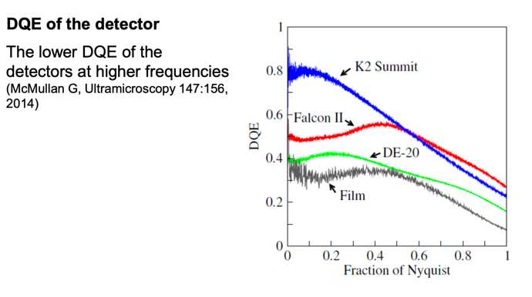
Detector DQE

DQE: Detector quantum efficiency

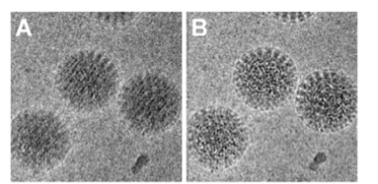
Correcting beam induced movement

- Ice layer moves in the electron beam: blurred image
- Direct detectors store 7-40 frames per exposure: Realignment of frames gives sharp image
- Correct for movement by using movies

Quality check for micrographs
CTF estimation – compare fitted power spectrum to image data:
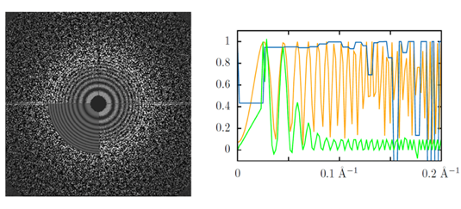

Check for drift and maximum resolution of power spectrum fit. Effects of charging and vibration cannot be corrected for by motion correction.

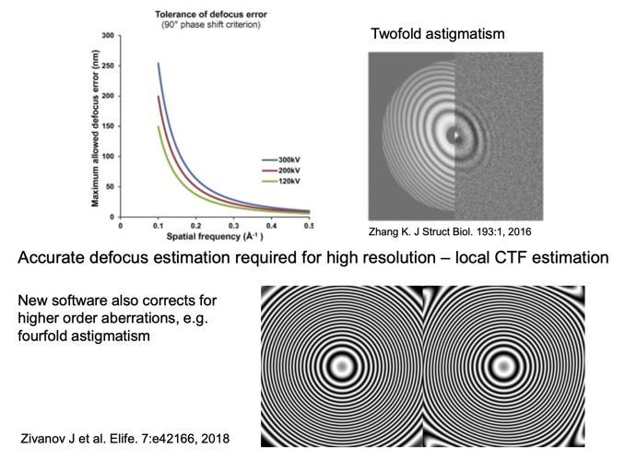
Residual aberrations

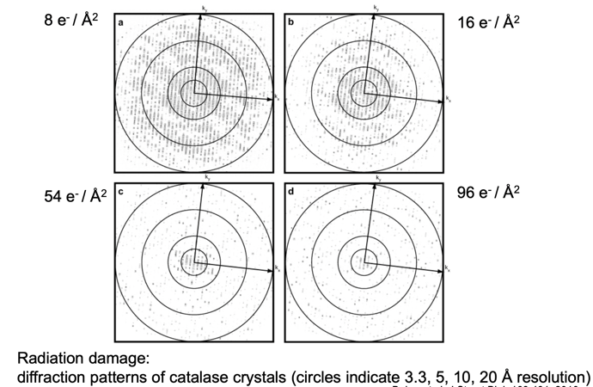
Radiation damage

gray: signal

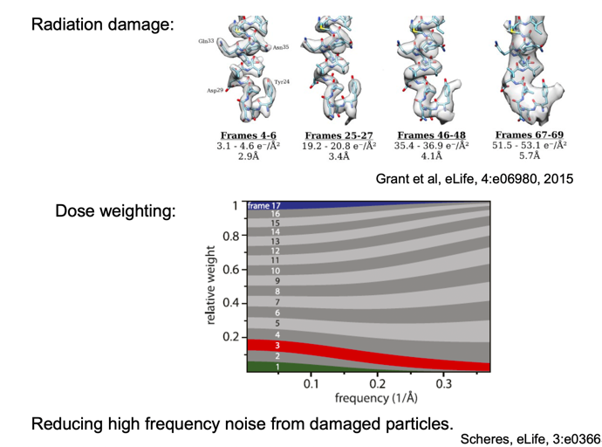
Dose weighting of image frames

SNR and projetion angle assignment errors
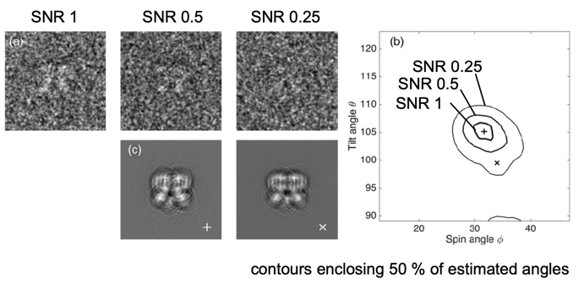
The noise in the image limits the accuracy of the angle assignment and maximum obtainable resolution of the 3D reconstruction.

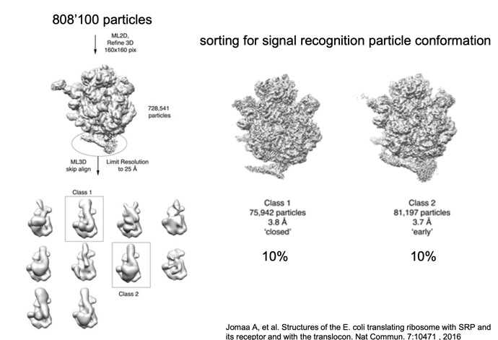
3D classification – heterogeneity

SNR and 3D classification
Identifibility problem: small structural variations cannot be resolved due to low SNR. What is the smallest detail that can be classified for ?
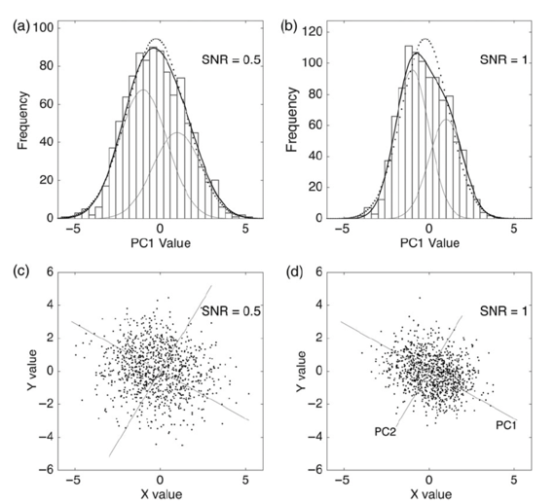

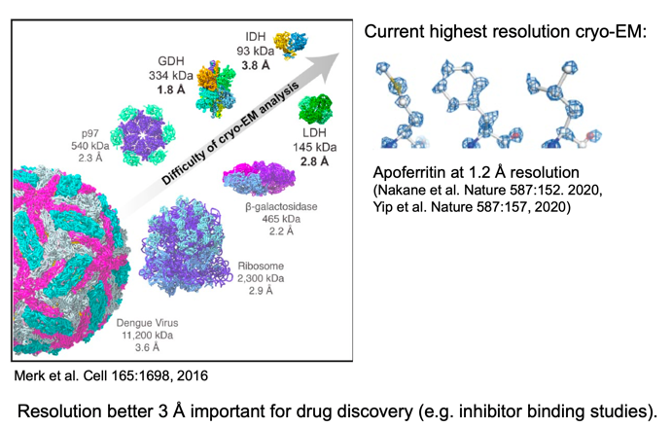

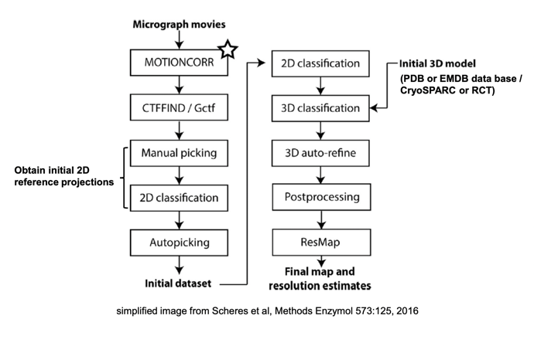
3D reconstruction workflow in Relion

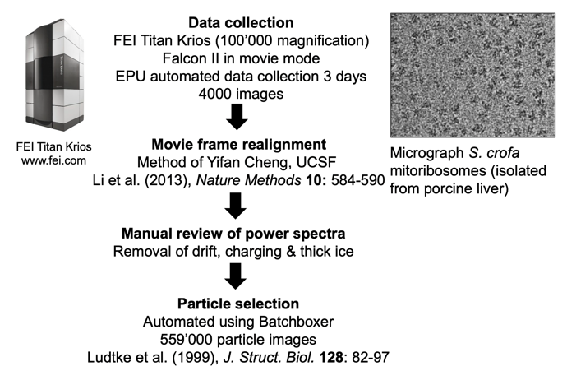
Mitochondrial ribosome @ 3.4 resolution

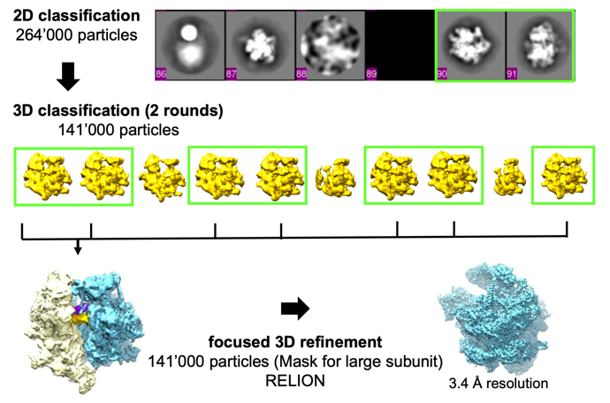

(Today: 5x as fast/ many images in same time)

Resolution and structural features
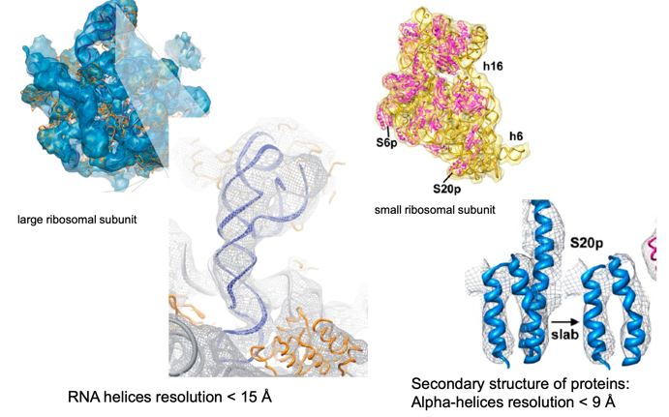

High resolution reconstructions

Suggested reading:
- Cheng Y. et al. (2015). A Primer to Single-Particle Cryo-Electron Microscopy. Cell 161, 438-449
- Sigworth F.J. (2015) Principles of cryo-EM single particle image processing. Microscopy 65, 57-67
- Orlova E.V. and Saibil H.R. (2011), Structural Analysis of Macromolecular Assemblies by Electron Microscopy. Chem Rev, 111:7710
Video lectures:
- LMB lectures on single particle EM: ftp://ftp.mrc-lmb.cam.ac.uk/pub/scheres/EM-course/
- Video tutorials by Grant Jensen http://cryo-em-course.caltech.edu/

Style of exam questions (FS17 & FS19)
- Equation ctf explain parts & provide it
- general questions like what affects reconstruction (sample quality, voltage etc)
- Resolution equation
- what is low pass filter, write ctf & which part is eliminated if low pass filter is used

L10: Cryo ET

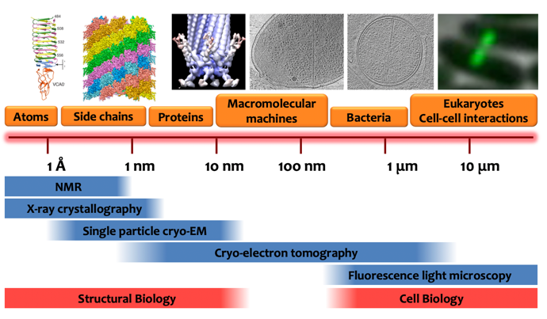
Multiscale approach

Cell and structural biology

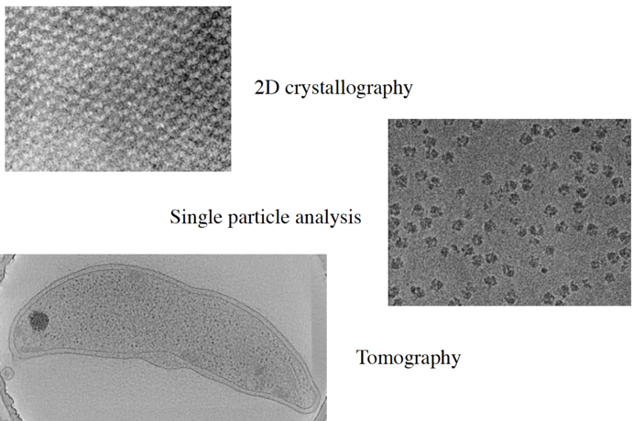
Basic approaches in cryo EM

Difference between methods: Way how they generate a 3D model

Fundamental challenges in biological EM
- Obtaining 3D information
- Dose limitations > low contrast
- Identifying structures
- Preserving native structure within microscope

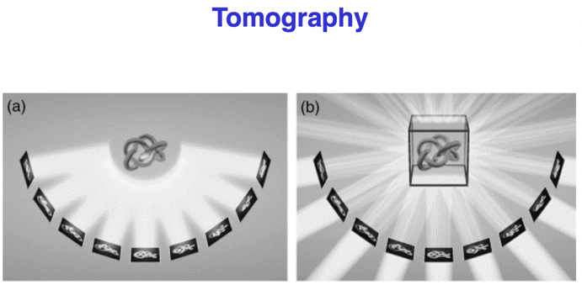
Tomography

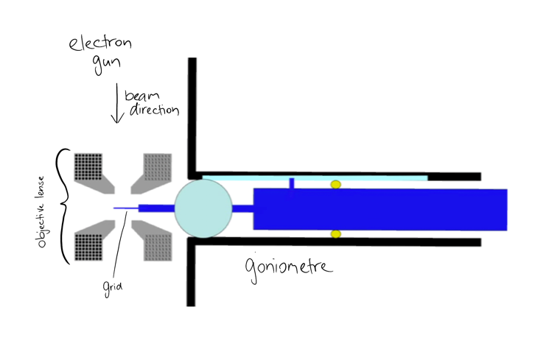
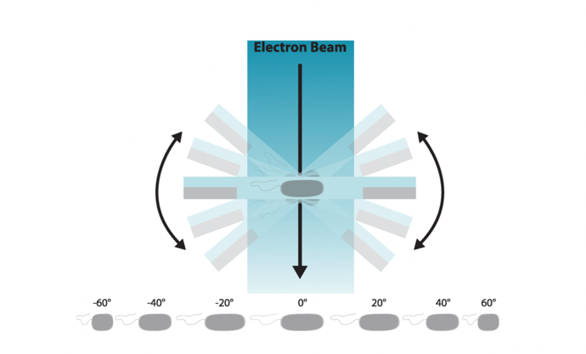
Goal: Image a unique sample, sample is tilted in the electron beam -> collect 2D projection images (tilt series), back project via computational methods to obtain 3D image => for cell you need much higher dose of radiation than for molecule

Projection theorem
Record 2D projection image of 3D object, calculate Fourie transform of 2D projection image. Fourie transform then represents a central slice of the 3D Fourie transform of 3D object
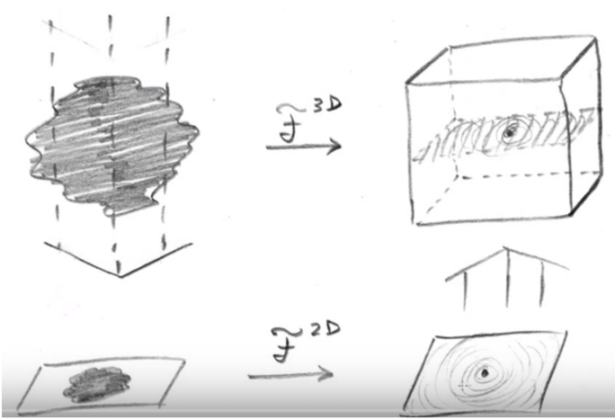
=> by collecting 2D projection images from different tilt angles one can populate the Fourie space of 3D Fourie transform and from there on back calculate to the structure of the 3D object

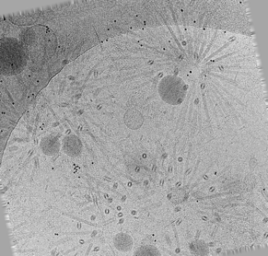
Image from tilt series

Plunge frozen sample with gold beads (black dots)

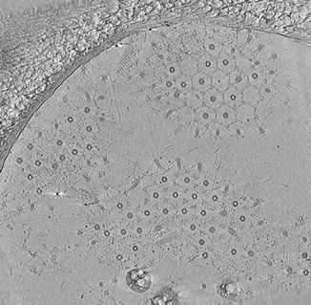

Tomogram
Central slice through tomogram

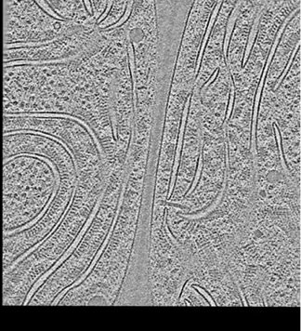
Slice of frozen cyanobacteria cell -> possible to do on cells, not only parts of it

(sub-tomogram average ~4-10nm resolution, but resolution difficult to determine in single sub tomogram)

Tilt series collection
Goniometer: allows grid to be inserted into high vacuum of column & allows it to be rotated

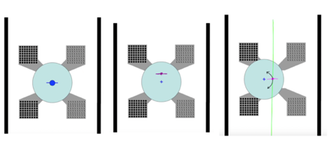
Eucentric height and tilt axis offset

Eucentric height: height of grid in microscope at which one can tilt the grid without the grid moving back and forth during tilting (otherwise it would move out of field of view!)

Tilt axis offset: Difficult to build microscope so electron beam coincides perfectly with center of goniometer, therefore there is an offset between beam and tilt axis -> Grid needs to be moved under electron beam. Grid now moves up and down when tilting, which influences focus/ defocus of images

=> Calibrations before image collection to minimize the movements, impossible to completely get rid of them

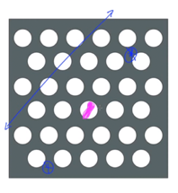
Tracking
- Manual (today: automated)
- Predictive methods
- Focus position methods (today)

To overcome problems because of
movement

Focus position method:
Collect one high resolution image of grid first, then have a trial area (blue dots with stars, parallel to tilt axis [blue line]) where images are collected after every tilting -> predict where the sample moved, computer (or manually) will adjust the position to have sample (pink dot) in center of view again.

Why not on sample directly? Reducing time where it is exposed to electron beam

Sequential automated tilt series
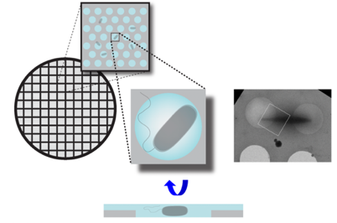
- Go into one square
- Collect low magnification overview
- Identify possible target regions
- Select targets (30-40)
- Computer will collect tilt series of targets automated

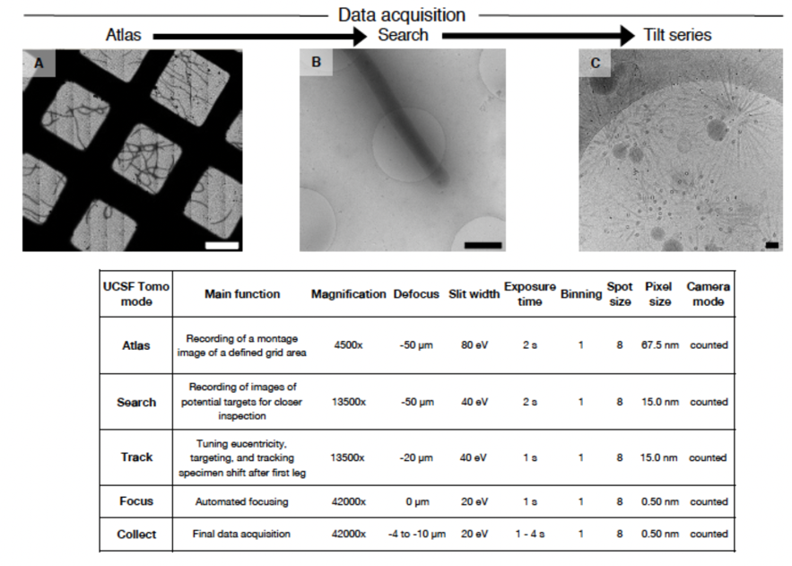
Imaging modes

Reconstruction (automated?)
- Drift correction
- Determine the following for each tilt (+/- fiducials, patches):
  - x, y shift
  - rotation
  - tilt angle
  - magnification
  - (defocus) -> Aligned tilt series
Weighted back projection in reciprocal space or simultaneous iterative reconstruction (SIRT)

Missing wedge
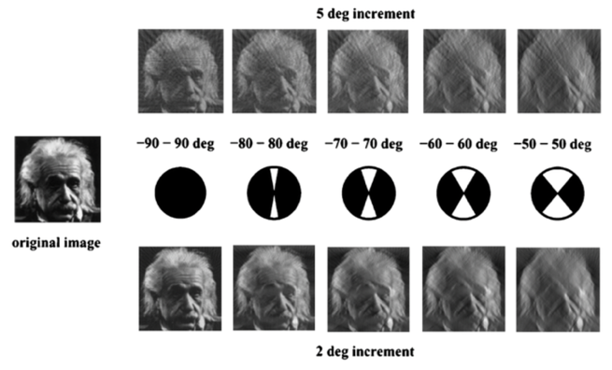
z-resolution lower while x- & y- resolutions are good

At higher tilt angles:
- Path at which electron beam travels through sample gets thicker -> prevents one from getting higher tilt angle than 70° as signal to noise for the path length gets to low
- Holder of grid gets in the way of electron beam

=> mostly 60° are used

Increments: frequency of images, depending on sample differently chosen.

Dual axis tomography
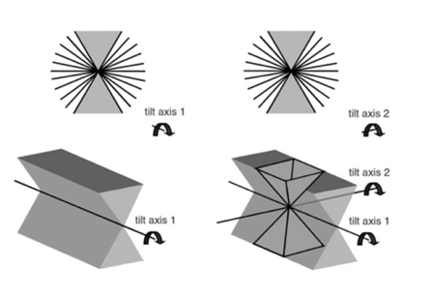
Overcome the missing wedge

Disadvantage: only limited amount of time one can spend on one sample because of radiation damage => use higher increment which leads to lower resolution or less electrons (makes image more noisy)

Today not used frequently anymore

Radiation damage
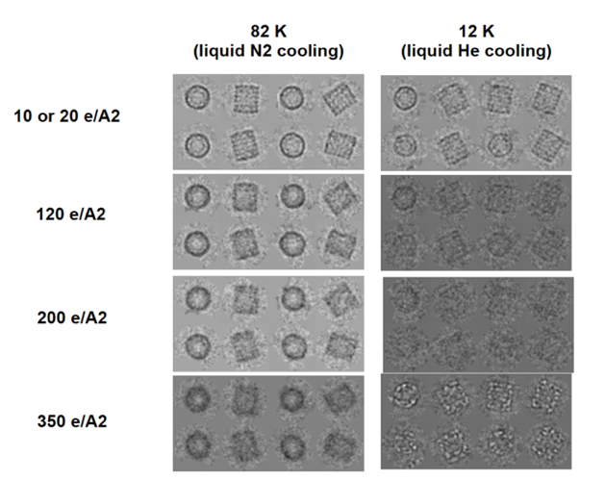
Different strengths of electron beams at different cooling agents

Imaging filter
The thicker the sample the more inelastically scattered electrons which leads to noise
Filters remove inelastically scattered electrons
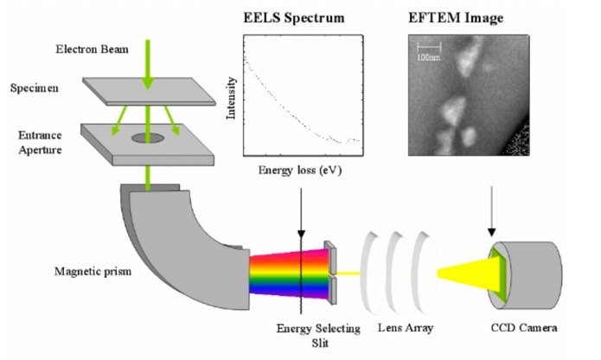

Defocusing
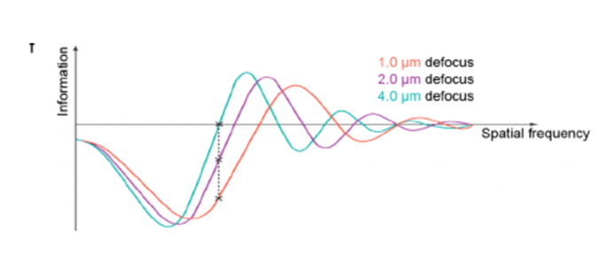
CTF (contrast transfer function)

At different defocus values it oscillates differently -> ET mostly between -5 to -10 microns to see structures (high resolution studies: By defocusing one also moves first zero to left of graph)

Phaseplate
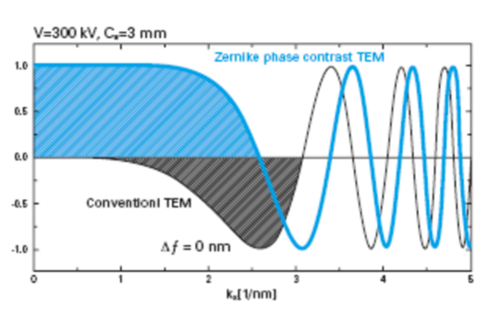
Carbon film (inserted into column of microscope), induces phase shift between scattered and unscattered electrons => change CTF to start out with full signal instead of oscillation which allows to image in focus with very low oscillation in focus and therefore recover high resolution features and improve contrast

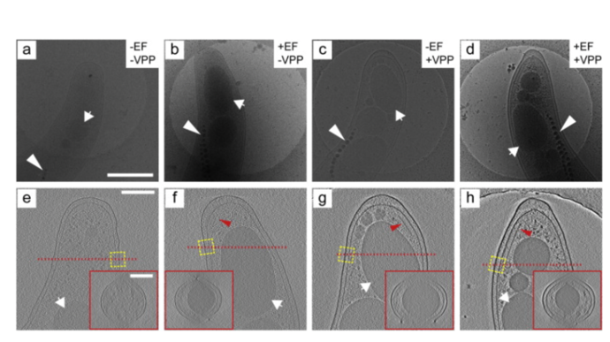

Phase plate (VPP) plus energy filter (EF) comparison

Today on everyday basis: mostly used EF, VPP used for special projects

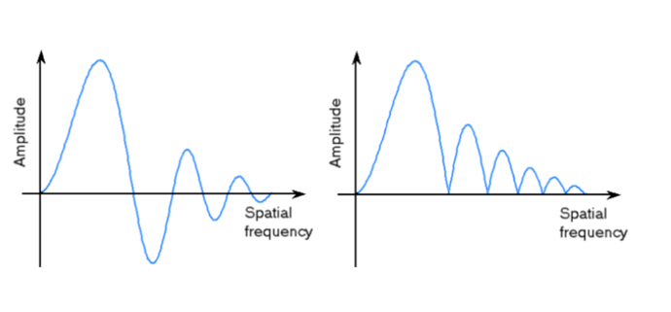
CTF correction

- After first 0 you flip phases to recover some of the high-resolution information
- still some zeros with no information left, so data collection usually at different defocus values

Subtomogram Averaging
- Model and extract subvolumes
- Align subvolumes
- Average subvolumes
- Possibility of classification
-> Atomic resolution (3.9A)

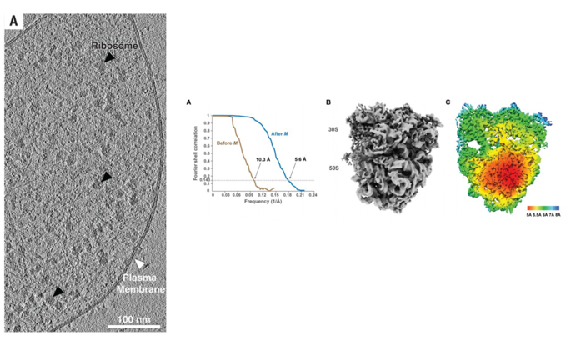
In situ ribosomes
Ribosomes in microplasma

Cutting edge: High resolution of protein complexes inside of cells (almost to level where one can start building models de novo!)
Only possible with a lot (!) of subvolumes, very thin samples

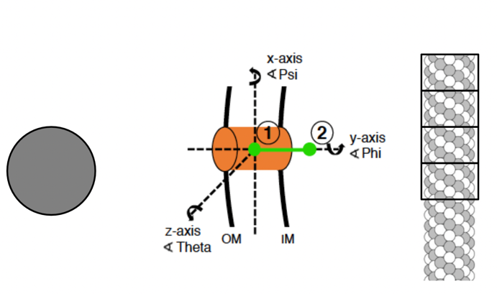
Extracting subvolumes

Idea of subtomogram averaging: Select subvolumes out of tomogram, align them, average them to generate high resolution structures -> combine single particle and ET data

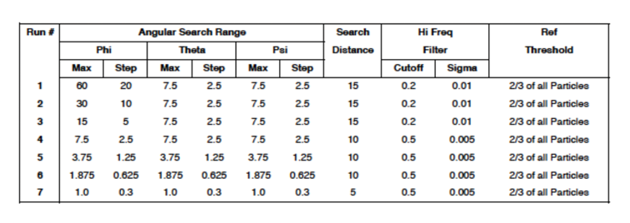
Iteration table

Search against template used for averaging: each particle is compared to template in an iterative way where increments of angles searched get subsequently lower which makes search finer and finer in different iterations. Like this the match of angles of subvolumes to template are found.

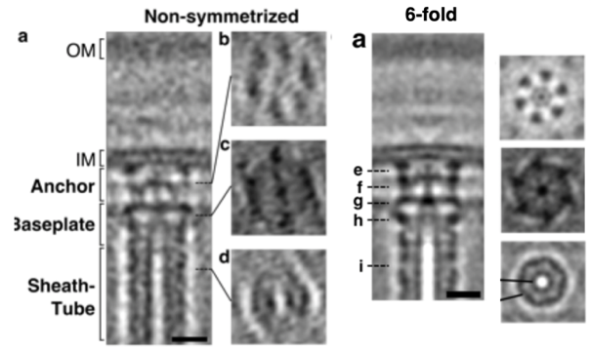
Symmetrization
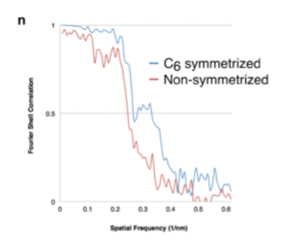

Improvement of images with symmetrized vs non symmetrized average

Identification of structures: High resolution
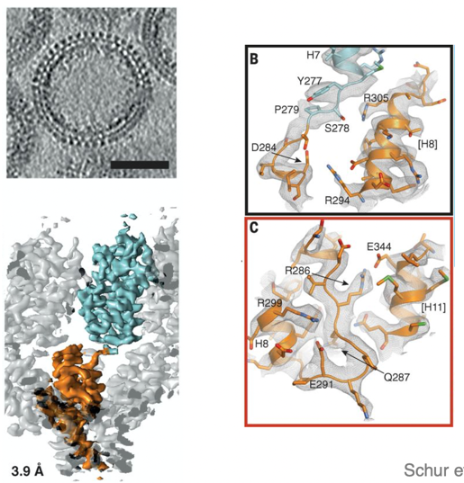
Generate averages with very high averages where de novo models can be made -> future?

Other ways:
- Known/obvious ultrastructure (actin, MTs, vaults, NPCs, golgi)
- Perturbing structures/abundance
- FFTs of structures with repeating subunits
- electron dense tags? Not used today, don't work as promised as of right now
- Purification, cryoET, mass spectroscopy

Template matching – visual proteomics
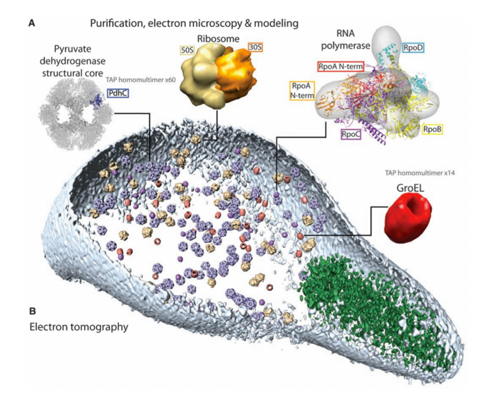
Search for matching densities

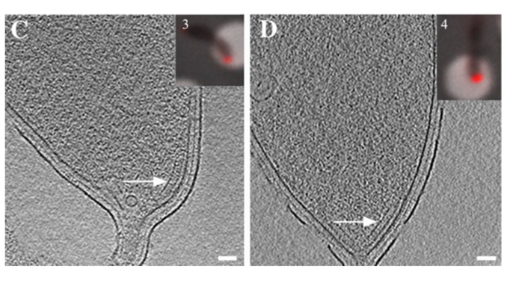
Correlated cryoLM-cryoET

Light microscopy: genetic tags to follow protein
Idea: correlate LM with cryo-ET to be able to follow proteins

Approach to image cell with fluorescent tag:
- Use LM with cryogenically cooled stage:
  - Image grid
  - determine where fluorophores are
  - record ET of cells with fluorophores (and hopefully use information to identify subcellular structures)
- Image: frozen grid recorded in LM, red tag: always in tip, made it possible to identify structure
Find very rare events (to find cells
Identify subcellular structure

Disadvantage: need to use long working distance arrow lenses (?) which leads to bad resolution (~300nm)

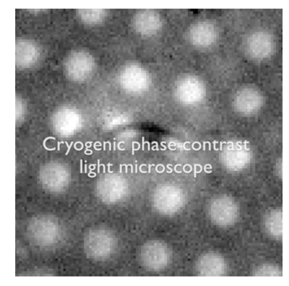
cryoPALM-cryoET
Not used much atm

Preserving native structure within microscope
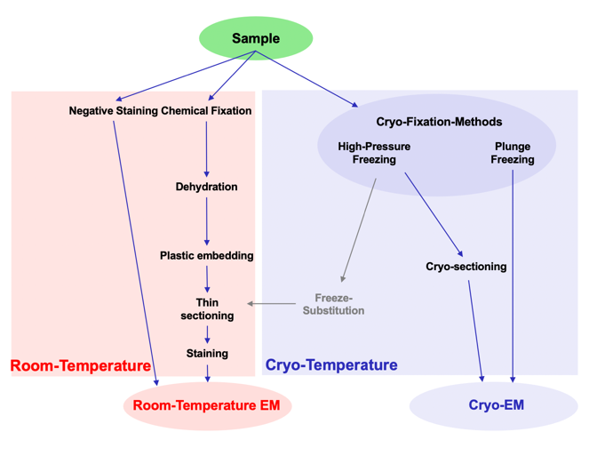
Different ways to prepare samples

Red: conventional EM -> lots of artifacts
blue: better to get to samples with are near native

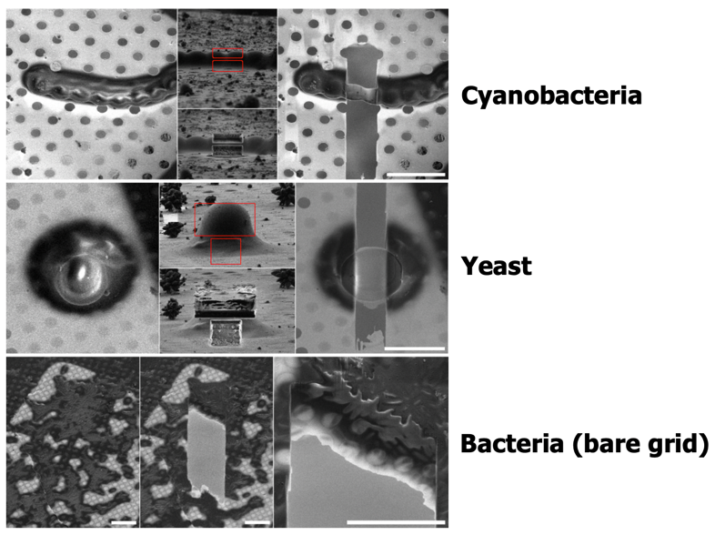
Problem: Sample thickness

- Cryo ET: limited to thin samples (~500nm, max 800nm)-> not appliable to eukaryotic cells (not even E.coli)
- The thicker the sample, the more inelastically scattered electrons

Overcome cryoET thickness limitation
- skinny strains
- optimize growth conditions
- skinny mutants (MreB, Min)
- tomography of vitreous sections (CEMOVIS) (difficult, leads to scatter and wrinkles, very difficult, not used today anymore)
- cryoFIB milling

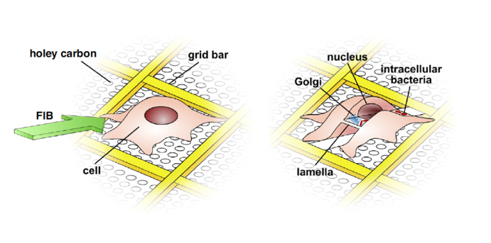
Cryo-focused ion beam (FIB) milling

- Cell plunge frozen on grid directly (pipet there or directly grow it there)
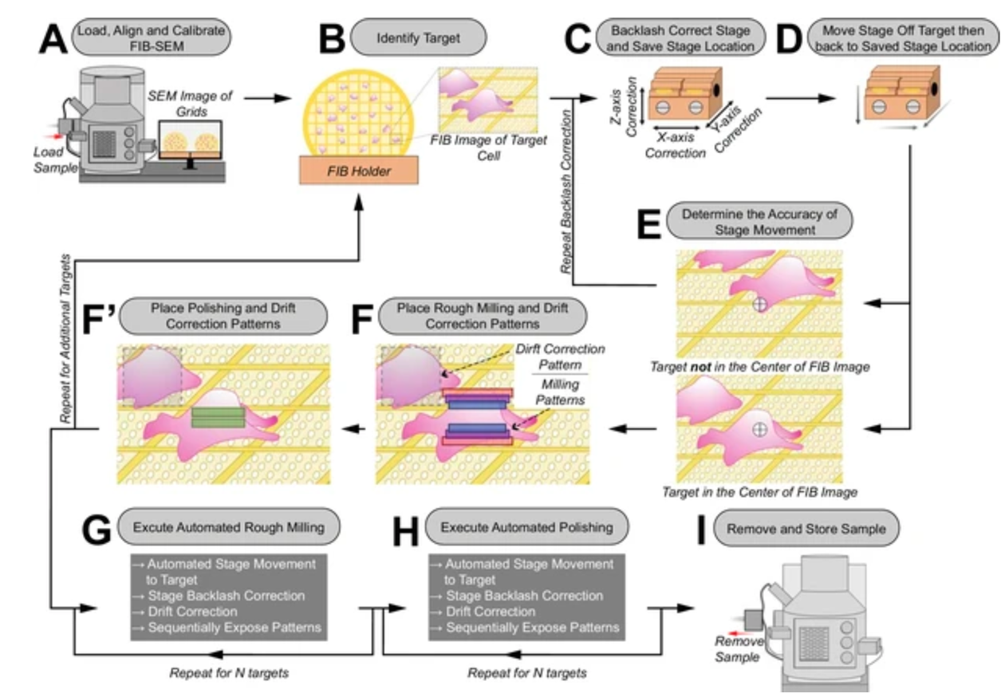
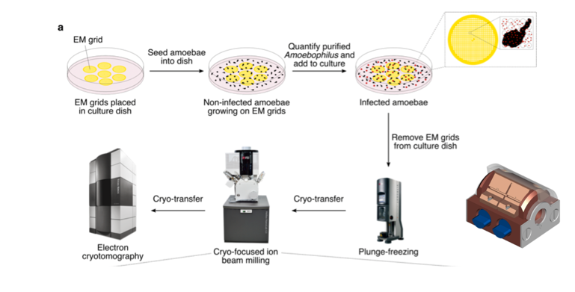
- transfer cell in microscope with electron focused ion beam -> generates thin lamellae
- image lamellae

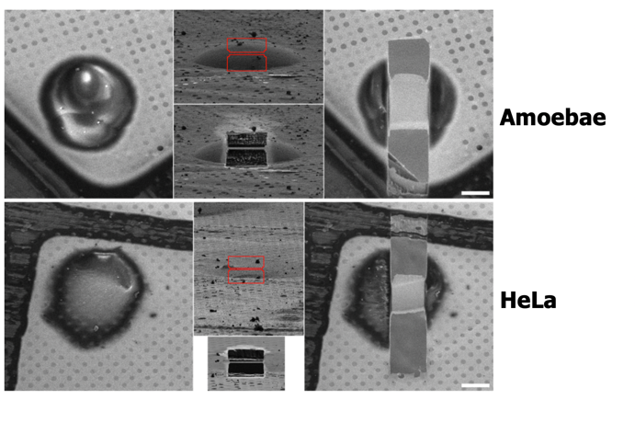
Example:

Allows to image more complex samples
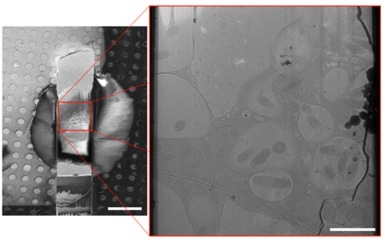
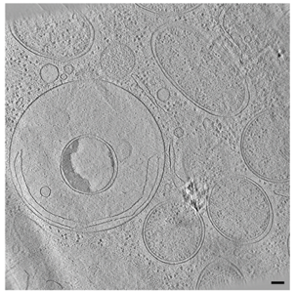
-> transfer lamellae to get more information out of them via ET

Automated sequential cryoFIB milling
Routine to not having to do the cryoFIB milling manually

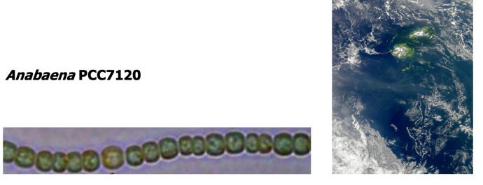
Multicellular cyanobacteria Example of height throughput milling
Study to understand cyanobacteria
communication

Understand structure and function of communication along filaments

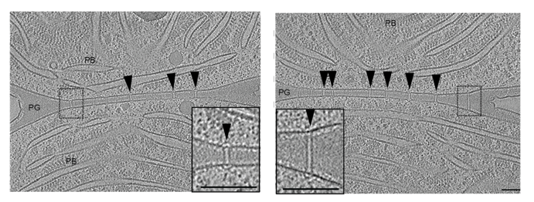
Septa and channels of different length running through septa plus caps and plugs at the end of the channels (septa junctions)

Structures of septa junction caps and plugs established via subtomogram averaging

Functional insight via combination with FRAP when stressed:
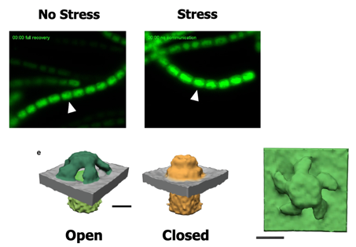
Different conformation when stressed => cells likely close septa junctions when stressed

Cryo ET: what it is good for
- unique objects
- in situ
- life-like, near native state
- 3D information
- macromolecular (atomic) resolution

Future Directions
- Faster detector readout for continuous tilting -> stages atm not stable enough
- Integrate cryoLM into milling instrument -> reduce steps in between
- Integrate LM with plunge-freezing (to freeze interesting event directly)

Style of exam questions (FS17 & FS19)
- Why fiducial markers
- how tilt series acquisition works scheme
- missing wedge

Ishikawa:
- abcd questions, easily solvable with handout

